4.7 - What you usually wear…

 |  |  | 
Bára málokdy nosí kraťasy.
Bára rarely wears shorts.

So now that we can say what we currently one (or someone else), we might want to talk about what we usually wear:

It could be in the context of:

- What you wear everyday.
- What you wear when it’s cold/hot out.
- What you wear when we go to work, school, a date, etc.
- What you like to wear.
- Or even what you never wear.

The verb you’ll want to use for this is nosit ‘to wear (regularly)’. It’s a regular -í- verb

nosit to wear
(já) | nosím ‘I wear’ | (my) | nosíme we wear’
(ty) | nosíš ‘you wear’ | (vy) | nosíte ‘you wear’
(on/ona/ono) | nosí ‘he/she wear’’ | (oni/ony/ona) | nosí ‘they wear’

 |  |  | 
Hana často nosí šaty.
Hana often wears dresses.

 |  | 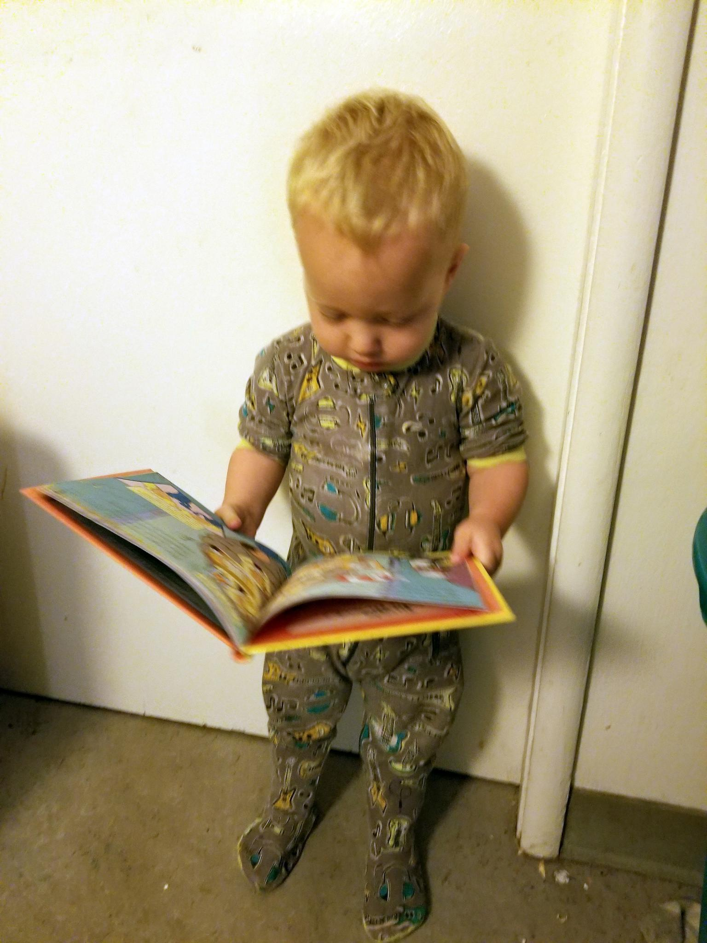 | 
Pavel rád nosí pyžama.
Pavel likes wearing pajamas.

Don’t forget, that since it is the thing being worn, whatever you put after nosit ‘to wear (regularly)’ needs to be in the accusative.

Images used in this document come from these sources.

