8.5 - Beginning and Ending

 | 

Just like most verbs we’re learning now, we’ll need to learn an imperfective and a perfective for these.

Imperfective | Perfective | Definition
začínat | začít | ‘to begin’
končit | skončit | ‘to end’

Let’s start with some present forms. For these we’ll be using the imperfective verbs. The verb začínat is a regular -á- verb, while končit ‘to end’ is a regular -í- verb.

 |  | 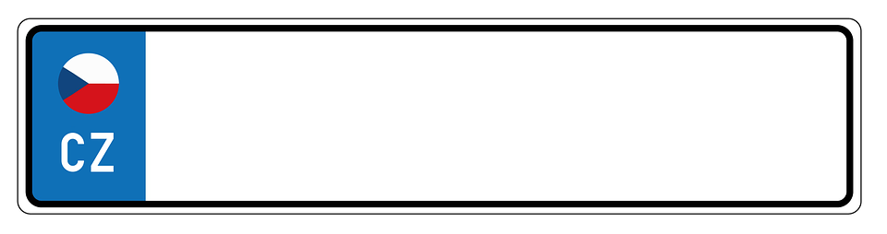
Film začíná v osm hodin.  The movie starts at 8 o’clock. | Přednáška začíná ve čtyři hodiny.  The lecture is beginning at 4 o’clock. | Hodina češtiny začíná v deset hodin a končí v jedenáct hodin.  Czech class begins at 10 and ends at 11.

As a final note, you’ll often see the dative case used to indicate who something begins or ends for (one literally says class to/for me starts at 10).

Škola mi začíná v osm.
School starts for me at 8.

Hodina matematiky nám začíná v 11.
Math class begins for us at 11.

We’ll practice the past tense forms (i.e. talking about when something began, when something ended) in another lesson.

Images used in this document come from these sources.

