7.4 - Indefinite Time Window

How do we express an indefinite time period (like I usually wake up sometime between 7 and 8am; or I usually have dinner sometime between 6-7 o’clock)??

Czechs will literally say ‘between the sixth and seventh hour’. We will need our ordinal numbers (první, druhý, třetí…). The word hodina will be understood.

To do this, we’ll need the preposition mezi ‘between’, which is followed by the instrumental case. Here are the endings (remember that almost all of the ordinal numbers are hard stem adjectives with the exception of třetí ‘third’):

instrumental adjective endings
feminine singular
hard stem | -ou
soft stem | -í

Sometime between...
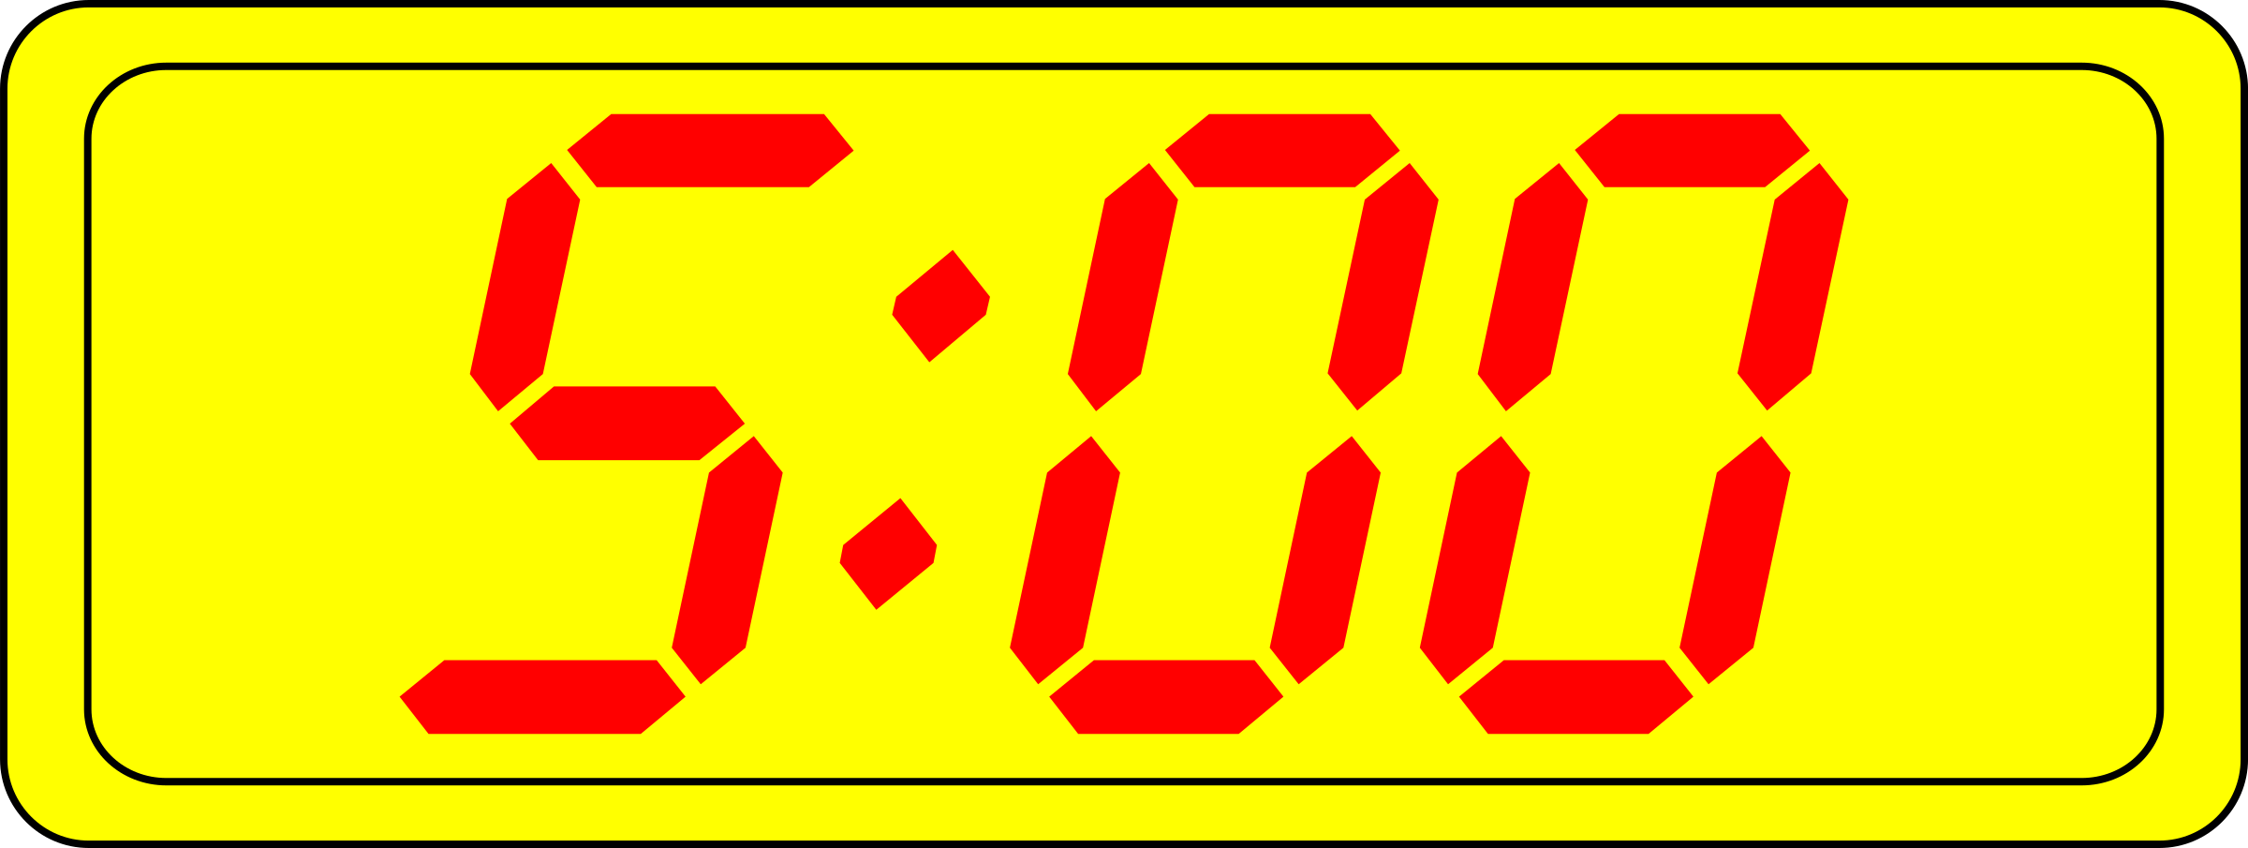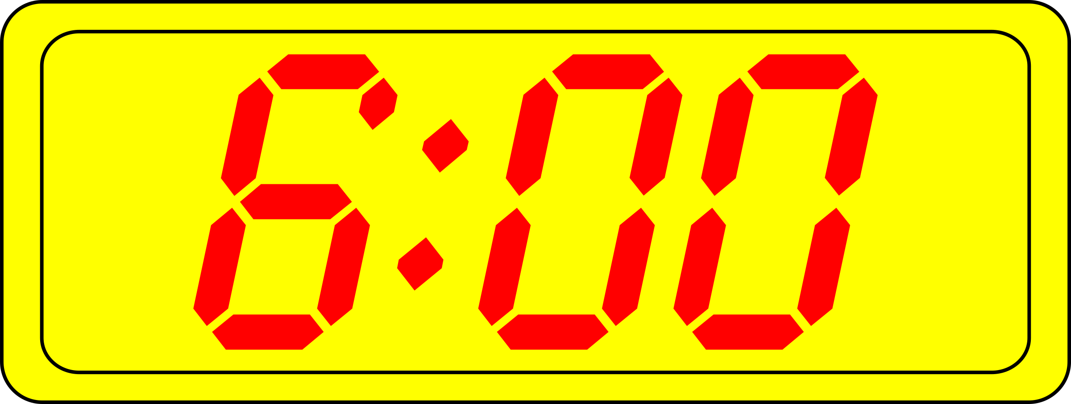
někdy mezi pátou a šestou (hodinou)

Sometime between...
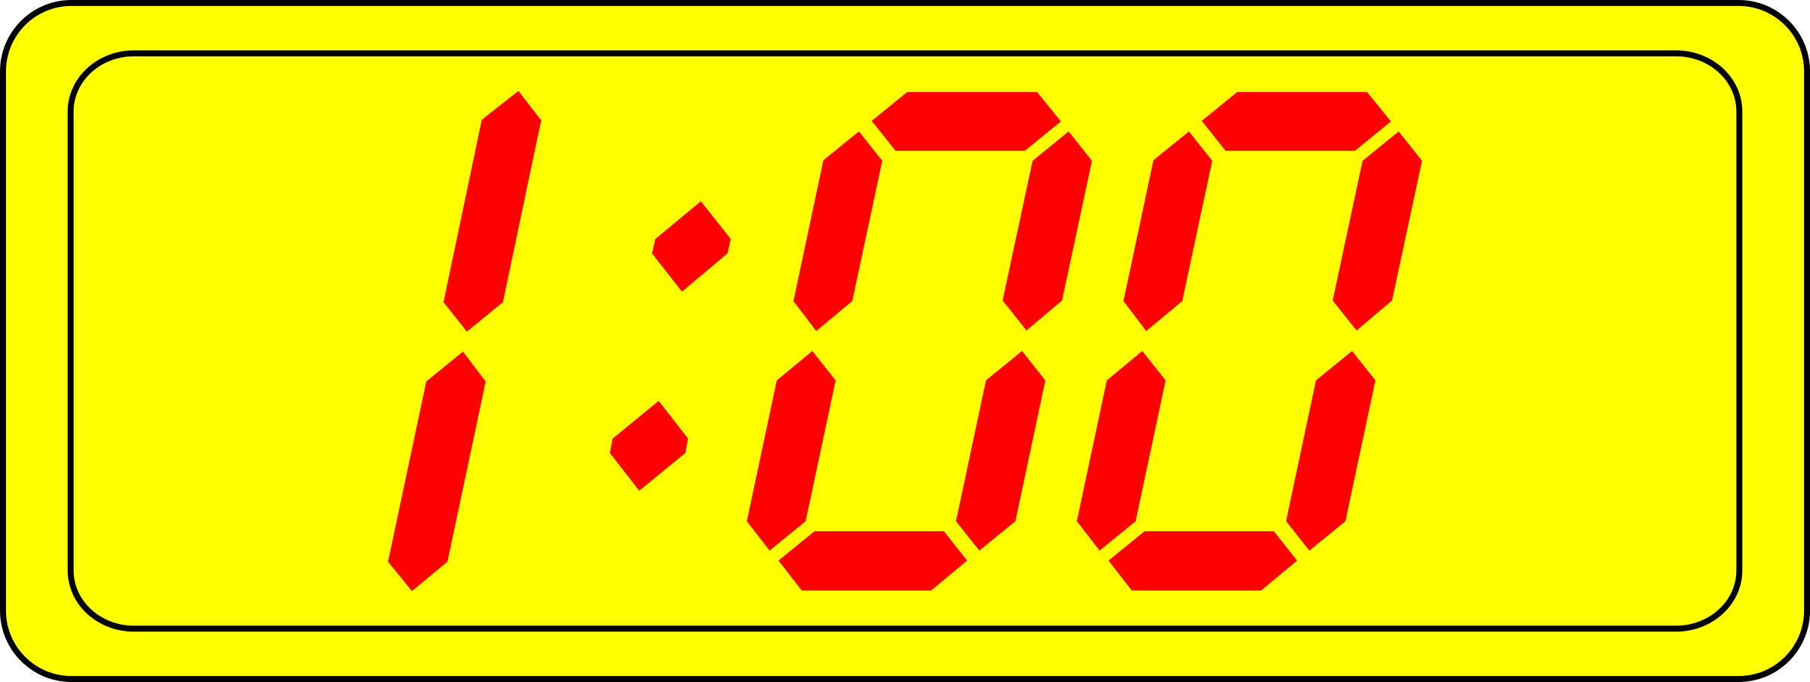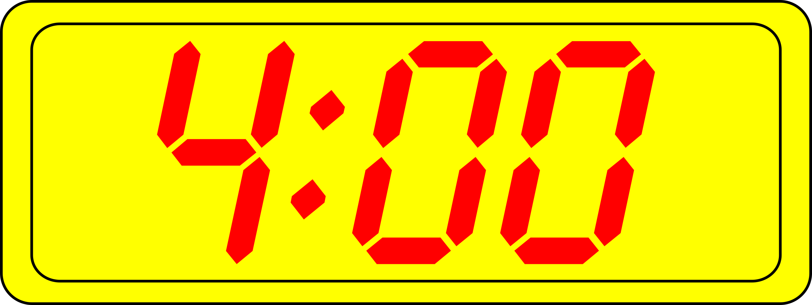
někdy mezi jednou a čtvrtou (hodinou)

Images used in this document come from these sources.

