5 | 1 | Lekcija 1: Sretan rođendan!

5.1 Zadatak 1. Moji dragi ljudi
 | 
Video recording. Tell us about people in your life who are very important to you. Say when they were born (do not include the year, only the day/month). Say what their characteristics are and what your relation to each of them is – family member or a friend. Talk about at least four people in your life. Submit your video recording online.

5.1 Zadatak 2. Što obično radiš?
Writing. Write a paragraph about your birthday celebration. The following questions are only the general guidelines. However, stay within the vocabulary and grammar that we covered so far.
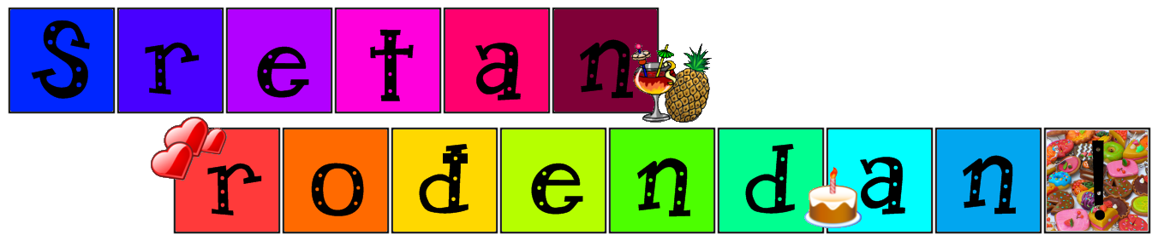 | 

| Pitanja
Kada je tvoj rođendan?
Što organiziraš za rođendan?
Tko dolazi na tvoj rođendan?
Što radiš za Dan zahvalnosti?
Planiraš li slaviti Dan zahvalnosti ove godine?
Kako planiraš proslaviti Dan zahvalnosti?

| Odgovor
→

5.1 Zadatak 3. Reci mi o sebi
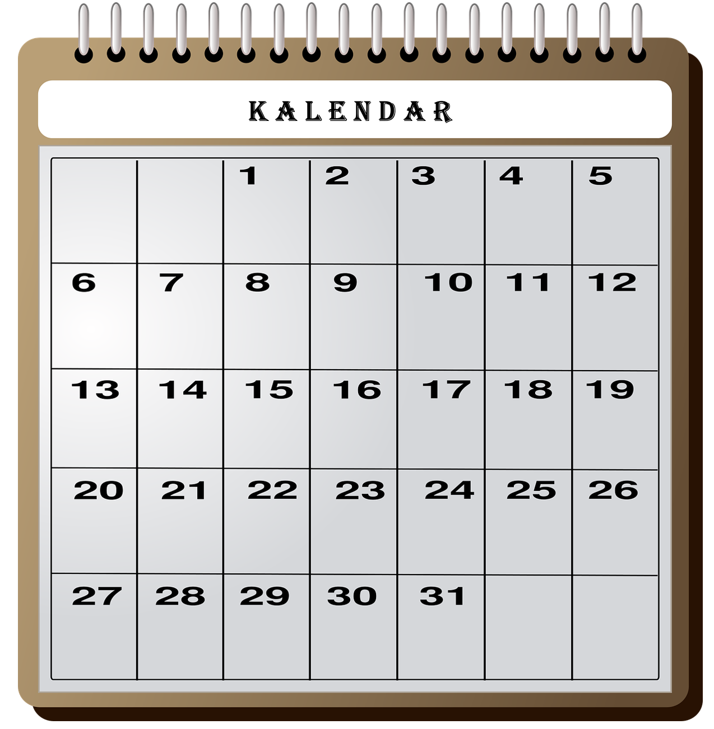 | 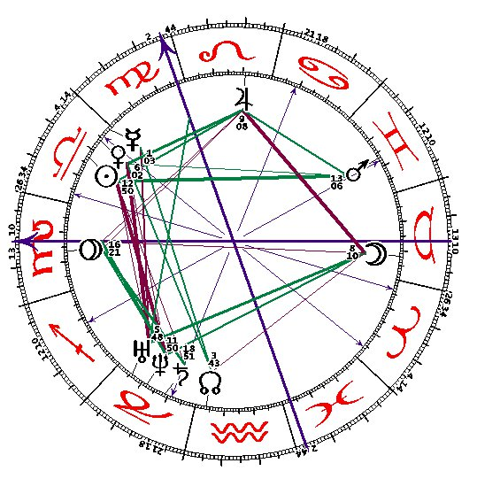
👥 Talk with one of your classmates. Find out when their birthday is and what they want to do for it. Make plans for each of your birthdays – where to go, what to do, who to invite and why. Use our dialogues from today’s lesson for inspiration/vocabulary. Submit your video recording online.

5.1 Zadatak 4. Kako se kaže?
1 | How would you express your surprise about hearing something?
 | -
2 | How would you say that you “are in” – that you want to do something?
 | -
3 | How would you wish someone a lot of happiness and luck in life?
 | -
4 | How would you say that you cannot show up without bringing something?
 | -
5 | How would you say that your gift is nothing big?
 | -

5.1 Zadatak 5. Kako se kaže?
Write a birthday card to our student James. What do you want to say to him? How would you express your wishes for his birthday?
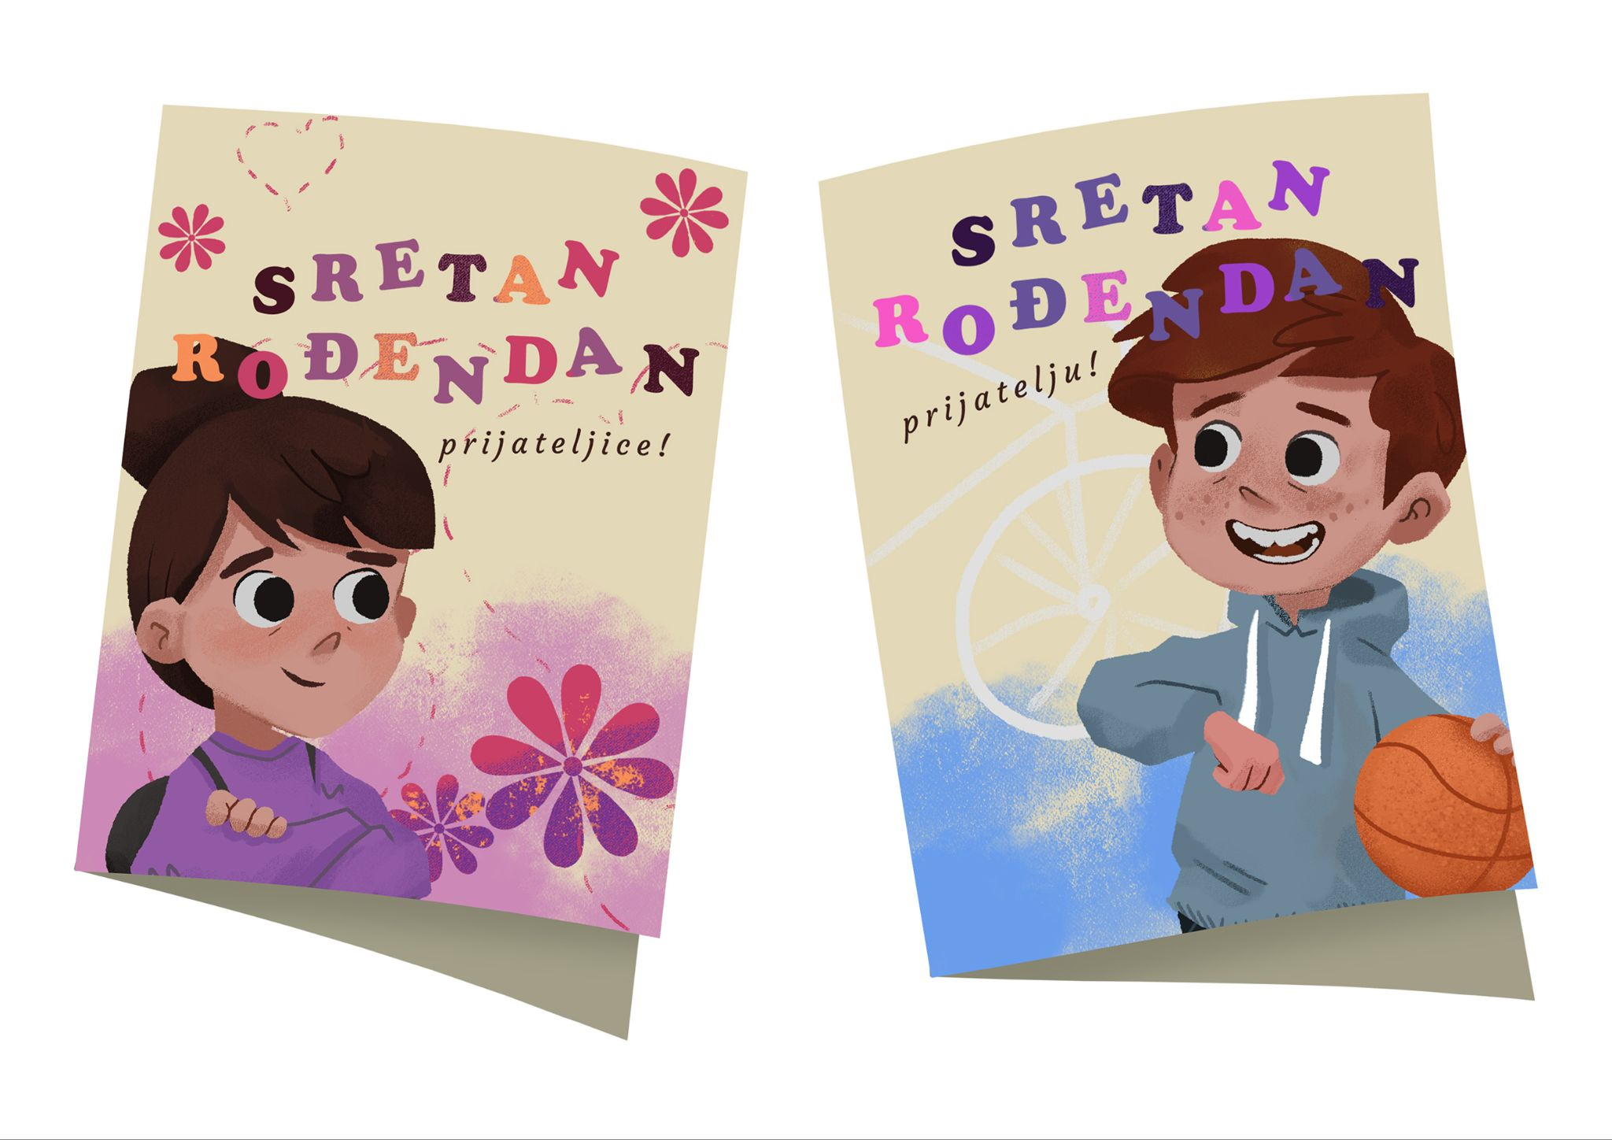 | Dragi James,  …

Images used in this document are from these sources.

