10 | 4 | Lekcija 1: Ponavljanje

# 10.4 Zadatak 1. Hotelski smještaj

Look at the picture with several hotels in Zagreb and answer the questions below.

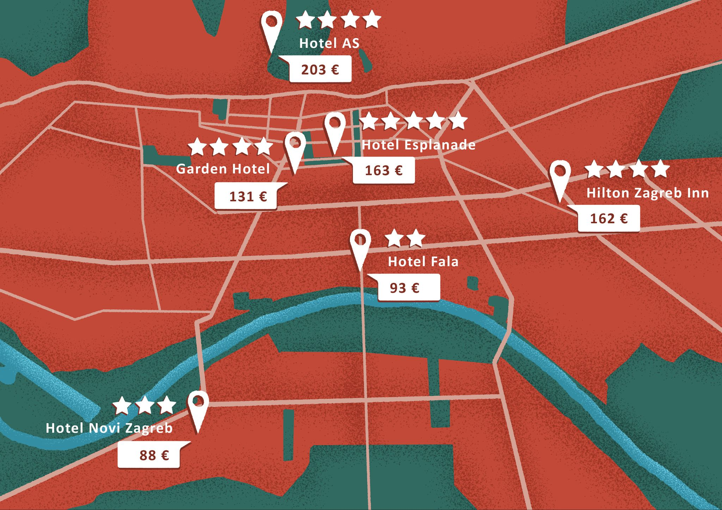

Answer the questions based on what you see on the map. Some questions will ask about the price. Use the Croatian word for € in your answers. Be careful with numbers. Example: 179 € = 179 euros.

[h5p id="863"]

# 10.4 Zadatak 2. Gdje je?

For each sentence, indicate the position of the apple in relation to the box.

[h5p id="864"]

# 10.4 Zadatak 3. Kamo, kuda, gdje?

Use the appropriate question based on the given answer. You should choose between: ***Kuda ideš? - Gdje si? - Kamo ideš?***

[h5p id="865"]

# 10.4 Zadatak 4. Od – do

[h5p id="866"]

# 10.4 Zadatak 5. Kamo idu?

Complete the sentences by using the most appropriate word from a word bank. Be careful, you need to change the noun form into the Genitive case. If more than one option is possible, choose only one. Word bank: *knjižara, zubar, baka, centar, grad, djed, banka*.

[h5p id="867"]

# 10.4 Zadatak 6. Gdje se nalazi?

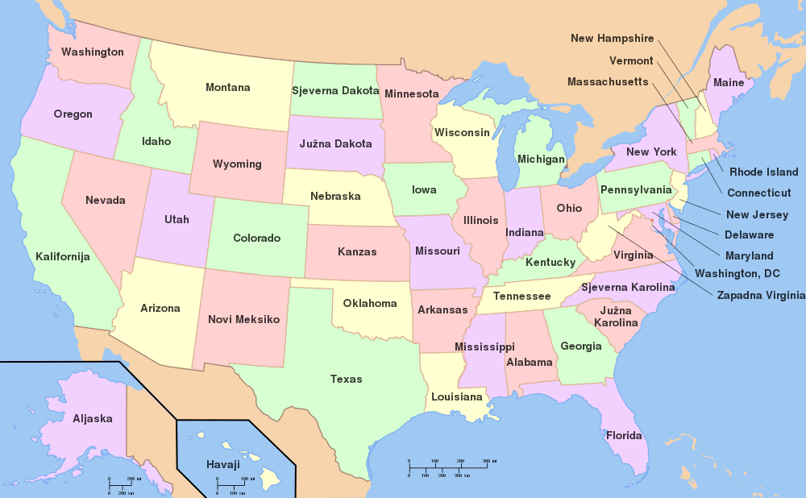

Read the sentences and write where each state in the U.S. is located in comparison to the other one. Use one of the following: ***sjeverno od, južno od, istočno od, zapadno od***.

[h5p id="868"]

Images used in this document are from [these sources](https://docs.google.com/document/d/1UxfltUzYXRFEdL2-mb6rFZPWlhNFdEf6Ch6wdUxDBL4/edit#heading=h.ou6sok6ab3dc).