2 | 3 | Lekcija 3: Izlazak

2.3 Zadatak 4. Moje aktivnosti
Look at the pictures. Complete the sentences based on the action on each picture.
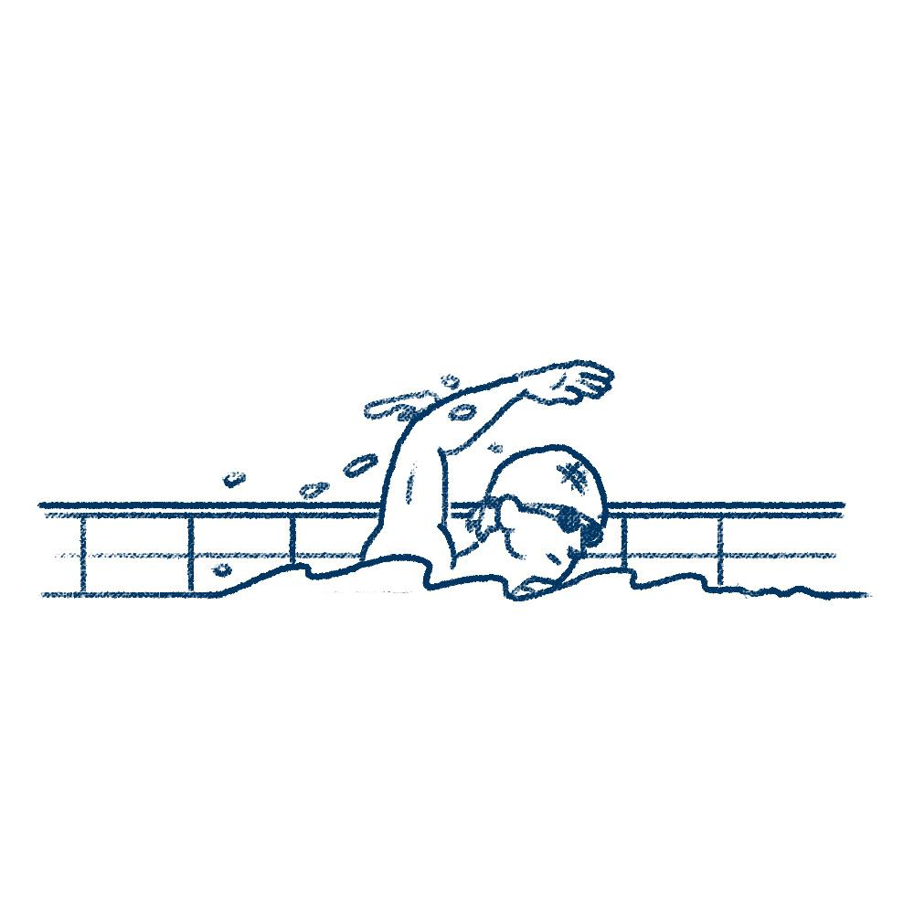 | 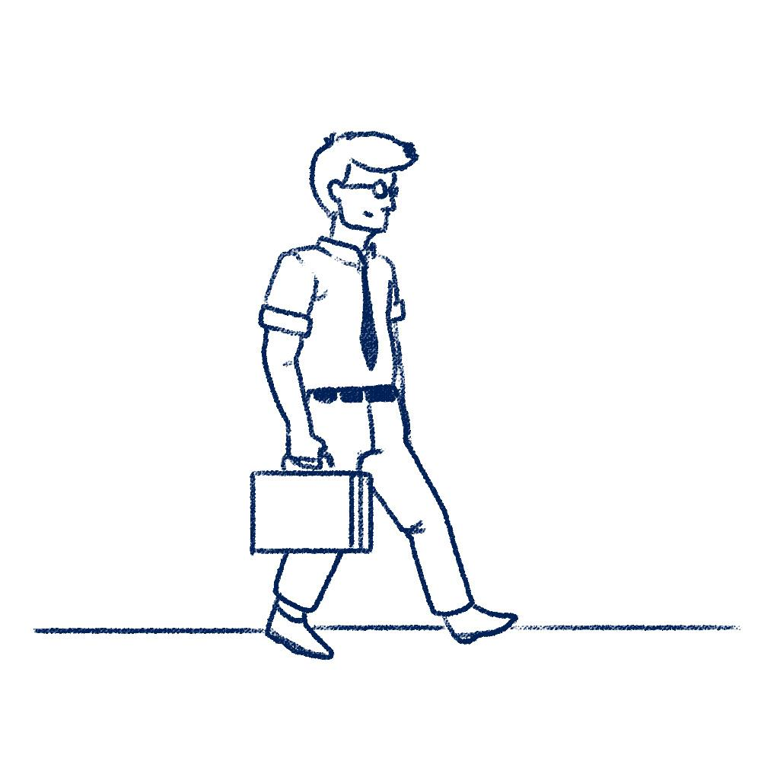 | 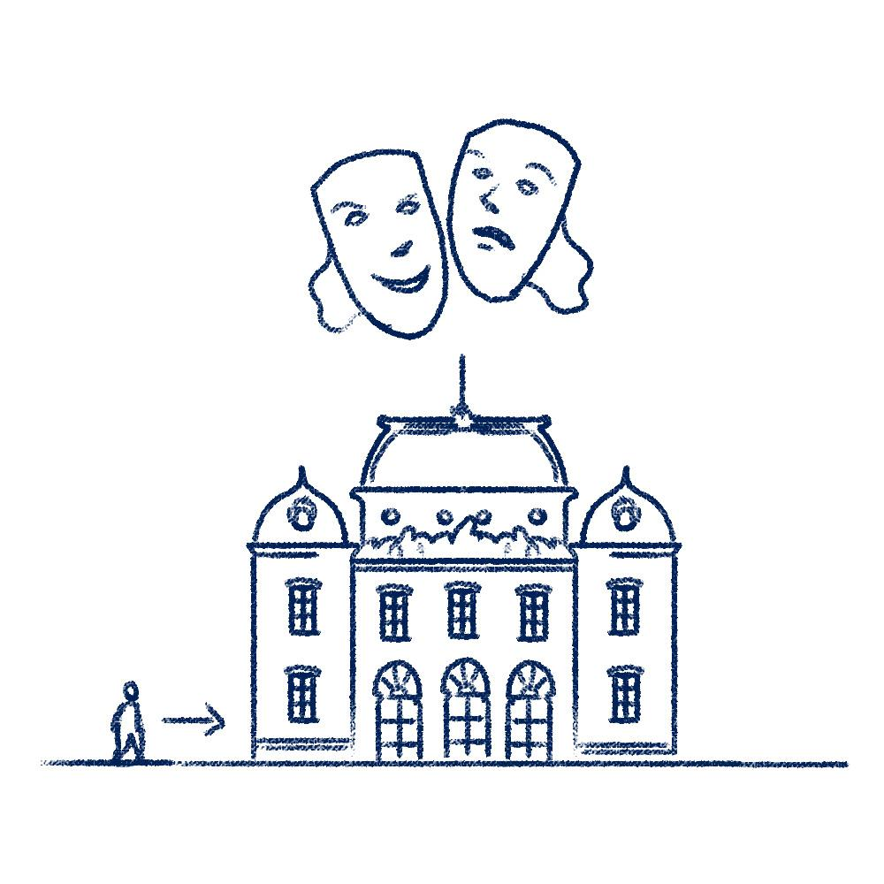
slika 1 | slika 2 | slika 3
[h5p id="315"]
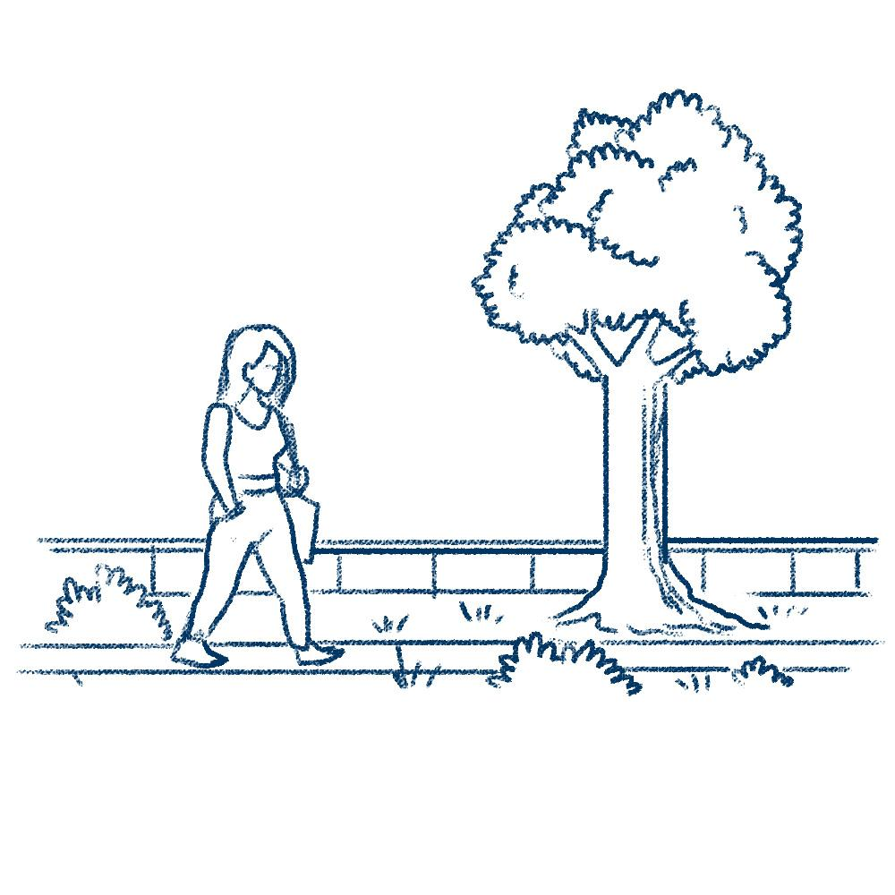 | 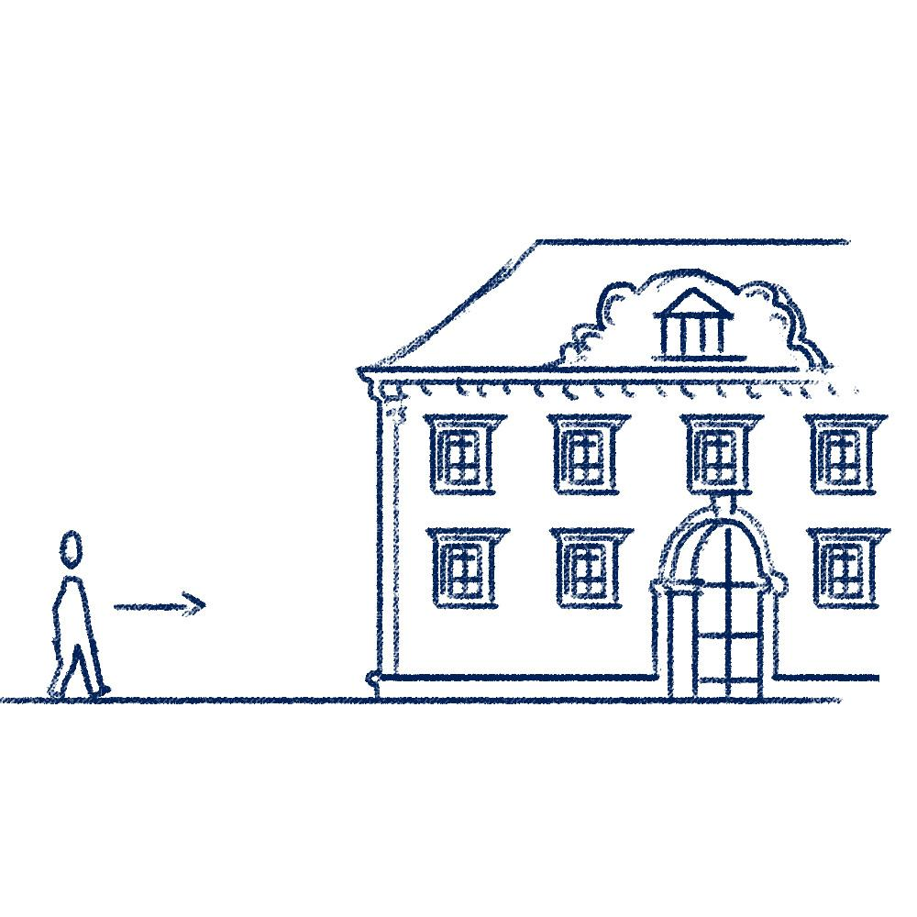 | 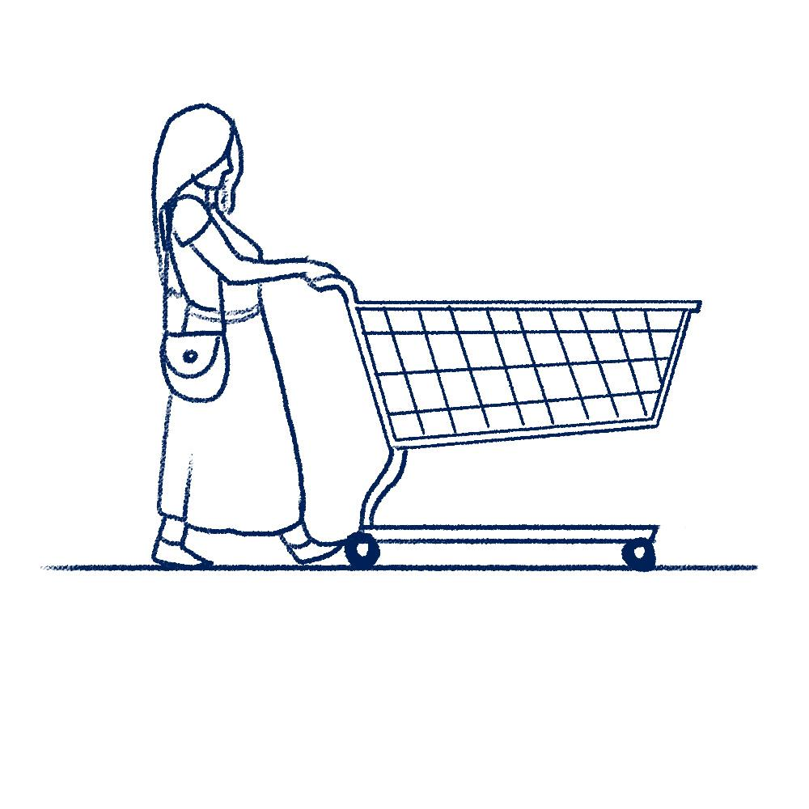
slika 4 | slika 5 | slika 6
[h5p id="316"]
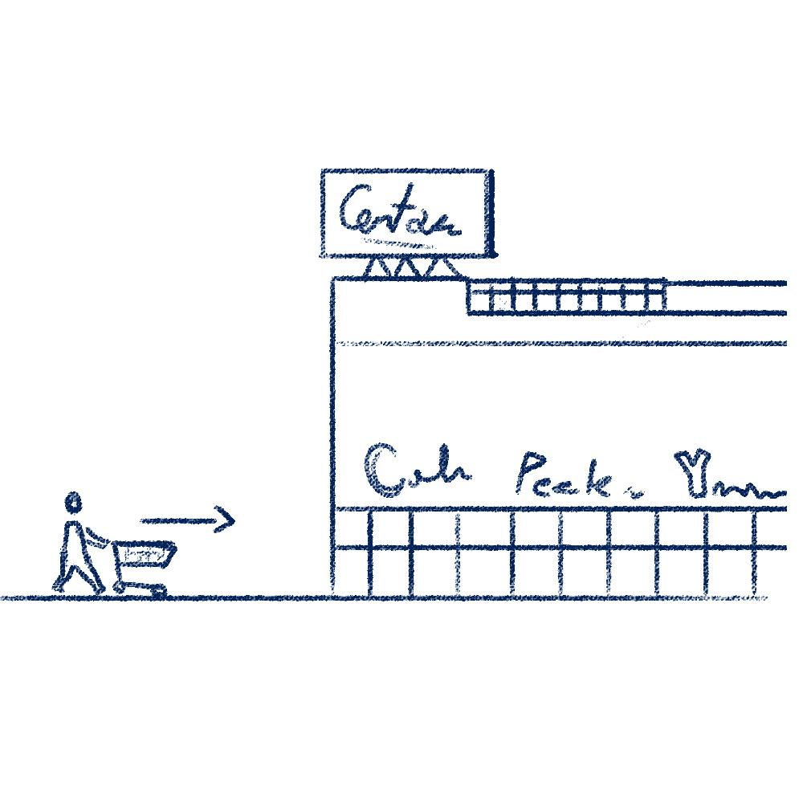 | 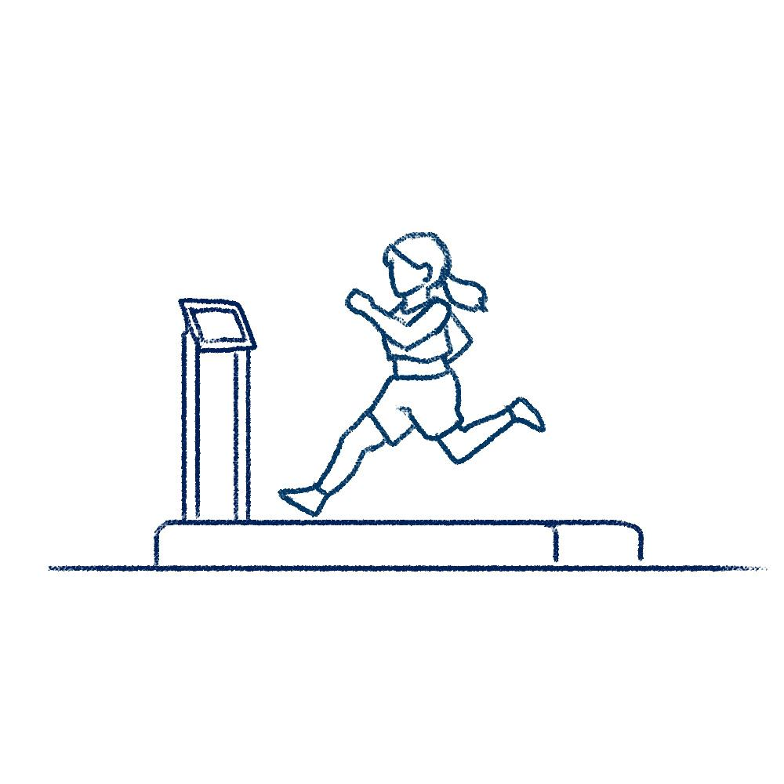 | 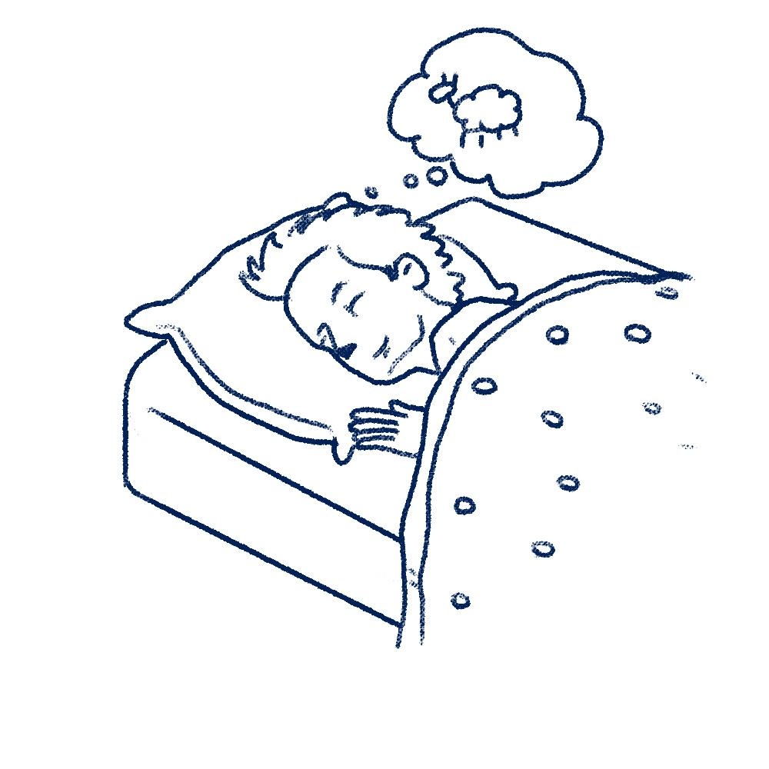
slika 7 | slika 8 | slika 9
[h5p id="317"]

2.3 Zadatak 5. Kamo idemo?
Each of the pictures below represents a certain location or event. From a drop-down menu, choose the correct answer so the sentence is grammatically and logically correct.

 | 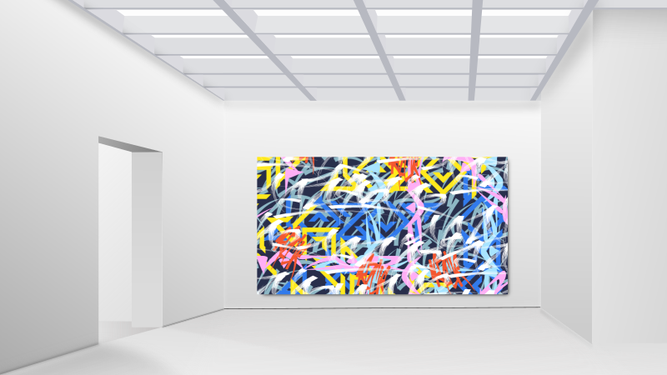 | 
slika 1 | slika 2 | slika 3
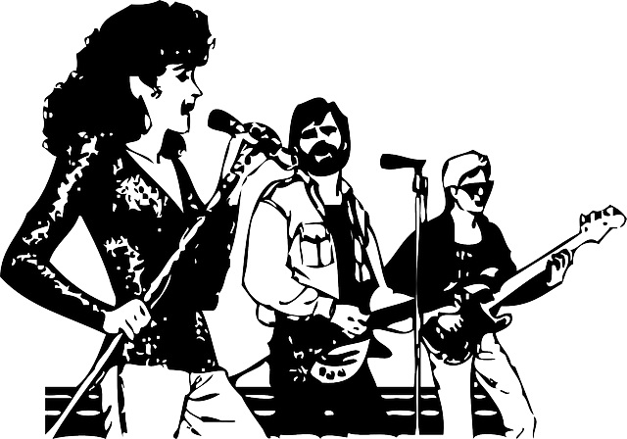 | 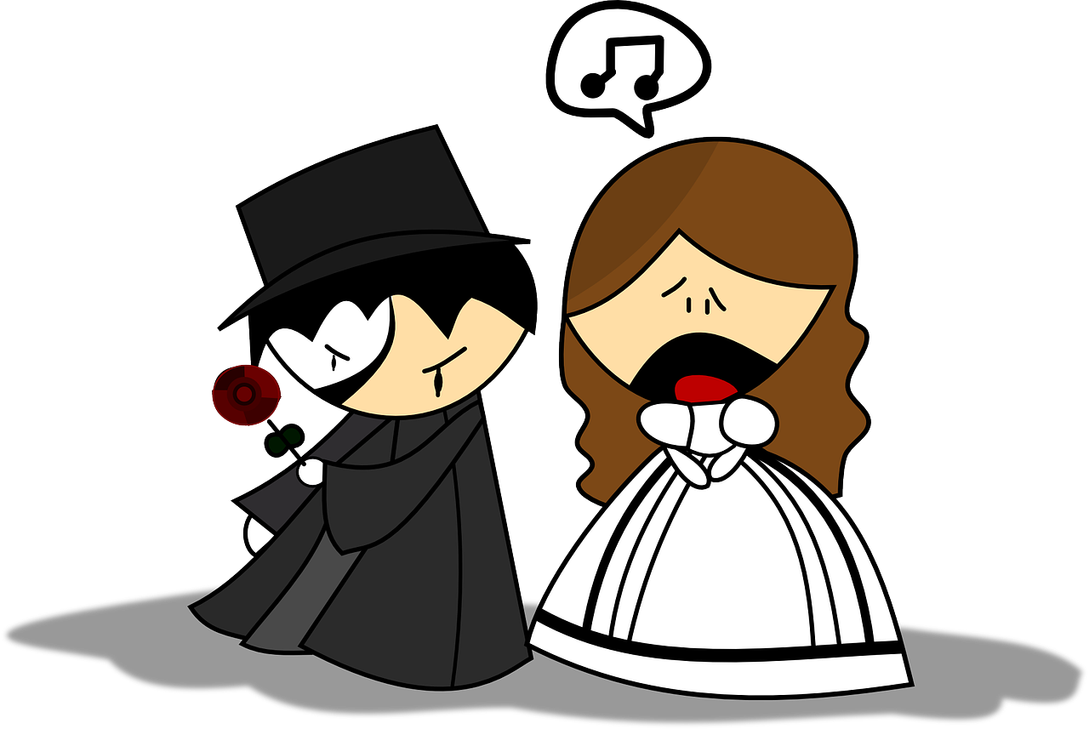
slika 4 | slika 5
[h5p id="318"]

Images used in this document are from these sources.

