8 | 2 | Lekcija 1: Moja košarica

# 8.2 Zadatak 1. Čega ima/nema?

Look at the picture and complete the task. What do you usually have in your fridge and your kitchen? Things that you usually buy might not all be listed. Add them to your list. Your instructor will check what you marked/wrote.

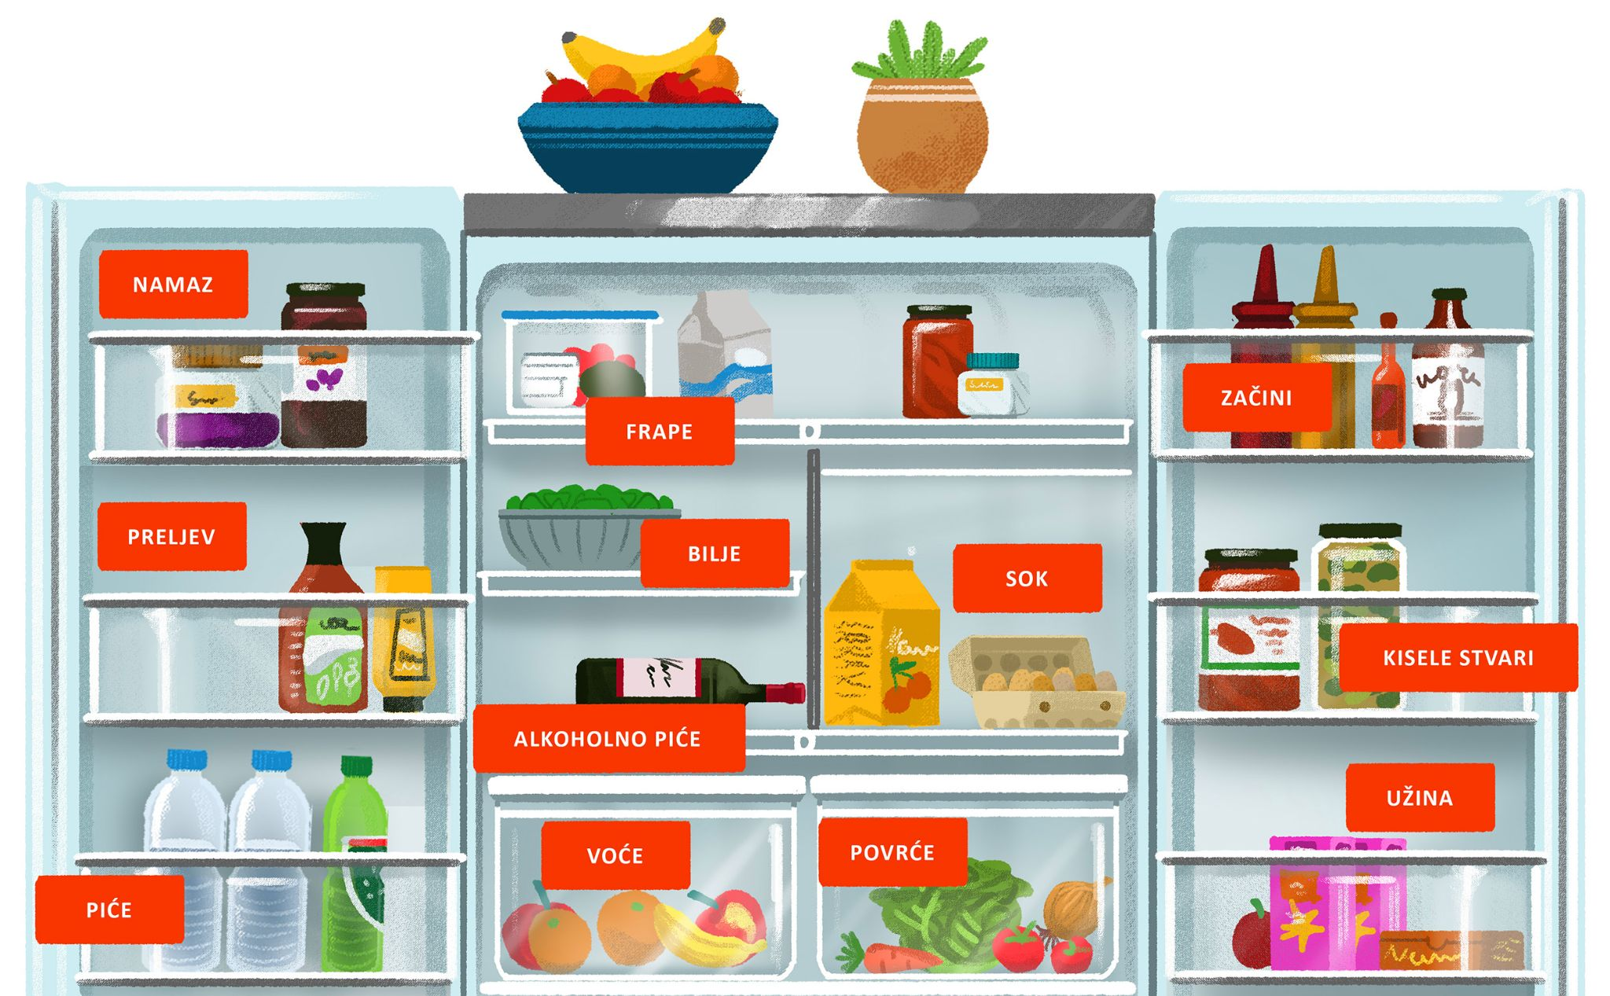

| Čega obično ima u tvojem hladnjaku / tvojoj kuhinji? - Ima… | | | | |
| --- | --- | --- | --- | --- |
| namaz | maslaca od kikirikija | Nutelle | marmelade | džema |
| mliječni proizvodi | maslaca | mlijeka | sira | vrhnja |
| piće | gaziranog pića | soka | vode | kave |
| voće | grožđa | bananā | ananasa | jabukā |
| jagodā | mandarinā | kivijā | limunā |
| povrće | špinata | češnjaka | salate | luka |
| krastavacā | paprikā | rajčicā | mrkve |
| meso/riba/jaja | mesa | ribe | piletine | jaja |
| desert | čokolade | kolača | sladoleda | keksi |
| (još nešto?) | → | → | → | → |

Talk with one of your classmates and compare your list. What items do you have in common?

| 1 | Što ti i tvoj prijatelj/-ica imate zajedničko? |
| --- | --- |
| - |

Based on your answers (things that you marked), what is currently missing in your fridge/kitchen?

| 2 | Čega nema u tvojem hladnjaku / tvojoj kuhinji? |
| --- | --- |
| - |

# 8.2 Zadatak 2. Sastojci za salatu

Look at the two salads. Which one do you like more?

|  |  |
| --- | --- |
| Mediteranska salata | Cezar salata |

| 1 | Koja salata ti se više sviđa? Zašto? |
| --- | --- |
| - |

| Što trebamo za mediteransku salatu? - Trebamo… | | | | |
| --- | --- | --- | --- | --- |
| sira | krastavacâ | mlijeka | vode | soli |
| ulja | mrkve | kukuruza | luka | rajčicâ |
| paprikâ | limuna | octa | jajâ | salate |
| Što trebamo za Cezar salatu? - Trebamo… | | | | |
| sira | krastavacâ | mlijeka | vode | soli |
| ulja | mrkve | kukuruza | luka | piletine |
| paprikâ | limuna | octa | jajâ | salate |

Based on your choice of salad. What are you missing at home to prepare that salad?

| 1 | Što moraš kupiti za salatu? Čega nemaš kod kuće? |
| --- | --- |
| - |

# 8.2 Zadatak 3. Pripreme i kupnja

🔊 Listen to **dialogue one** and answer the questions.

Laura i Sandra razgovaraju o Marijevoj večeri. Laura ne želi doći praznih ruku, ali nije sigurna što kupiti ili što napraviti…

|  |  |
| --- | --- |

## | Razumijevanje

| 1 | Što prijateljice mogu donijeti? |
| --- | --- |
| - |
| 2 | Koji je Laurin komentar? |
| - |
| 3 | Što planira Laura raditi danas? |
| - |
| 4 | Kamo Laura i Sandra planiraju ići danas? |
| - |
| 5 | Čime idu i zašto? |
| - |
| 6 | Koji je tvoj savjet za Lauru? Što može kupiti/napraviti? (savjet = advice) |
| - |

🔊 Listen to **dialogue two** and answer the questions. *Sandra i Laura su u trgovini. Što moraju kupiti?*

|  |  |
| --- | --- |

## | Razumijevanje

| 1 | Što je Laura odlučila napraviti za Marijevu večeru? |
| --- | --- |
| - |
| 2 | Što će Sandra kupiti? |
| - |
| 3 | Koje sastojke Laura mora kupiti? |
| - |
| 4 | Kamo Laura i Sandra idu prvo? |
| - |

# 8.2 Zadatak 4. Kolač – sastojci

Laura decided to make something for dessert. What is it? Can you find a recipe online and find the ingredients? Keep it simple and ignore the exact measurements. Save the link, you will need it later again.

|  |  |
| --- | --- |

| 1 | Koji kolač će Laura napraviti? |
| --- | --- |
| - |
| 2 | Koji su sastojci? |
| - |

# 8.2 Zadatak 5. Koliko košta?

👥

**Handout.** Let’s see how much things cost in Croatia. Is life in Croatia more expensive or cheaper than in the US? Each of you will receive prices for two pictures. The first one is without prices, the second one is with prices. Your classmate will have answers for your picture without prices. Find out how much things cost.

| **1**  21, 31, 41,...  101…201, 901, … | **2, 3, 4**  22, 23, 24…  32, 33, 34,... | **5–20**  30, 40, 50, 60,...  25, 26, 27,...35, 36,... |
| --- | --- | --- |
|  |  |  |
| 1 dola**r** | 2 dolar**a** | 5 dolar**a** |
|  |  |  |
| 1 eur**o** | 2 eur**a** | 5 eur**a** |

### Appropriate questions to ask:

|  | Koliko **košta**? – **Sok** košta… |
| --- | --- |
|  | Koliko **koštaju**? – **Jabuke** koštaju… |
| ***?*** | Je li hrana jeftinija ili skuplja u Hrvatskoj? |

# 8.2 Zadatak 6. Internet kupovina

Use the following [link](https://www.konzum.hr/kreni-u-kupnju) and let’s do some online shopping. We will investigate how much money Laura will spend for her cake. List all the ingredients below. Then, search for them online and write the price of each item. What is the total amount?

| Sastojci: | Koliko košta? |
| --- | --- |
|  |  |
|  |  |
|  |  |
|  |  |

Koliki je ukupni trošak? [total $$$]



Following the last question in Zadatak 1, find all items that are missing from your fridge/kitchen in [Konzum website](https://www.konzum.hr/kreni-u-kupnju). How much will you spend? Add more rows if needed.

| Moje namirnice: | Koliko košta? |
| --- | --- |
|  |  |
|  |  |
|  |  |
|  |  |

Koliki je ukupni trošak? [total $$$]

Images used in this document are from [these sources](https://docs.google.com/document/d/1QNP_zlTJC5LpAvUZZC5aOptW6sFIUO_kBkTnu8s_MTM/edit#heading=h.ktkus0ccq3de).