2 | 2 | Lekcija 2: Glazba i film

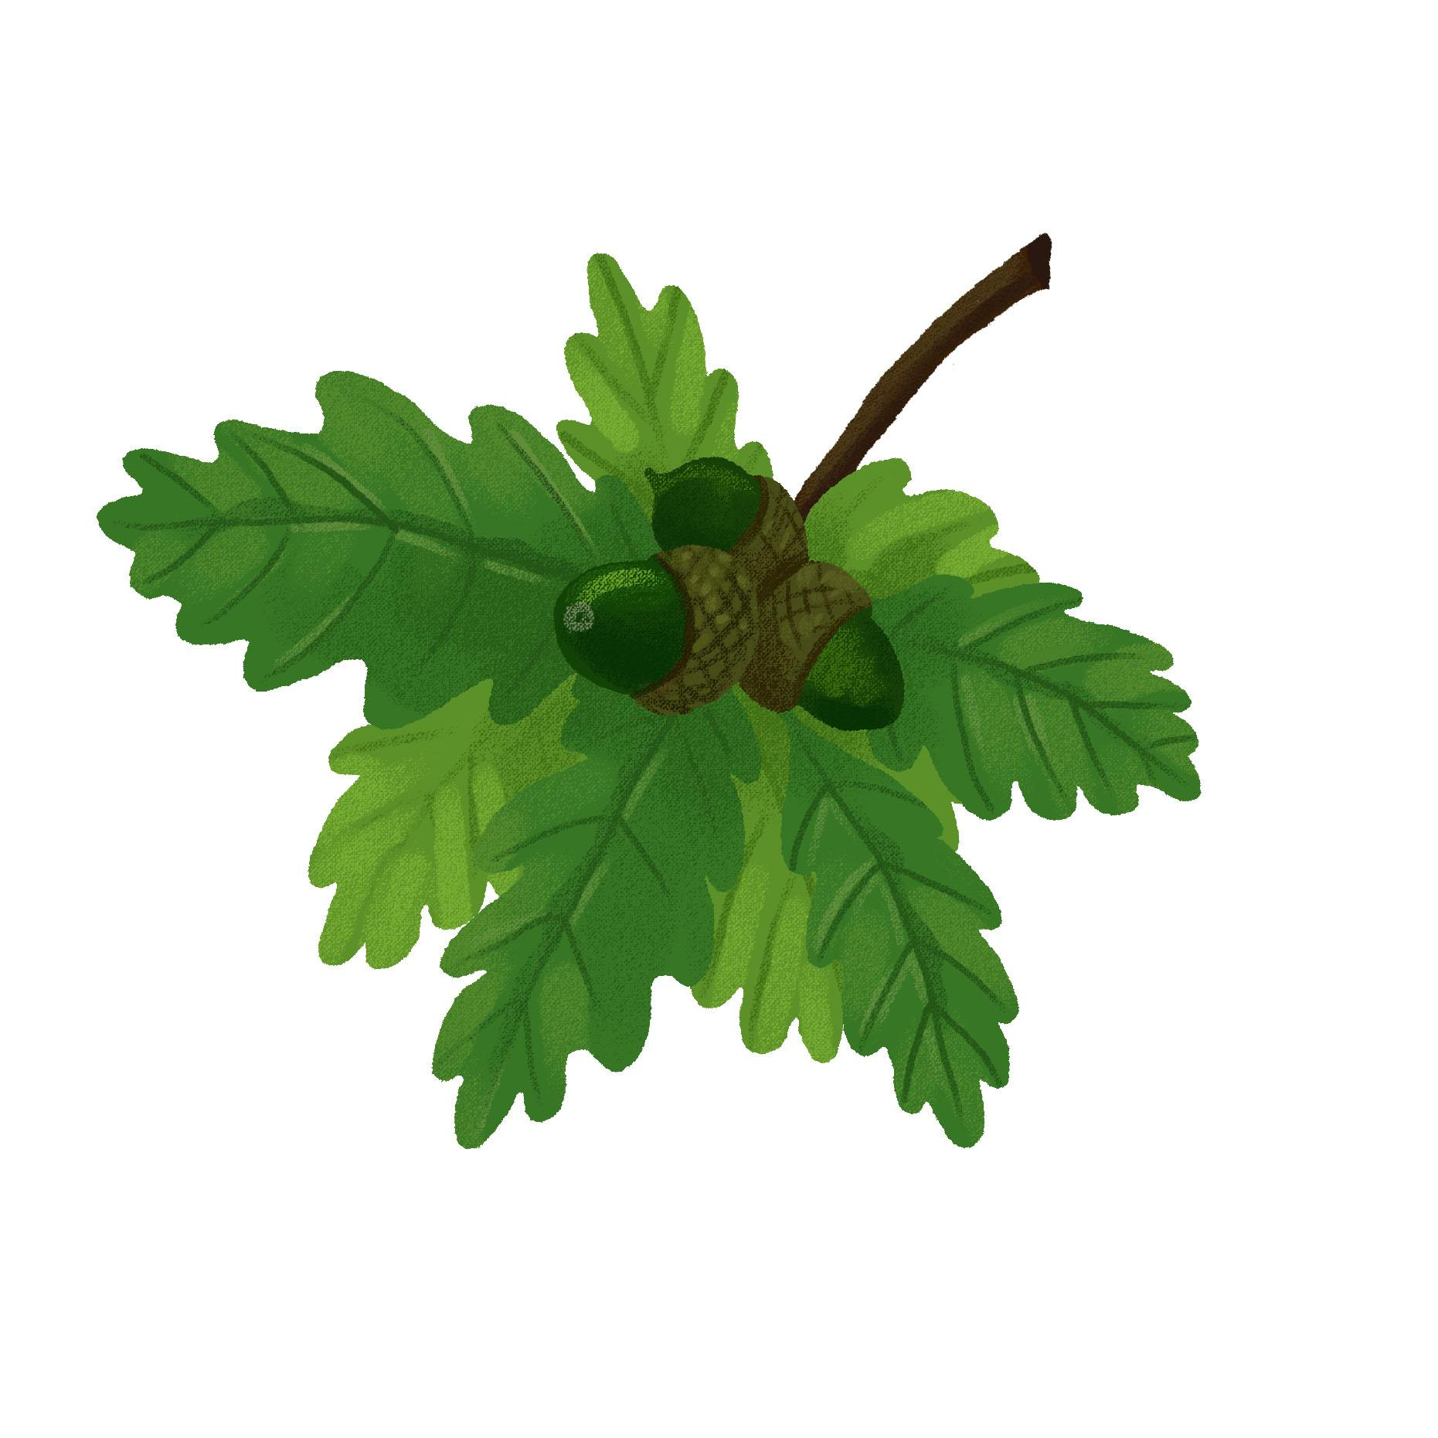 2.2 Zadatak 5. Što radiš u slobodno vrijeme?
Talk with one of your classmates to find out what he/she likes to do in their free time and how similar you both are.
 | 

Što voliš raditi u slobodno vrijeme?
[odgovor] → (ja) Volim…
slušati glazbu | gledati filmove | čitati knjige | pisati pjesme
šopingirati | surfati | plivati | trčati
puno spavati | crtati | kuhati ručak | učiti

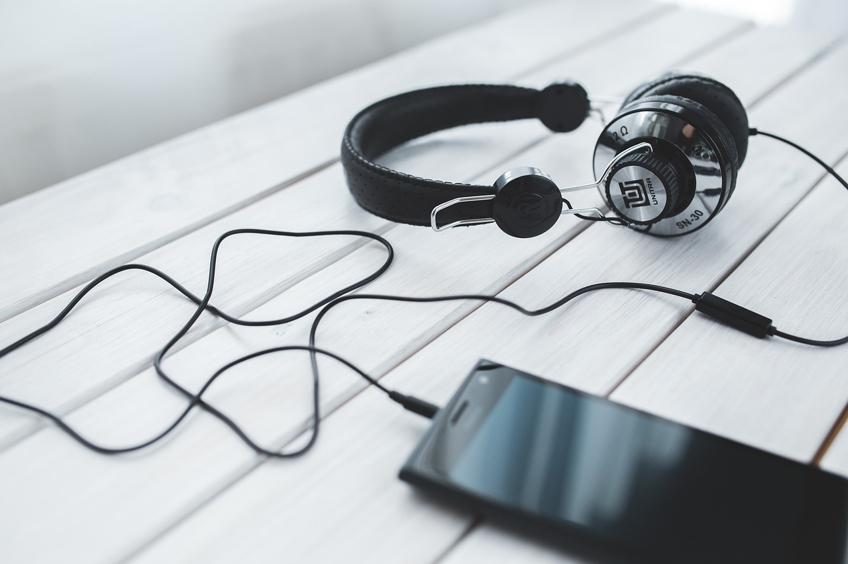 | 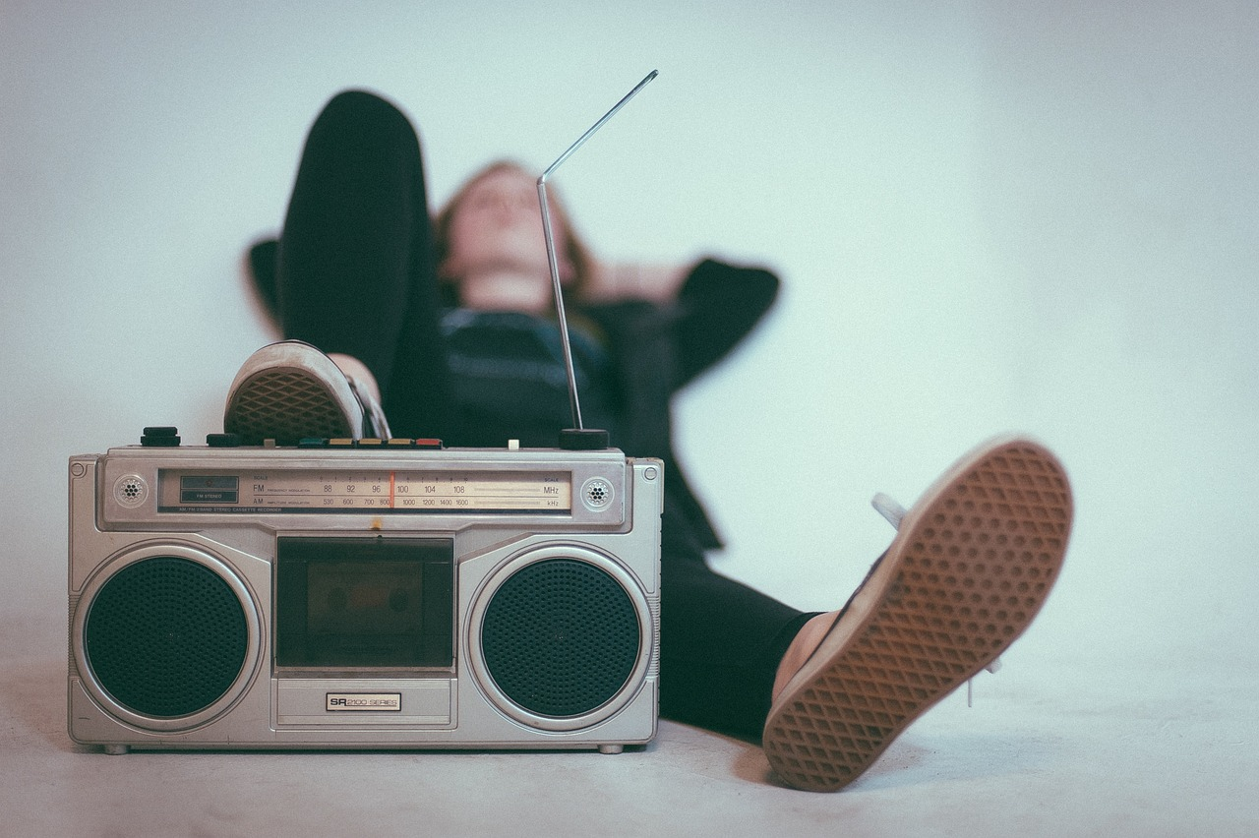

Što voliš slušati?
[odgovor] → (ja) Volim slušati…
rock-glazbu | pop-glazbu | narodnu glazbu | turbofolk
metal | country | džez | klasičnu glazbu

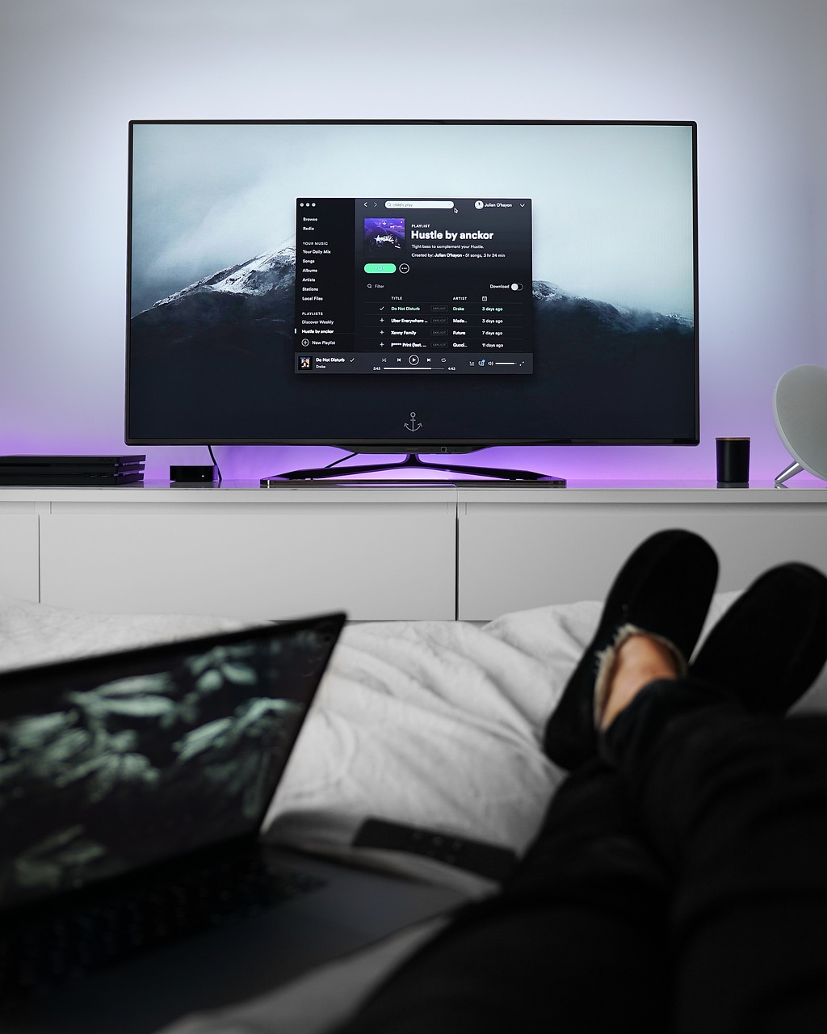 | 

Što voliš gledati?
[odgovor] → (ja) Volim gledati…
horor-filmove | drame | trilere | komedije
romantične  filmove | znanstvenu fantastiku | dokumentarne filmove | crtane  filmove

2.2 Zadatak 6. Što vole raditi tvoji roditelji?
Use the options from the previous task to answer the following questions about your parents, brother(s), and/or sister(s). What do they like to do? When you are done, talk with one of your classmates to compare your answers. Write your answers in complete sentences. The structure is provided for you. Your instructor will ask you about your findings.

1 | Što voli raditi tvoj brat / tvoja sestra?
 | - Moj brat voli… / Moja sestra voli…
2 | Što voli raditi tvoj tata / tvoja mama?
 | - Moj tata voli… / Moja mama voli…
3 | Što roditelji vole raditi zajedno?
 | - Moji roditelji vole…

2.2 Zadatak 7. Što želiš raditi?

Part 1
Talk with your classmates to find out what they want to do in their free time (something they would like to do more often). 1️⃣
1 | Što želiš raditi u slobodno vrijeme?
 | - Ja želim…

igrati (tenis) | surfati | trčati | plivati
kuhati | puno spavati | svirati (gitaru) | **

Tko? | Što?
 | ↦
 | ↦
 | ↦
 | ↦
 | ↦
 | ↦

2️⃣ Look at the information that you collected and say who is a good match to spend their free time together. Na primjer:

Marko i ja želimo igrati tenis. / Marko i Ana žele igrati tenis.
1
2
3
4
5

(Any other pair?)
[odgovor] →

2.2 Zadatak 8. On/-a želi...
Answer the following questions about your parents, brother, and/or sister. What do they like to do (something they would like to do more often)? When you are done, talk with one of your classmates to compare your answers. Write your answers in complete sentences. The structure is provided for you. Your instructor will ask you about your findings.
1 | Što želi raditi tvoj prijatelj / tvoja prijateljica?
 | - Moj prijatelj želi… / Moja prijateljica želi…
2 | Što vi zajedno želite raditi?
 | - Mi zajedno želimo…

2.2 Zadatak 9. Moji omiljeni...
👥 Answer the following questions and talk with your classmates to compare your answers. Answer the questions in complete sentences. Take notes on your classmates’ responses.
1 | Koji je tvoj omiljeni pjevač?
 | -
2 | Koja je tvoja omiljena pjevačica?
 | -
3 | Koja je tvoja omiljena grupa?
 | -
4 | Koji je tvoj omiljeni glumac?
 | -
5 | Koji je tvoj omiljeni film?
 | -
6 | Koji film želiš gledati?
 | -

2.2 Zadatak 10. Izlazak
🔊 Listen to the dialogues and answer the questions.
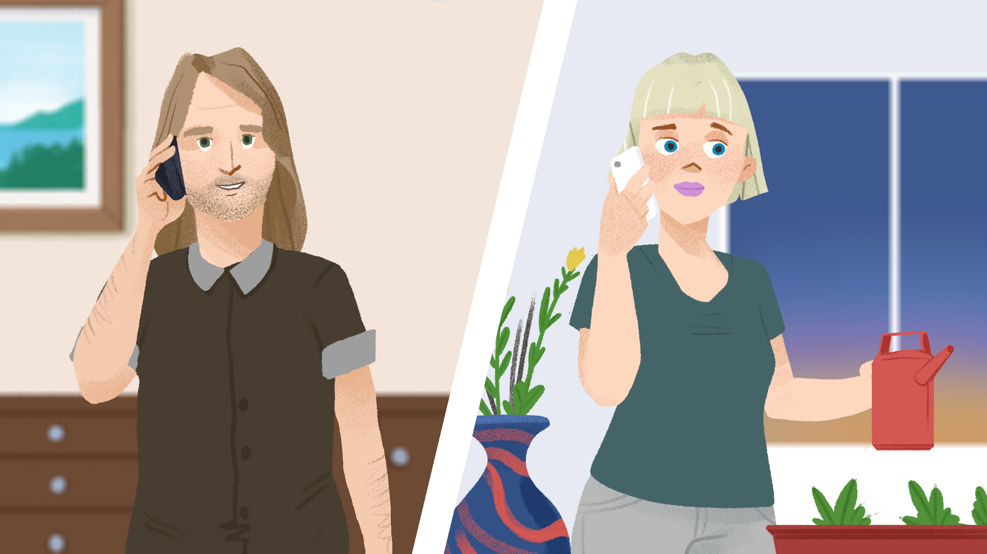 | 

1 | Što Mario i Sandra planiraju raditi večeras? [tonight]
 | -
2 | Gdje oni planiraju ići? [to go]
 | -
3 | Je li Laura slobodna večeras?
 | -
4 | Koji film gledaju?
 | -
5 | U koliko sati je film?
 | -

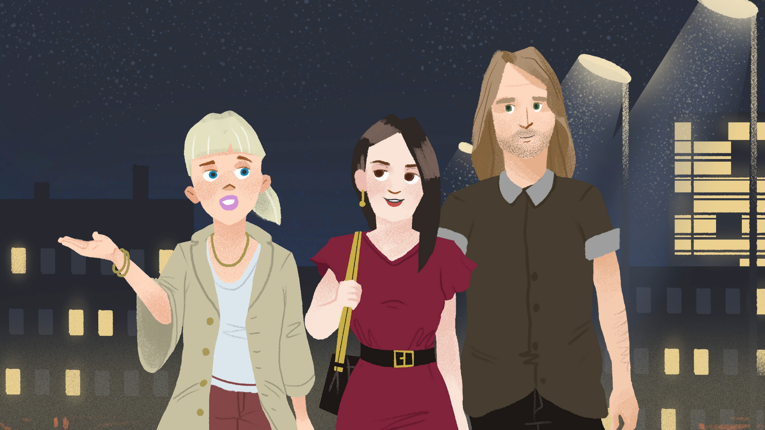 | 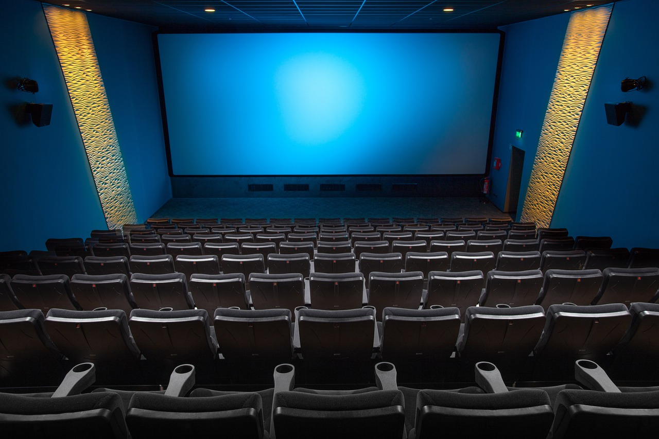

1 | Što Laura misli, kakav je film?
 | -
2 | Gleda li Laura često trilere?
 | -
3 | Je li film drama?
 | -
4 | Što Mario, Sandra i Laura planiraju raditi sljedeći vikend?
 | -
5 | Koji su poznati hrvatski filmovi?
 | -

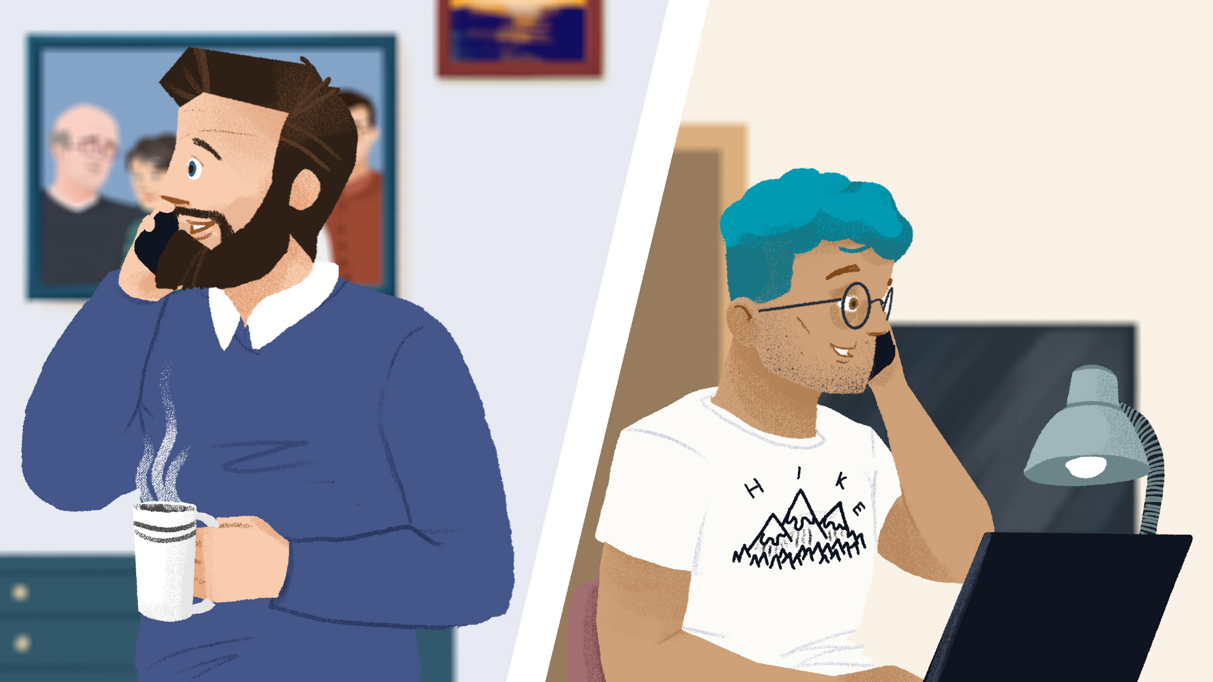 | 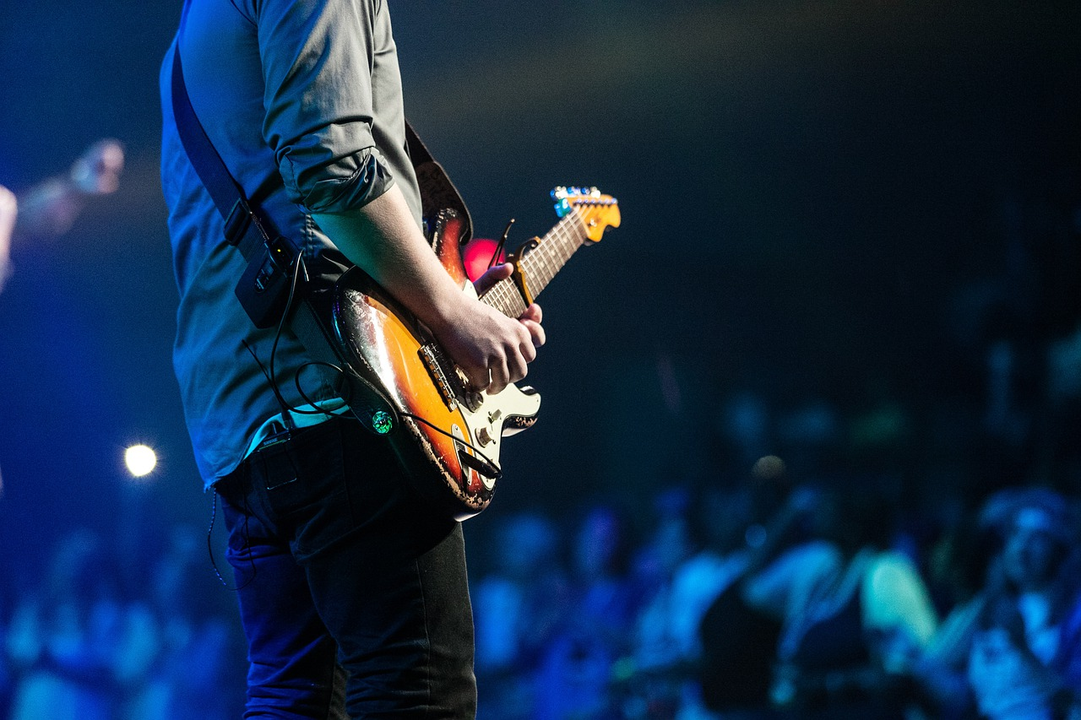

1 | Što radi James večeras?
 | -
2 | Što planiraju raditi Luka i Ines večeras?
 | -
3 | Tko nastupa?
 | -
4 | U koliko sati je koncert?
 | -

 | 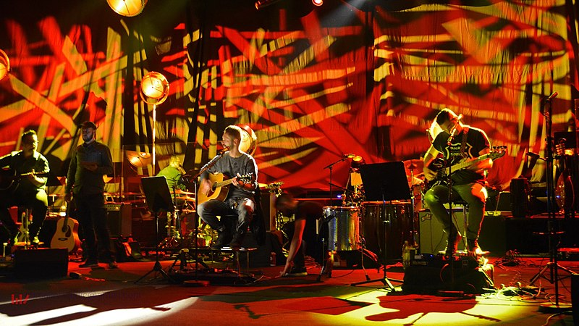

1 | Kakav je ambijent?
 | -
2 | Što radi Matija?
 | -
3 | Što James misli, kakav je koncert?
 | -
4 | Koje grupe/bendove sluša Ines?
 | -
5 | Koje grupe/bendove sluša Luka?
 | -

Based on the answers you have collected about the music genre(s) that Ines and Luka are listening to:
 | Investigate each music group online ⭐
 | Which one do you like or don’t like (at least in terms of melody)? Place each group in the appropriate column below
 |  | 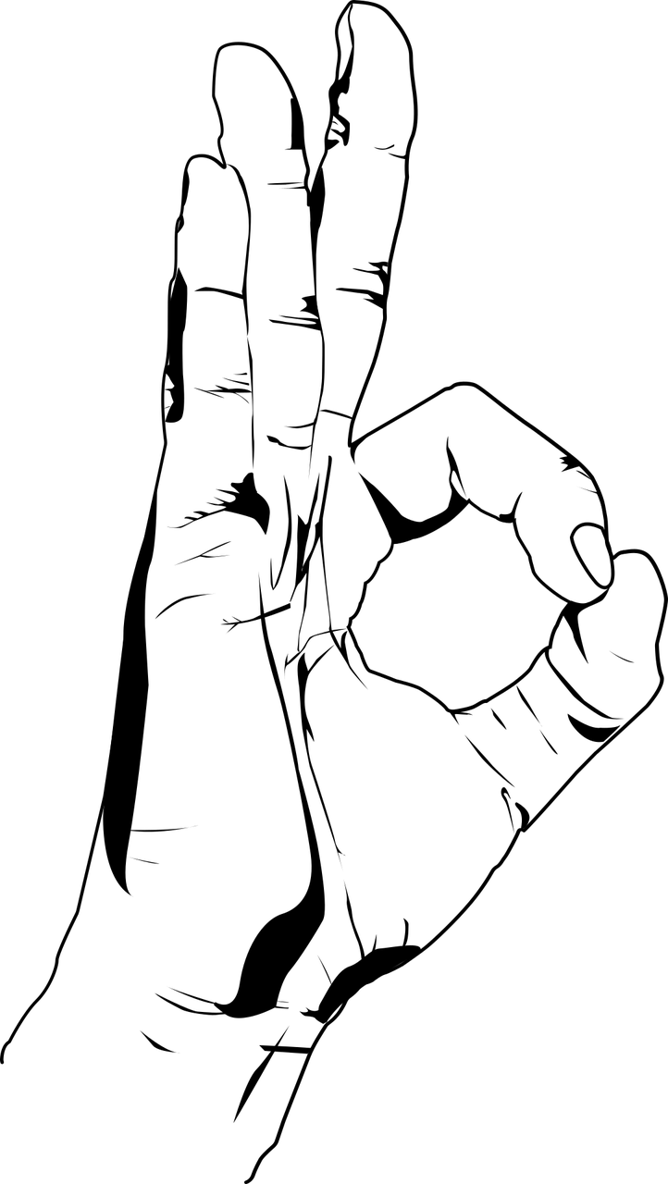 | 
odlična grupa | dobra grupa | ništa posebno | ne sviđa mi se
Your instructor will check your answers. Listen carefully as you will need to say who among you has similar music preferences.

Images used in this document are from these sources.

