5 | 2 | Lekcija 5: Sretna Nova godina!

| Religijski blagdani [Religious holidays]
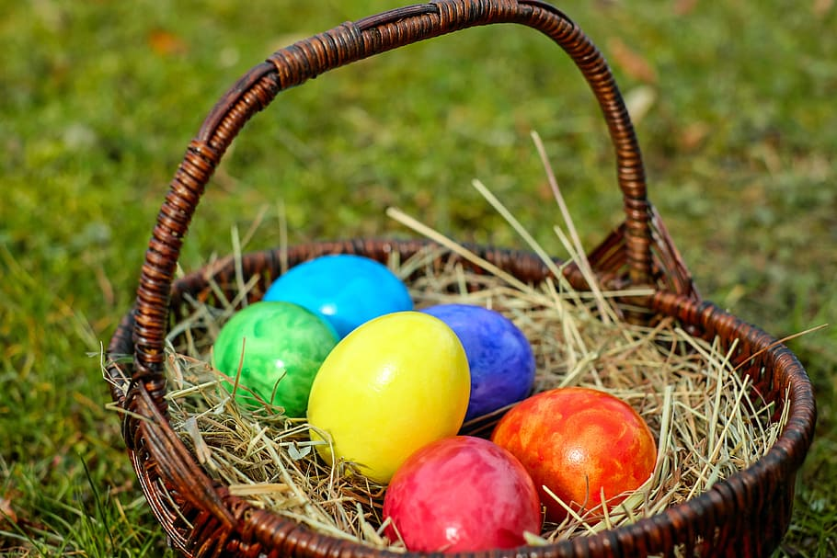 | 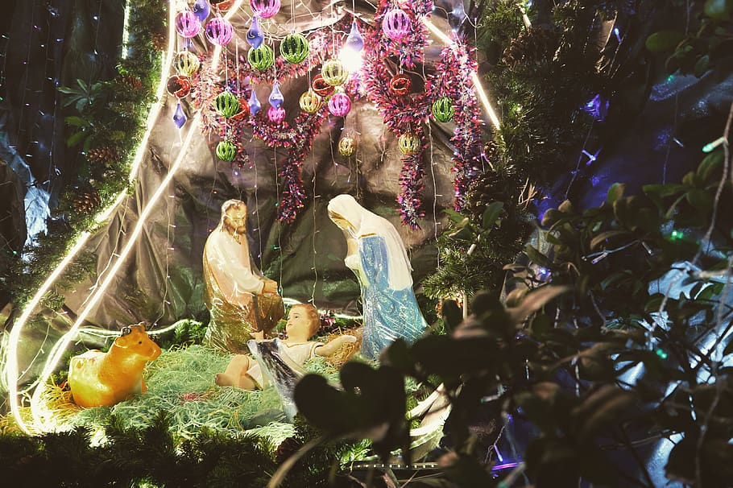
Uskrs | Božić
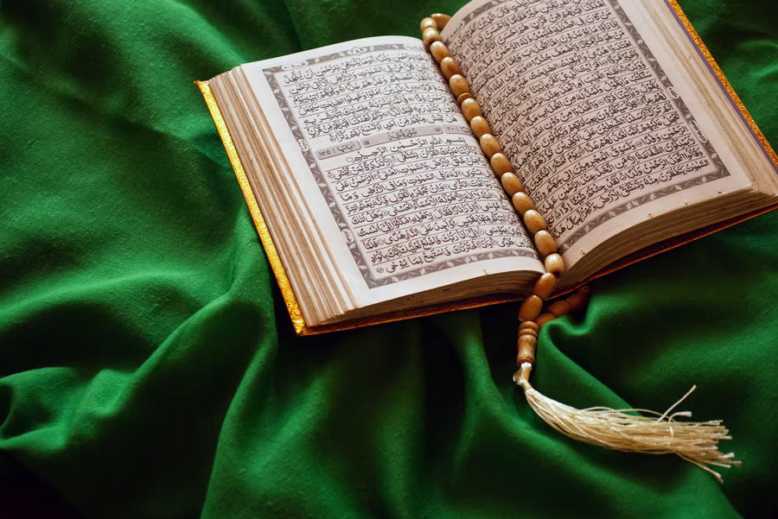 | 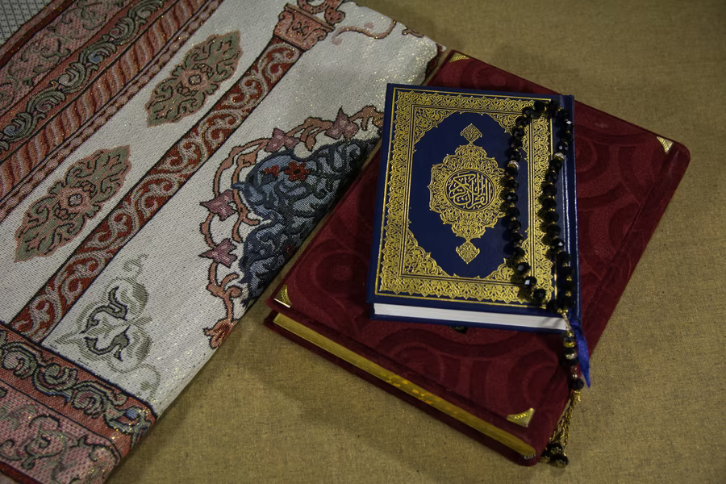
Ramazanski bajram | Kurban bajram

| Posebna prigoda [Special occasion]
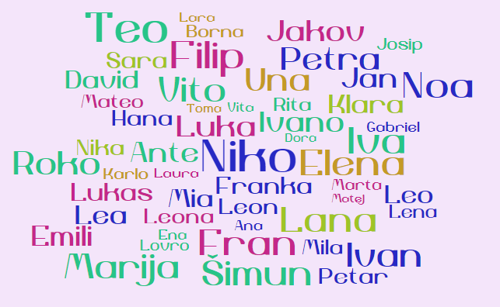 | 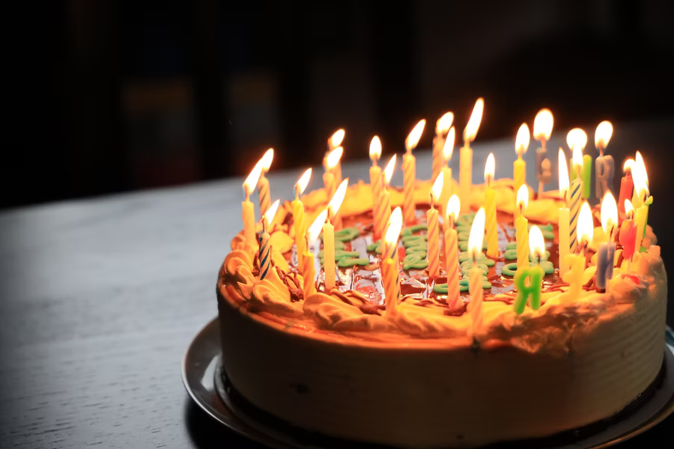
imendan | rođendan

| Komercijalni praznici [Commercial holidays]
 | 
Valentinovo | Nova godina
Usually, for religious holidays, when expressing wishes for holidays, there is a standard form that you should use:

For Christmas, depending on religion, you might use one of the following expressions:
| In the Catholic sphere you can say one of the following phrases:
Želim vam/ti sretan i blagoslovljen Božić!
Sretan i blagoslovljen Božić!
Sretan Božić!

| In the Orthodox sphere you can say:
Mir Božji, Hristos se rodi!
(You should reply with) Vaistinu se rodi.
You can also say Srećan Božić

For Easter, depending on religion, you might use one of the following expressions:
| In the Catholic sphere you can say one of the following phrases:
Sretan Uskrs!
| In the Orthodox sphere you can say:
Hristos vaskrse.

For Eid al-Fitr, you will most likely use the expressions:
| In the the Islamic world
Bajram šerif mubarek olsun.
(You should reply with) Allah razi olsun.

5.2 Zadatak 6. Kako se kaže
Read the following scenarios and decide what you should say for each of the given holidays or special occasions.
[h5p id="657"]

| Želje za dobar život
For special occasions, you will usually start your wish with the standard opening. Then you will add whatever you would like to wish to your family member, relatives, friends, colleagues, etc. Start your wish with the following phrases:

 |  | 
For birthday (rođendan): Sretan rođendan! | For name day (imendan): Sretan imendan! | For the New Year:  Sretna Nova godina!
After the opening line, you will usually wish them one or more of the following things.

Želim ti (puno)…
 |  |  | 
ljubavi  love | uspjeha  success | zdravlja  health | sreće  happiness
 |  |  | 
prijateljstva  friendship | radosti  joy | veselja  joy | sve najbolje  all the best

5.2 Zadatak 7. Što želiš prijateljima?
Listen to the following phrases. Each recording expresses a wish to a friend for their birthday. After you listen to the recording, identify what a person is wishing to a friend.
[h5p id="658"]

5.2 Zadatak 8. Kako se kaže?
This vocabulary quiz covers words learned in this module. Look at the picture and choose the corresponding Croatian word.
[h5p id="659"]

Images used in this document are from these sources.

