[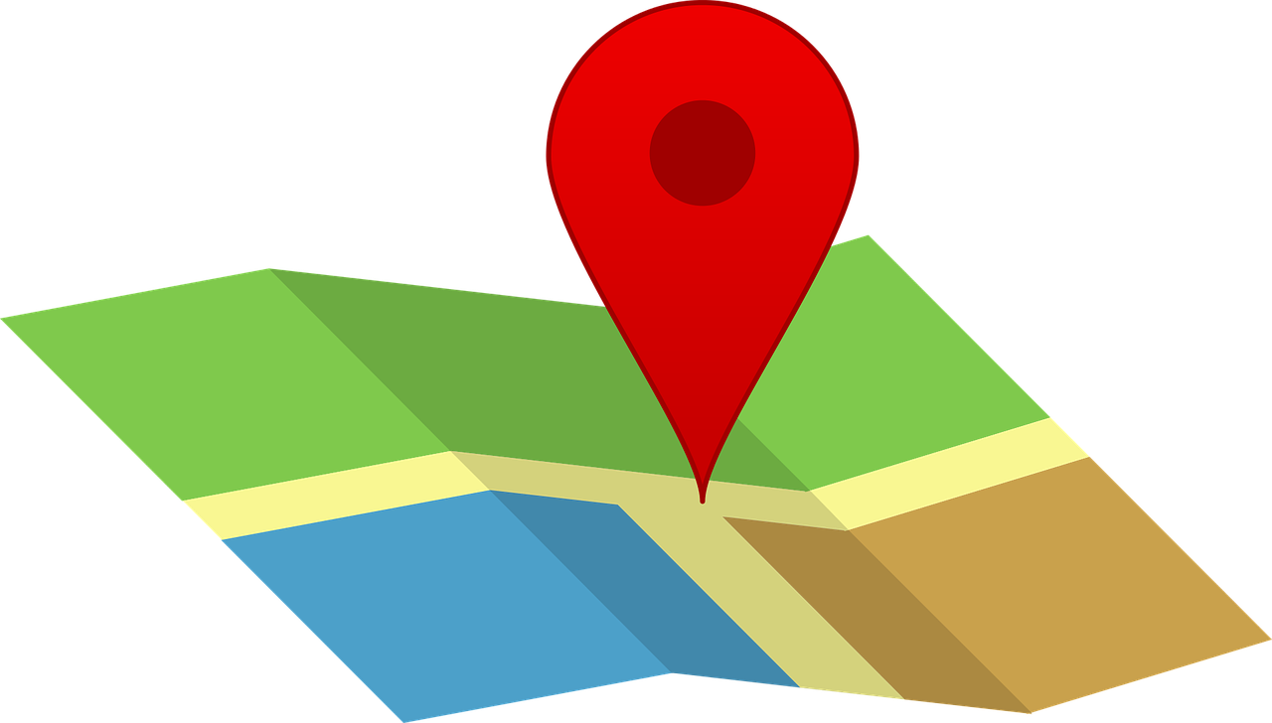](https://pixabay.com/vectors/map-pin-icon-map-pin-travel-1272165/)

Explore any of the places below by either clicking on the title of the video or explore [directly on the map](https://drive.google.com/open?id=1VsrVDmCWAiRSINFaOibDkQo-YeWiSIZr&usp=sharing).

| [**Kyvadlo**](https://realityczech.org/map-videos/JdmXkjvoE2M) | [**Lennonova zeď**](https://realityczech.org/map-videos/9yzuKcyYT5o) |
| --- | --- |
| [**Lokál Dlouhááá**](https://realityczech.org/map-videos/tPhSSRuxrRg) | [**Národní divadlo**](https://realityczech.org/map-videos/xNiUtCtVMDw) |
| [**Půjčení loděk na Vltavě**](https://realityczech.org/map-videos/I_4agoI0ffE) | [**Sapa**](https://realityczech.org/map-videos/yMfzumkWQDk) |
| [**Tančící dům**](https://realityczech.org/map-videos/36JFaL3imsk) | [**Zámky lásky**](https://realityczech.org/map-videos/y7D5DB8SpOI) |
| [**Socha Franze Kafky**](https://realityczech.org/map-videos/i6bsY5RABrk) | [**Kavárna Slavia**](https://realityczech.org/map-videos/-Uqj8Et80_o) |
| [**Náplavka**](https://realityczech.org/map-videos/dnL6Y1TorQY) |  |