9 | 1 | Lekcija 2: Dnevni ritam

| Activities and repetition
When we want to express that we do something regularly (i.e., an action that repeats on certain days/times), we need to use the Instrumental case. As you can see in today’s lesson (dialogue four), Luka said:
 | Ponedjeljkom, srijedom i petkom je košarka, a utorkom i četvrtkom nogomet.
In this sentence, the days are expressed in the Instrumental case, which indicates that the action of playing basketball repeats regularly on Mondays, Wednesdays, and Fridays. While soccer is usually on Tuesdays and Thursdays.

Remember
When we express the meaning of repeating an action on a certain day, it is also very common to use words such as često (often), ponekad (sometimes), or nikada (never) in the sentence. Remember that when we use nikada we also need to use the negative particle. For example: Ja nikada ne igram nogomet vikendom. Look at the following examples and note the difference in their meanings:
 | U subotu idem u park. | Subotom idem u park.
 | U subotu (preposition + accusative) | (instrumental)
 | This Saturday I [will] go to the park. | On Saturdays I go to the park.

| Reflexive verbs
You have already encountered reflexive verbs throughout the previous units. However, now we will look at some that have irregular forms (i.e. those that use different types of endings based on their infinitive form).
In this lesson you encountered regular verbs whose forms change based on the regular -ati or -iti endings. However, you also encountered some verbs whose forms change differently than what we would think based on their infinitive endings. Let’s look at both groups more closely.

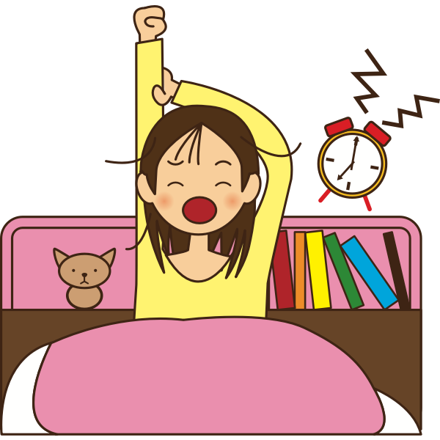 | 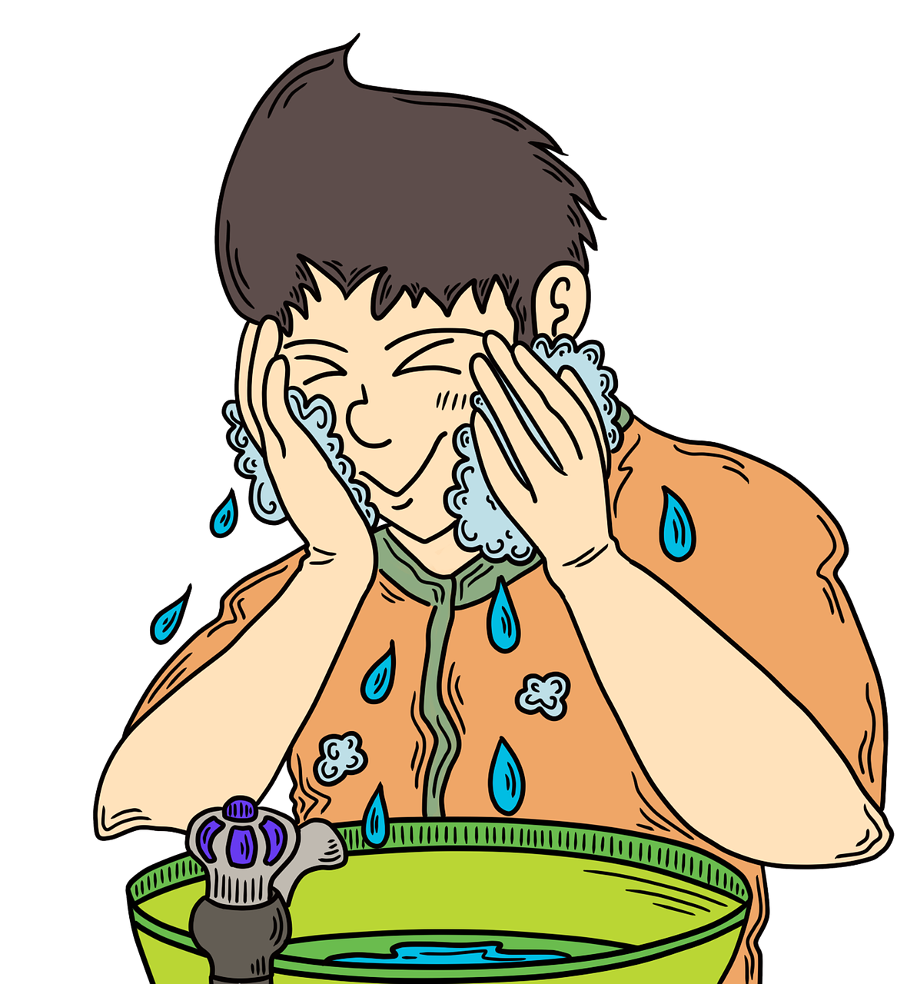 | 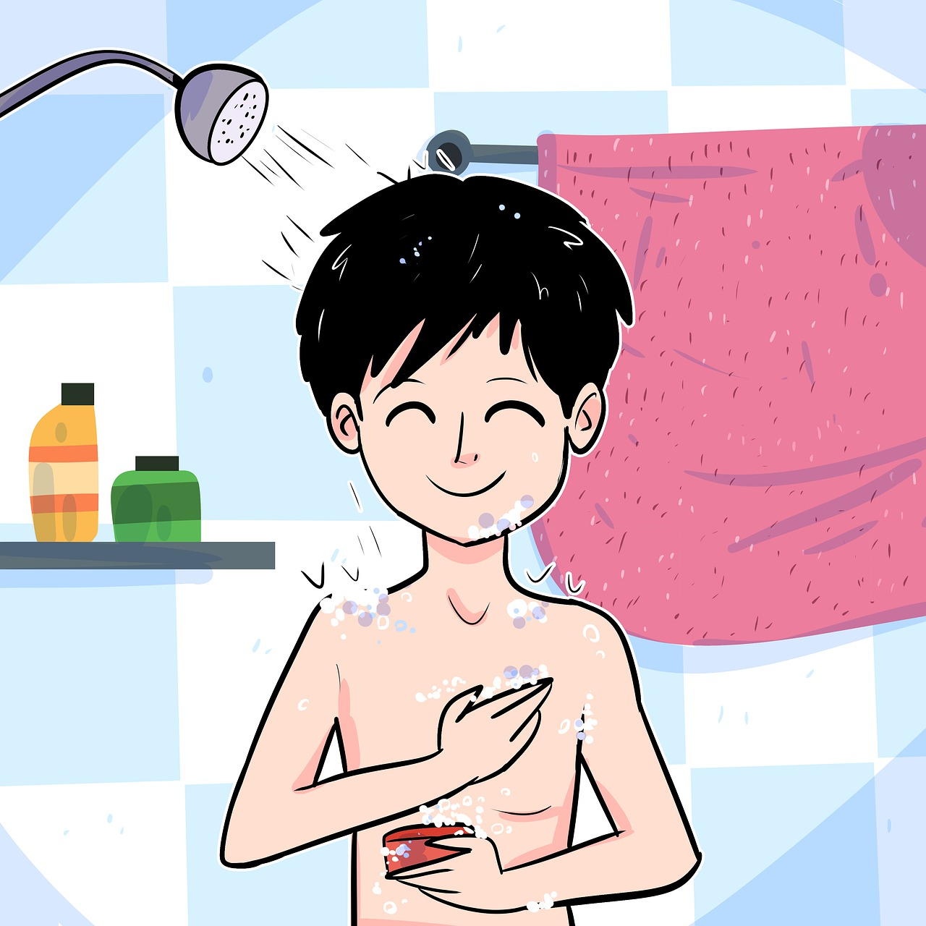 | 
buditi se | umivati se | tuširati se | prati zube
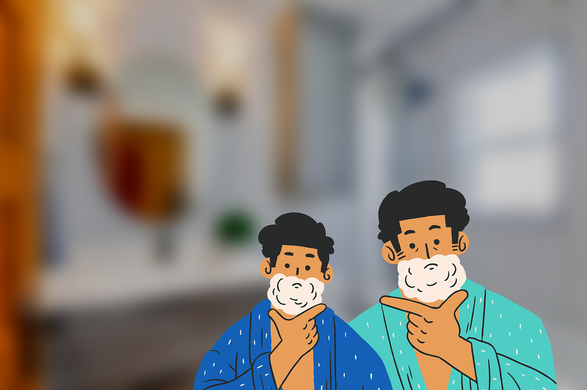 | 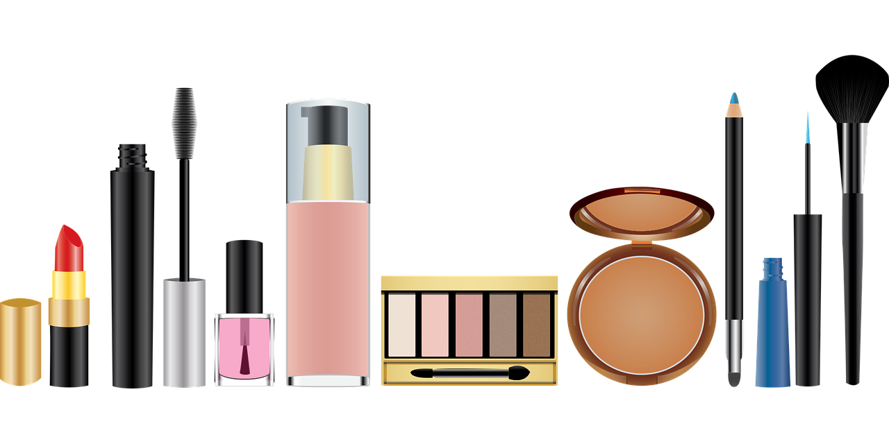 |  | 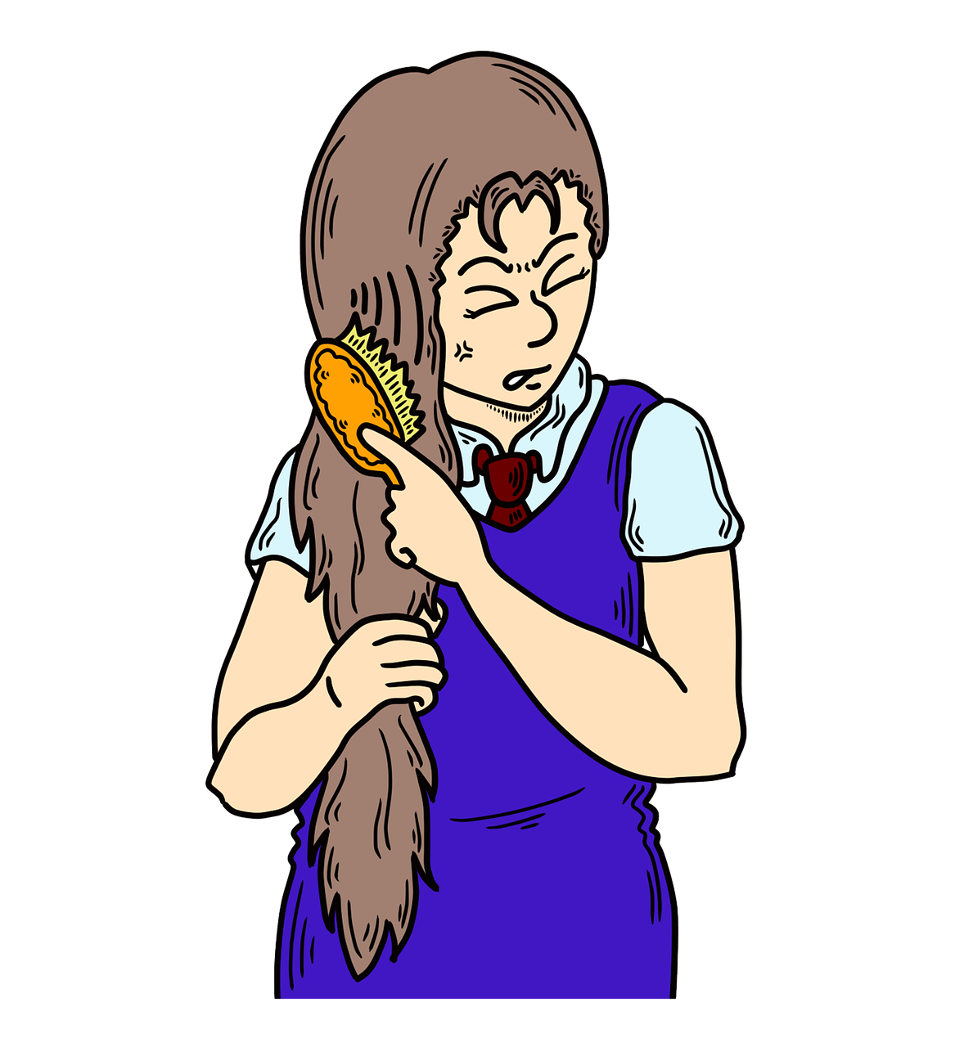
brijati se | šminkati se | oblačiti se | češljati se

| Group 1: Regular (expected) endings
–ati verbs | Word order – with a personal pronoun | Word order – without a personal pronoun
češljati se | ja se češljam | češljam se
umivati se | ja se umivam | umivam se
tuširati se | ja se tuširam | tuširam se
šminkati se | ja se šminkam | šminkam se
–iti verbs | Word order – with a personal pronoun | Word order – without a personal pronoun
buditi se | ja se budim | budim se
oblačiti se | ja se oblačim | oblačim se

| Group 2: Irregular (unexpected) endings
These verbs use a different set of endings than what their infinitive ending would suggest.
–ati verbs | Word order – with a personal pronoun | Word order – without a personal pronoun
brijati se | ja se brijem | brijem se
prati se | ja se perem | perem se

| The verb BRIJATI (SE)
Verb brijati se: when we cut the infinitive ending -ati, what is left is brij–. Thus, since the infinitive stem ends in -j- (one of the Croatian palatal letters), we need to use the endings -em, -eš, -e, etc.
SINGULAR |  |  | PLURAL
(audio) | ja | brij-em se | (audio) | mi | brij-emo se
(audio) | ti | brij-eš se | (audio) | vi | brij-ete se
(audio) | on/-a/-o | brij-e se | (audio) | oni/-e/-a | brij-u se

| The verb PRATI (SE)
Verb prati se: when we cut the infinitive ending -ati, what is left is pr–. Thus, since the infinitive stem has only one syllable composed of two consonants, we need to add -e- between pr– (for easier pronunciation) and then add the endings -em, -eš, -e, etc.
SINGULAR |  |  | PLURAL
(audio) | ja | p-e-r-em se | (audio) | mi | p-e-r-emo se
(audio) | ti | p-e-r-eš se | (audio) | vi | p-e-r-ete se
(audio) | on/-a/-o | p-e-r-e se | (audio) | oni/-e/-a | p-e-r-u se

| Reflexive or not? When to use them?
All of the above verbs can be either reflexive or not. The difference is:
Reflexive verb | It means the action comes back to the subject. The subject of the verb is also its object. When we take a shower (tuširati se), we shower ourselves, when we put on makeup (šminkati se), we make up ourselves, when we wake up (buditi se), we wake ourselves up.
NOT reflexive verb | It means the subject (of the verb) performs the action on something or someone else (i.e., the subject and object of the verb are different).

| Let’s look at the following sentence:
Ja se perem ujutro. | I shower (myself) in the morning.
Ja perem zube ujutro. | I brush my teeth in the morning.
Ja se uvijek budim u 7:00. | I always wake (myself) up at 7am.
Ja budim sestru u 7:00 svaki dan. | I wake my sister up at 7am every day.
Ja se češljam ujutro. | I comb my (own) hair in the morning.
Ja češljam sestru ujutro. | I comb my sister’s hair in the morning.
Ja se šminkam svaki dan. | I put makeup on (myself) every day.
Ja šminkam sestru svaki dan. | I put makeup on my sister every day.

As you can see, all the sentences that DON’T have a reflexive verb use the Accusative case, indicating that the person performing the action is performed on someone/something else.

9.1 Zadatak 3. Što radiš?
Look at the following pictures. Complete the sentences in a logical way using the ja form. Then, indicate whether the verb is reflexive or not.
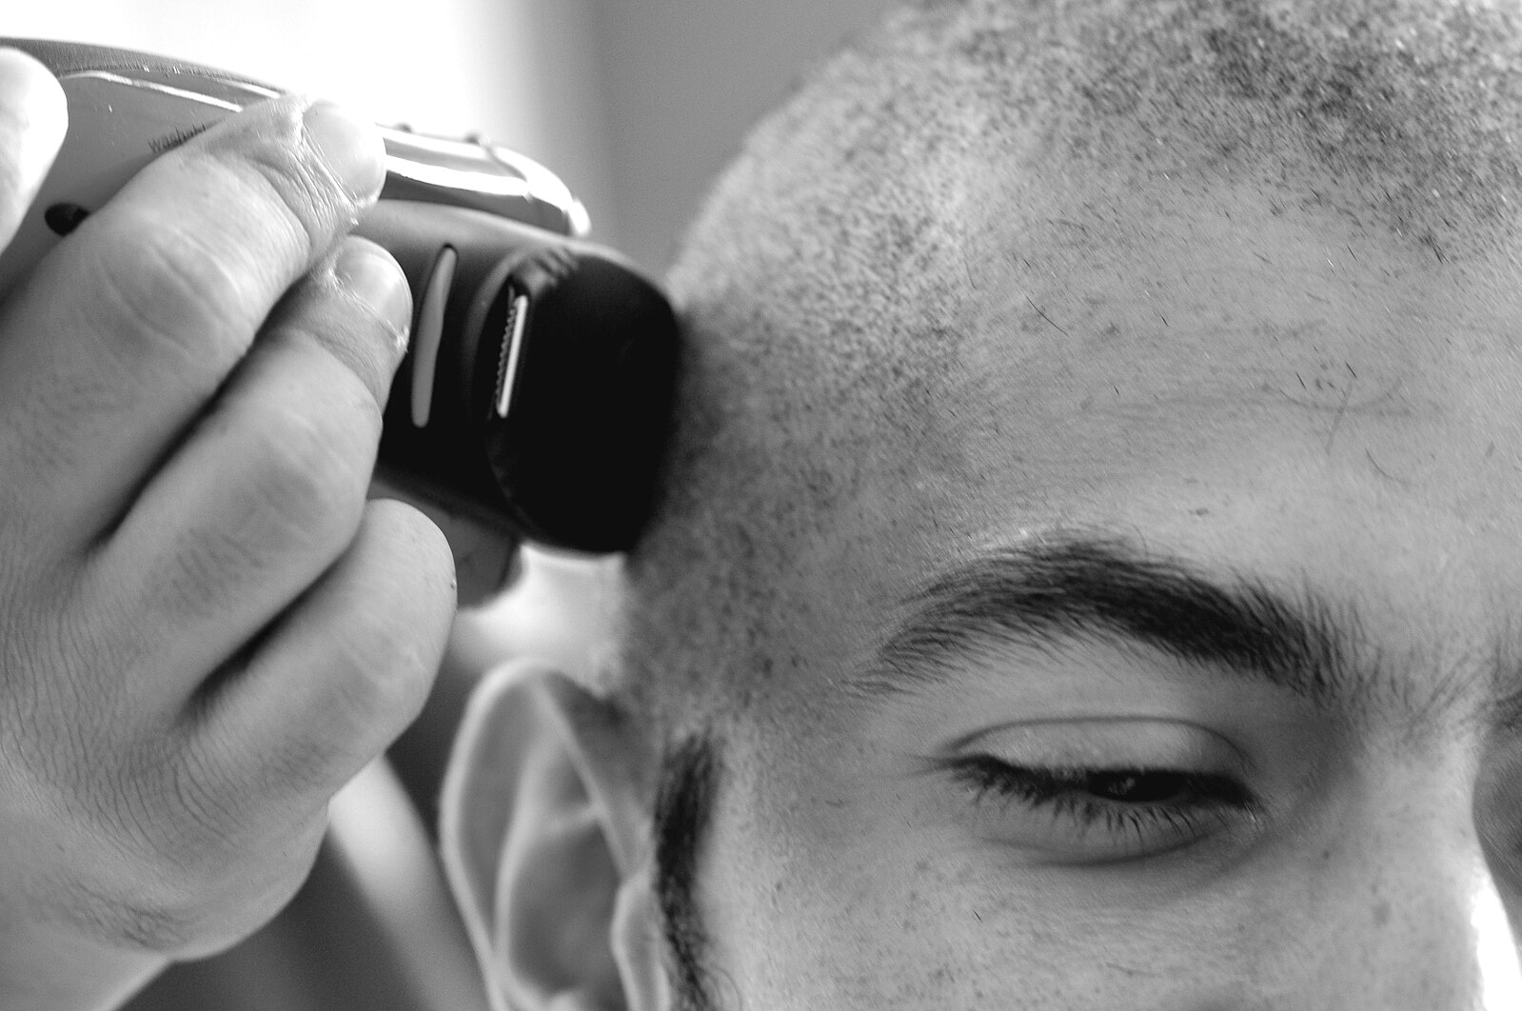 | 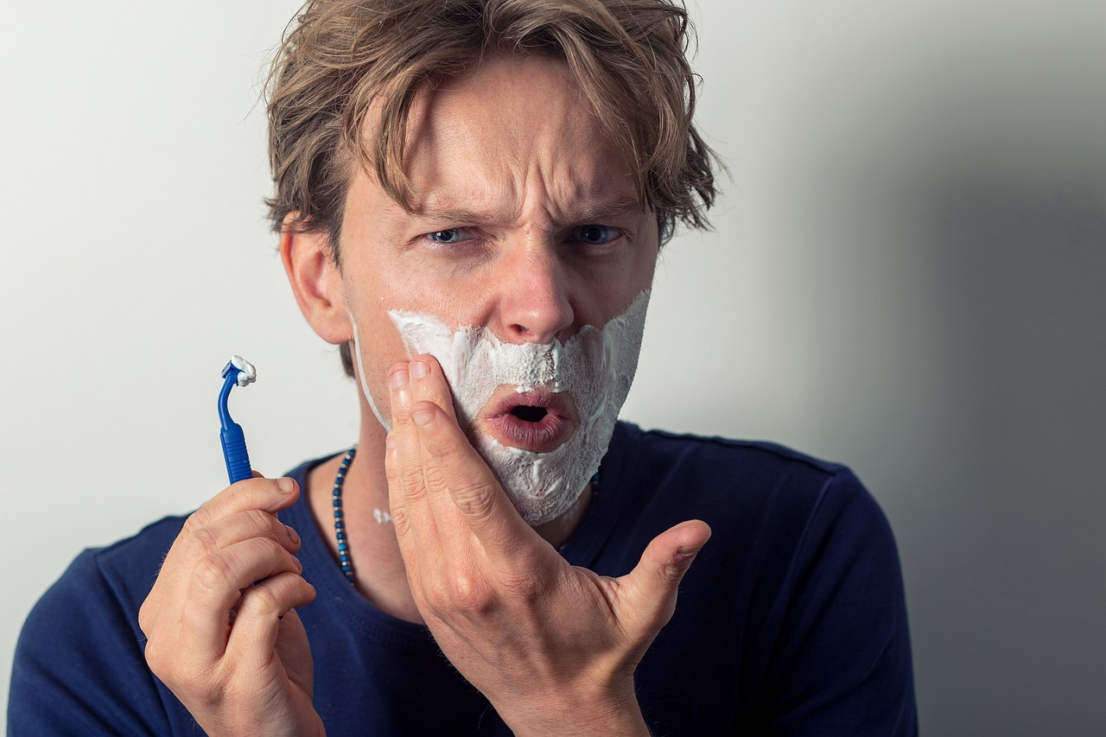
Brijem glavu, vruće je ljeti.  Brijati - not a reflexive verb | Ja se brijem svako jutro.  Brijati se - reflexive verb
[h5p id="834"]

Images used in this document are from these sources.

