2 | 3 | Lekcija 2: Vikend putovanje

| Doba dana (Parts of the day)
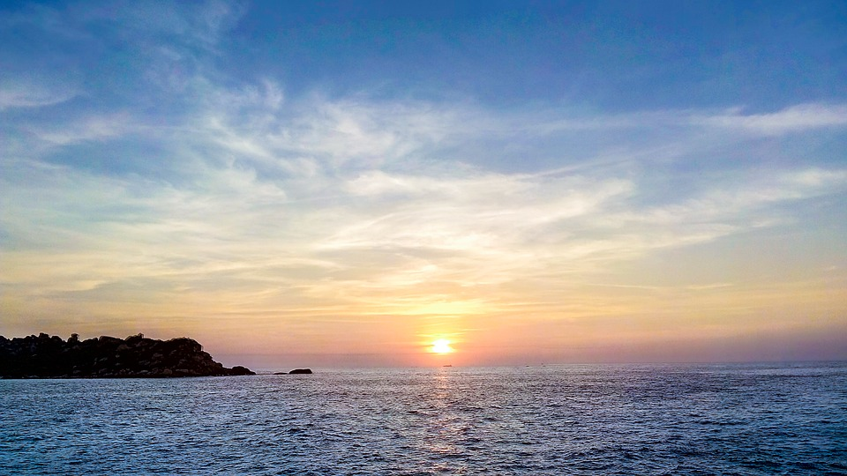 | 
zora | jutro
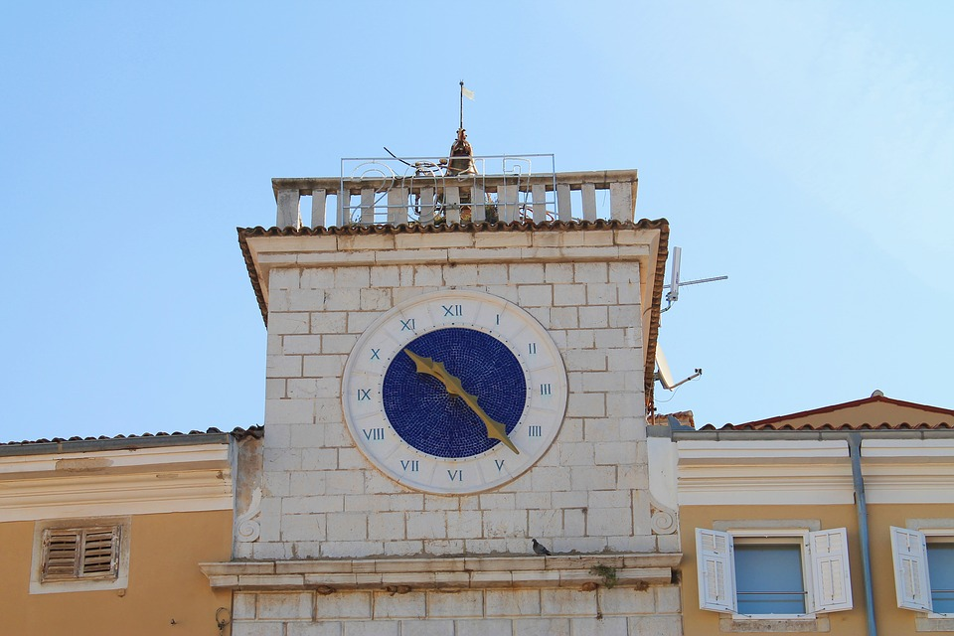 | 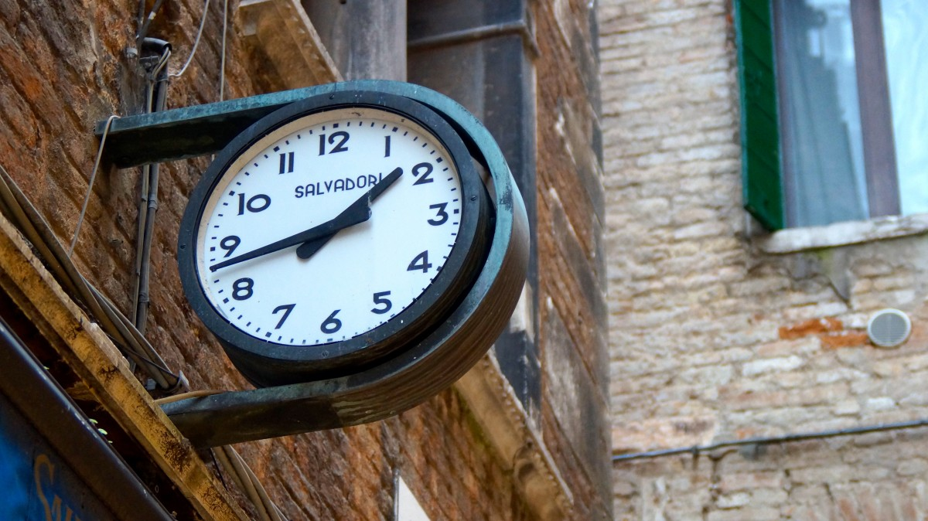
prijepodne | poslijepodne
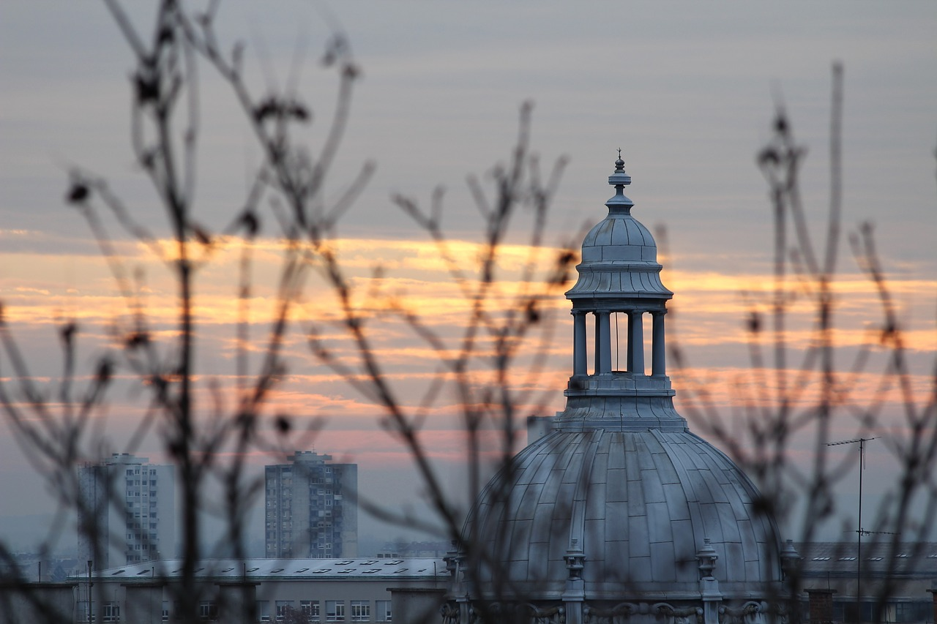 | 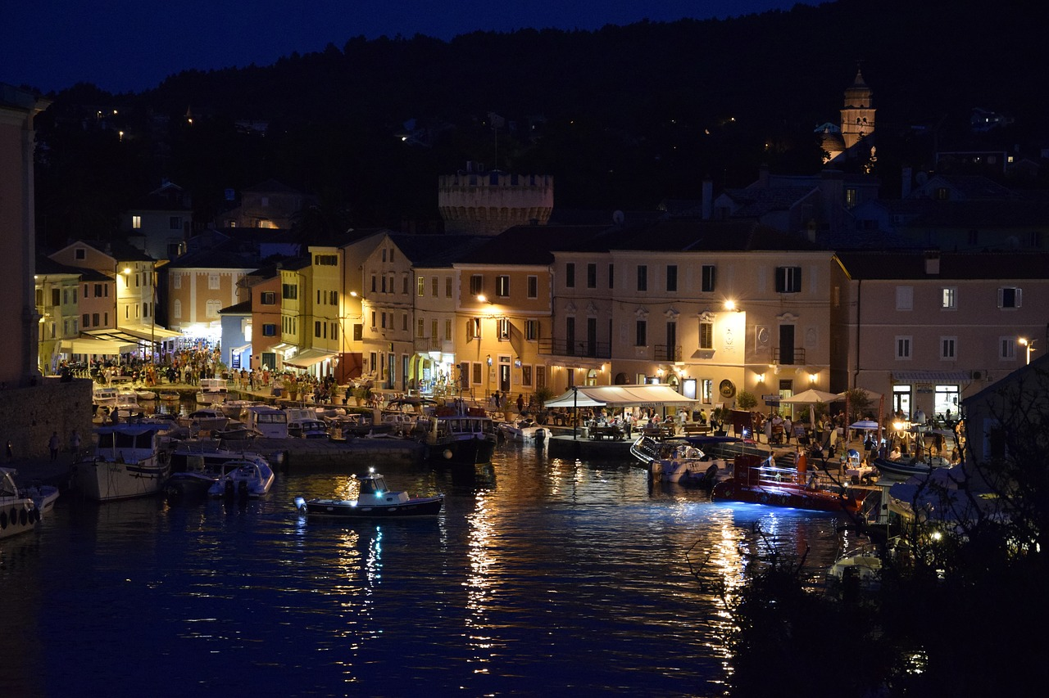
večer | noć

| Kada? (When?)
When we want to express that we do something or we go somewhere at certain point during the day, we should use the following time expressions:

Kada ideš na fakultet? Idem na fakultet...
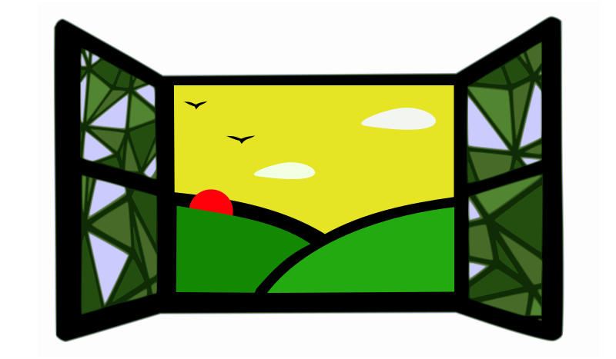 | 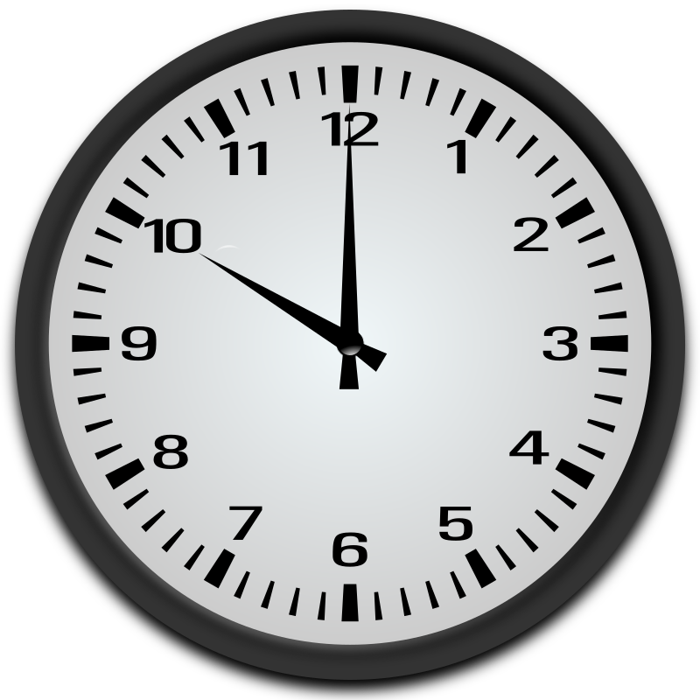
ujutro | prijepodne
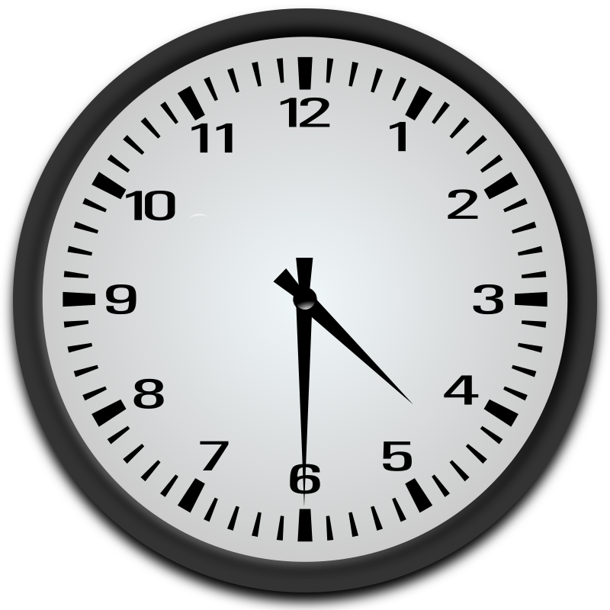 | 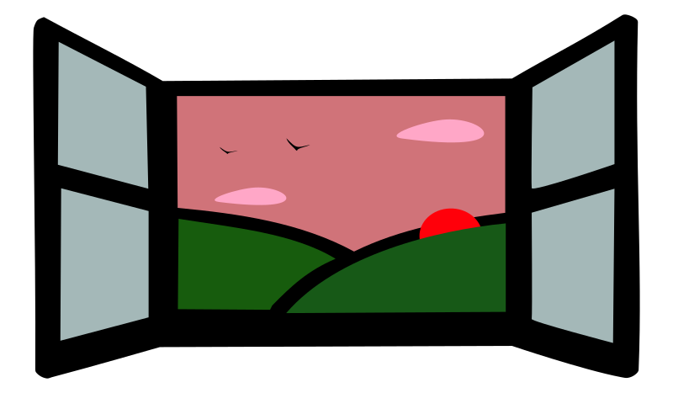
poslijepodne | navečer
See the difference between: jutro (morning) and ujutro (in the morning) - večer (evening) and navečer (in the evening).

| U koliko sati (At what time?)

At noon and at midnight!
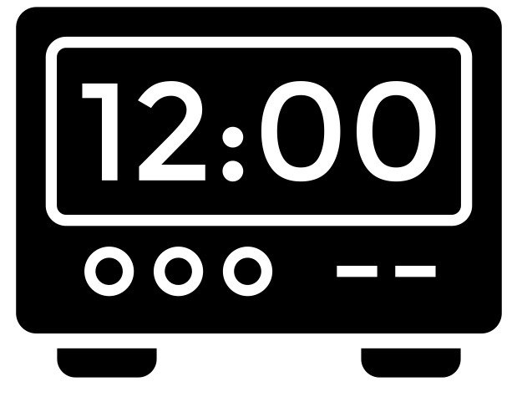 | 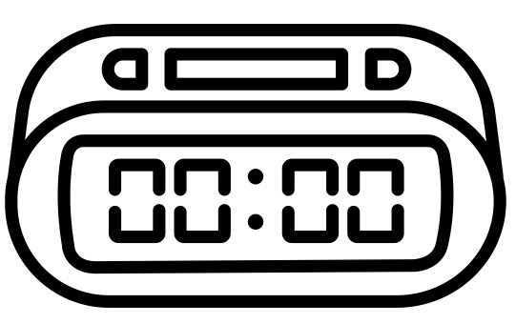
u podne | u ponoć

Images used in this document are from these sources.

