1 | 3 | Lekcija 1: Odakle si?

| Areas of studies
Look at the following areas of studies separated by gender.
F E M I N I N E
 |  | 
književnost 📚 | umjetnost 🎨 | povijest ⌛
(audio) | (audio) | (audio)
 |  | 
ekonomija 💰 | lingvistika 🗣️ | sociologija 👥
(audio) | (audio) | (audio)
 |  | 
biologija 🧬 | kemija 🧪 | matematika ➕ ➗
(audio) | (audio) | (audio)
 |  | 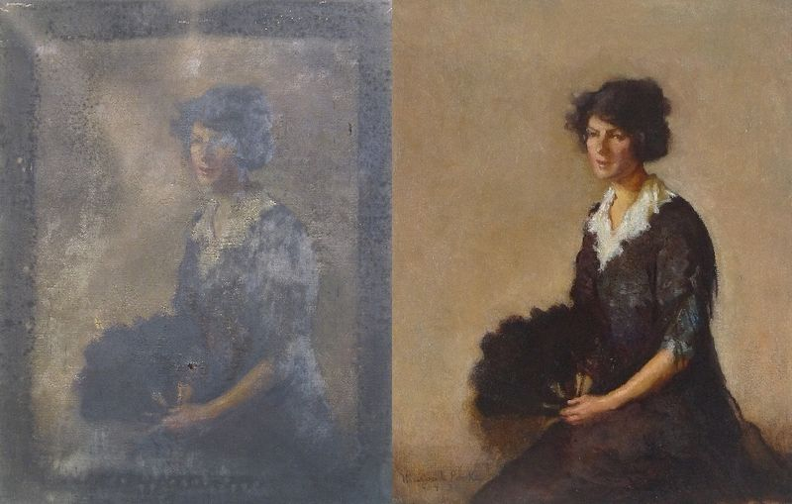
fizika ⚛️ | medicina 🏥 | restauracija 🖼️
(audio) | (audio) | (audio)
F E M I N I N E (Plural Form) | N E U T E R
 |  | 
političke znanosti 🌐 | pravo 🧑‍⚖️ | novinarstvo 🗞️
(audio) | (audio) | (audio)
M A S C U L I N E
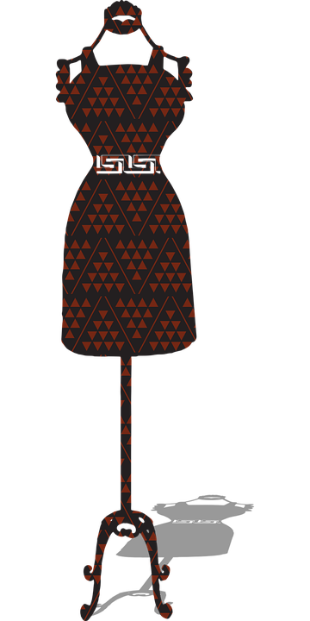 | 
dizajn 👗 | film 🎞️
(audio) | (audio)
Looking at the chart above, we see several irregularities:
The following nouns are in feminine gender
književnost | umjetnost | povijest
(audio) | (audio) | (audio)
We will come back to these irregular nouns later on. For now, note that only regular feminine nouns will go through a certain change when expressing that we study something or that we like something.

To explain in more detail: In this lesson you have encountered two new questions that we can ask to collect more information about someone:

Questions:
 | Što voliš? [What do you like?]
 | Što studiraš? [What are you studying?]

With these two questions we are taking a step further with grammar in Croatian.

The verb voljeti (to like/to love) and the verb studirati (to study) require that the noun that they refer to is in the Accusative Case form. Since this is just the initial step in learning the Accusative case, just remember that only regular feminine nouns will change their endings. Look at the chart below.
 | Does not change the form | Changes the form
Studiram…  Volim… | dizajn  film  književnost  umjetnost  povijest  novinarstvo  pravo  političke znanosti | ekonomija | → | ekonomiju
 |  | lingvistika | → | lingvistiku
 |  | sociologija | → | sociologiju
 |  | biologija | → | biologiju
 |  | kemija | → | kemiju
 |  | matematika | → | matematiku
 |  | fizika | → | fiziku
 |  | medicina | → | medicinu
 |  | restauracija | → | restauraciju
| Direct object and the Accusative case
The Accusative case is used when we want to add more information about a certain action. For example, the English sentence “I study.” makes sense, but it still does not express a complete meaning/message that we want to express.

Now, look at the following sentence: I study biology.

It answers the question ‘what do you study’. Biology is the what – the thing being studied, also known as the direct object of the verb ‘study’.

The Nominative case endings of nouns are the "dictionary forms" for nouns. Almost all of the nouns that you have encountered in Unit 1 have been shown in the nominative case. As you already know, the nominative forms of:
 | masculine singular nouns end in a consonant
 | feminine singular nouns end in –а
 | neuter singular nouns end in –о or –e
 | masculine plural nouns mostly end in –i
 | feminine plural nouns mostly end in –e
 | neuter plural nouns mostly end in –a

The Accusative case singular form endings:
 | masculine singular nouns (not referring to people) are identical to the Nominative case forms
 | feminine singular nouns (ending) change from: –a → –u
 | neuter singular nouns are identical to the Nominative case forms

The Nominative and the Accusative of various areas of study are presented in the table below, separated by gender: masculine, feminine, neuter, respectively.
gender → | masculine | feminine | neuter
Nominative | film | fizika | novinarstvo
Accusative | film | fiziku | novinarstvo

1.3 Zadatak 1. Što studiraš?
Look at the picture and choose the correct answer.
[h5p id="687"]

1.3 Zadatak 2. Što voliš?
slika 1 | slika 2 | slika 3
 |  | 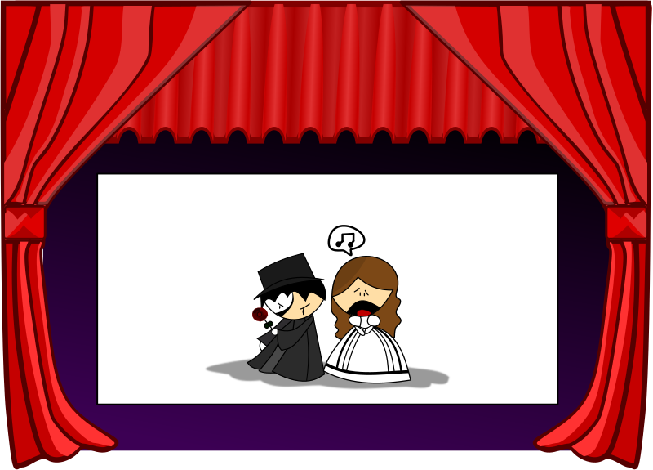
slika 4 | slika 5 | slika 6

[h5p id="129"]
Images used in this document are from these sources.

