2. lekce - Rodina a známí / Unit 2 - Family and Friends

In this unit you will be introduced to family vocabulary and talk about where they live, what they like to do. You will also learn how to conjugate verbs and learn vocabulary associated with everyday activities. You will additionally learn how to talk about the languages that you know and are studying or have studied in the past.  To the right you can download a copy of the activity book which contains exercises and activities to be completed along with each day in the textbook. For more information about using these materials, see Using the Reality Czech Curriculum | 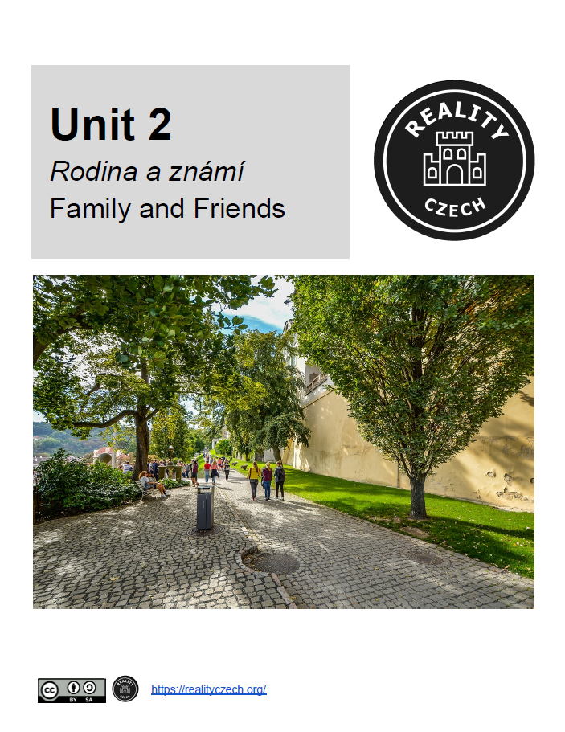  Classroom Activity Book

Communicative Goals | Grammar | Vocabulary
- identify members of your family and their relationship to you  - say what kinds of things you (and other people) do frequently  - say what kinds of things you (and other people) do rarely or never do  - talk about what you (and other people) like doing and dislike doing  - talk about what languages you know how and how well you know them | - conjugate regular verbs in the present tense  - the reflexive pronoun se  - adverbs that denote frequency (často, obvykle, každý den + někdy/nikdy)  - rád/ráda + conjugate verb - ‘to like’  - intro to accusative  - comparatives starší and mladší | - family  - languages  - professions  - verbs expressing common activities  - verbs of communication (read, write, speak, understand)

