8 | 1 | Lekcija 1: Idemo na kavu

| Things made with… / made of…
When we want to express that something is made of…/made with…, we need to use two different cases.

| Made with + Instrumental case
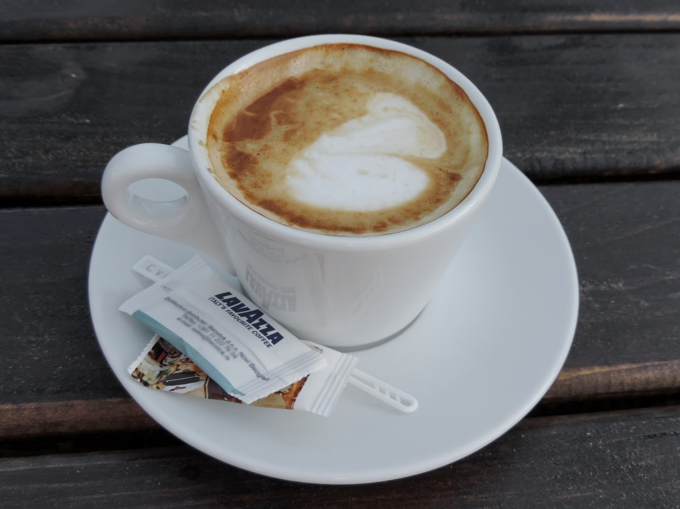 | 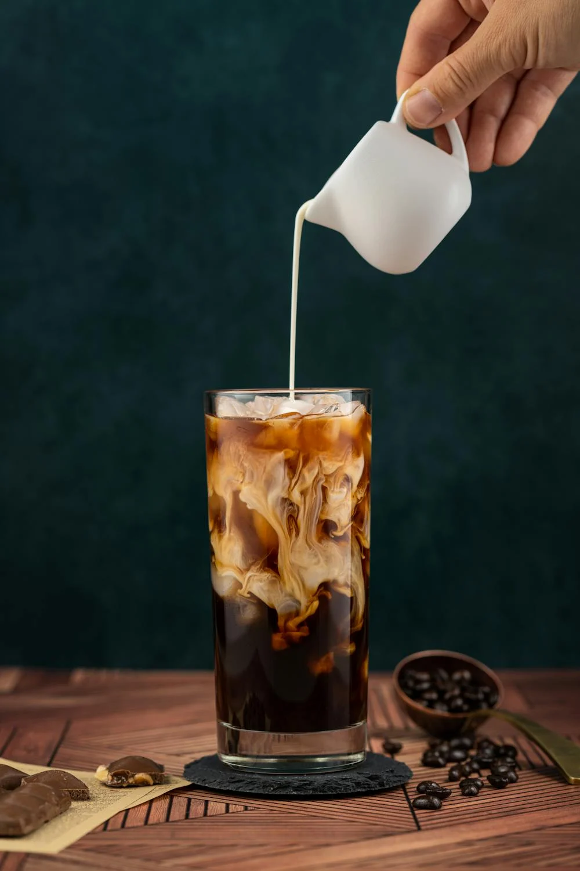 | 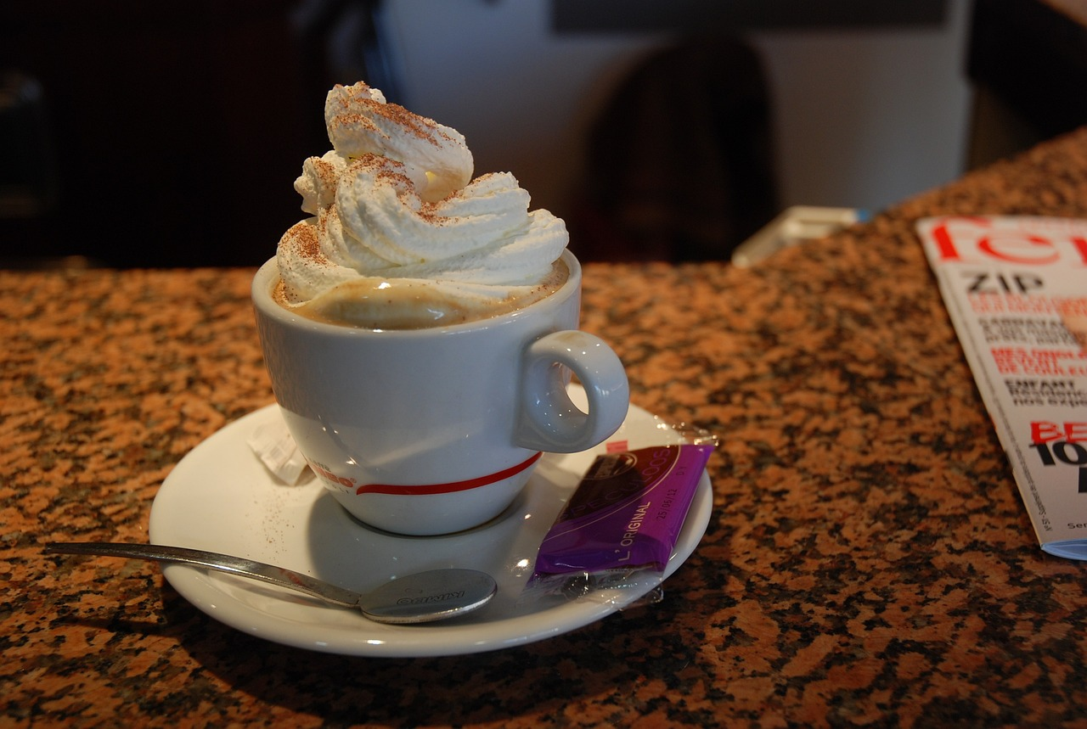 | 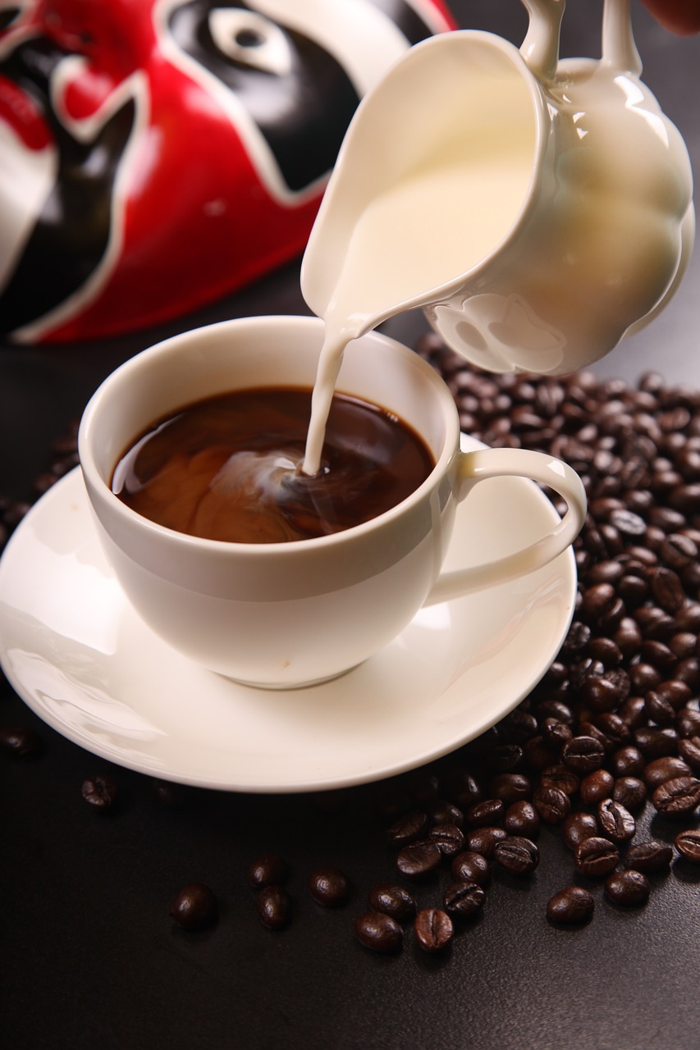
kava s toplim mlijekom | kava s hladnim mlijekom | kava sa šlagom | kava s vrhnjem
You already learned about Instrumental Case endings. However, here are the endings for the Instrumental Case again in the singular form for all three genders.
Kava s/sa…  Kolač s/sa… | šlag | čokolada | mlijeko
 | šlag-om | čokolad-om | mlijek-om

| Made of + Genitive case
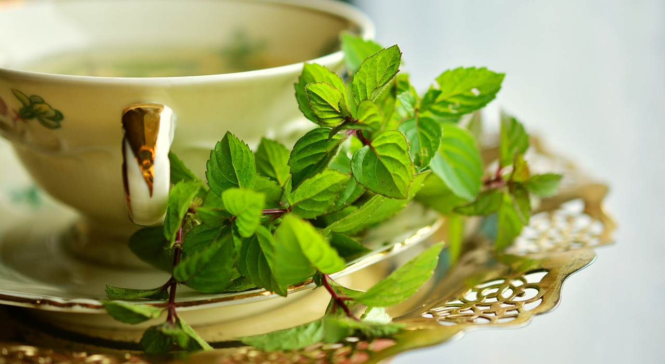 | 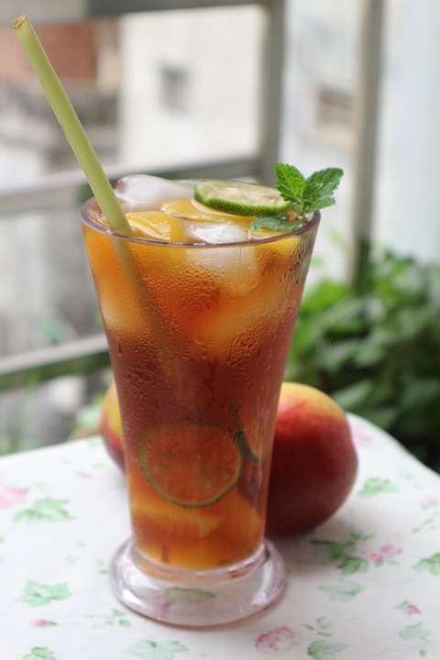 | 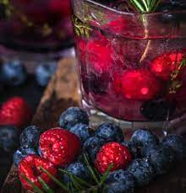 | 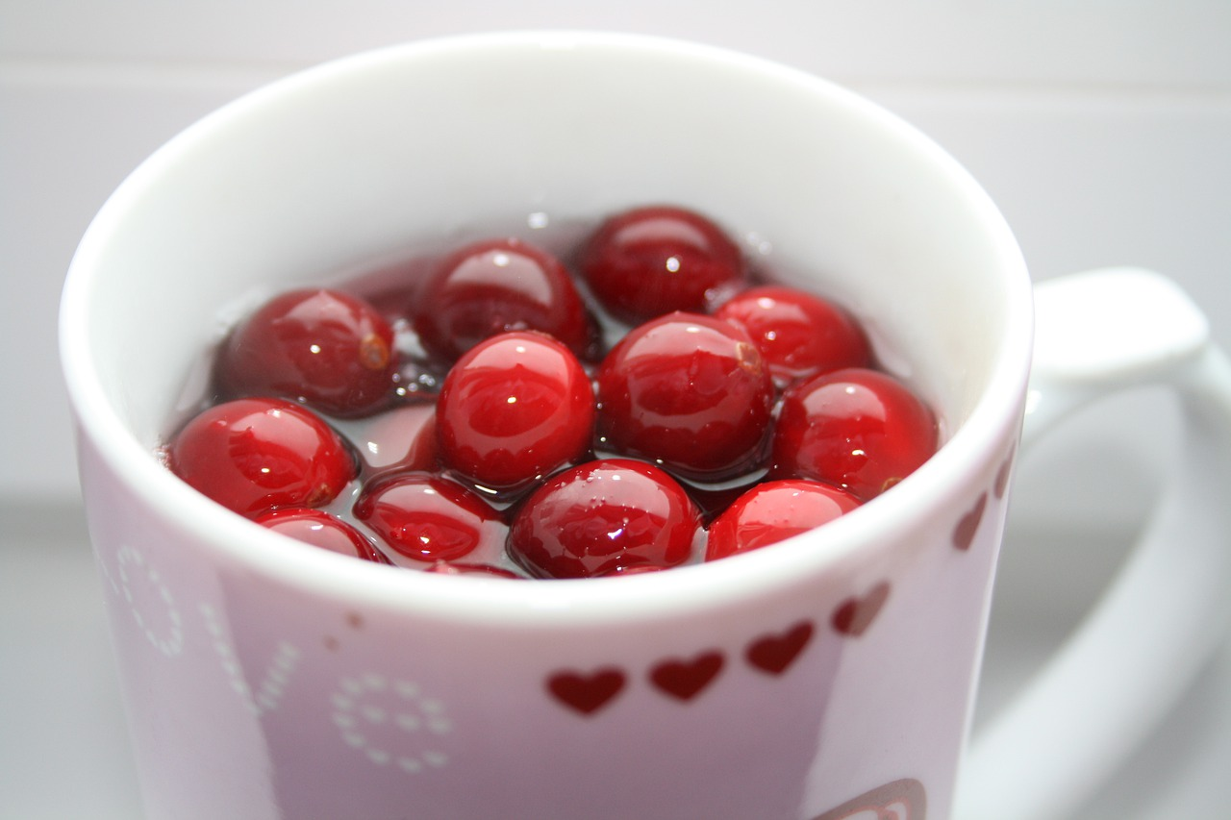
čaj od mente | čaj od breskve | čaj od šumskog voća | čaj od brusnice
You already learned about Genitive Case endings. However, here are the endings for the Genitive Case again in the singular form for all three genders.
Kolač od…  Torta od… | sir | čokolada | vrhnje
 | sir-a | čokolad-e | vrhnj-a

8.1 Zadatak 1. Od čega? S čime?
[h5p id="526"]

| The verb PITI
After we remove the -ti ending of the verb, the stem piti (to drink) has only one syllable. This will require the use of the following endings:
PITI
SINGULAR |  |  | PLURAL
(audio) | ja | pi-jem | (audio) | mi | pi-jemo
(audio) | ti | pi-ješ | (audio) | vi | pi-jete
(audio) | on/-a/-o | pi-je | (audio) | oni/-e/-a | pi-ju

| The verb ISPIJATI
Another verb that you have encountered in today’s lesson is the verb ispijati which can be translated as sip / sipping on. This verb is useful to know as the coffee culture shows that a lot of people like to ispijati their coffee for hours (no matter how small the coffee is). The verb is a regular -ati verb.
ISPIJATI
SINGULAR |  |  | PLURAL
(audio) | ja | ispij-am | (audio) | mi | ispij-amo
(audio) | ti | ispij-aš | (audio) | vi | ispij-ate
(audio) | on/-a/-o | ispij-a | (audio) | oni/-e/-a | ispij-aju

The verbal noun is ispijanje.
Look at the following two sentences that both mean the same thing. The first one uses the verb ispijati, and the second one uses the verbal noun ispijanje.
ispijati | Ja uvijek ispijam kavu barem dva sata.  I usually sip on my coffee for two hours.
ispijanje | Moje ispijanje kave obično traje dva sata.  My coffee drinking ritual takes/lasts two hours.

8.1 Zadatak 2. Što pijemo?
[h5p id="525"]

Images used in this document are from these sources.

