4 | 1 | Lekcija 2: Smještaj

# | Adjectives in the Locative Case

So far you already learned that adjectives (i.e., *lijep – lijepa – lijepo*) need to agree with the nouns they describe. When nouns are in the Locative case, adjectives must also be in the Locative form. In the Locative case, the basic adjective ending for masculine and neuter forms is –om and for feminine nouns is –oj. The alternative ending for masculine and neuter gender is: -em (i.e., vrući [hot], tuđi [foreign]).

|  | **MASCULINE** | | **NEUTER** | | **FEMININE** |
| --- | --- | --- | --- | --- | --- |
| **N. sing** | lijepi  student | vrući  čaj | lijepo  selo | vruće  mlijeko | lijepa  kuća |
| **L. sing** | lijep**om** student**u** | vruć**em**  čaj**u** | lijep**om**  sel**u** | vruć**em** mlijek**u** | lijep**oj**  kuć**i** |

# | Countries and the Locative Case

When we think of adjectives and the Locative case with its main function indicating location, we need to mention countries, like Hrvatska, Norveška, and Njemačka. All the countries that end in the -ska / -ška / -čka ending (e.g., Francuska, Hrvatska, Njemačka, Grčka, Norveška) will use the feminine adjective ending -oj to express location. Example:

#### Ja sam u Hrvatskoj / Norveškoj / Njemačkoj.

Other countries with the standard noun form, such as *Srbija, Italija, Portugal, Brazil*, etc. will use the regular noun ending according to their gender.

#### Ja sam u Portugalu / Brazilu / Italiji.

*Crna Gora* is an exception since it combines both an adjective and a noun in its name. Thus, to express the meaning that someone is in Montenegro we need to say:

#### Ja sam u Crnoj Gori.

# 4.1 Zadatak 6. Gradovi u svijetu

Look at the list of cities around the world. Indicate the country/state where each of them is located. Be careful what the Nominative form of each country is. You also need to use the correct preposition. Na primjer: *Zagreb je u Hrvatskoj*.

[h5p id="667"]

# 4.1 Zadatak 7. Gdje živimo?

Look at the map and the given names. Where do they live? Include the name of the country and the city. Na primjer: Artan živi na Kosovu, u Prištini.

[h5p id="666"]

# 4.1 Zadatak 8. Gramatika

[h5p id="400"]

# 4.1 Zadatak 9. U budućnosti

Look at the following pictures. Use one of the following adjectives to complete the sentence. You cannot repeat the adjective twice (except the adjective “star” that will appear twice).

| visok | ružan | star | star |
| --- | --- | --- | --- |
| nizak | nov | moderan | lijep |

|  |  |  |  |
| --- | --- | --- | --- |
| slika 1 | slika 2 | slika 3 | slika 4 |
|  |  |  |  |
| slika 5 | slika 6 | slika 7 | slika 8 |

[h5p id="399"]

# 4.1 Zadatak 10. U Zagrebu, u domu

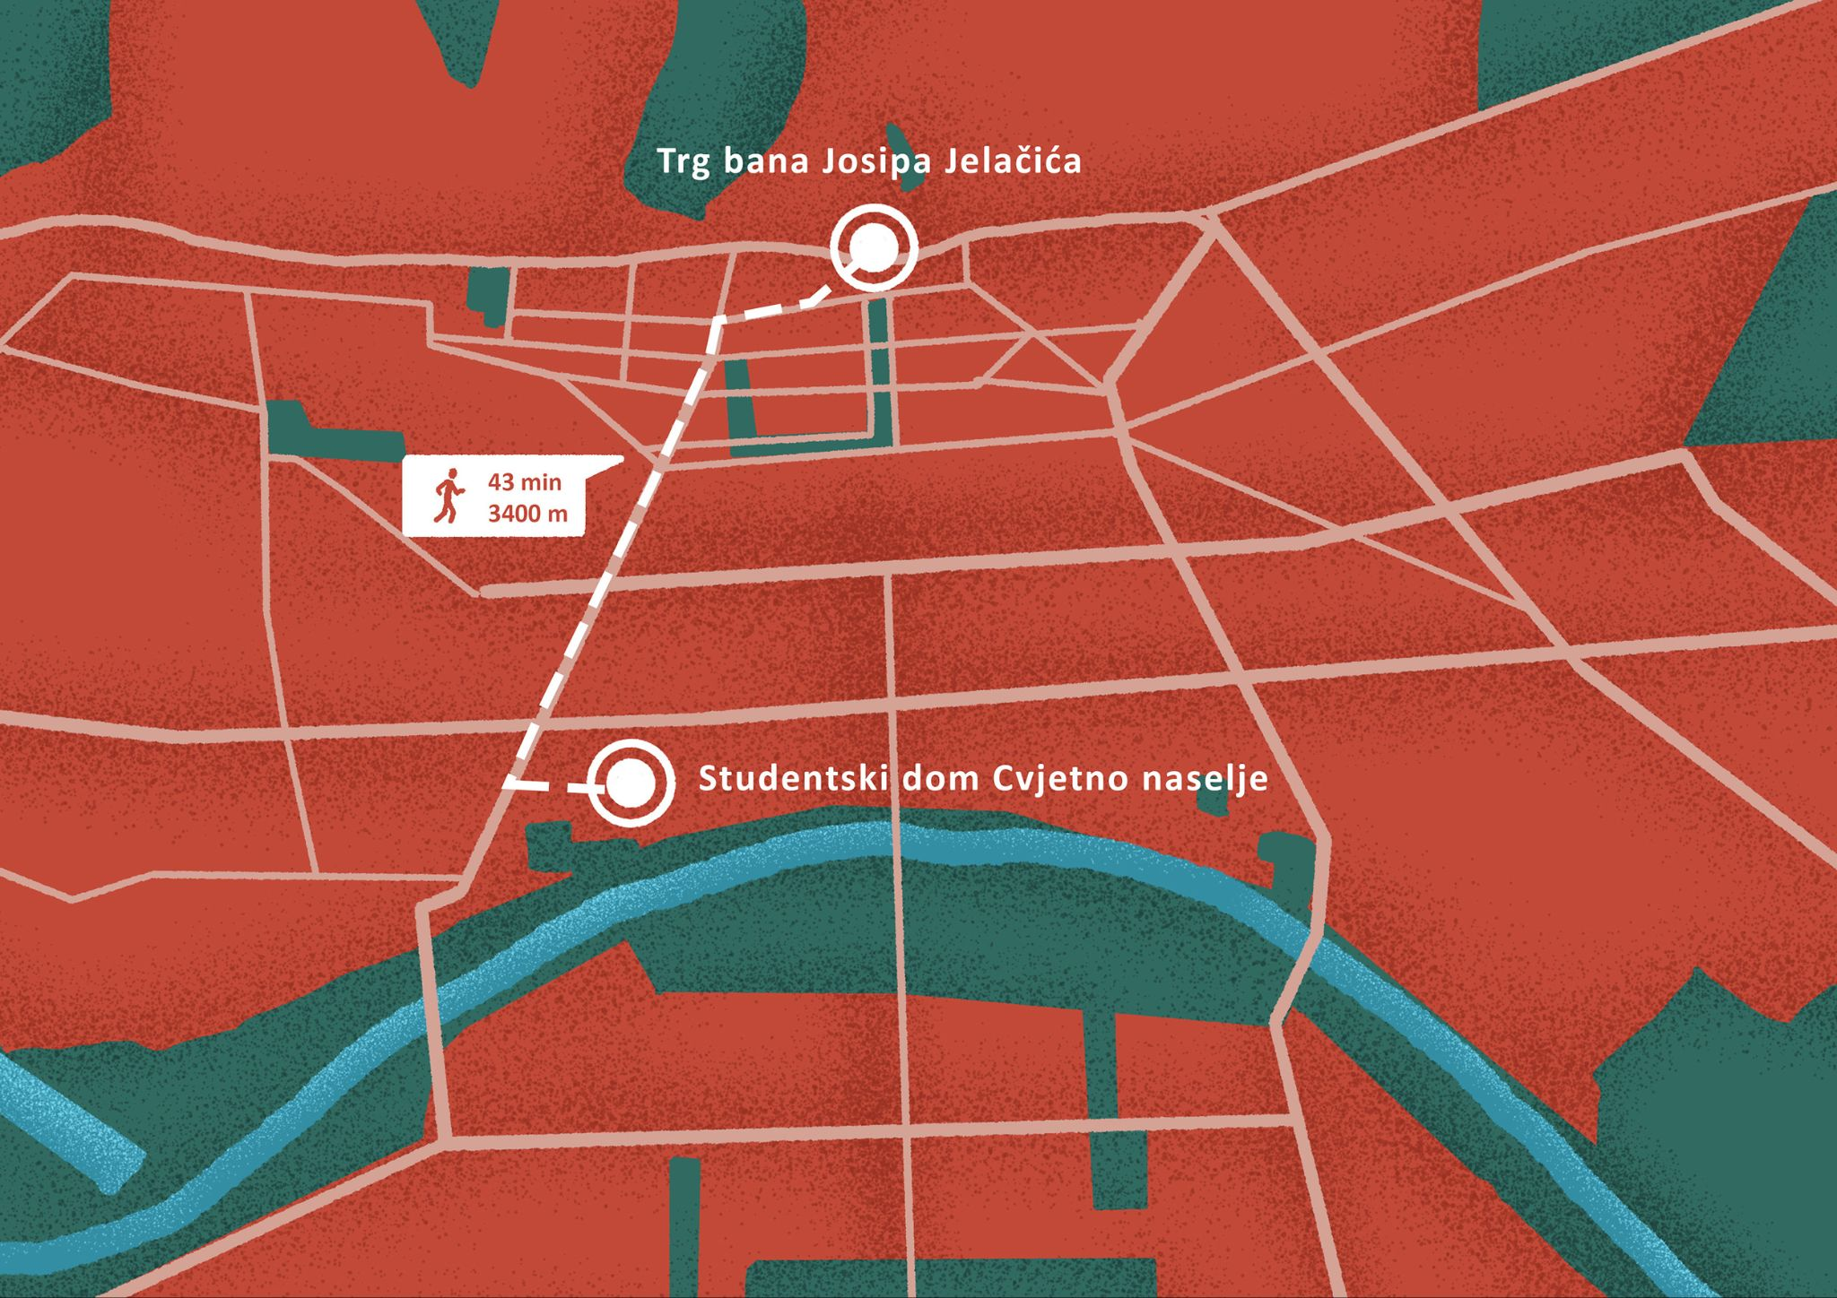

[h5p id="401"]

[h5p id="402"]

Images used in this document are from [these sources](https://docs.google.com/document/d/1OSyVOXtBWqGHIhMo4tBgFKbLWuL9CmHTEj1QkSpS6EM/edit#heading=h.2ddkne9nvlct).