10.7 - flying - the verbs létat (coll. - lítat) and letět

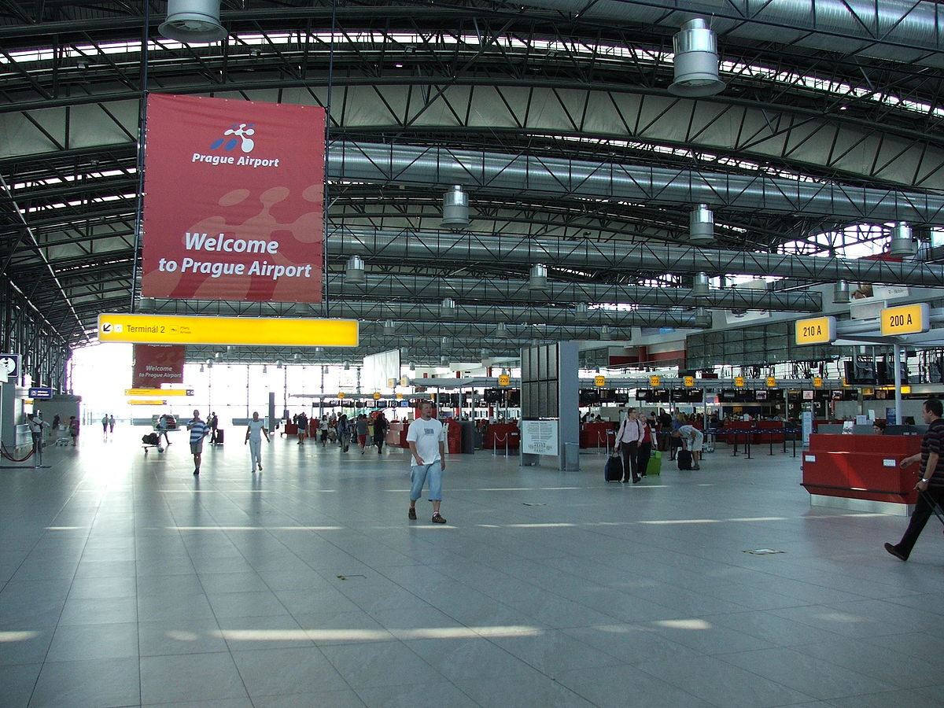 | 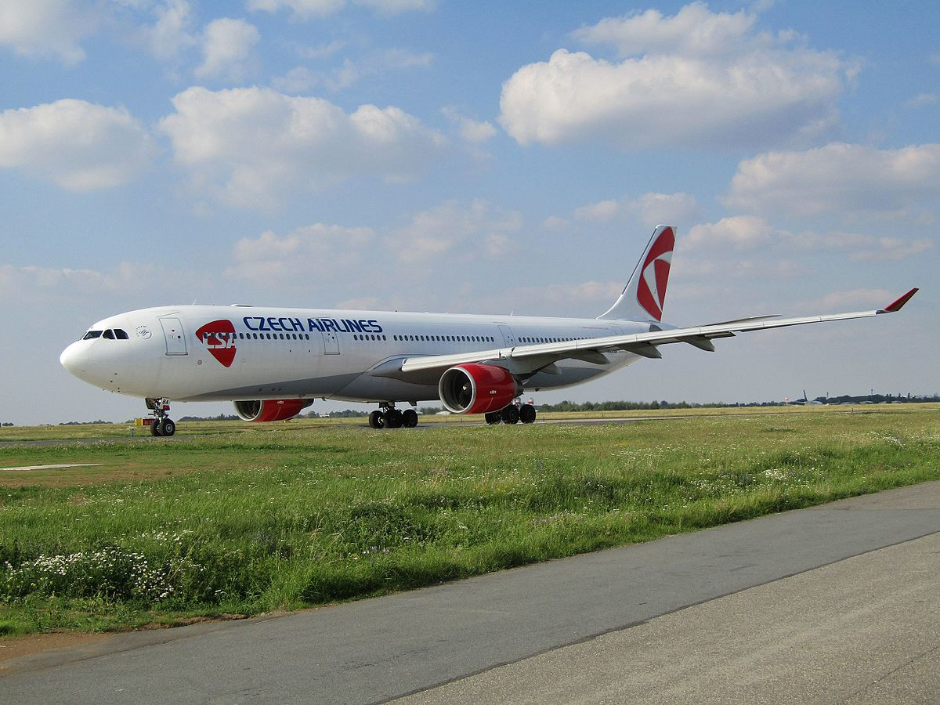

In this lesson we are going to learn about two more verbs, létat ‘to fly(indet.)’ and letět ‘to fly (det.)’. The verb létat (like the verb chodit, jezdit),is an indeterminate verb of motion. It has a colloquial variant lítat. The verb letět (like jít, jet) is a determinate verb of motion.

indeterminate | determinate | definition
chodit | jít | to go (by foot)
jezdit | jet | to go (by vehicle)
létat (lítat) | letět | to fly

indeterminate (létat) | determinate (letět)
- habitual acts of going - use the verb jezdit when you are describing frequent or habitual trips.  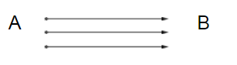 | - single trip - use the verb jet when you describing a single trip from point A to point B.  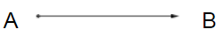
Létám několikrát za rok.  I fly a few times a year. | Kam letíte?  Where are you flying to?
Hodně jsme létali, když jsem byla mladší.  We used to fly a lot when I was younger. | Minulý týden jsme letěli do Chorvatska na víkend.  Last weekend we flew to Croatia for the weekend.
Budu asi hodně létat kvůli práci.  I’m probably going to fly a lot because of work. | Za měsíc poletíme zpátky domů.  We’ll fly back home in a month.
- goal-less motion

Ptáci létali nad námi.
Birds were flying above us.

V pokoji létala moucha.
A fly was flying around the room.

Finally, létat and letět can be used colloquially to talk about hurrying and rapid movement, as in the examples here below:

indeterminate (létat) | determinate (letět)
Děti lítaly celý den po venku a v noci pak spaly jak zabité.  The children were zooming around outside all day and at night they slept like logs (lit. like the dead). | Promiň, ale už musím letět! Za 10 minut mi začíná hodina.  Excuse me, but I have to hurry off! My class starts in ten minutes (lit. starts for me).  Kam zase letíš? Vždyť ses ani nenajedl!  Where are you rushing off to again? You haven’t even had a bite to eat!

Images used in this document come from these sources.

