4 | 1 | Lekcija 2: Smještaj

# 4.1 Zadatak 5. Što ima u kući?

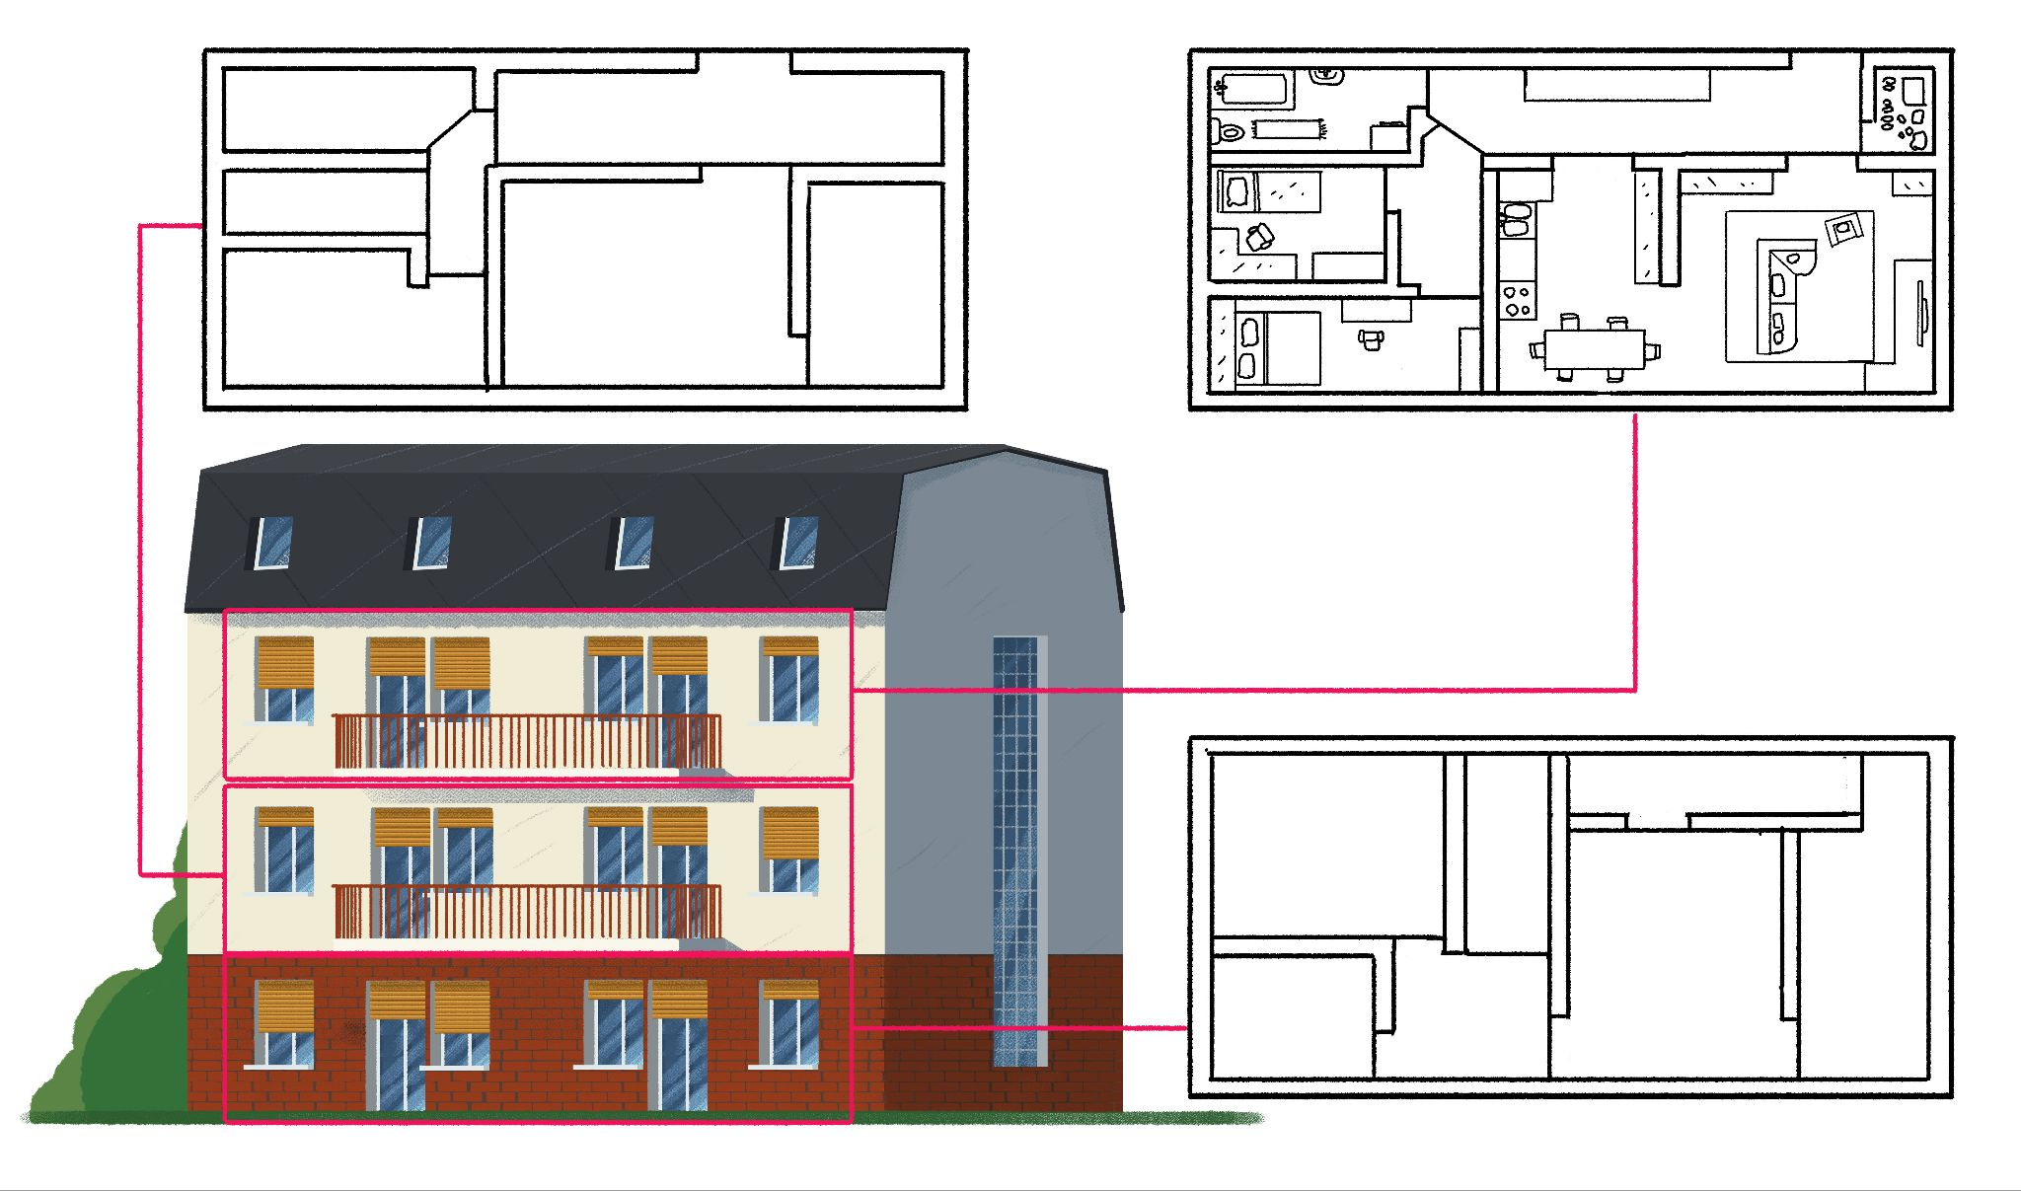[h5p id="426"]

# 4.1 Zadatak 6. Njihov stan

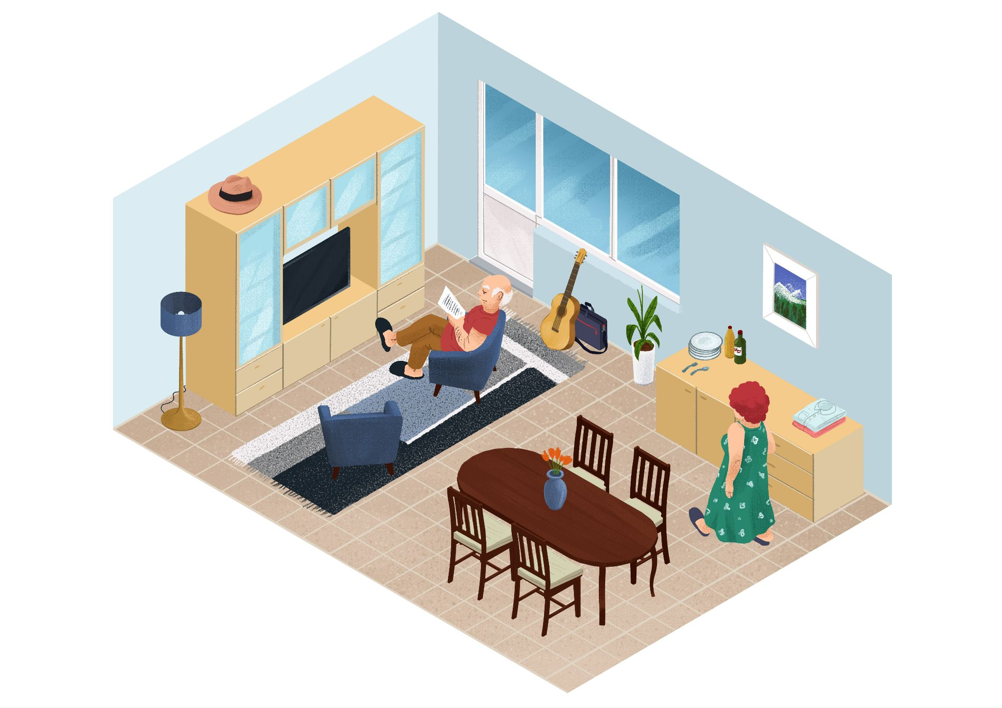

[h5p id="427"]

# | Život u Hrvatskoj

## *OPTIONAL*

Here is a [YouTube video](https://www.youtube.com/watch?v=zZJB4zZntSg) of a person who is traveling around the world and who spent a month in Zagreb. Watch the video to learn some new vocabulary (listed below) related to living and monthly expenses.

| Smještaj | Airbnb: struja, internet, voda, wifi | $1087/mjesec |
| --- | --- | --- |
| Namirnice | jabuke $1/kg | $351/mjesec |
| banane $1.50/kg |
| rajčice $1.50/kg |
| luk $0.60/kg |
| kruh $1.50 |
| mlijeko $1 |
| Prijevoz | autobus | $0.60/30 min |
|  | tramvaj |  |
| Restorani | $4.50 - $8.90 obrok [meal] |  |
| $1.50 - $4 zalogaj [bite] |
| Telefon i SIM kartica | mobilna mreža | $8.80/mjesec |
| Razno |  | $72/mjesec |

Images used in this document are from [these sources](https://docs.google.com/document/d/1OSyVOXtBWqGHIhMo4tBgFKbLWuL9CmHTEj1QkSpS6EM/edit#heading=h.cr7zz964nq1).