# 8.4 - *Ročník* - Year in School

[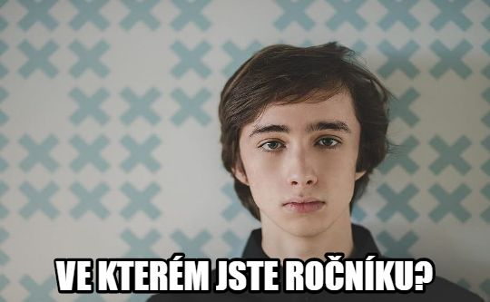](https://commons.wikimedia.org/wiki/File:Jakub_%C4%8Cech.jpg)

The word *ročník* refers to your year in school. It is related to words you already know – *rok* ‘year’, *ročně* ‘yearly’, etc.

So what will we need this for? Well, in English we use terms such as *freshman, sophmore, junior, senior*, or even more simply *first year, second year, third year, fourth year*…

Well, Czech uses *ročník* and you literally say “I am in first/second/third/fourth year.”

For this we’ll need our ordinal numbers and then we’ll need to put them in the locative.

| *první ročník* | *jsem v prvním ročníku* | ‘I’m in (my) first year’ |
| --- | --- | --- |
| *druhý ročník* | *jsem v druhém ročníku* | ‘I’m in (my) second year’ |
| *třetí ročník* | *jsem ve třetím ročníku* | ‘I’m in (my) third year’ |
| *čtvrtý ročník* | *jsem ve čtvrtém ročníku* | ‘I’m in (my) fourth year’ |
| *pátý ročník* | *jsem v pátém ročníku* | ‘I’m in (my) fifth year’ |

You can also hear people say *v posledním ročníku* ‘in (my) last year’.

Additionally, sometimes you’ll see these qualified - *v prvním ročníku doktorského studia* - ‘In my first year of doctoral studies.’

The question that corresponds to this is *Ve kterém jste ročníku?* lit. - ‘In what school year are you?’

Images used in this document come from [these sources](https://docs.google.com/document/d/1HQqSIqnOQo0_cjj3ZbBSyDe-fgq1AEZhIxgZ_W4CIUA/edit#heading=h.s69dzbq2p4a3).