2 | 3 | Lekcija 4: Tradicija

2.3 Zadatak 14. Moja prezentacija o gradu
💻 You already started preparing your presentation in class. Practice your presentation at home and come to class prepared. You will not be allowed to have any notes during your presentation. Submit your presentation online prior to our class session, in order to share it with other students.

2.3 Zadatak 15. Aktivnosti u gradu
Look at the following set of pictures. Write down what each of them represents. What actions are the people/tourists doing?
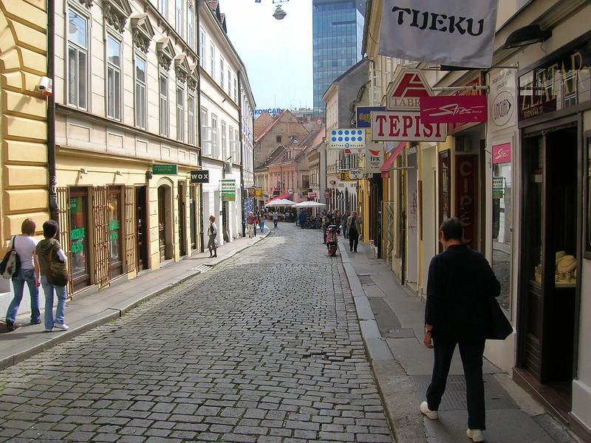 | 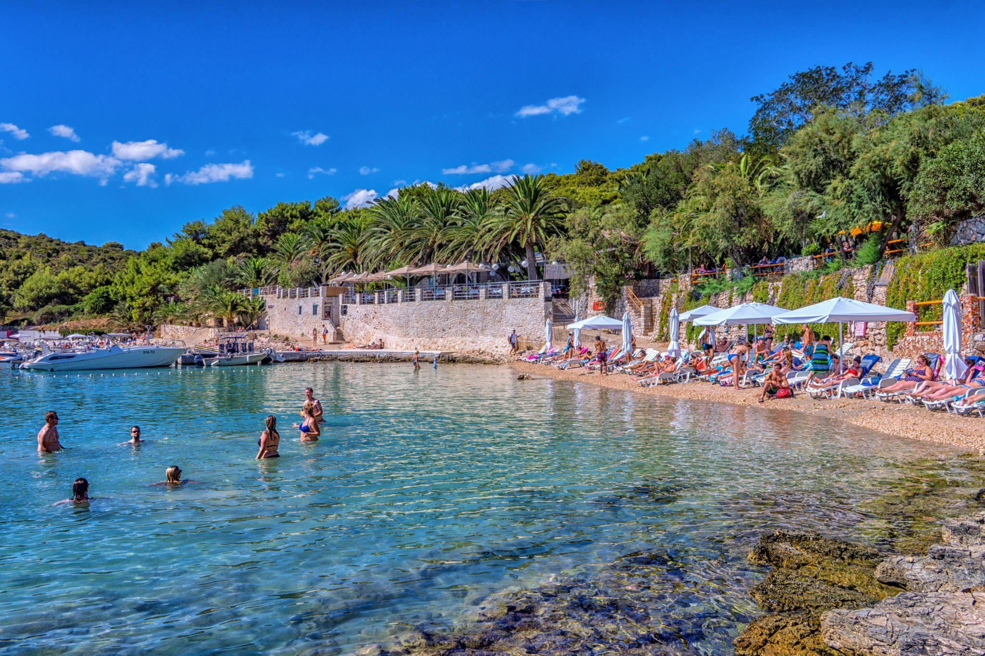 | 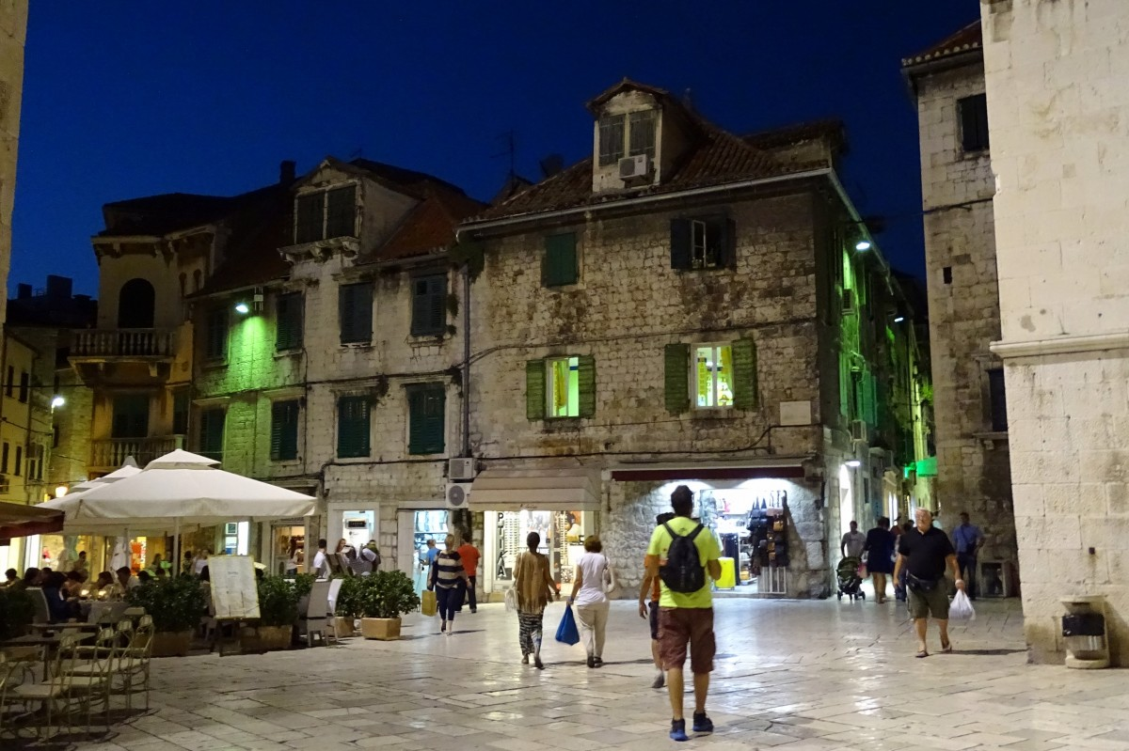
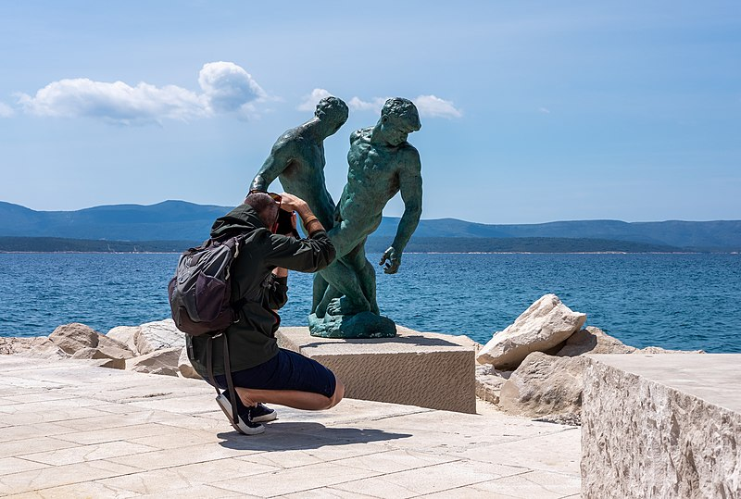 | 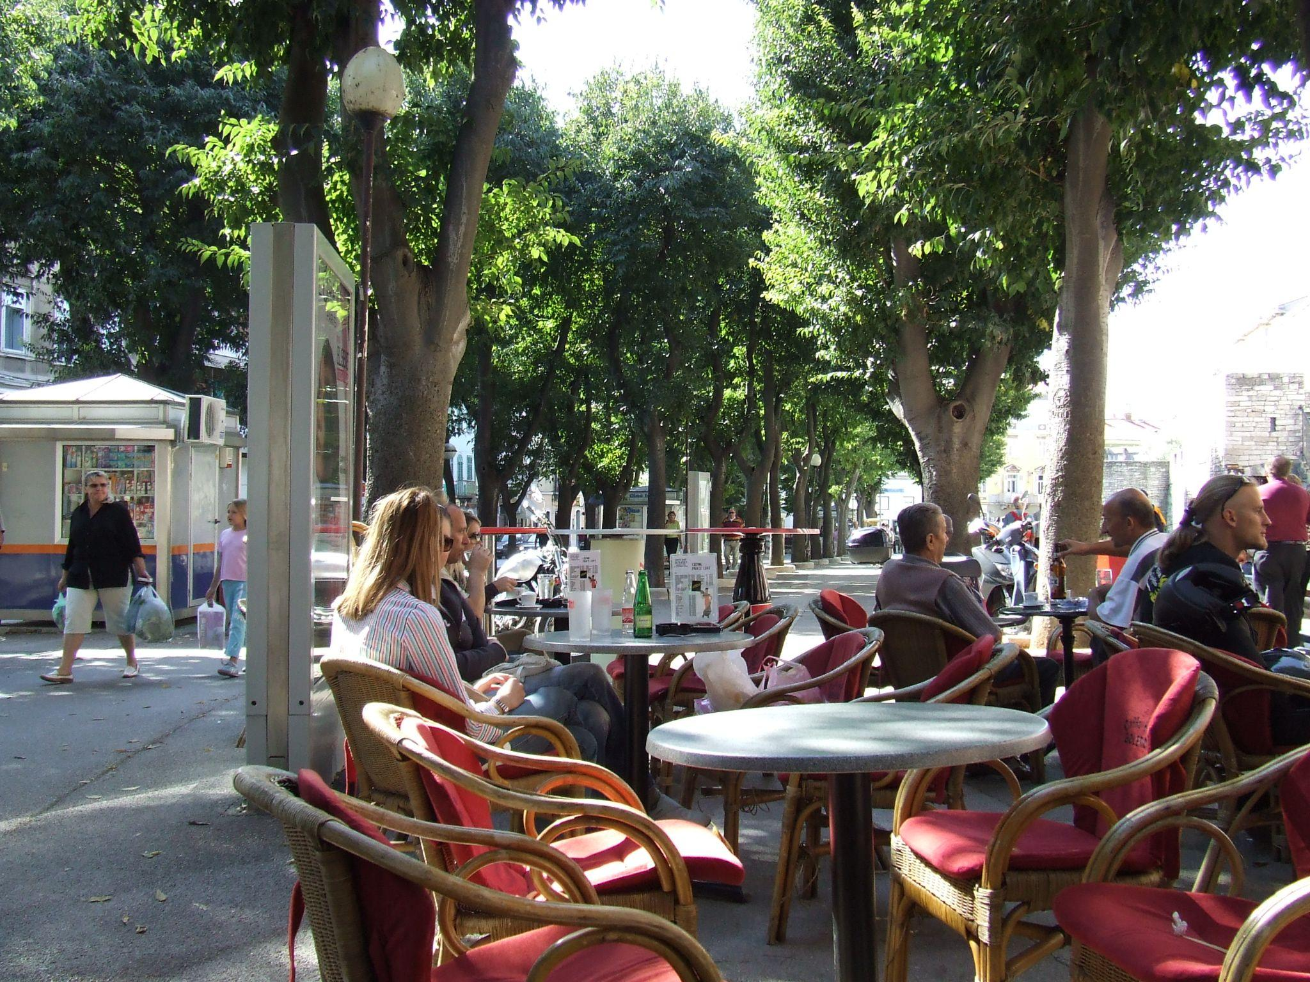 | 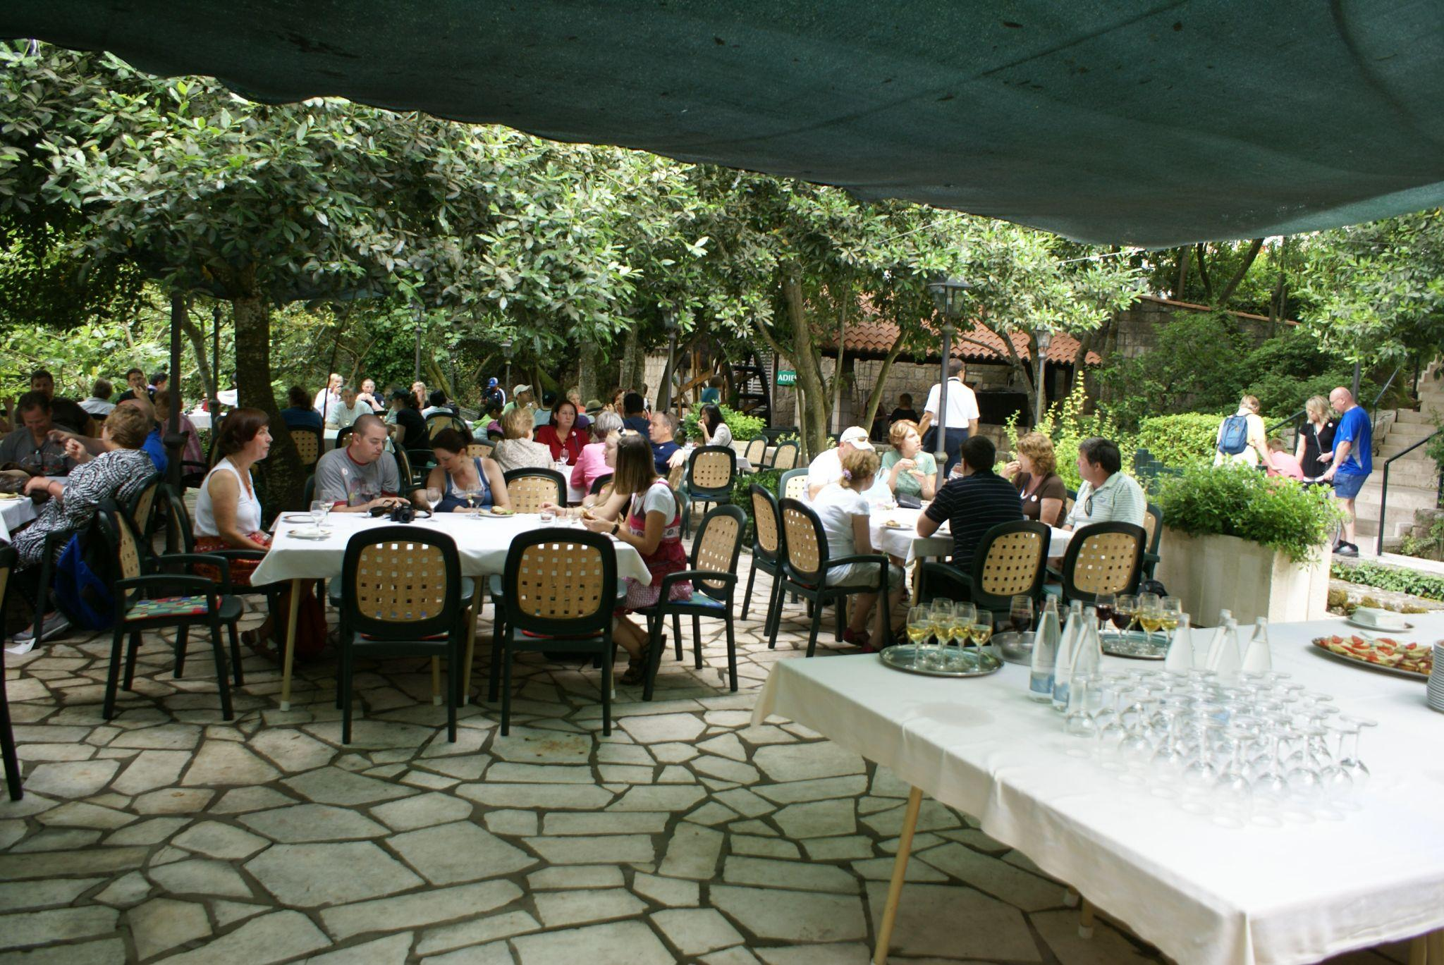
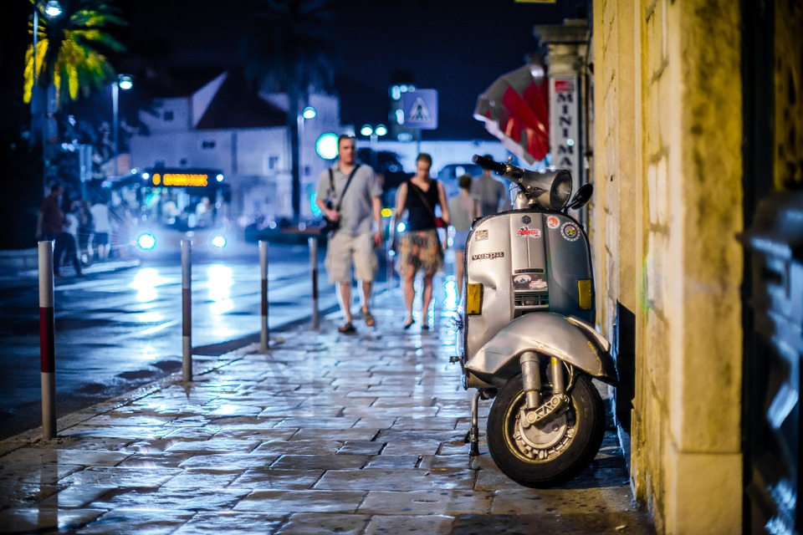 | 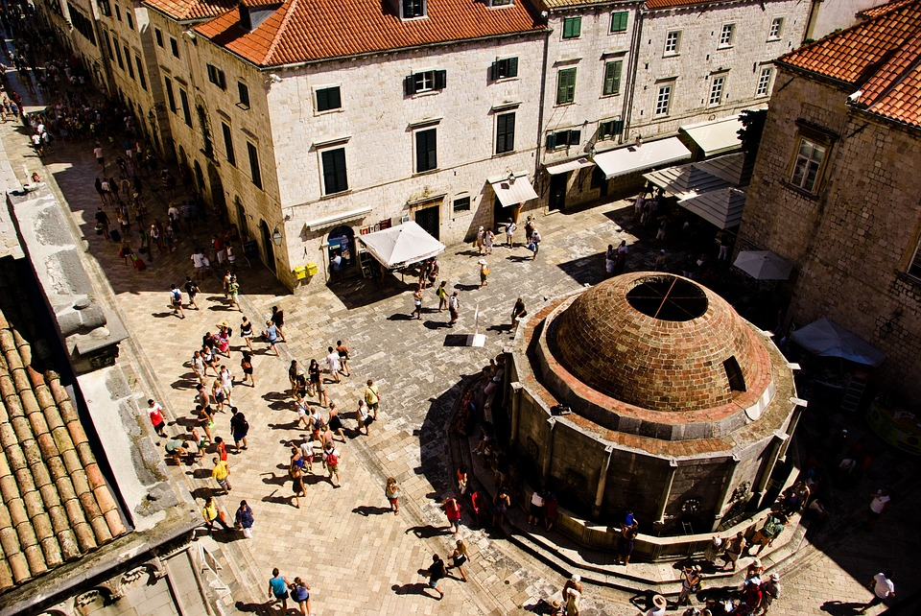 | 
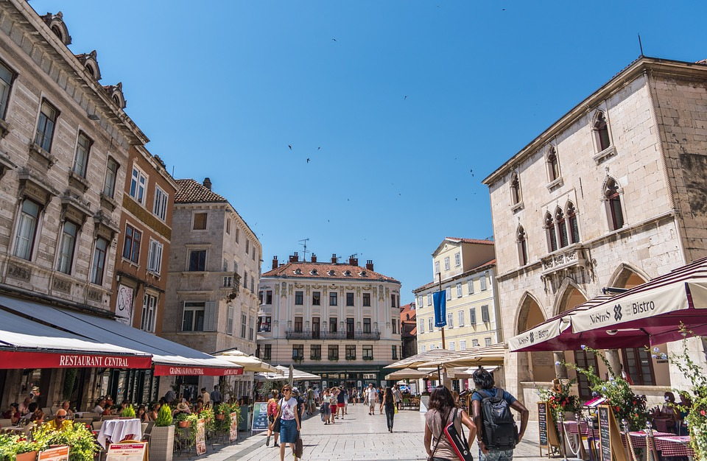 | 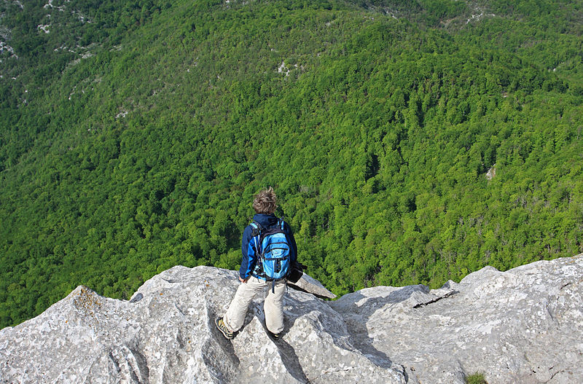 | 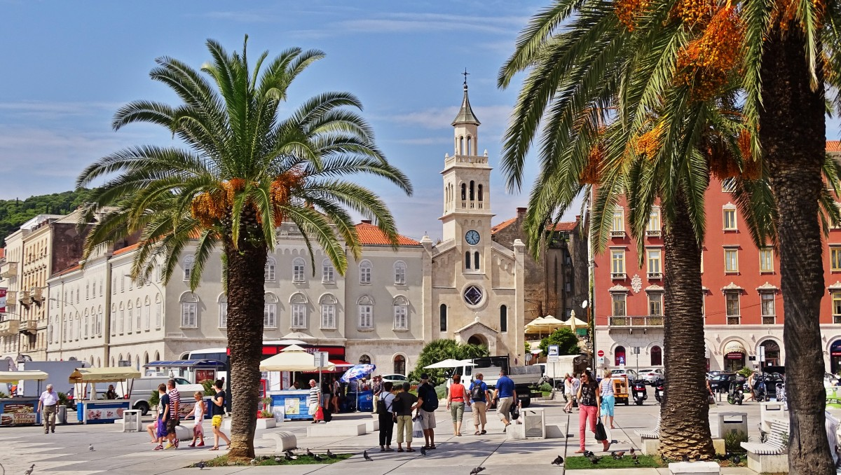
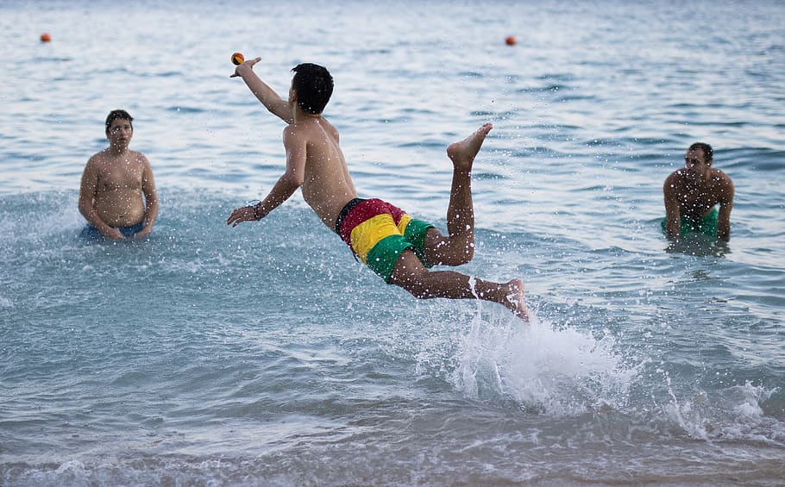 | 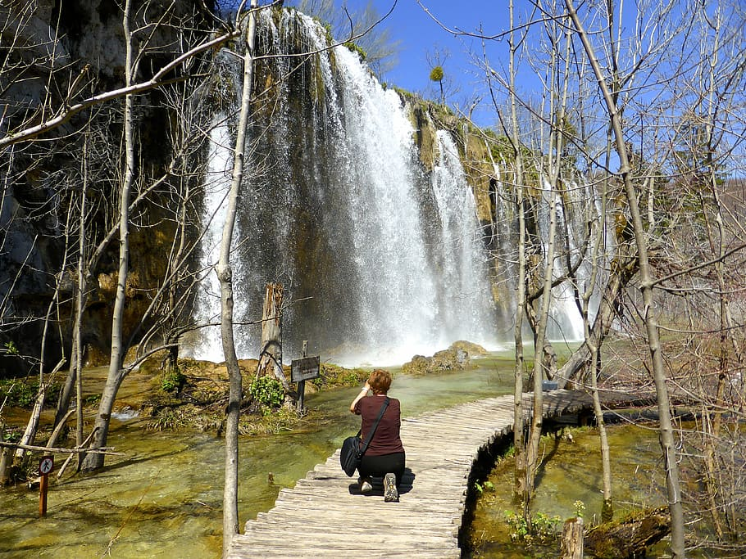 | 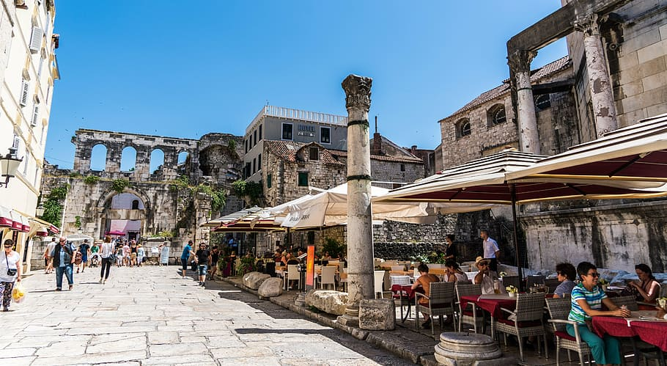
Na primjer:
Turisti vole fotografirati spomenike.
Slika 1
Slika 2
Slika 3
Slika 4
Slika 5
Slika 6
Slika 7
Slika 8
Slika 9
Slika 10
Slika 11
Slika 12
Slika 13
Slika 14
Slika 15

Pitanje:
1 | Which of the actions above do you usually do when traveling?
 | -

Images used in this document are from these sources.

