4 | 1 | Lekcija 2: Smještaj

# 4.1 Zadatak 9. Prostorije u stanu/kući

## Part 1

Look at the pictures and write what you have in each of the following rooms.

### Što se nalazi u:

|  |  |  |
| --- | --- | --- |
| u spavaćoj sobi | u dnevnoj sobi | u radnoj sobi |
|  |  |  |
|  |  |  |
|  |  |  |
|  |  |  |
|  |  |  |
|  |  |  |
|  |  |  |

## Part 2

Ask your classmate about his apartment. While your classmate tells you what he/she has in each of the rooms listed above, think of your rooms and write what you have in common. You will need to present your answers to your instructor.

# 4.1 Zadatak 10. U dječjoj sobi

Look at the following picture. Mark your answer for each of the following questions. This is your personal opinion. There is no wrong answer and you may choose more than one possible answer.

### Gdje se nalaze stvari u spavaćoj sobi?

[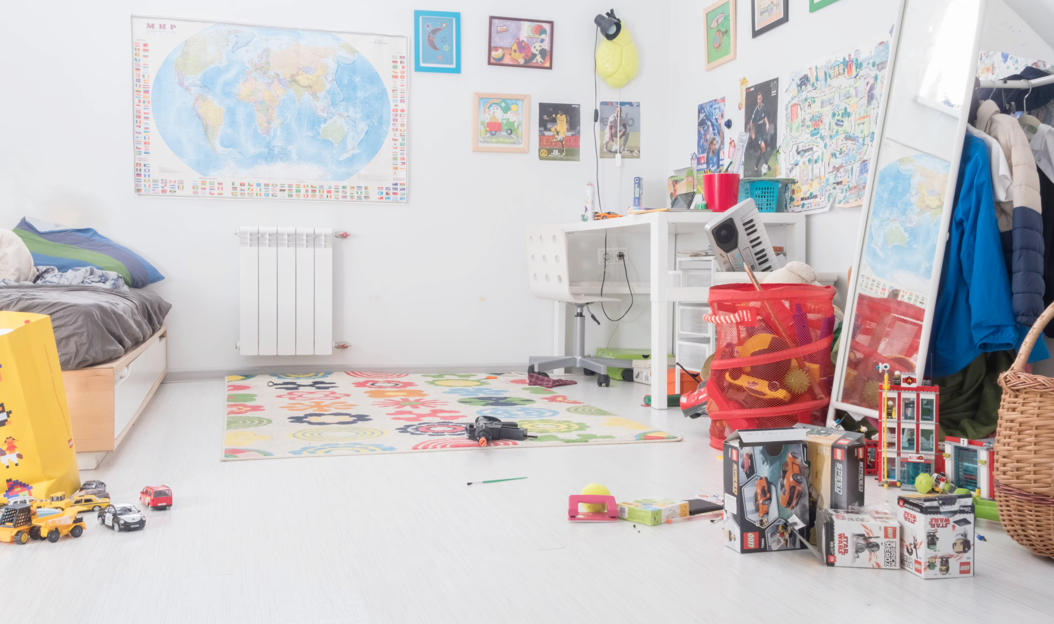](https://unsplash.com/photos/8u-OaI3MZrc)

| Slike su na: | Jastuci su na: | Laptop je na: | Igračka su na: |
| --- | --- | --- | --- |
| lijepom zidu | lijepom krevetu | lijepom stolu | čistom podu |
| starom zidu | starom krevetu | starom stolu | starom tepihu |
| velikom zidu | malom krevetu | modernom stolu | modernom tepihu |
| ružnom zidu | velikom krevetu | ružnom stolu | ružnom tepihu |
| Igračke su u: | Knjige su u: | Auto je u: | Odjeća je u: |
| lijepoj košari | lijepoj komodi | lijepoj kutiji | lijepoj košari |
| staroj polici | staroj komodi | velikoj kutiji | staroj košari |
| modernoj komodi | modernoj komodi | maloj kutiji | velikoj košari |
| ružnoj košari | ružnoj komodi | ružnoj kutiji | ružnoj košari |

# 4.1 Zadatak 11. Gdje živiš?

🔊 Listen to the dialogue between Matija and James. It's a continuation of their dialogue at Matija’s place. Answer the following questions.

### Jamesova ulica

|  |  |
| --- | --- |

### Matijina ulica

|  |  |
| --- | --- |

## | Razumijevanje

| 1 | U kojoj ulici živi James? |
| --- | --- |
| - |
| 2 | U kojoj zgradi živi James? |
| - |
| 3 | Koje je boje zgrada? |
| - |
| 4 | Živi li James u jednosobnom ili u dvosobnom stanu? |
| - |
| 5 | Kako se zove njegov cimer? |
| - |
| 6 | Je li on uredan ili neuredan? |
| - |
| 7 | Je li zgrada nova ili stara? |
| - |
| 8 | Ima li u zgradi lift? |
| - |

## | Osobna pitanja

| 1 | Živiš li ti u jednosobnom ili u dvosobnom stanu? |
| --- | --- |
| - |
| 2 | Živiš li u centru? |
| - |
| 3 | Živiš li u niskoj ili u visokoj zgradi? |
| - |
| 4 | Koje je boje tvoja zgrada/kuća? |
| - |

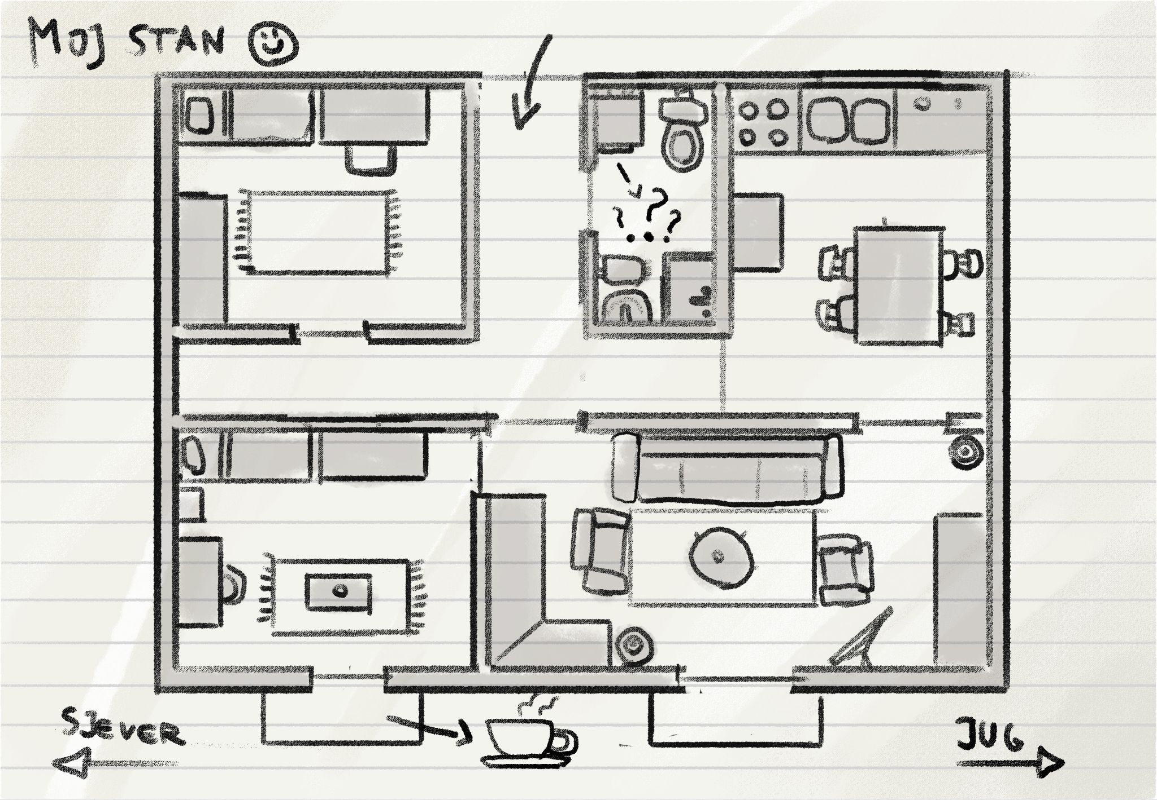

## | Razumijevanje

| 1 | Što ima Jamesova dnevna soba? |
| --- | --- |
| - |
| 2 | Što ima u kuhinji? |
| - |
| 3 | Što ima u kupaonici? |
| - |
| 4 | Što ima na balkonu? |
| - |
| 5 | Gdje je perilica rublja? |
| - |
| 6 | Kako ljudi suše odjeću? |
| - |

## | Osobna pitanja

| 1 | Gdje je u tvojem stanu perilica rublja? |
| --- | --- |
| - |
| 2 | Gdje ti sušiš odjeću? |
| - |
| 3 | Imaš li radnu sobu? |
| - |

# 4.1 Zadatak 12. Gdje žive?

Look at the map to see where James and Matija live. Are they close to each other or not? James živi u Tolstojevoj (Ulica Lava N. Tolstoja), a Matija živi u Viškoj (Viška ulica) ulici.

### [Mapa](https://www.google.com/maps/dir/Ul.+Tolstojeva,+21000,+Split,+Croatia/Vi%C5%A1ka+ul.,+21000,+Split,+Croatia/@43.5074033,16.4417207,16z/data=!3m1!4b1!4m14!4m13!1m5!1m1!1s0x13355e06f01dff21:0xd1118923edbb6f51!2m2!1d16.4442897!2d43.5112832!1m5!1m1!1s0x133560a82e7b9a3d:0x851c4e92742a0f84!2m2!1d16.4497385!2d43.5035235!3e2?hl=hr&authuser=0)

|  |  |
| --- | --- |

## Pitanja:

### Žive li Matija i James blizu ili daleko?

What are some things/places that they can go to, and is it a walking distance from where they live? Compare your answers with one of your classmates.

### Kamo oni mogu ići?

| Restoran: |  |
| --- | --- |
| Muzej: |  |
| Plaža: |  |
| Trgovina: |  |
| Turistička atrakcija: |  |

# 4.1 Zadatak 13. Kako urediti balkon?

Look at the picture of James’ balcony. Then answer the questions. Compare your answer/proposal with another classmate to see how similar you are in terms of decorating a space.

|  |  |
| --- | --- |
| pitanje | odgovor |
| Kakav je Jamesov balkon? |  |
| Kako James može urediti balkon? |  |
| Što on treba imati na balkonu? |  |

# 4.1 Zadatak 14. Tvoj stan

Let’s summarize what we learned so far. Tell us more details about your apartment or a house. Where is it (city, address), what does it look like, rooms in the house, etc. Use/read again the dialogues that we covered so far and create a dialogue with your classmate. Ask each other questions about the apartment/house, ask and provide comments on some details that reflect the housing situation. You do not need to use your real information.

Images used in this document are from [these sources](https://docs.google.com/document/d/1OSyVOXtBWqGHIhMo4tBgFKbLWuL9CmHTEj1QkSpS6EM/edit#heading=h.i0fvnp5n68s7).