2 | 2 | Lekcija 1: Slobodno vrijeme

2.2 Zadatak 1. Što radiš u slobodno vrijeme?
Talk with one of your classmates and tell each other what you usually do in your free time. Answer the following three questions. Example yes / no answers are provided below for each question.

Ti treniraš/igraš neki sport?
[odgovor] → Da, treniram/igram […]
[odgovor] → Ne, ne treniram/igram sportove.
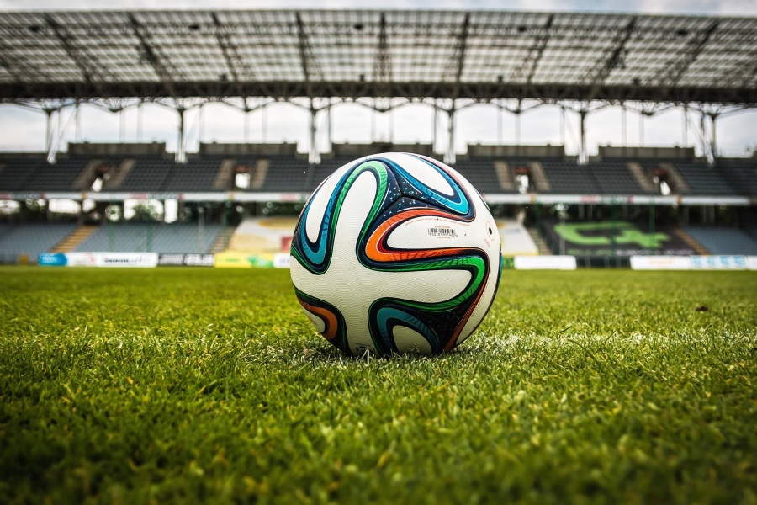 | 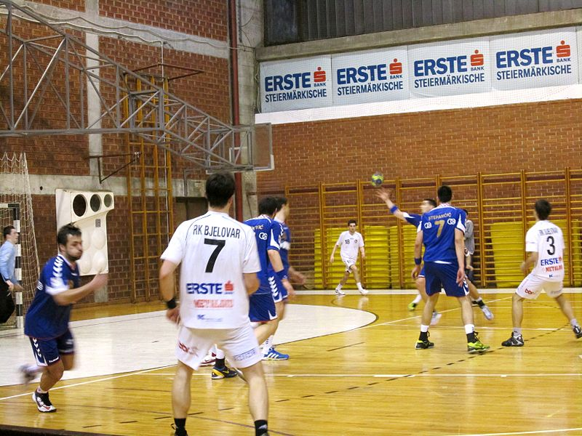 | 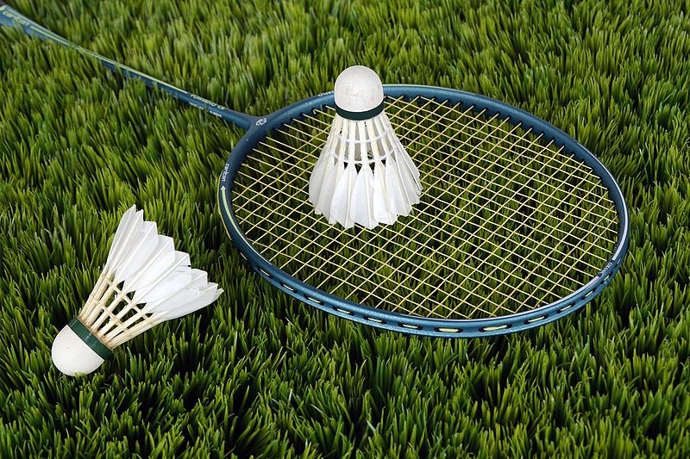
⚽ nogomet | 🤾 rukomet | 🏸badminton
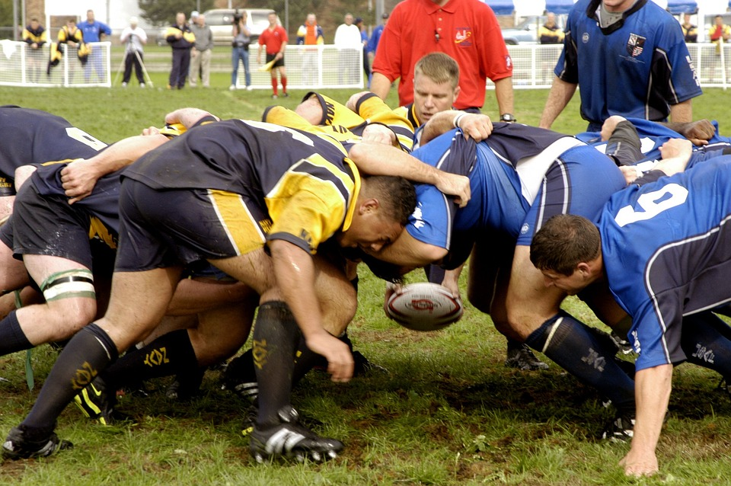 | 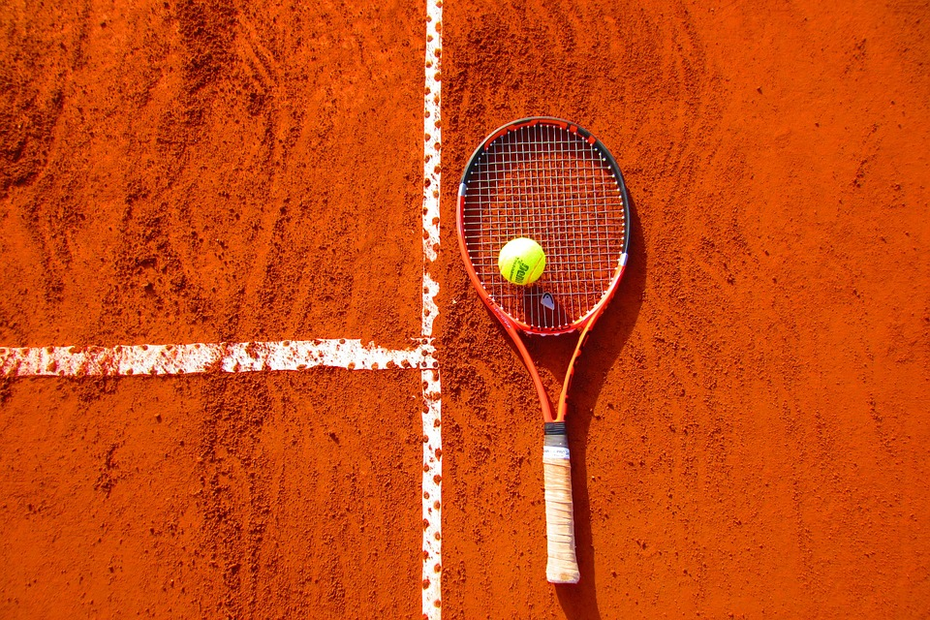 | 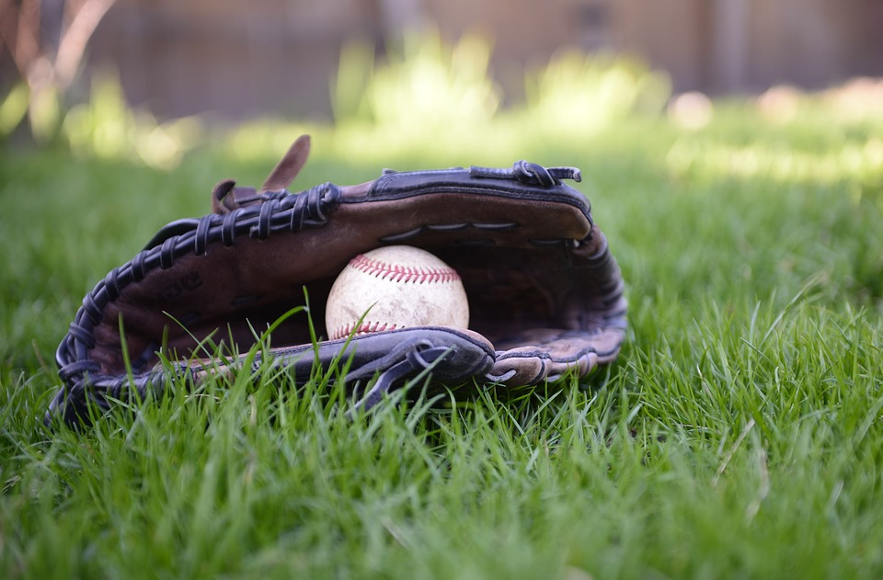
🏉 ragbi | 🎾 tenis | ⚾ bejzbol
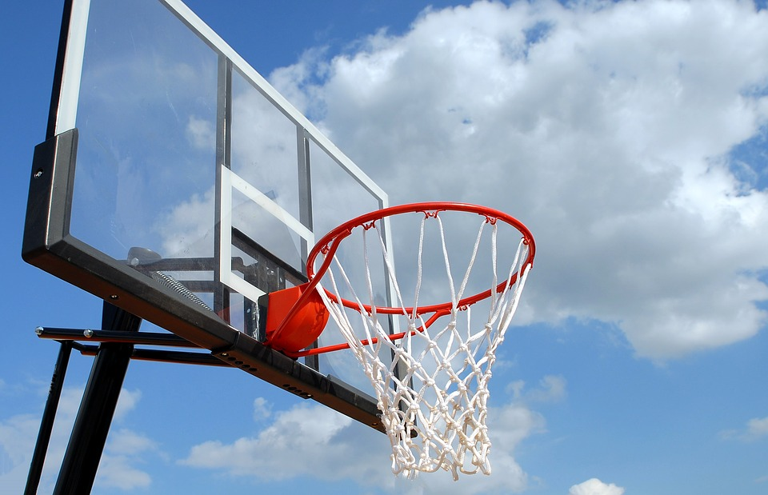 | 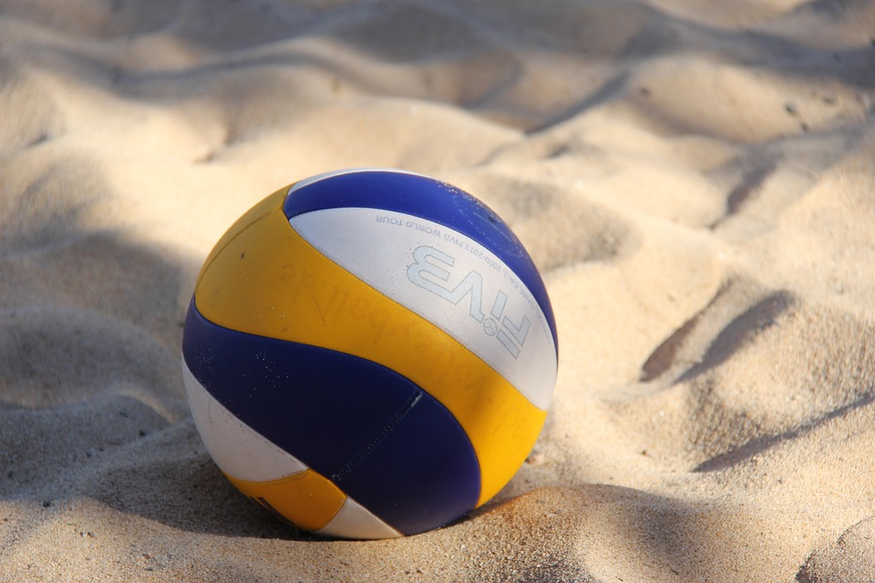 | 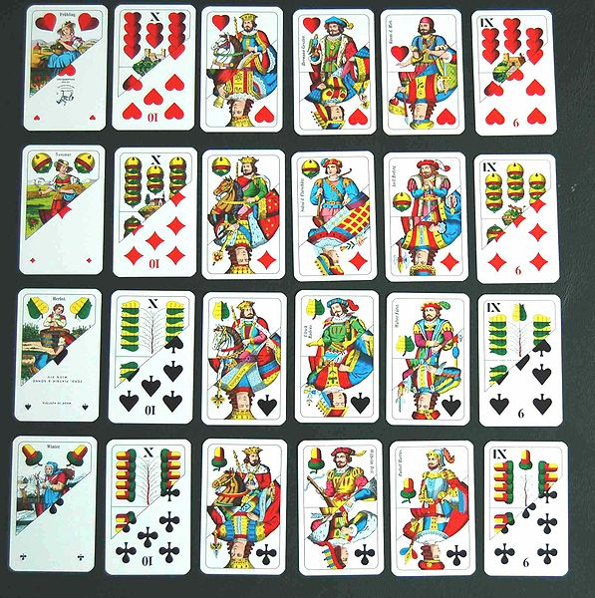
🏀 košarku | 🏐 odbojku | karte

Sviraš li neki instrument?
[odgovor] → Da, sviram […]:
[odgovor] → Ne, ne sviram nijedan instrument.
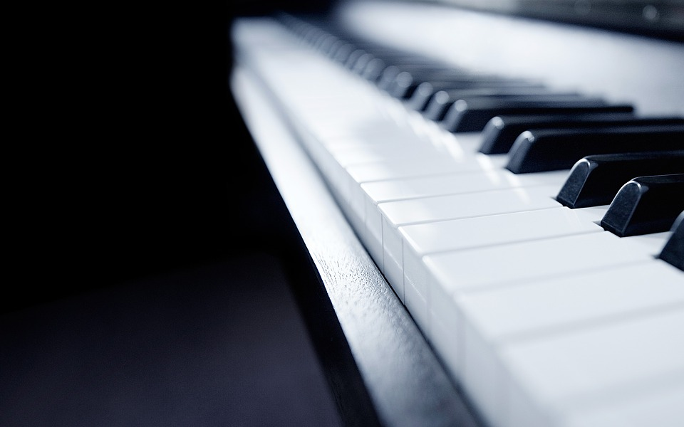 | 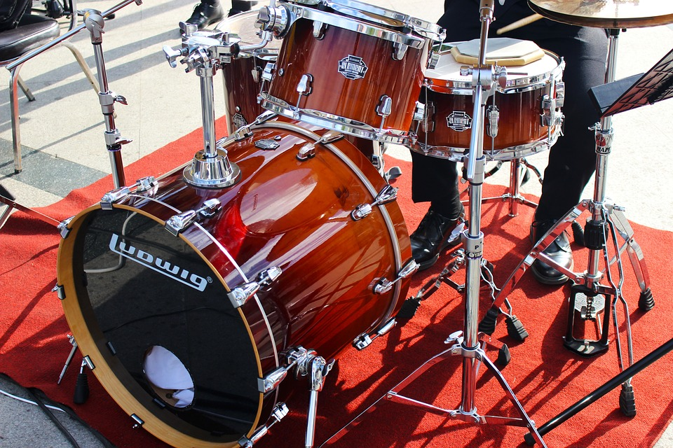 | 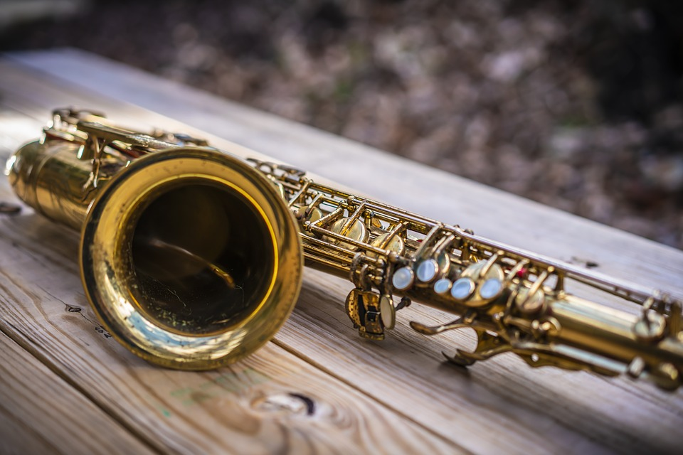
🎹 klavir | 🥁bubnjeve | 🎷saksofon
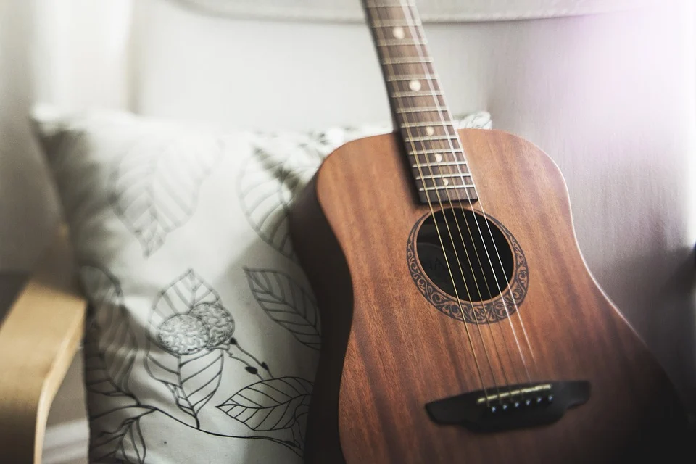 | 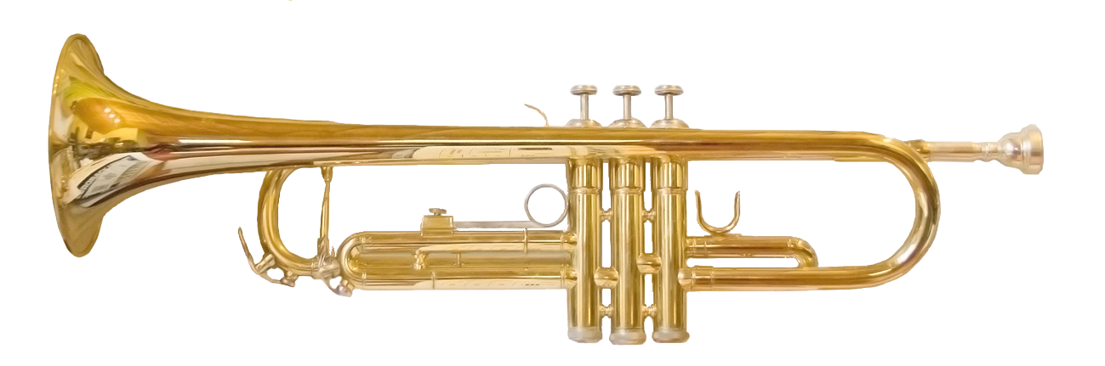 | 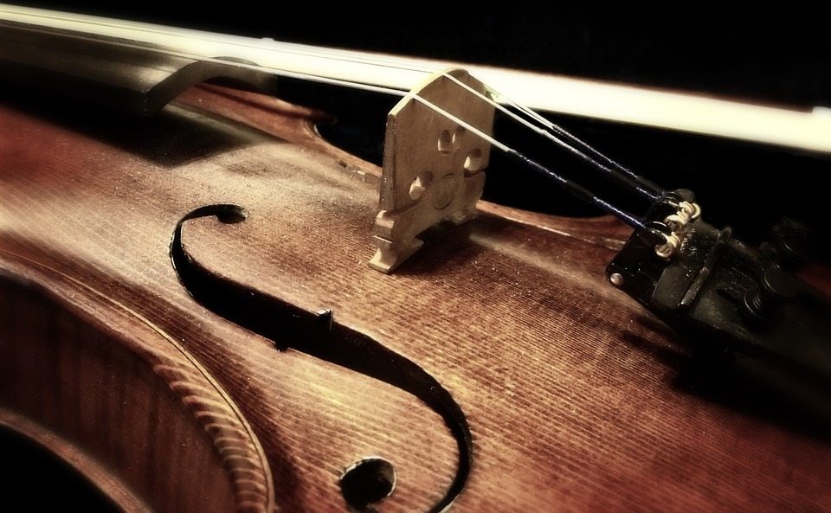
🎸gitaru | 🎺trubu | 🎻 violinu
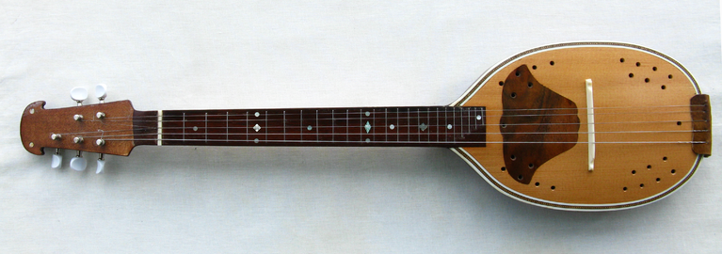 | 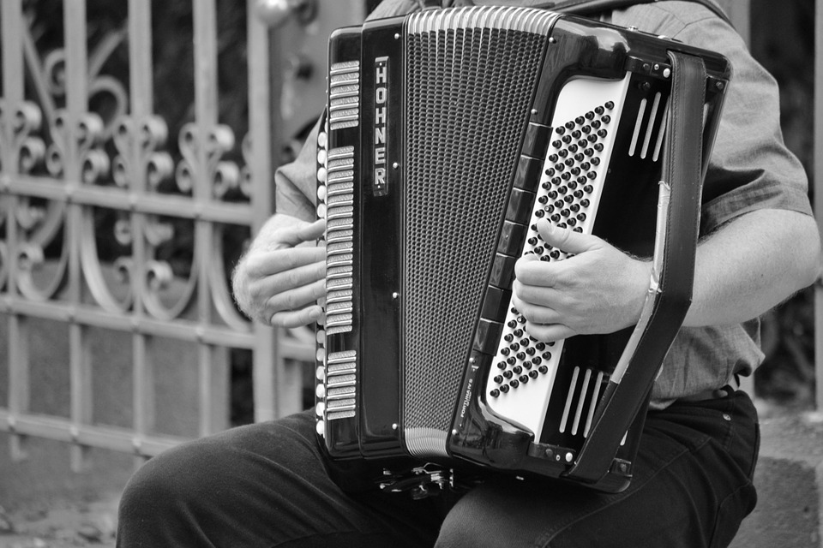 | 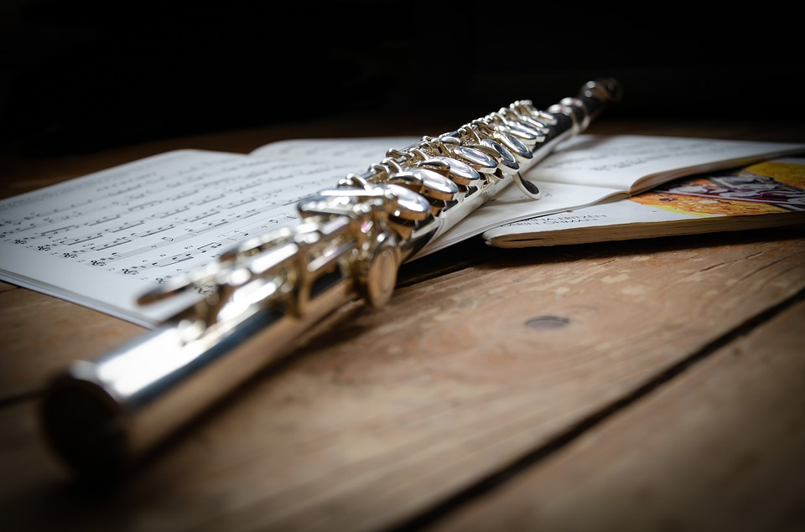
tamburicu | 🪗 harmoniku | 🪈 flautu

Što (ti) još radiš u slobodno vrijeme?
[odgovor] → Ja obično […]
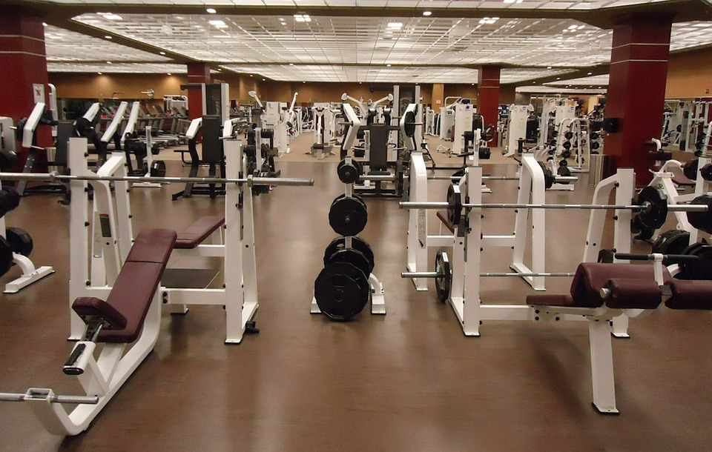 |  | 
treniram (sport) | gledam (televizor) | crtam
 | 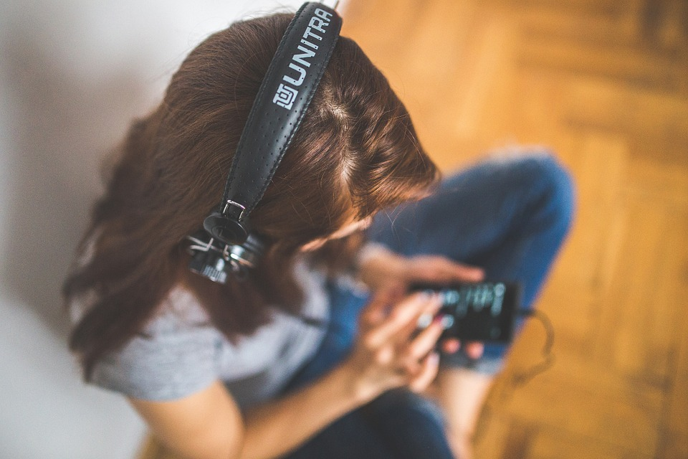 | 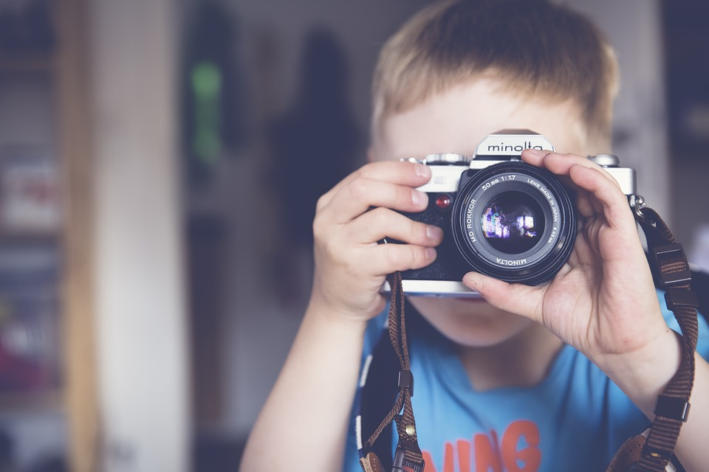
čitam (knjigu) | slušam (muziku) | slikam
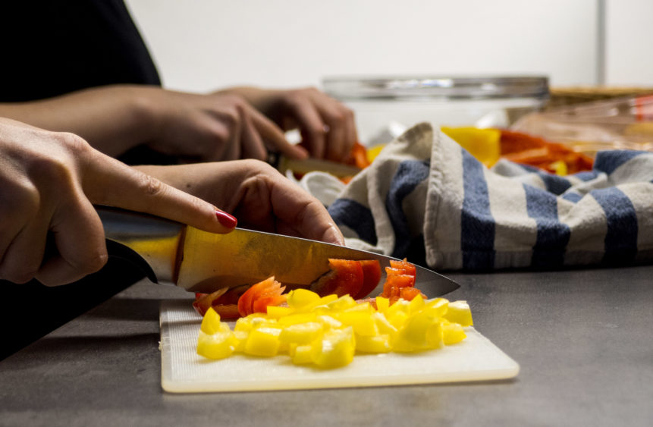 | 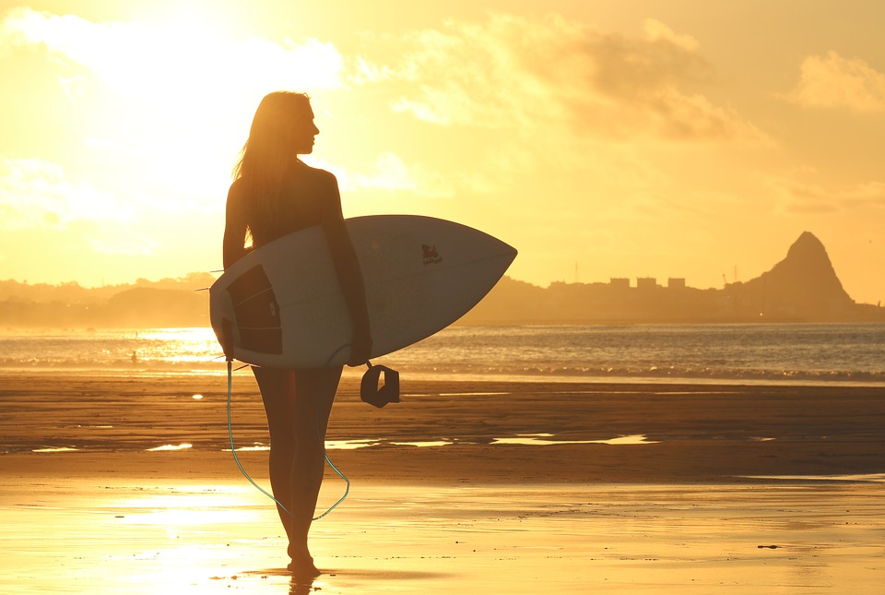 | 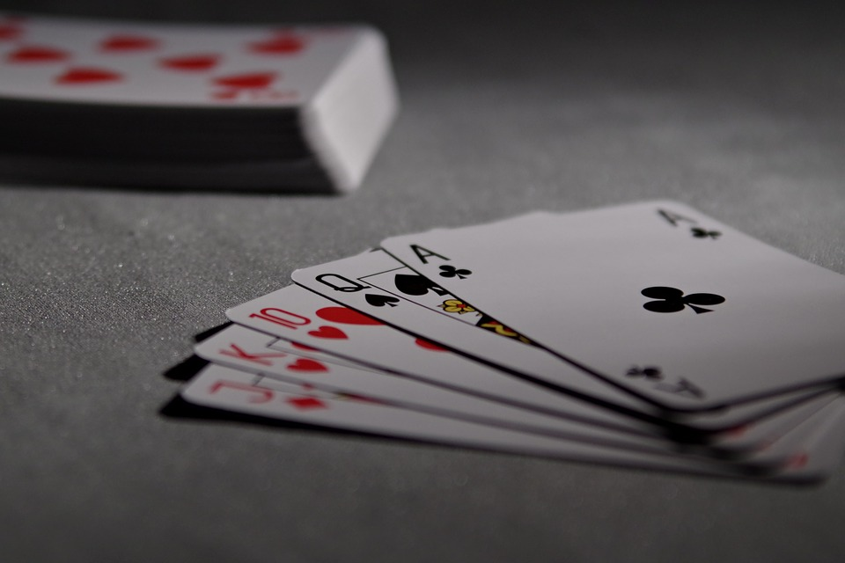
kuham (ručak/večeru) | surfam | igram karte
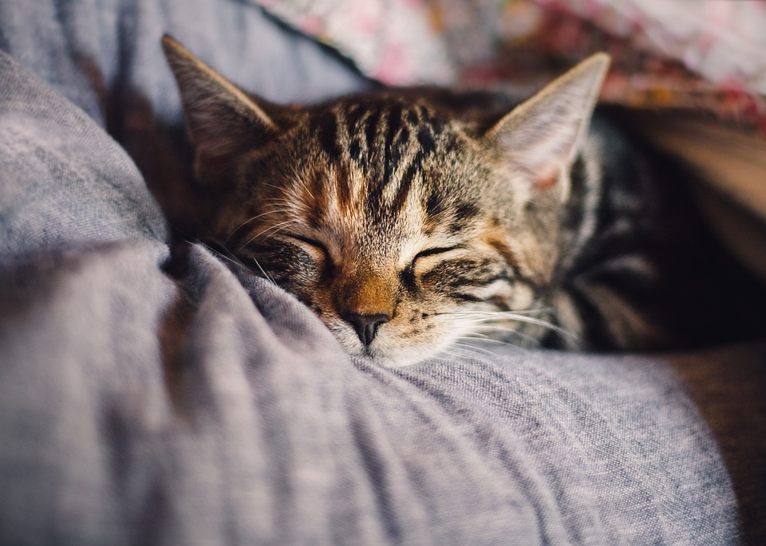 | 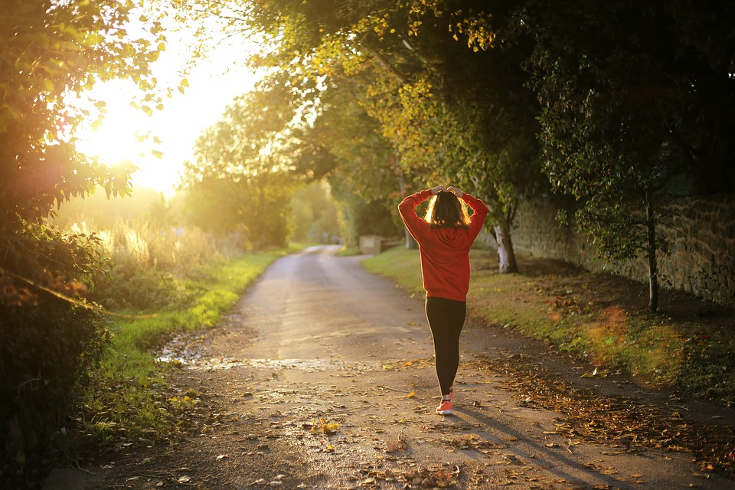 | 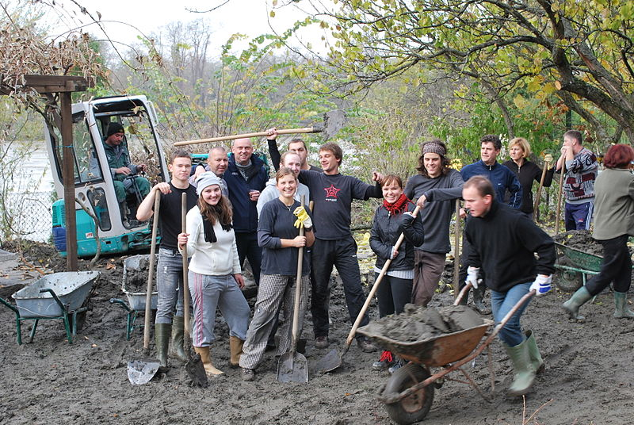
spavam (puno/malo) | šetam | volontiram
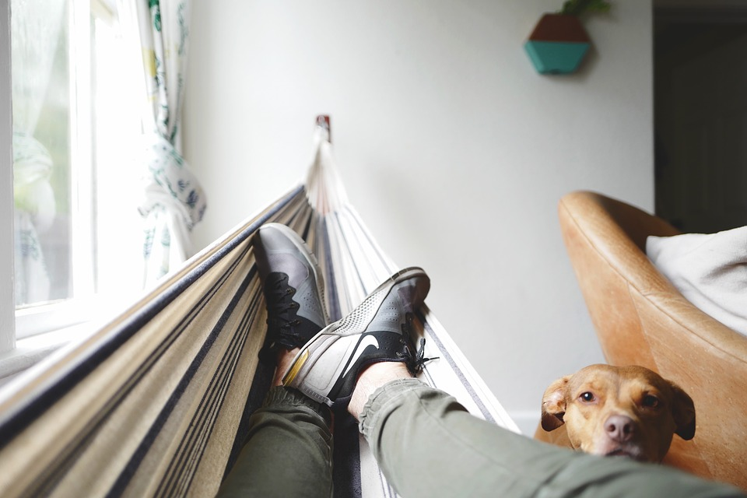 | 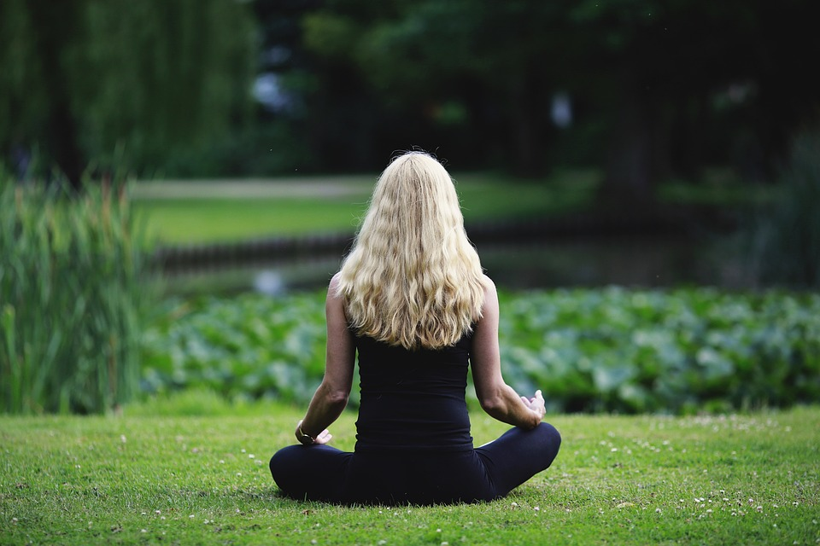 | 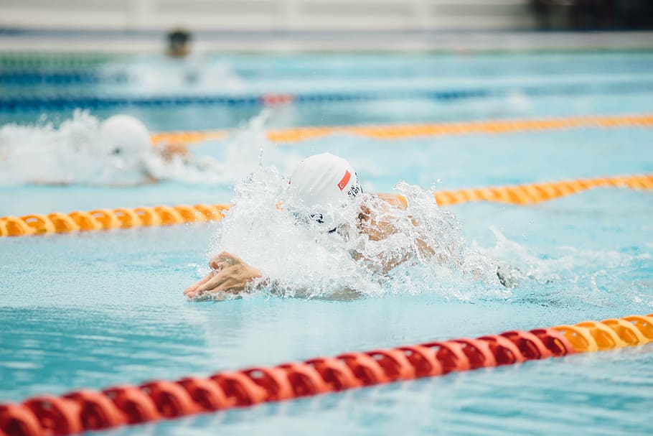
odmaram | meditiram | plivam
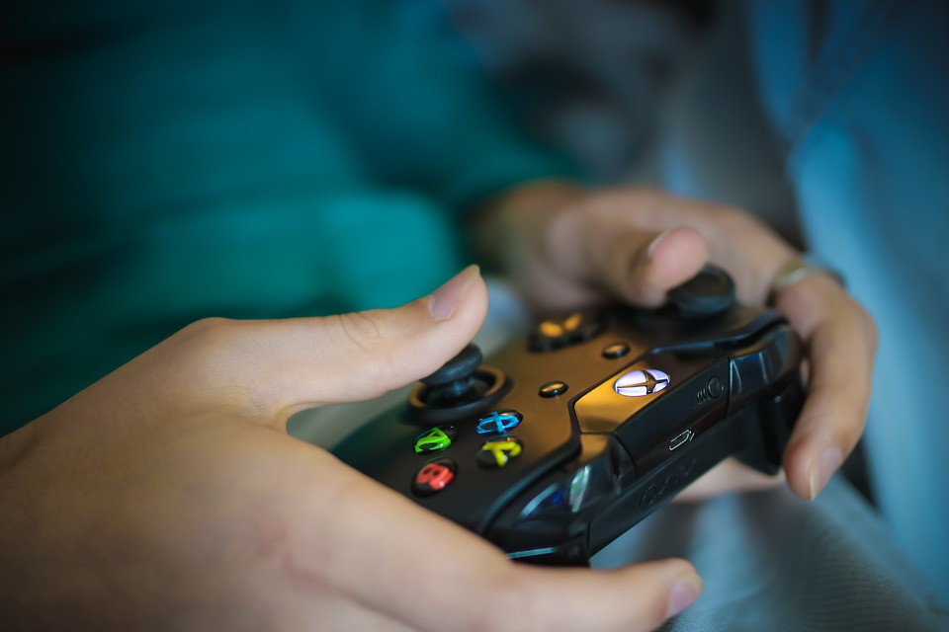 | 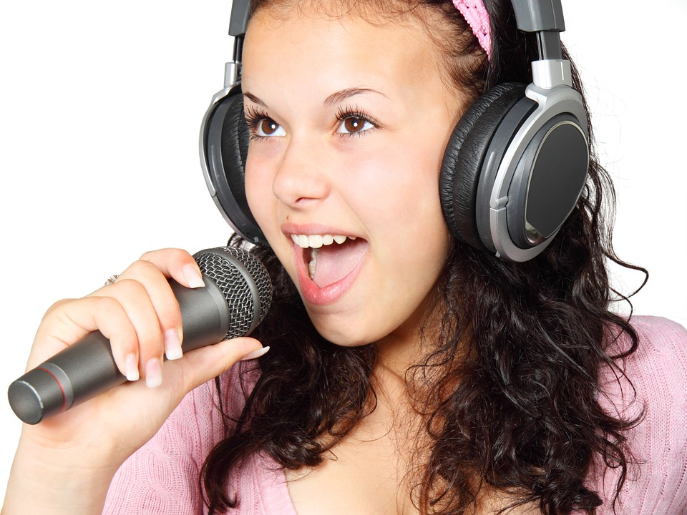 | 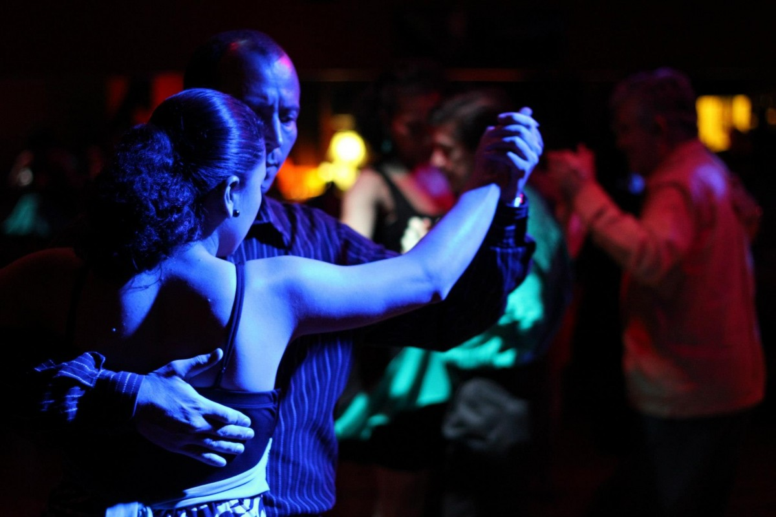
igram videoigre | pjevam | plešem
Now that you completed the task, your instructor will ask you what your classmate usually does in their free time. Be ready to present what you learn. Listen carefully while other students present their findings about each other. Mark everything you hear about each person in order to get the full picture of what you all do. In this way, you will find out what you all have in common.

(Marko/Ana)…
trenira | gleda | igra | čita | volontira | sluša
svira | kuha | priča | spava | pliva | crta

što ↓ / tko →
trenira
gleda
igra
čita
sluša
svira
kuha
priča
spava
crta
meditira
volontira
surfa

Što vi radite u slobodno vrijeme?
[odgovor] → Mi…
treniramo | gledamo | igramo | čitamo | volontiramo | slušamo
sviramo | kuhamo | pričamo | spavamo | plivamo | crtamo

2.2 Zadatak 2. Što oni rade?
🔊 Dialogue one: Listen carefully what each of our charactes from Zagreb says about their free time. Mark all the activities they do in their free time.

Što oni rade u slobodno vrijeme?
Kada? ↓ Tko? → | Laura | Davor | Sandra | Mario
svaki dan |  | vježba, igra nogomet
uvijek
često |  |  |  | igra  videoigre
ponekad | gleda  filmove
rijetko
nikada ne
nije specificirano

Tko je sličan?
Based on the answers that you have collected, work with another classmate and answer the following questions.
1 | Tko je aktivna osoba i trenira sport?
 | -

In terms of their free time activities, are the following people a good match? Look at the table above. It will help you answer the questions. Answer with da, ne or možda (maybe).
br. | Pitanje | (DA) | (NE) | (MOŽDA)
1 | Jesu li Davor i Laura dobar par?
2 | Jesu li Sandra i Laura dobar par?
3 | Jesu li Mario i Laura dobar par?
4 | Jesu li Davor i Sandra dobar par?
5 | Jesu li Mario i Davor dobar par?
6 | Jesu li Sandra i Mario dobar par?

A ti? What about you?
1 | Što ti i Laura imate zajedničko? [imati zajedničko = “to have in common”]
 | - Ja također […]
2 | Što ti i Davor imate zajedničko?
 | - Ja također […]
3 | Što ti i Sandra imate zajedničko?
 | -Ja također […]
4 | Što ti i Mario imate zajedničko?
 | - Ja također […]

2.2 Zadatak 3. Aktivnosti
🔊 Dialogue two: Listen to the dialogue among our students from Split and answer the following questions. Use complete sentences when providing an answer.

| Razumijevanje [Comprehension]
1 | Što Luka radi u slobodno vrijeme?
 | -
2 | Kako se zove tradicionalni / lokalni sport?
 | -
3 | Koji sport Luka i Ines igraju zajedno? [together]
 | -
4 | Koji sport igraju Ines i James?
 | -
5 | Tko voli kuglati?
 | -
6 | Što Ines radi u slobodno vrijeme?
 | -
7 | Što James radi u slobodno vrijeme?
 | -
8 | Što Matija radi u slobodno vrijeme?
 | -
9 | Što Luka planira ovaj vikend?
 | -
10 | Što James i Matija imaju zajedničko?
 | -

| Osobna pitanja [Personal questions]:
Talk with your classmates, answer the following questions in order to find out if you have anything in common.

Your possible answers may start with:
[odgovor 1] → Da, ja volim […]
[odgovor 2] → Ne, ja ne volim […]

1 | Ti voliš slikati?
 | -
2 | Ti voliš pisati pjesme?
 | -
3 | Ti voliš kuglati?
 | -
4 | Ti voliš klasičnu glazbu?
 | -

2.2 Zadatak 4. Turisti u gradu

Part 1
1️⃣ Give your opinion on what tourists usually do when visiting your city. See what you have in common and present it to your instructor. Use the following structure when presenting your findings. Na primjer [Example]: Mi mislimo da ljudi/turisti često […]

Turisti obično…
fotografiraju spomenike | šetaju | plivaju
odmaraju | čitaju brošure | razgledavaju grad
rade selfie | gledaju [predstavu] | spavaju
šopingiraju | ručaju (13:00) | večeraju (20:00)

Part 2
Pick one of the cities listed below and answer the question: Što turisti često rade? When you are done, talk with a classmate who picked a different city in order to compare your findings.
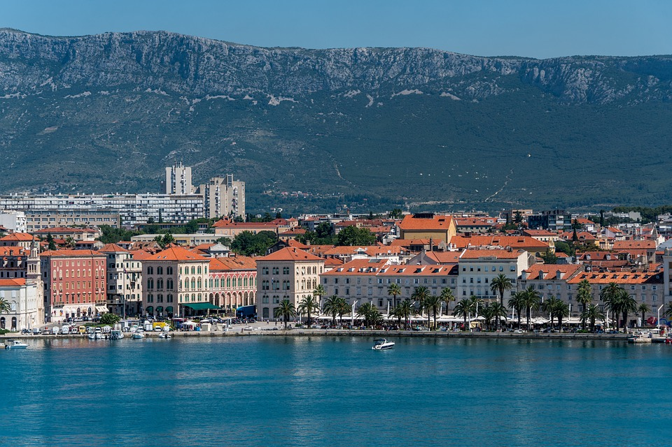 | 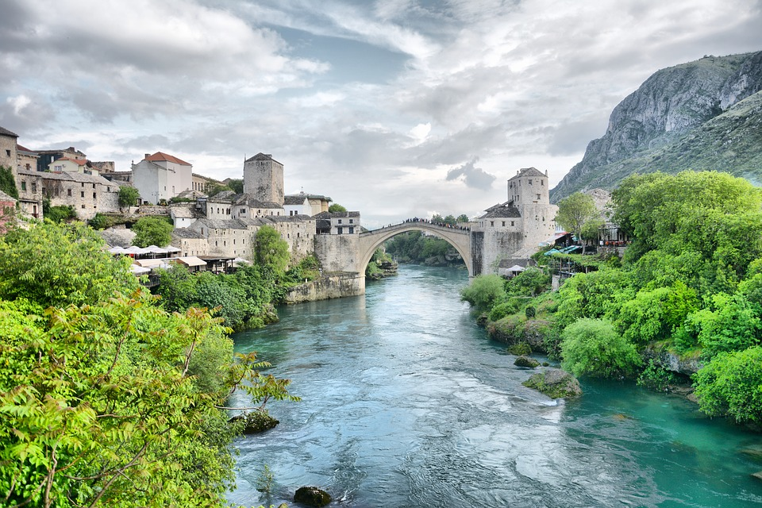 | 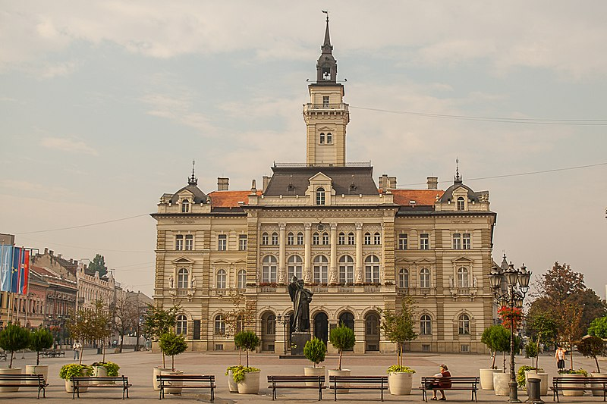 | 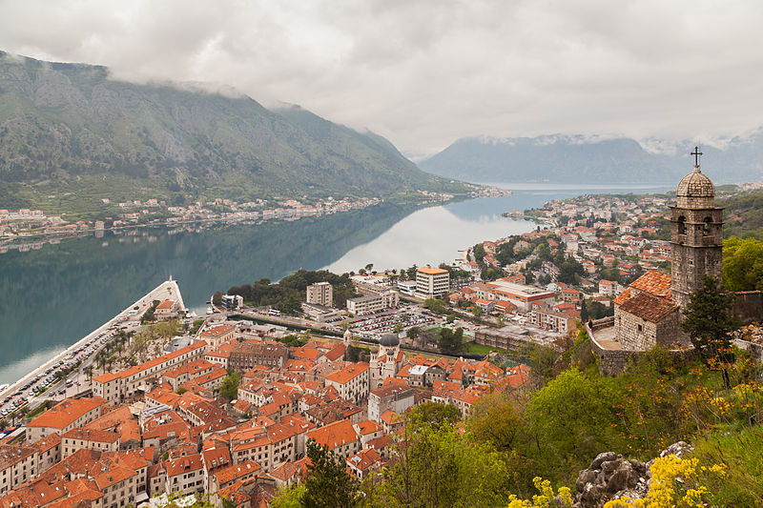
Split | Mostar | Novi Sad | Kotor

1 | Što ti voliš raditi kao turist? [What do you like to do on vacation?]
 | - Ja [meditiram]...

Images used in this document are from these sources.

