2 | 1 | Lekcija 2: Što posjetiti?

# 2.1 Zadatak 9. Koji grad posjetiti?

Answer the following questions and then talk with your classmates to see what they answered. Which city would you like to visit? Why? Write what else we can see in the city.

| 1 | Koji grad želiš posjetiti? |
| --- | --- |
| - Želim posjetiti [...] |
| 2 | Zašto? |
| - Zato što ima [...] |

# 2.1 Zadatak 10. Tvoj rodni grad

Talk with one of your classmates in order to find out more about the city where they are originally from. You need to come up with questions while talking with your classmate. You do not have time to write the questions down first. While talking to your classmate, he/she will provide you with the answer to what ***ima*** (it has) or ***nema*** (it does not have). Place each of your classmate's answers in the appropriate rubric.

| 1 | Kako se zove tvoj rodni grad? |
| --- | --- |
| - Moj rodni grad se zove… |
| 2 | Ima li u gradu [...]? |
| - Da, u gradu ima [...]. / Ne, u gradu nema [...]. |

Let’s talk more about your city. What else can we see/visit? Now we are focusing on multiple locations.

### Ima li tvoj grad […]?

### [odgovor] → Moj grad ima + /nema – […].

|  |  |  |  |
| --- | --- | --- | --- |
| muzeje 🖼️ | restorane ⛰️ | spomenike | stadione |
|  |  |  |  |
| vrtove | mostove | parkove | slapove |
|  |  |  |  |
| knjižnice | rijeke | galerije | planine |
|  |  |  |  |
| jezera | kazališta | kina | šetališta |

# 2.1 Zadatak 11. Ima ili nema?

How well do you know geography and countries around the world? Read the following questions with a classmate and indicate if the answer would be: *Da, ima…* or *Ne, nema…* You will check your answers together with your instructor and the rest of your class. When presenting your answers, use complete sentences. 💬

|  |  |
| --- | --- |
| Ima li Francuska otoke?  Da, ima … / Ne, nema… | Ima li Belgija tornada?  Da, ima … / Ne, nema… |
|  |  |
| Ima li kanada slapove?  \Da, ima … / Ne, nema… | Ima li SAD nacionalne parkove?  Da, ima … / Ne, nema… |
|  |  |
| Ima li Italija vulkane?  Da, ima … / Ne, nema… | Ima li Grenland parkove?  Da, ima … / Ne, nema… |
|  |  |
| Ima li Australija pustinje?  Da, ima … / Ne, nema… | Ima li Island gejzire?  Da, ima … / Ne, nema… |
|  | HRVATSKA IMA OTOKE.  HRVATSKA NEMA TORNADA |
| Ima li Finska fjordove?  Da, ima … / Ne, nema… |

Look at the following attractions in Croatia. In your opinion, which of these should one visit? Talk with a classmate to compare your choices.

### Što treba posjetiti?

### [odgovor] → Treba posjetiti…

|  |  |  |
| --- | --- | --- |
| Dubrovačke zidine | slapove Krke | Plitvička jezera |
|  |  |  |
| tvrđave (sv. Mihovil, sv. Ivan, sv. Nikola, Barone) | jezera  (Modro i Crveno jezero) | Morske orgulje |
|  |  |  |
| Paklene otoke* | iločke vinograde | Brijune |

Use Google search and place the above attractions on the map. To complete the task, you can also download a [fillable PDF](https://drive.google.com/file/d/1c87UktXC_B4ubyPLWk1Dyak2Ro-asUYx/view?usp=sharing) if you want.

*Official name is Paklinski otoci.

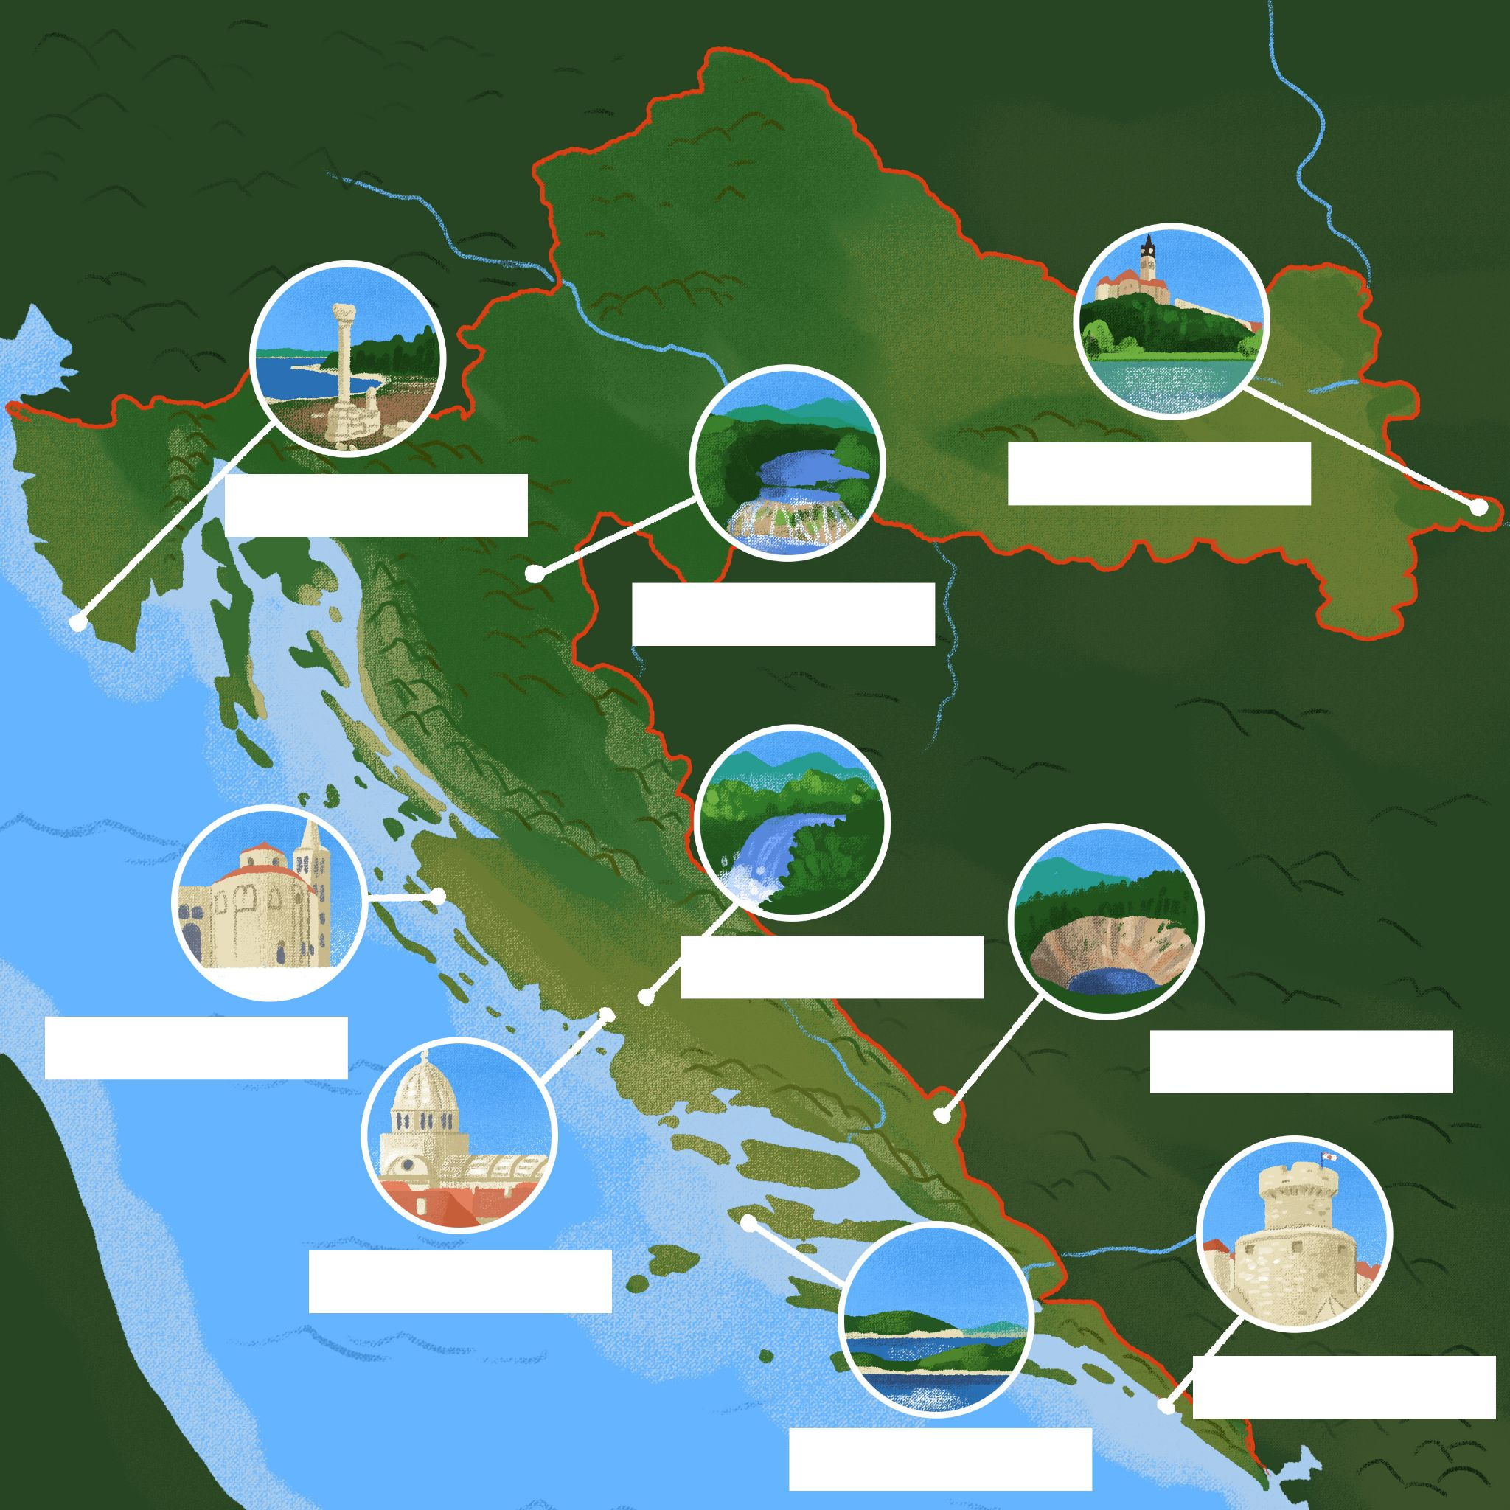

# 2.1 Zadatak 13. Gradovi

## Dijalog 1

🔊 Listen to **dialogue one** and answer the questions. Laura and her friends are relaxing after a day tour around Zagreb. Based on the dialogue, what should we visit in Zagreb?

Moramo posjetiti

| jezero | more | palaču | **barove** | šetalište |
| --- | --- | --- | --- | --- |
| rijeku | planinu | galeriju | **tržnicu** | plažu |
| **parkove** | tvrđavu | **spomenike** | **restorane** | muzeje |

Based on the above options, choose the correct words in order to answer the following questions.

|  | Što je Dolac i kakav je Dolac?  [odgovor] → |
| --- | --- |
|  |  |
| Kako se zove glavna ulica?  [odgovor] → | Što ima glavna ulica?  [odgovor] → |
|  |  |
| Kakvi su parkovi?  [odgovor] → | |

What did we learn about San Francisco?

| 1 | Što ima San Francisco? |
| --- | --- |
| - |
| 2 | Koje je popularno odredište (popularna destinacija)? |
| - |

|  |  |
| --- | --- |
| Koje su popularne četvrti?*  [odgovor] → | |

*četvrt: feminine gender. It is an exception among feminine nouns since it ends in a consonant (not in -a, as feminine nouns usually do).

## Dijalog 2

🔊 Listen to **dialogue two** and answer the questions. James and his friends are finishing a day tour around Split. What places did James visit with his friends?

### Što James misli, kakav je Split?

[odgovor] →

### Što ima Split?

[odgovor] →

|  |  |
| --- | --- |
| Kako se zove galerija?  [odgovor] → | Kakva je galerija?  [odgovor] → |

### Što James misli, kakvi su ljudi?

[odgovor] →

### What did we learn about Austin?

|  |  |
| --- | --- |
|  |  |
| Što ima njegov grad?  [odgovor] → | |

| 1 | Kakav je njegov grad? |
| --- | --- |
| - |
| 2 | Koje su popularne lokacije? |
| - |

# 2.1 Zadatak 14. Koji grad posjetiti?

👥 **Rad u paru.** Work with another classmate in order to prepare an in-class presentation. You should pick a city of your choice in one of the following countries:

Hrvatska, Bosna i Hercegovina, Crna Gora, Srbija. In your opinion, what are must-see places? Before you start making your presentation, answer the following questions:

| 1 | Kako se zove grad? |
| --- | --- |
| - |
| 2 | Kakav je grad? |
| - |
| 3 | Što ima u gradu? |
| - |
| 4 | Kakav je [muzej]? |
| - |
| 5 | Kakva je [galerija]? |
| - |
| 6 | Kakvo je [jezero]? |
| - |

# | Vokabular

Useful vocabulary that can help you in your presentation.

|  |  |  |
| --- | --- | --- |
| [(audio)](https://croatian.takolako.org/wp-content/uploads/Muzej.mp3) | [(audio)](https://croatian.takolako.org/wp-content/uploads/Restoran.mp3) | [(audio)](https://croatian.takolako.org/wp-content/uploads/Stadion.mp3) |
|  |  |  |
| [(audio)](https://croatian.takolako.org/wp-content/uploads/Knjiznica.mp3) | [(audio)](https://croatian.takolako.org/wp-content/uploads/Spomenik.mp3) | [(audio)](https://croatian.takolako.org/wp-content/uploads/Most.mp3) |
|  |  |  |
| [(audio)](https://croatian.takolako.org/wp-content/uploads/Park.mp3) | [(audio)](https://croatian.takolako.org/wp-content/uploads/Planina.mp3) | [(audio)](https://croatian.takolako.org/wp-content/uploads/Galerija.mp3) |
|  |  |  |
| [(audio)](https://croatian.takolako.org/wp-content/uploads/Jezero.mp3) | [(audio)](https://croatian.takolako.org/wp-content/uploads/Kazaliste.mp3) | [(audio)](https://croatian.takolako.org/wp-content/uploads/Sveuciliste.mp3) |
|  |  |  |
| [(audio)](https://croatian.takolako.org/wp-content/uploads/Kino.mp3) | [(audio)](https://croatian.takolako.org/wp-content/uploads/Setaliste.mp3) | [(audio)](https://croatian.takolako.org/wp-content/uploads/Bar.mp3) |
|  |  |  |
| [(audio)](https://croatian.takolako.org/wp-content/uploads/Palaca.mp3) |  |  |

Images used in this document are from [these sources](https://docs.google.com/document/d/1biMwhGMU3bm3OrhL1_f0S7xsTir9bDlJj6dUWo4KB0o/edit#heading=h.8ljj6bh3sjk7).