8 | 1 | Lekcija 1: Idemo na kavu

# 8.1 Zadatak 1. Moje mišljenje

|  |  |
| --- | --- |

## | Pitanja

| Što vidite na slikama? |
| --- |
| Kakva je atmosfera? |
| Što ljudi rade? |
| Koji je vaš dojam o ljudima? (dojam = impression) |
| Kojoj grupi pripadaš i zašto? Američki stil ili hrvatski stil? (pripadati = to belong) |

# 8.1 Zadatak 2. Što piješ?

👥 Talk to your classmates and find out what they like to drink.

| Što piješ za doručak, ručak, večeru? | | | |
| --- | --- | --- | --- |
| pijem kavu | pijem sok | pijem čaj | pijem (mineralnu) vodu |
| pijem jogurt | pijem mlijeko | pijem gazirana pića | pijem energetski napitak |

| Tko? | za doručak | za ručak | za večeru |
| --- | --- | --- | --- |
|  |  |  |  |
|  |  |  |  |
|  |  |  |  |
|  |  |  |  |

# 8.1 Zadatak 3. Na kavi

Before we listen to the dialogues, talk to your classmate and answer the following questions with each other.

### | Pitanja

| Koje je vaše omiljeno mjesto za kavu? |
| --- |
| S kim često ideš na kavu/čaj? |
| Zašto (ti) piješ kavu? |
| Naručiš li kavu za van (to go) ili sjediš u kafiću? |

🔊 To complete the following tasks, you will need to use the coffee shop price list attached [**here**](https://docs.google.com/document/d/16ggaT2GK3ETfrUgimru_VhKHfGFc4yzpAqkjVIuHCUw/edit?usp=sharing). Listen to **dialogue one** and answer the questions.

|  |  |
| --- | --- |
| Caffe Nostradamus - Poljana Tina Ujevića | |

## | Razumijevanje

| 1 | Što je naručio James? |
| --- | --- |
| - |
| 2 | Što je naručio Luka? |
| - |
| 3 | Što je naručila Matija? |
| - |
| 4 | Koliko košta njihova narudžba? |
| - |

Listen to **dialogue two** and answer the questions.

|  |  |
| --- | --- |
| Riva, Split - Obala Hrvatskog narodnog preporoda | |

## | Razumijevanje

| 1 | Što je naručila Ines? |
| --- | --- |
| - |
| 2 | Što je naručila Matija? |
| - |
| 3 | Što je konobarica donijela? Je li to točna narudžba? |
| - |
| 4 | Kamo idu prijateljice nakon kave? Zašto? |
| - |
| 5 | Kakvo je vrijeme danas? |
| - |
| 6 | Zašto Ines voli ići na kavu? |
| - |

Listen to **dialogue three** and answer the questions.

|  |  |
| --- | --- |
| Prokurative, Split - Trg Republike 1 | |

## | Razumijevanje

| 1 | Što je naručila Matija? |
| --- | --- |
| - |
| 2 | Što je naručio James? Koliko to košta? |
| - |
| 3 | Što je konobarica donijela Jamesu? Koliko to košta? |
| - |
| 4 | Koliko će prijatelji platiti njihovu narudžbu? |
| - |

Now work in groups and answer the following questions. The answers will reflect your personal opinion/observation from the dialogues so there are no wrong answers.

## | Osobno mišljenje

| 1 | Naručujemo li kavu na isti način u SAD-u i u Hrvatskoj? Objasni. |
| --- | --- |
| - |
| 2 | Cjenik. Je li kava skuplja u Hrvatskoj ili u SAD-u? |
| - |
| 3 | Dijalog 2. Što možeš reći o konobarici? Je li ona: (a) pristojna, (b) nepristojna, (c) dobro raspoložena, (d) prijateljski raspoložena, (e) ozbiljna? |
| - |
| 4 | Dijalog 2. Što možeš reći o Matiji? Je li ona u razgovoru s konobaricom: (a) pristojna, (b) nepristojna, (c) dobro raspoložena, (d) prijateljski raspoložena, (e) ozbiljna? |
| - |
| 5 | Dijalog 3. Što Matija misli o konobarici? |
| - |
| 6 | Dijalog 3. Što možeš reći o konobarici? Je li ona: (a) pristojna, (b) nepristojna, (c) dobro raspoložena, (d) prijateljski raspoložena, (e) ozbiljna? |
| - |
| 7 | Dijalog 3. Što možeš reći o Jamesu? Je li on u razgovoru s konobaricom: (a) pristojan, (b) nepristojan, (c) dobro raspoložen, (d) prijateljski raspoložen, (e) ozbiljan? |
| - |
| 8 | In English: Did James change his opinion about the service situation? Did he change his attitude toward the waitress? Explain. |
| - |
| 9 | Kakav je razgovor u dijalozima? Jesu li ovo službeni ili neslužbeni razgovori? |
| - (in your answers provide examples as well) |
| 10 | Što ti želiš naručiti? |
| - |
| 11 | Gdje ti želiš piti kavu? |
| ↓ (options listed bellow) |

Research the following places online. Where would you like to go for coffee? Which one is your favorite? Why?

| Caffe bar Teak  Ulica Majstora Jurja 11, Split | Caffe bar Fro  Obala Hrvatskog narodnog preporoda 11 |
| --- | --- |
| Kavana Bellevue  Trg Franje Tuđmana, Split | Caffe bar Žbirac  Šetalište Petra Preradovića 5, Split |

# 8.1 Zadatak 4. Što vi pijete?

Talk with your classmates and find out what their preference is. Do they like to drink coffee or tea?

| | Pitanja |
| --- |
| Piješ li više kavu ili čaj? |
| Koju kavu piješ? |
| Koji čaj piješ? |

|  |  |  |  |
| --- | --- | --- | --- |
| kava s toplim mlijekom | kava s hladnim mlijekom | kava sa šlagom | kava s vrhnjem |
|  |  |  |  |
| crna kava | kratka kava | frappuccino | cappuccino |

|  |  |  |  |
| --- | --- | --- | --- |
| čaj od mente | čaj od breskve | čaj od šumskog voća | čaj od brusnice |
|  |  |  |  |
| zeleni čaj | crni čaj | bijeli čaj | biljni čaj |

# 8.1 Zadatak 5. Zašto piješ kavu/čaj?

👥 Talk to your classmates and find out more about their habits and reasons for why they drink coffee/tea.

### Gdje ti često piješ kavu/čaj?

| kod kuće | na poslu | na fakultetu | u kafiću | u restoranu |
| --- | --- | --- | --- | --- |

### Zašto ti piješ kavu/čaj?

| za energiju | dobro miriše | dobar okus | zbog društva | iz čiste navike |
| --- | --- | --- | --- | --- |
| jutarnji ritual | čista navika | za buđenje | bijeg od stresa | (?) |

|  |  |
| --- | --- |
| Kakve su američke kave, a kakve su hrvatske kave? Koja je razlika? | |

Look at the following three local products that you can find on the menu and order if you are in kafić and want to order something to go with your coffee (except a glass of water [with no ice] that is always complimentary with any coffee order).

|  |  |  |
| --- | --- | --- |
| Cedevita | Pipi | Cockta |

Do some online research and answer the questions below. Pick from the following options in order to answer the questions (more than one answer is possible):

| Što je cedevita? | Što je pipi? | Što je cockta? |
| --- | --- | --- |
| alkoholno piće | bezalkoholno piće | energetski napitak |
| voda s limunom/narančom | gazirano piće | gazirano piće |

# 8.1 Zadatak 6. Zašto Hrvati često piju kavu?

Watch the video [Kultura ispijanja kave](https://www.youtube.com/watch?v=GEcUV-Tjtwo) and answer the following questions. First, you will work with your classmate. Then, together with your instructor, you will discuss the topic all together.

### | Šalica dobre kava

Based on the video, answer the following questions. For the first question - at the very beginning of the video, you will hear several people mentioning the reasons why they drink coffee. Provide their reasons in Croatian.

| 1 | Zašto Hrvati često piju kavu? |
| --- | --- |
| - |
| 2 | Koju kavu oni piju? |
| - |
| 3 | Koja je standardna veličina kave? |
| - |
| 4 | Koliko dugo oni piju kavu? |
| - |
| 5 | Kakvi su kafići u Hrvatskoj? |
| - |

### Pitanje

→ Are your reasons for drinking coffee/tea similar to those that you heard in the video?

# 8.1 Zadatak 7. Starbucks

👥 **Pair-work.** Look at the following data visual representations and complete the task below.

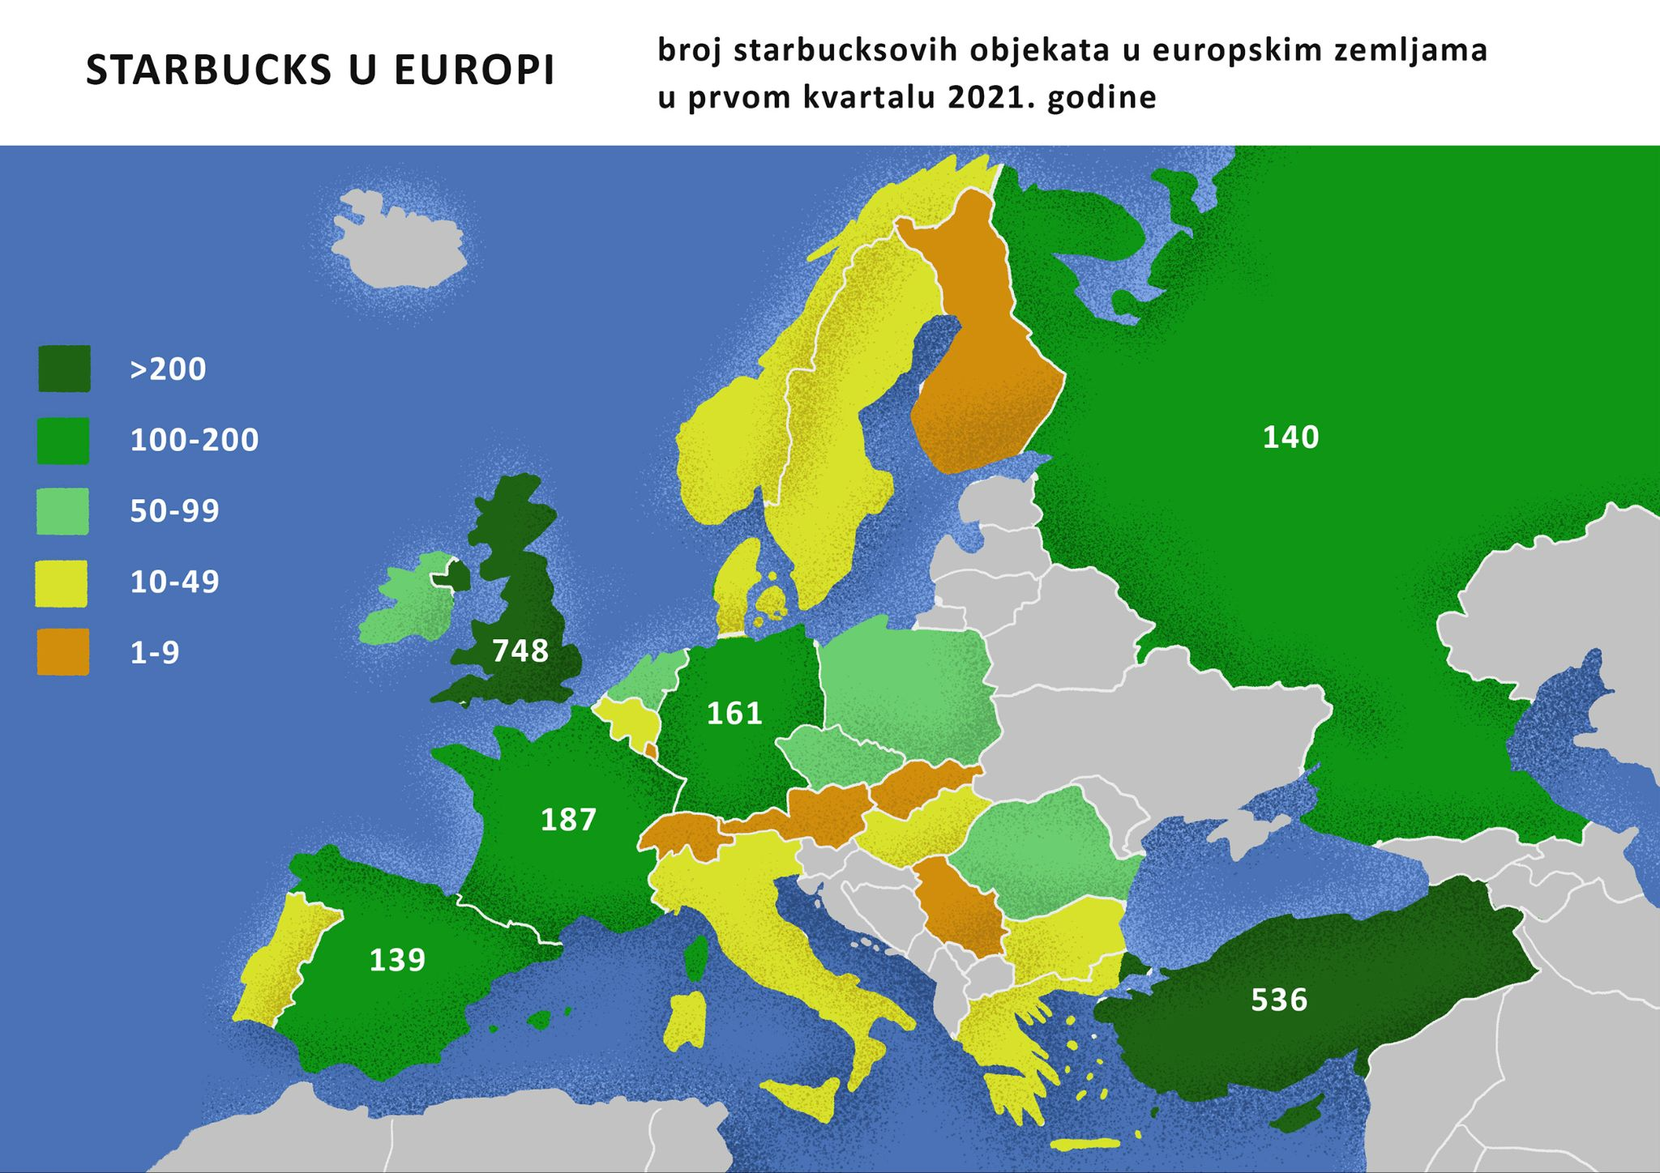

Work with your classmates and come up with answers to the following questions. The last question asks for your opinion. Try to be as specific as you can.

## | Pitanja

| U kojim europskim državama imamo Starbucks? |
| --- |
| Koja država ima najviše Starbucks lokacija? Što misliš zašto? (najviše = the most) |
| Je li Starbucks otvoren u Hrvatskoj? Što misliš zašto? |

# 8.1 Zadatak 8. Reklame

Watch the following Croatian coffee advertisements available on YouTube. Talk with your classmates and answer the questions.

| [Jubilarna kava, Franck](https://www.youtube.com/watch?v=C6pEgEYNV9c) | [Prelij, uživaj, kreni!](https://www.youtube.com/watch?v=XmYx5qVnNic) |
| --- | --- |

## | Pitanja

| Sviđaju li ti se reklame? |
| --- |
| O čemu govore reklame? |
| Jesu li američke reklame iste kao i hrvatske? |

## | In English

What values does this commercial promote? Do you find anything in the narratives that you think are cultural components, or you do not fully agree with?

Images used in this document are from [these sources](https://docs.google.com/document/d/1P80JLZEce3FcAraNZgjm604fySoIEmF3w7GuTPsAAqs/edit#heading=h.ktkus0ccq3de).