4.3 - Things to do when it's hot and sunny…

[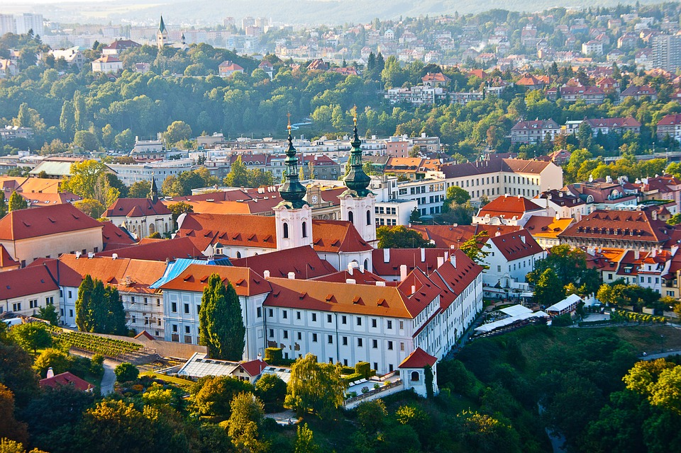](https://www.maxpixel.net/Old-Town-View-From-Above-Prague-Czech-Republic-1798529)

In this unit you will learn some verbs to talk about things that you might do when it’s hot and/or sunny outside. Here they have been divided into *-á-*, *-í-*, and *-e-* verbs in order to help you with conjugation.

-**á- verbs** (see [2.2 - Conjugation of -á- verbs](https://realityczech.org/conjugation-of-a-verbs))

| *běhat* - to run | *chytat ryby* - to catch fish |
| --- | --- |

**-í- verbs** (see [2.2 - Conjugation of -í- verbs](https://realityczech.org/conjugation-of-i-verbs))

|  |  |
| --- | --- |
| *chodit do parku* - to go to the park | *pouštět draka* - to fly a kite |
| *procházet se* - to go on a walk, stroll | *jezdit na kole* - to ride a bike |

**-e- verbs** (see [2.4 - Conjugation of -e- verbs](https://realityczech.org/conjugation-of-e-verbs))

| *sportovat* - to play sports | *koupat (koup-) se* - to swim |
| --- | --- |
| *hrát (hraj-) tenis* - to play tennis | *hrát (hraj-) volejbal* - to play volleyball |
| *hrát (hraj-) fotbal* - to play soccer | *opalovat se* - to suntan |

| Finally, when all else fails, one can simply *jíst zmrzlinu* - to eat ice cream (conjugation of the verb *jíst* in [3.2 - the verb *jíst* ‘to eat’](https://realityczech.org/the-verb-jist-to-eat)) |  |
| --- | --- |

Images used in this document come from [these sources](https://docs.google.com/document/d/1Xo646gq_-RYxFseXVAapjPBPXowVA9NjxukSlYo8has/edit#heading=h.hdjnhefftgnl).