# 4.2 - *Stupně Celsia* - Degrees Celsius

[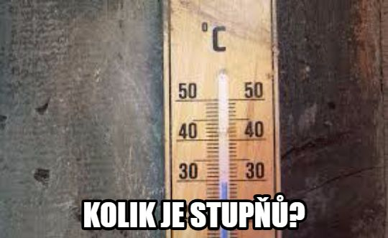](http://maxpixel.freegreatpicture.com/Temperature-Thermometer-Degrees-Celsius-Scale-1696961)

*Kolik je stupňů?*

How many degrees is it?

This is a phrase you might hear in relation to the weather (of course!)...in this lesson we’ll be learning how to state the temperature.

First, Czechs, like pretty much the rest of the world, use Celsius. You can of course convert – **C = 5/9 (F-32)**

However, this tends to be a pain and not something we can do on the fly. Here are some common temperatures. The Czech that is given beside it is just to help you orient with those phrases and as with most things regarding temperature, it’s all relative and open to opinion.

| **Celsius** | **Fahrenheit** |  |
| --- | --- | --- |
| 38°C | ~100°F | *Je vedro!* |
| 32°C | ~90°F | *Je horko!* |
| 28°C | ~82°F | *Je teplo.* |
| 22°C | ~72°F | *Je příjemně (pleasant).* |
| 15°C | ~60°F | *Je trochu chladno.* |
| 10°C | ~50°F | *Je chladno.* |
| 5°C | ~41°F | *Je zima!* |
| 0°C | 32°F | *Mrzne!* |
| -5°C[1] | 23°F | *Mrzne!!* |
| -10°C | 14°F | *Mrzne!!!* |

The more important point of this lesson is to actually state the temperature. To do this, use the word *stupeň* ‘degree’. Of course, you’ll have to change the forms depending on the number....

[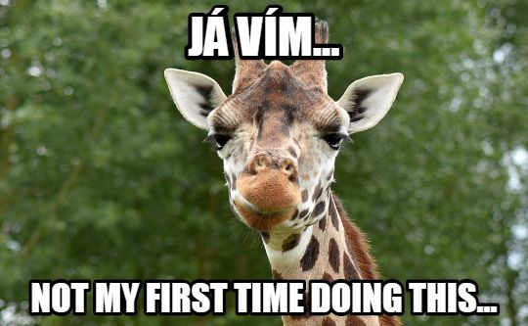](https://pixabay.com/en/giraffe-animal-safari-cute-neck-1544348/)

Use the following chart:

| jeden | stupeň | 1 with singular form |
| --- | --- | --- |
| dva, tři, čtyři | stupně | 2-4 with nominative plural |
| pět + | stupňů | 5+ with genitive plural |

You can optionally combine it with the form *Celsia*, which means ‘of Celsius’ (the genitive case). So…

*dvacet stupňů (Celsia)*

twenty degrees (of) Celsius

*čtyři stupně (Celsia)*

four degrees Celsius

**Stating the temperature – Only for the brave:**

[](http://maxpixel.freegreatpicture.com/Fearless-Brave-Snake-Monkey-Animal-Cobra-1245007)

| **je** jeden | stupeň Celsia | ‘It is one degree Celsius’ |
| --- | --- | --- |
| **jsou** dva, tři, čtyři | stupně Celsia | ‘It’s 2-4 degrees Celsius’ |
| **je** pět + | stupňů Celsia | ‘It’s 5+ degree Celsius’ |

Use the verb *jsou* in stating the temperature if the number is 2-4, otherwise use the form *je*

Images used in this document come from [these sources](https://docs.google.com/document/d/1Xo646gq_-RYxFseXVAapjPBPXowVA9NjxukSlYo8has/edit#heading=h.h0didb5dib89).

1. *mínus 5 nebo 5 pod nulou* (lit. 5 below zero)