2 | 1 | Lekcija 2: Što posjetiti?

| Accusative Case Endings in Plural form
We already talked about Accusative forms for singular. Here is the review:
 | masculine nouns (not referring to people) are like the Nominative
 | feminine nouns: –a → –u
 | neuter nouns are like the Nominative

Case | Masculine | Feminine | Neuter
Nominative | kolodvor | rijeka | jezero | kazalište
Accusative | -ø | -u | -o | -e
Now, let’s investigate the plural forms of nouns (masculine, feminine, and neuter gender) in the Accusative case.
masculine plural nouns end in –e
feminine plural nouns end in –e
neuter plural nouns end in –a
The Nominative and the Accusative plural forms of inanimate nouns are presented in the table below.
Case | Masculine | Feminine | Neuter
Nominative | kolodvori | rijeke | jezera | kazališta
Accusative | -e | -e | -a | -a

2.1 Zadatak 7. Što ima Hrvatska?
Look at the images that can be associated with different attractions that we can visit in Croatia.
[h5p id="232"]

2.1 Zadatak 8. Laura i njezino mišljenje
Look at the following text. The text is a modification from our class lesson. It represents Laura’s opinions on Zagreb and San Francisco. Read it carefully and mark all the nouns that are in the Accusative form.
[h5p id="231"]

| Adjective Accusative Case Endings in Plural Form
Adjective endings for the Accusative plural forms are as follows:
Case | Masculine | Feminine | Neuter
Nominative pl. | lijep-i | lijep-e | lijep-a
Accusative pl. | -e | -e | -a

As you can see, masculine and feminine forms have the same ending in the Accusative plural form: ending -e.

The neuter form for adjectives in the Accusative plural form is the same as Nominative plural form: ending -a. ❗

The overall differences between Nominative and Accusative forms for all three genders can be seen in the following chart.
singular | masculine |  | feminine |  | neuter
 | adjective | noun | adjective | noun | adjective | noun
Nominative | lijep | park | lijepa | rijeka | lijepo | jezero
Accusative | lijepi | park | lijepu | rijeku | lijepo | jezero

plural | masculine |  | feminine |  | neuter
 | adjective | noun | adjective | noun | adjective | noun
Nominative | lijepi | parkovi | lijepe | rijeke | lijepa | jezera
Accusative | lijepe | parkove | lijepe | rijeke | lijepa | jezera

2.1 Zadatak 10. Grad
Look at the following text. The text is a modification from our class lesson. It represents James’ opinions on Split and Austin. Read it carefully and mark all the adjectives that are in the Accusative form.
[h5p id="104"]

2.1 Zadatak 11. Kakav je grad?
Expand the text by choosing an appropriate adjective form. It's your choice what adjective to use in each sentence. Be careful what gender (m/f/n), case (nominative/accusative), and number (singular/plural) you need to use. 👋 💬
star | velik | lijep
malen | moderan | zanimljiv
[h5p id="105"]

| The Verb NEMATI
Usually when we write the negative form of a verb (i.e., when we want to express that someone does not do something), in Croatian we use NE + verb form (as two separate words). However, the verb IMATI (“to have”) is the exception. Just like the verb “to be” (ja sam – ja nisam), the verb IMATI in its negative form is written all together.
SINGULAR |  |  | PLURAL
(audio) | ja | nem-am | (audio) | mi | nem-amo
(audio) | ti | nem-aš | (audio) | vi | nem-ate
(audio) | on/-a/-o | nem-a | (audio) | oni/-e/-a | nem-aju

2.1 Zadatak 12. Ima ili nema?
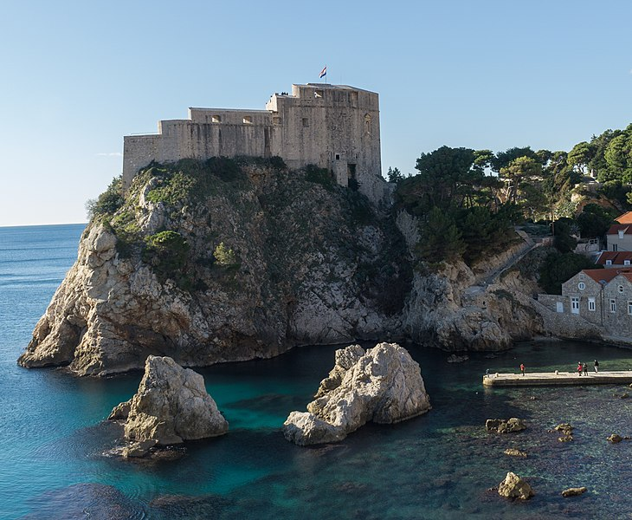  Dubrovnik - zidine | 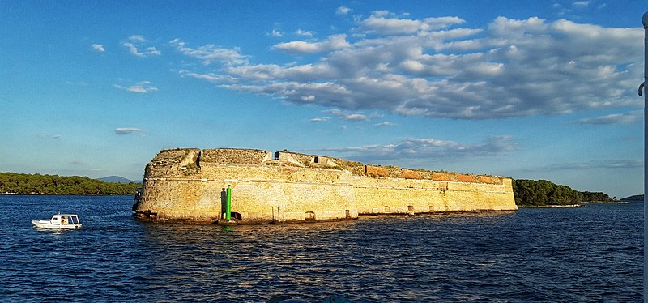
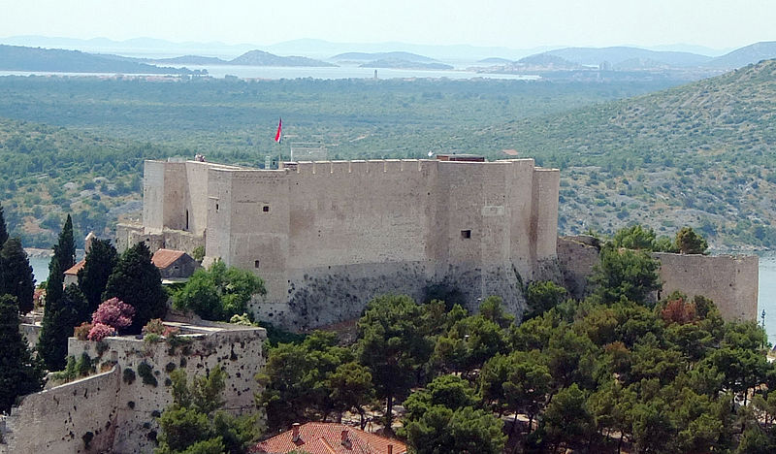
Šibenik - tvrđave

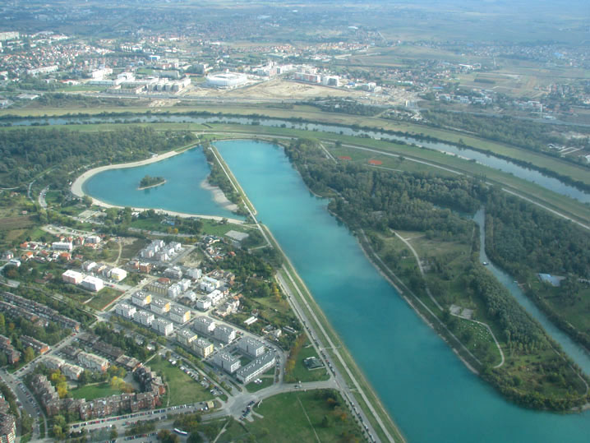  Zagreb (Jarun) | 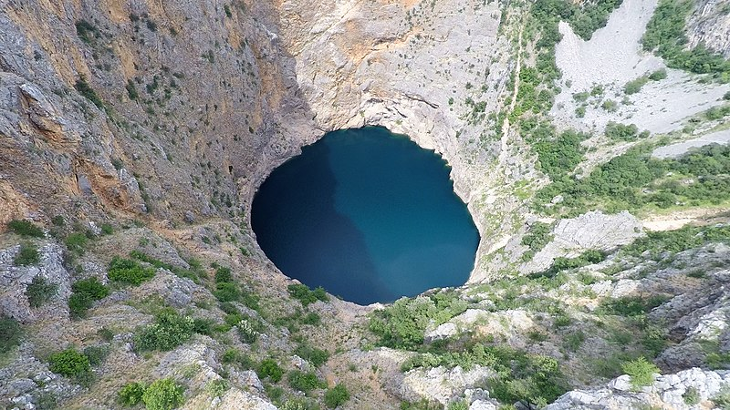
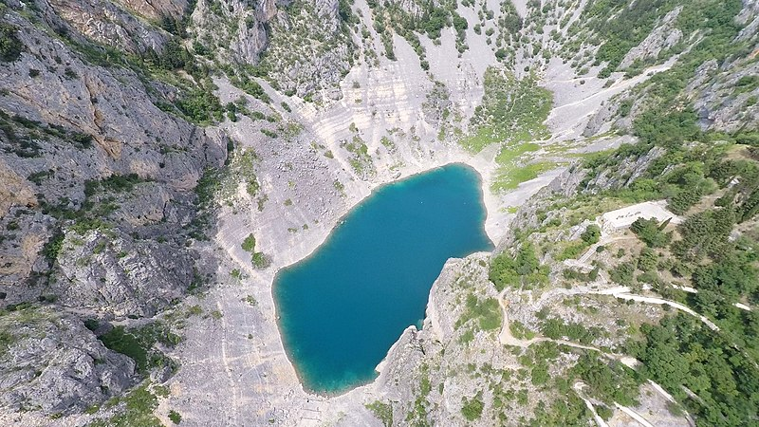
Imotski - Modro i crveno jezero

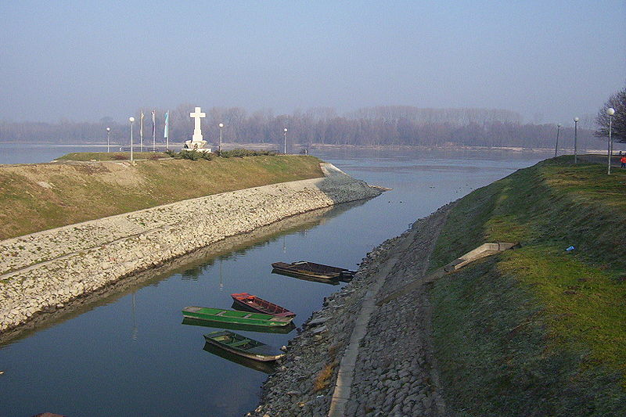  Vukovar, rijeka Dunav |  | 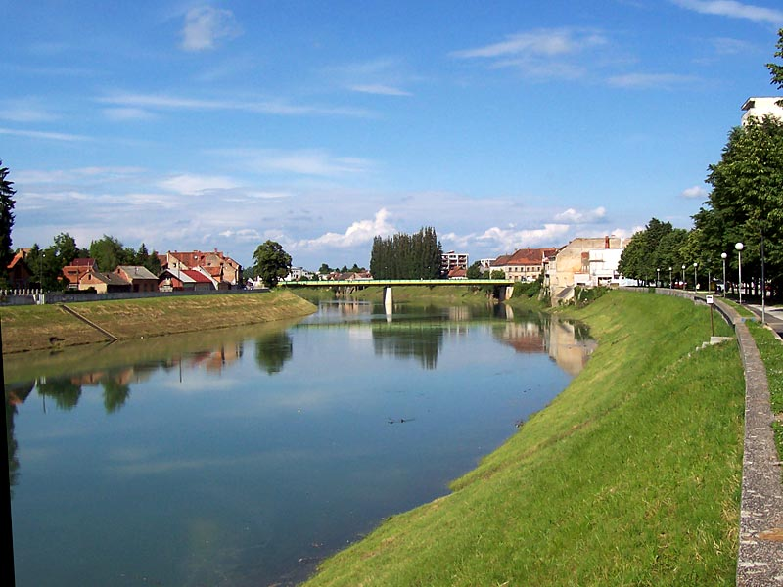  rijeka Kupa | 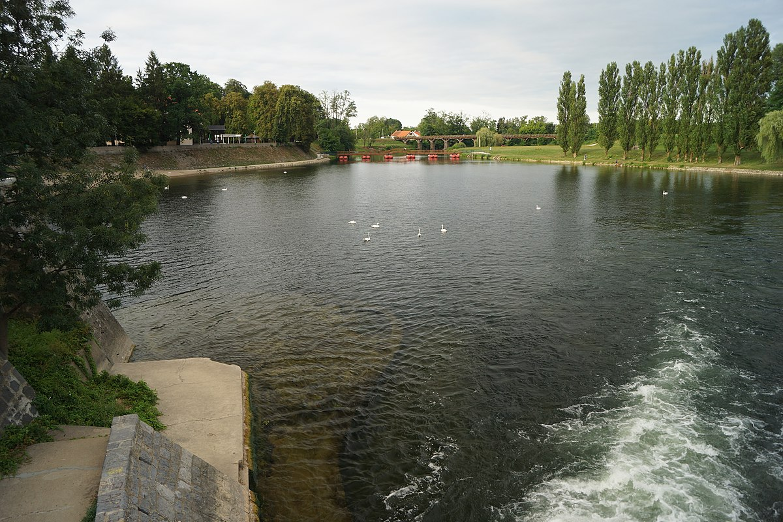  rijeka Korana
 |  | 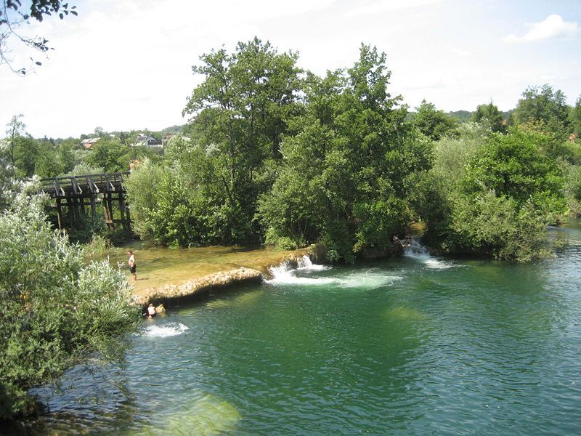  rijeka Mrežnica | 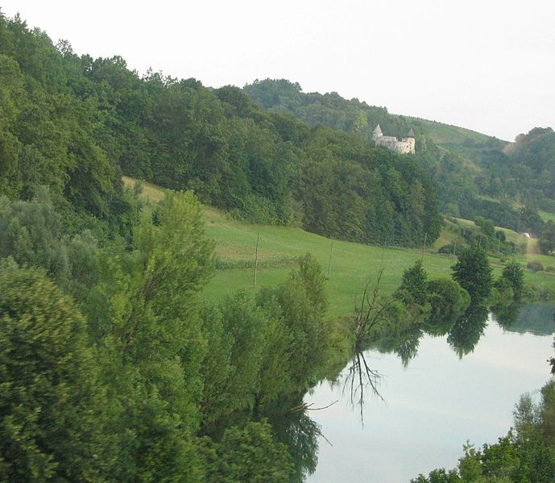  rijeka Dobra
 |  | Karlovac
Use the appropriate form of the verb imati in each question. Then, in each answer use the verb imati or nemati, based on the information you have about each city.
[h5p id="106"]
Images used in this document are from these sources.

