5 | 1 | Lekcija 2: Blagdani u mojoj zemlji

| The verb SLAVITI
In the previous lesson you encountered the verb proslaviti (to celebrate something one time, a completed action). In this lesson you have seen the verb slaviti. This verb will be used when we want to indicate that someone is celebrating something repeatedly.
SINGULAR |  |  | PLURAL
(audio) | ja | slav-im | (audio) | mi | slav-imo
(audio) | ti | slav-iš | (audio) | vi | slav-ite
(audio) | on/-a/-o | slav-i | (audio) | oni/-e/-a | slav-e

| Na primjer
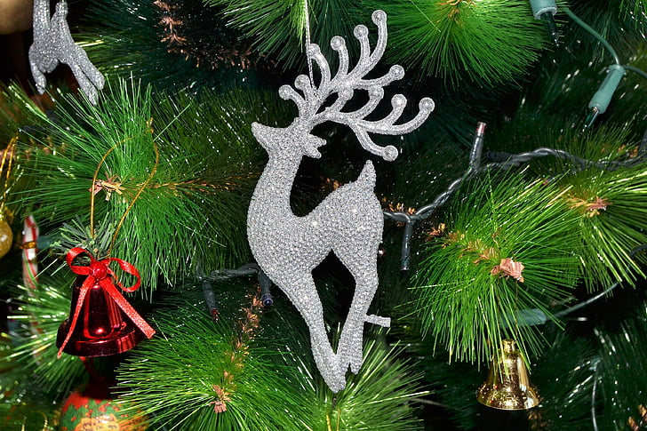 | Hrvati slave Božić.  Croatians celebrate Christmas. – meaning they do it every year
 | Amerikanci slave Dan zahvalnosti.  Americans celebrate Thanksgiving. – meaning they do it every year

| Look at the difference:
 | Kad planiraš proslaviti rođendan? Planiram proslaviti rođendan u subotu.  When are you planning to celebrate your birthday? I plan to celebrate it this Saturday. (One day only.)
 | Što slaviš? Slavim Božić i Uskrs.  What do you celebrate? I celebrate Christmas and Easter. (Every year)

5.1 Zadatak 4. Što slavimo?
Listen to each date and mark whether the given statement is True (Točno) or False (Netočno).
[h5p id="649"]

| Preposition PO
In this unit you learned that each of the countries in the region follows a specific calendar. To express this, you need to use the preposition po + Locative case. For example:
 | Bosna slavi Bajram po lunarnom kalendaru.
 | Hrvatska slavi Božić po gregorijanskom kalendaru.
 | Srbija slavi Božić po julijanskom kalendaru.

Thus, in terms of B/C/M/S terminology, each calendar consists of: a possessive adjective (julijanski, gregorijanski, lunarni) and the noun (kalendar). Because of this, when you want to say that a certain holiday is celebrated according to a specific calendar you need to use the preposition po and the adjective ending in the locative for ”julijanski, gregorijanski, lunarni“ and the noun ending in the locative for ”kalendar“.

| Calendar names
[h5p id="647"]

5.1 Zadatak 4. Države i religije
Look at the map and indicate what calendar each of the countries uses for celebrating their holidays.
[h5p id="648"]

5.1 Zadatak 5. Blagdani i praznici
Look at the following holidays (national or religious) and write in what month each of them is celebrated. Be sure to use the correct preposition as well. Example: Božić se u Hrvatskoj slavi po gregorijanskom kalendaru u prosincu.
[h5p id="438"]

Images used in this document are from these sources.

