2 | 3 | Lekcija 4: Tradicija

2.3 Zadatak 10. Kamo idu turisti?
Look at the following pictures and determine what each of them represents. Then, complete the sentences in a logical way. Be careful, you will need to use an appropriate preposition (u or na).
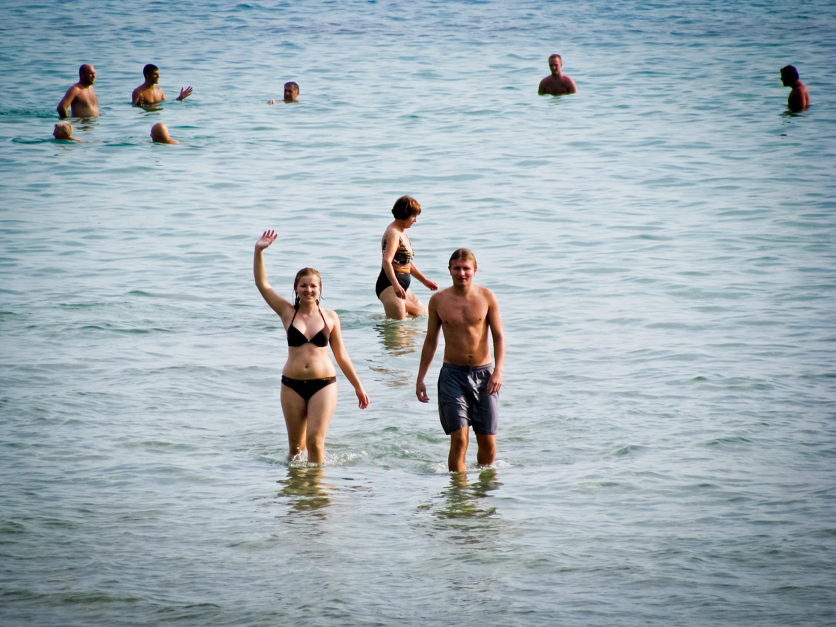 | 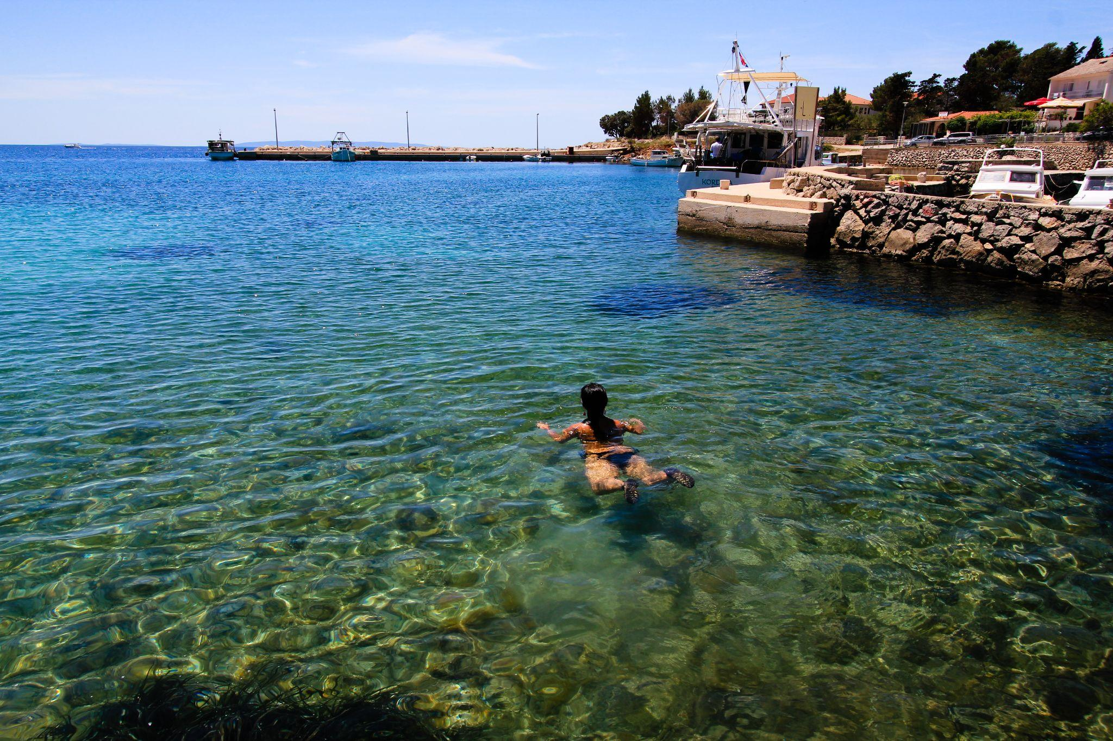
[h5p id="237"]
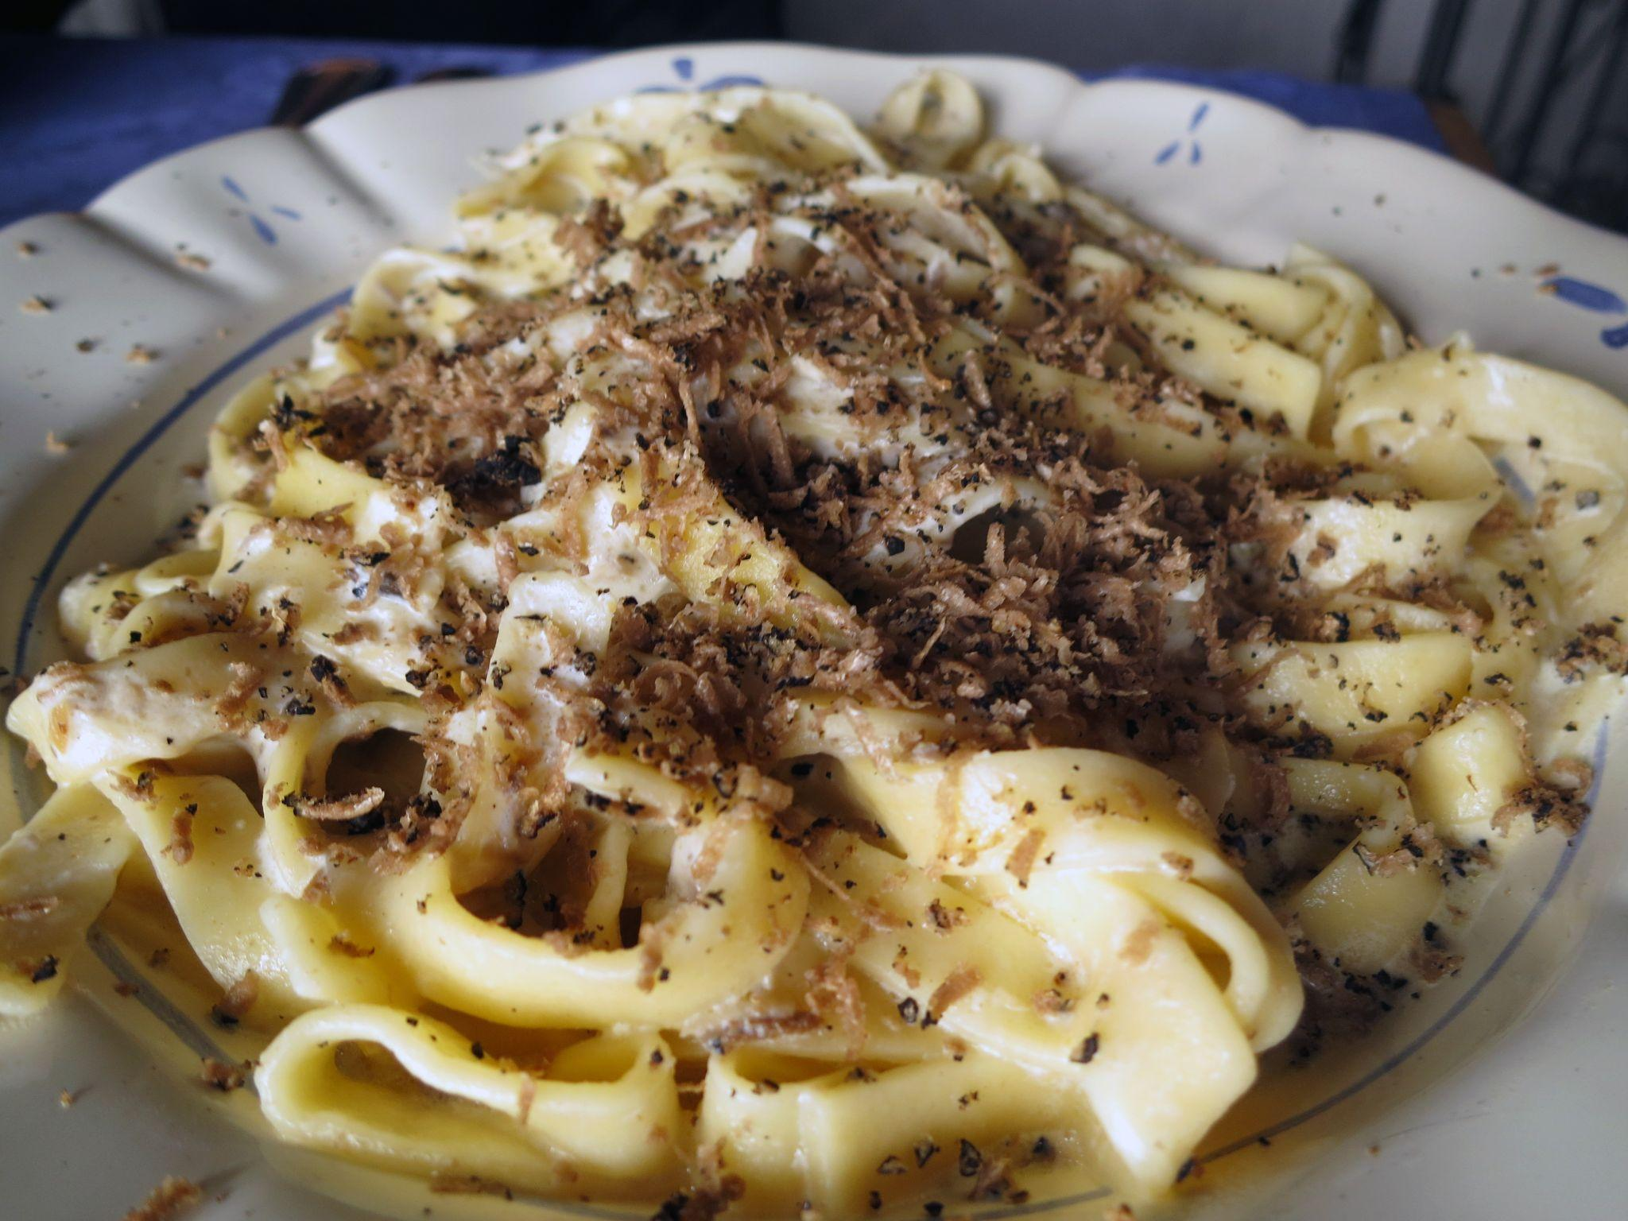 | 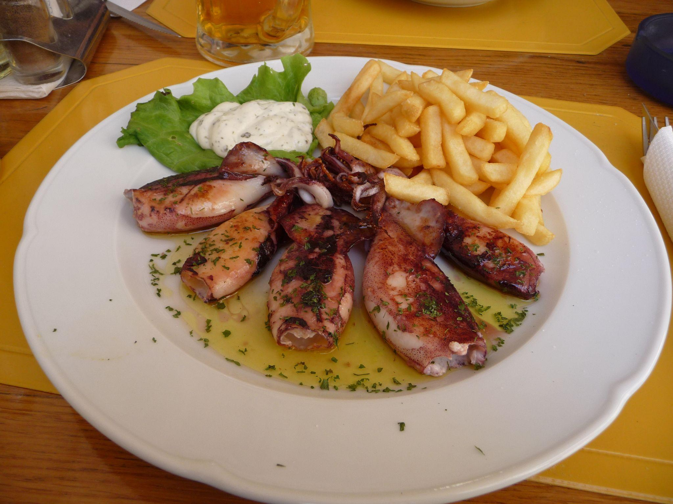
[h5p id="238"]
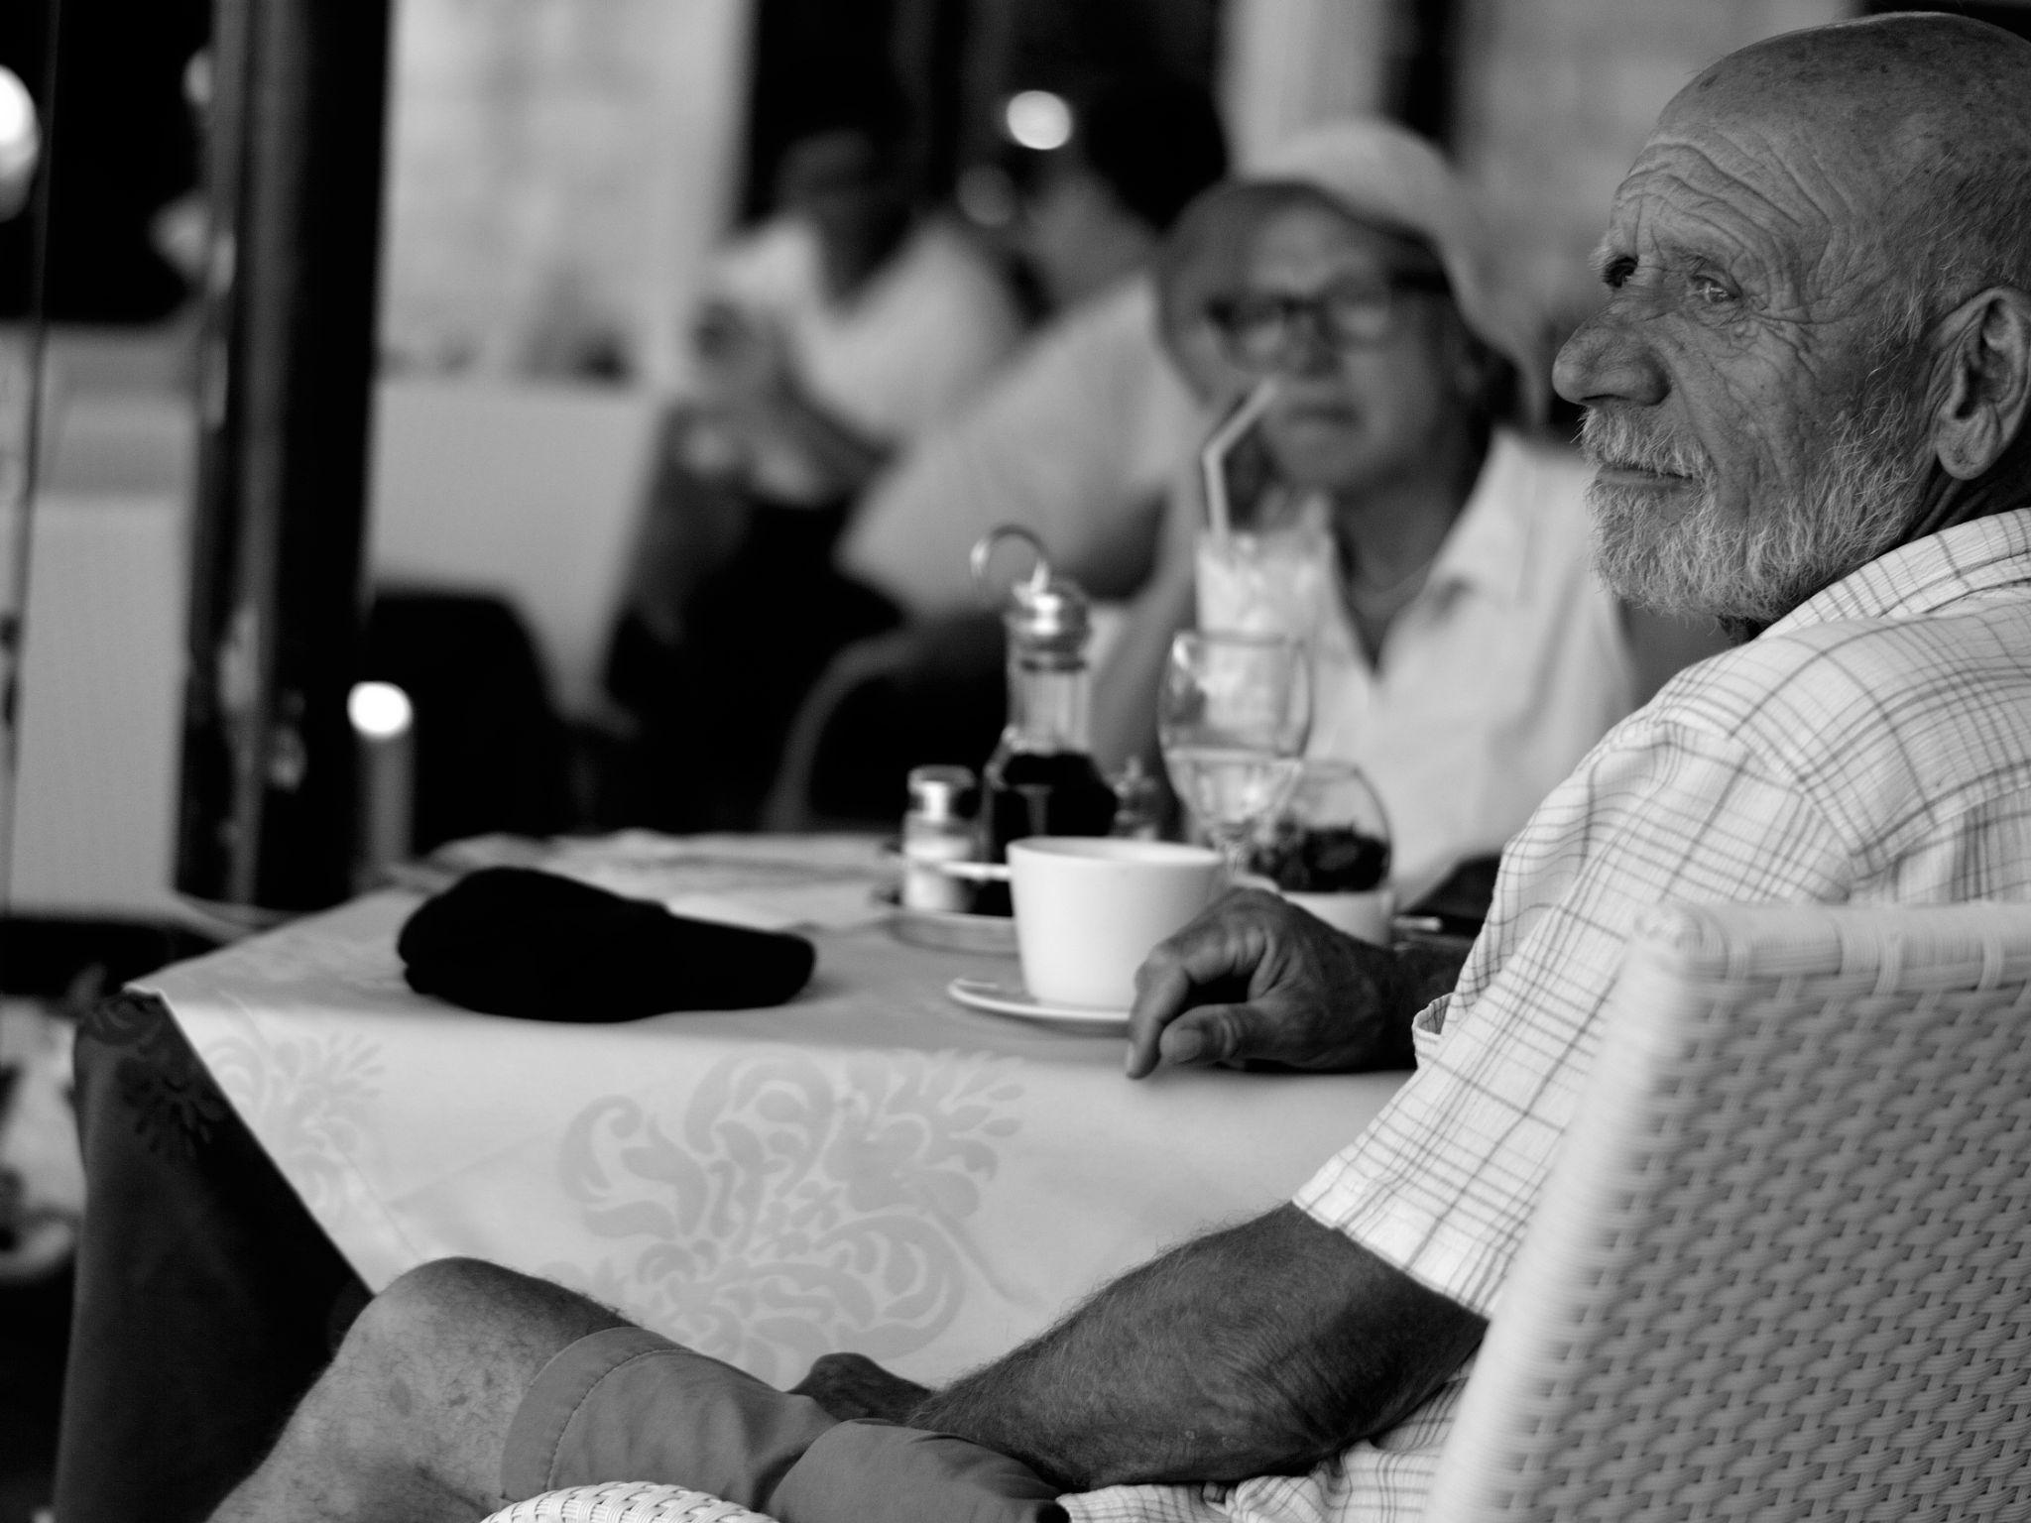 | 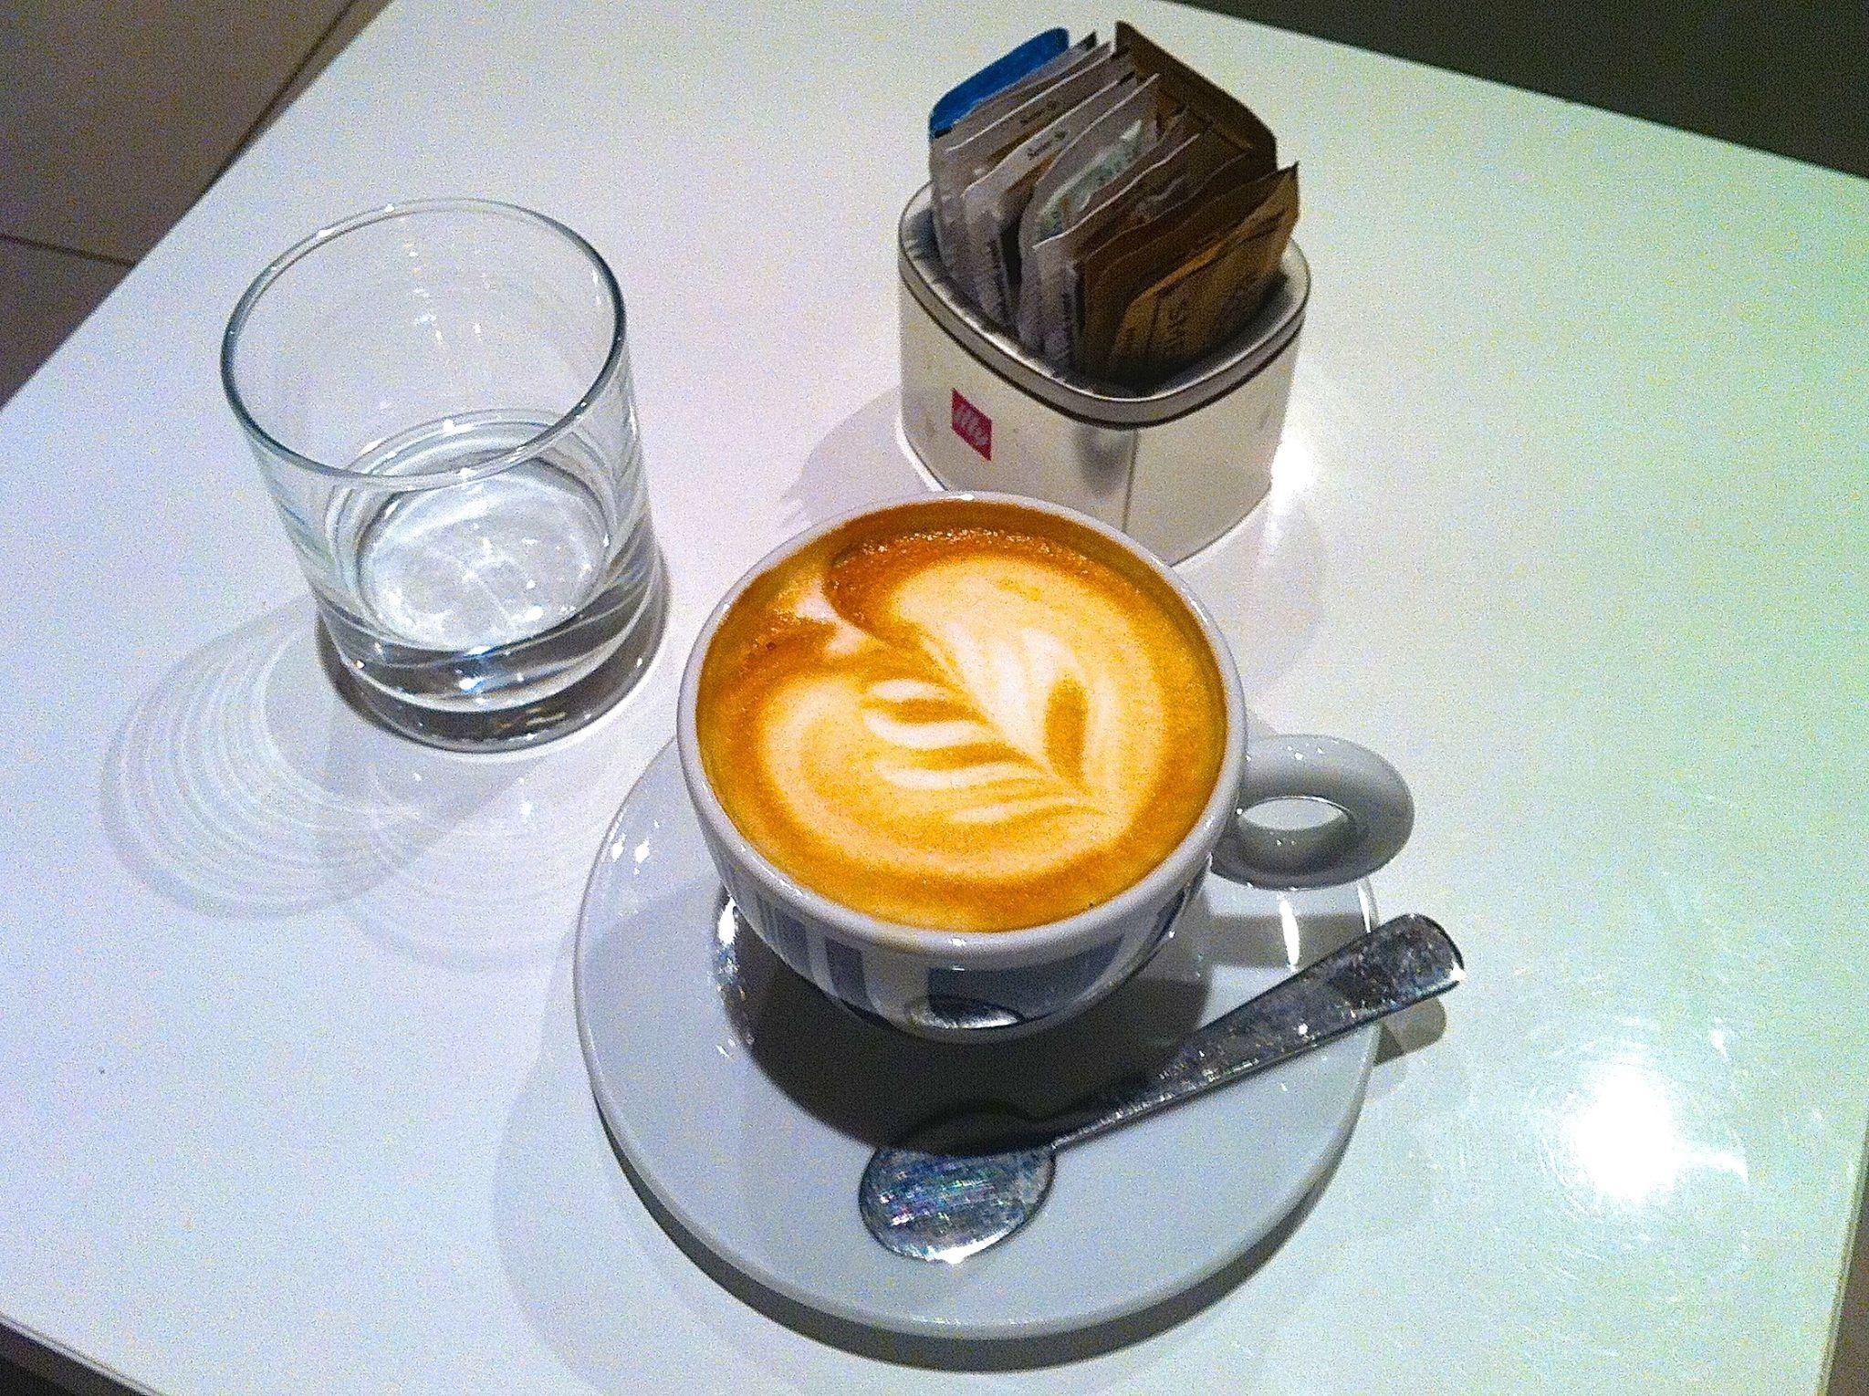
[h5p id="239"]
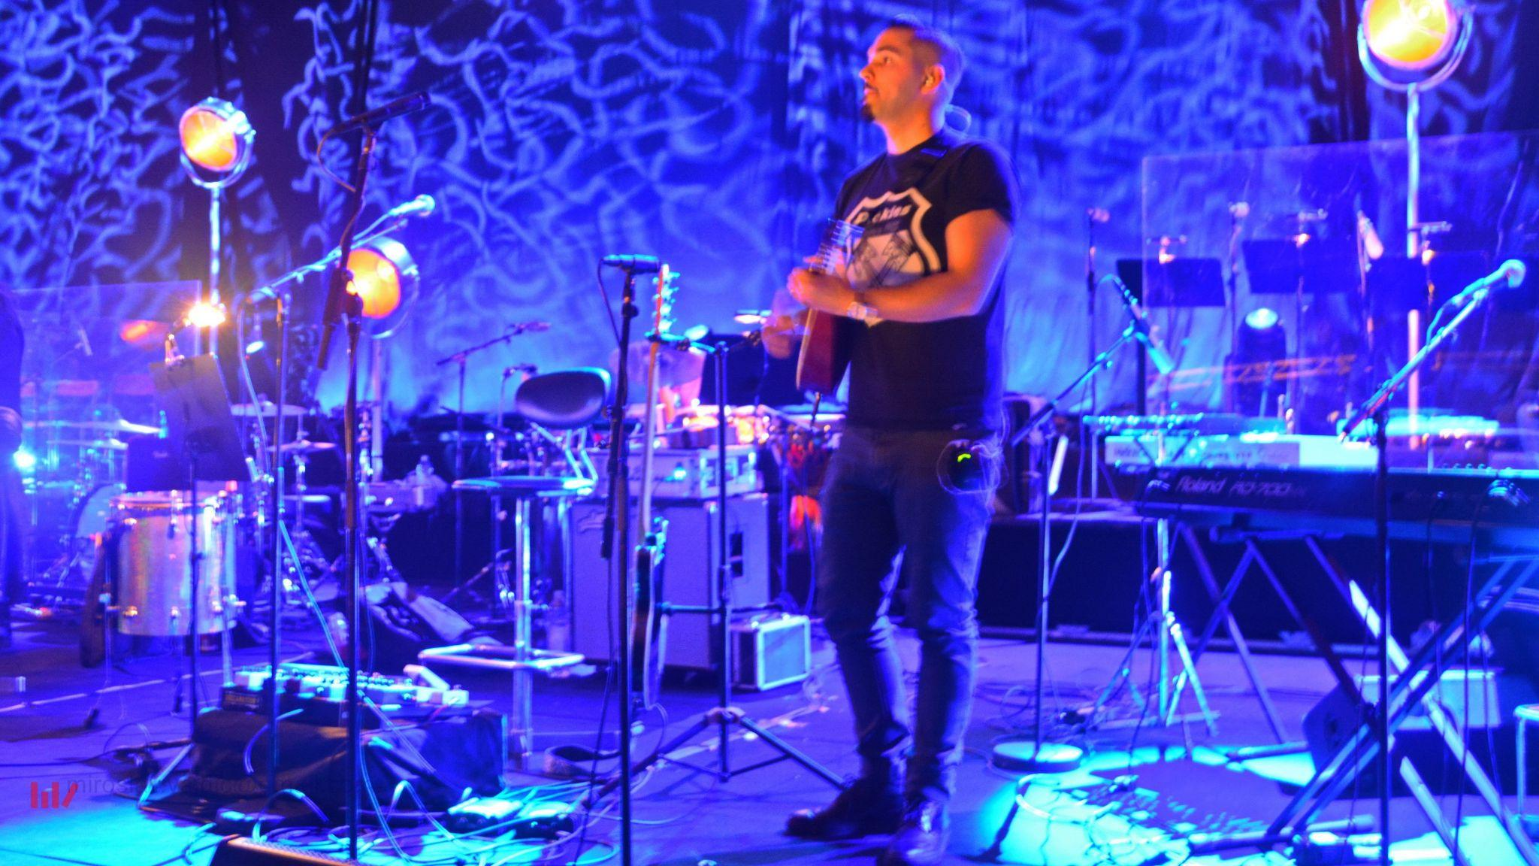 | 
[h5p id="240"]
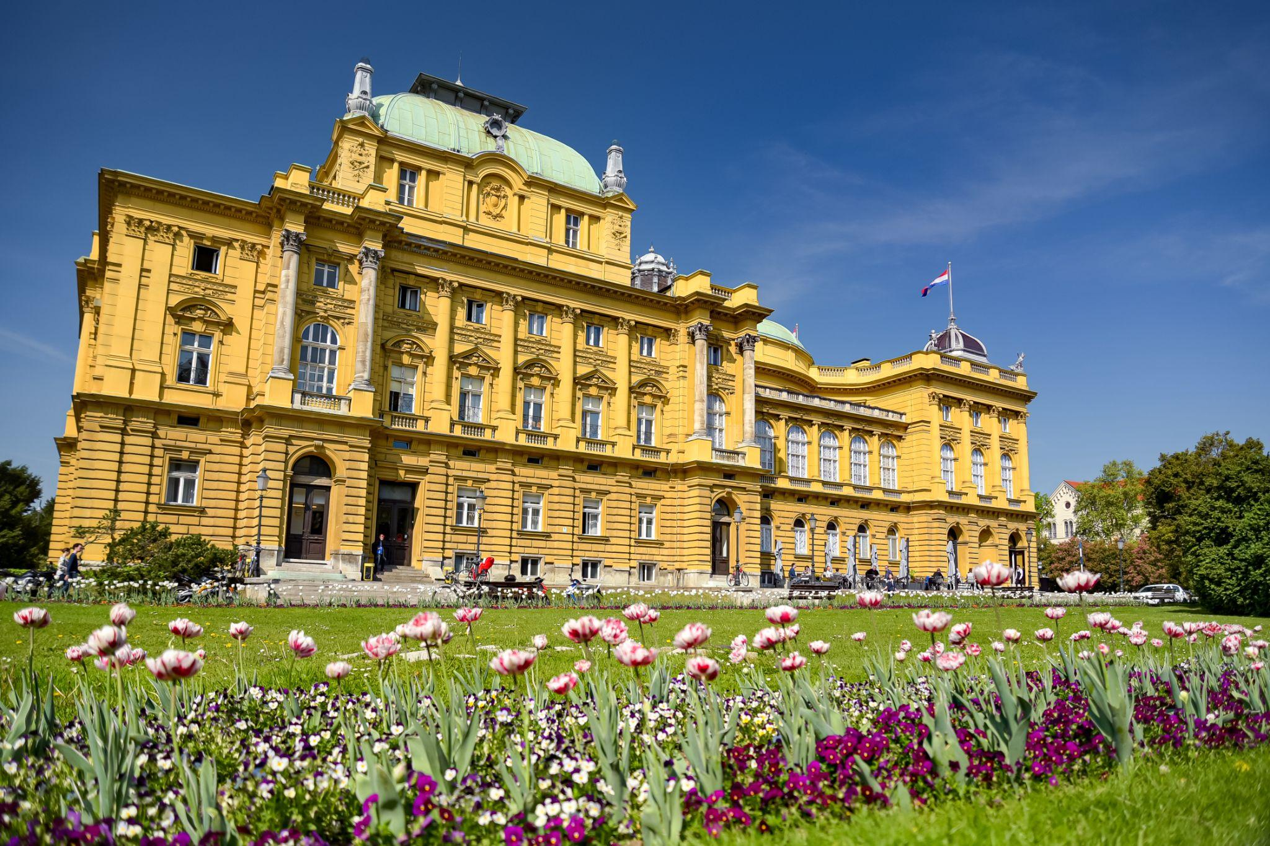 | 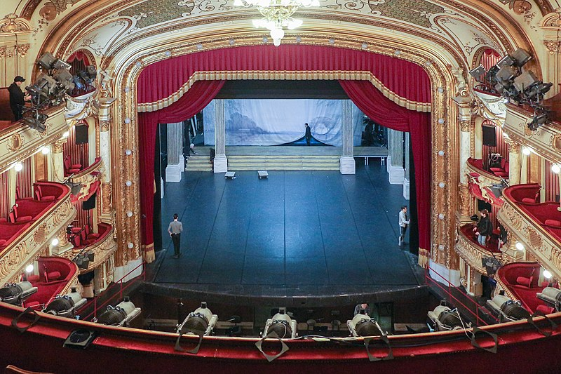
[h5p id="241"]

2.3 Zadatak 11. Što rade i kamo idu?
Complete the sentences based on the visual components associated with each sentence. Be careful to use appropriate prepositions when needed.
[h5p id="242"]
[h5p id="243"]
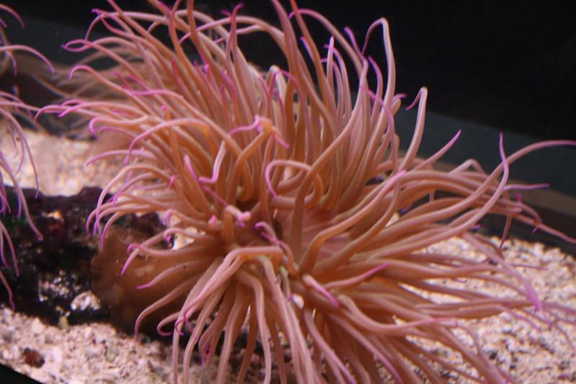 | 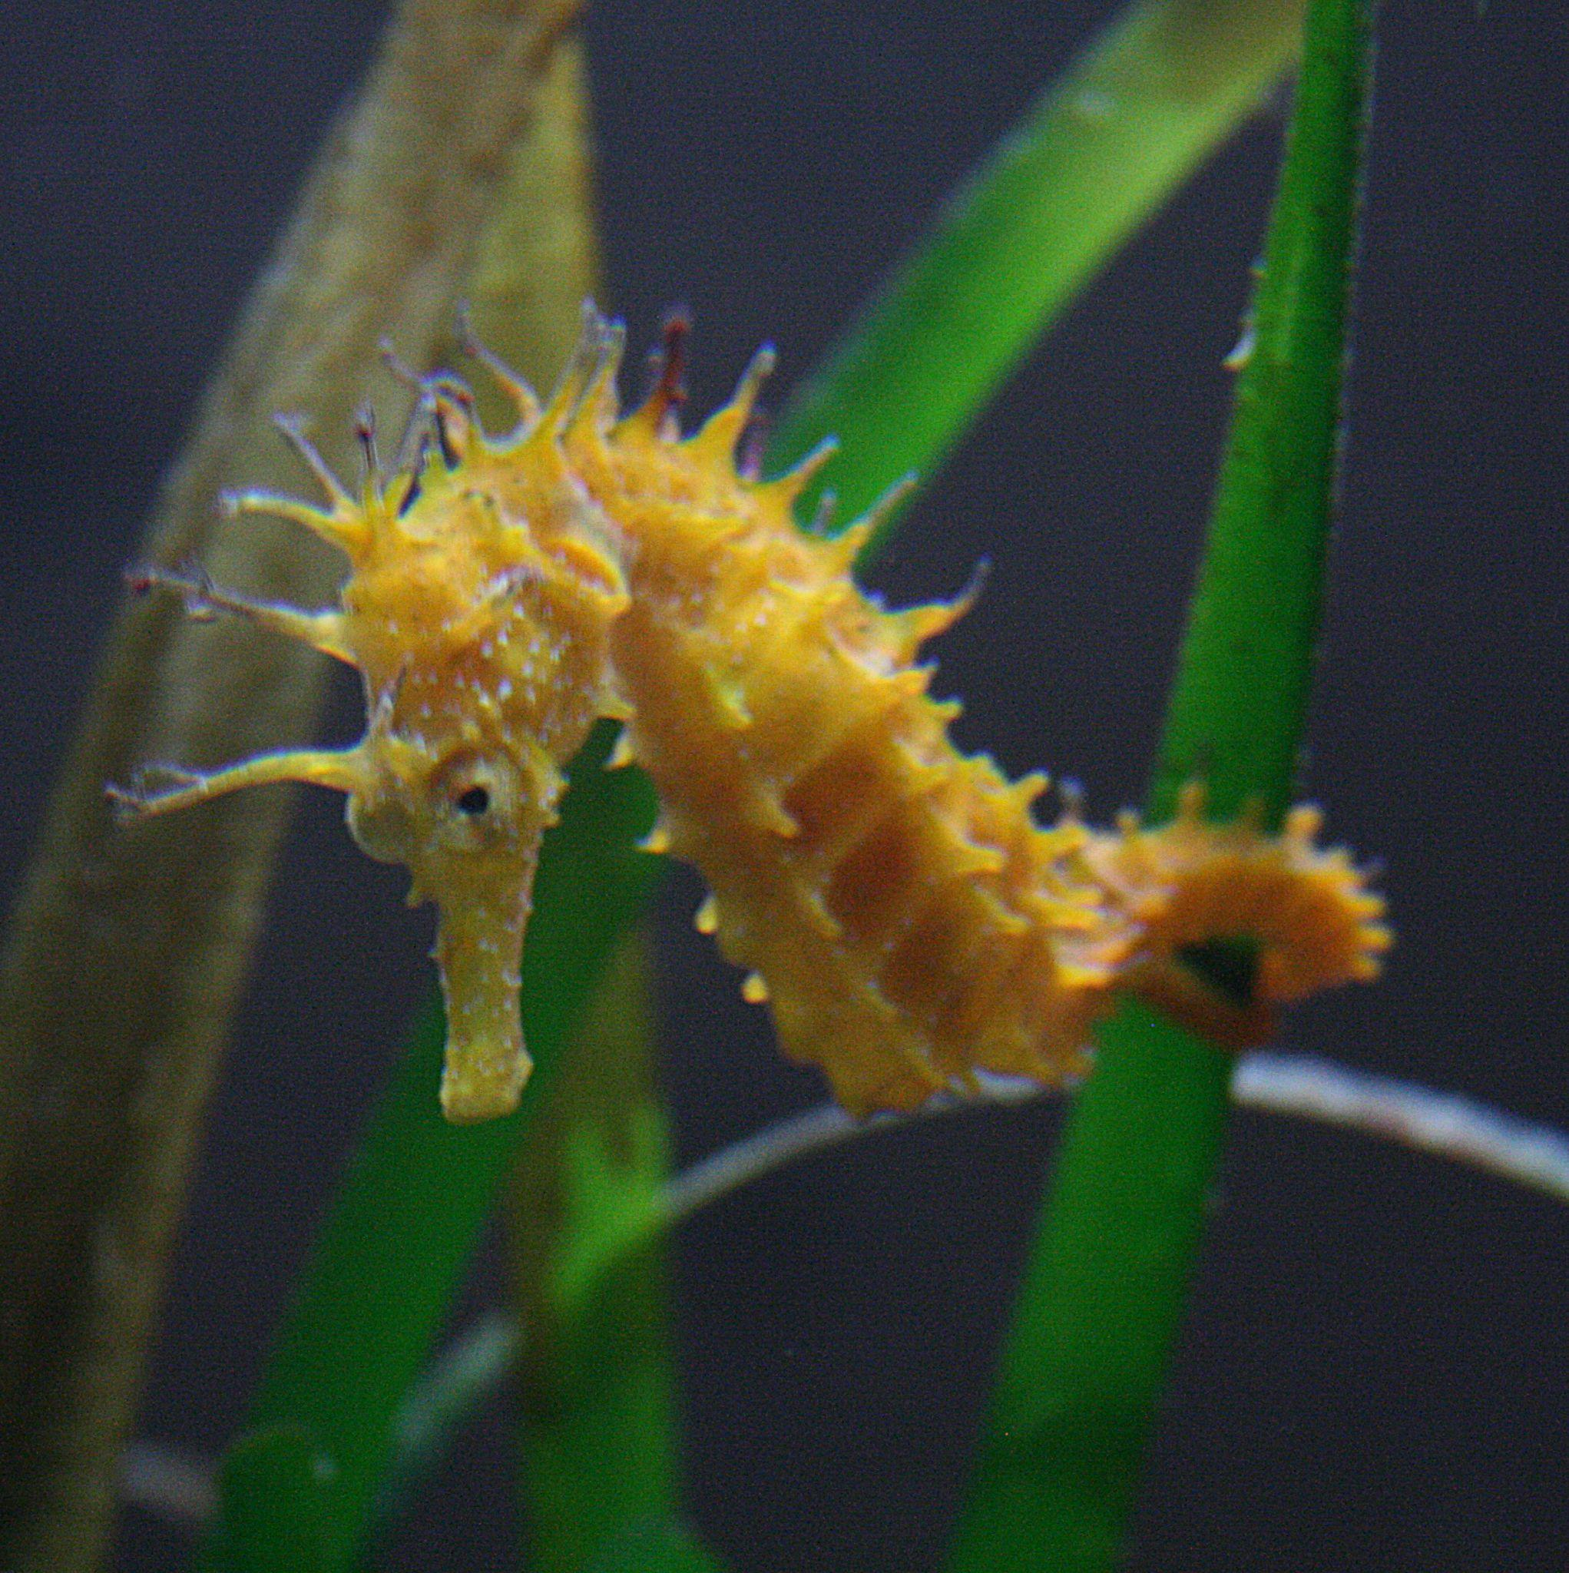
[h5p id="244"]

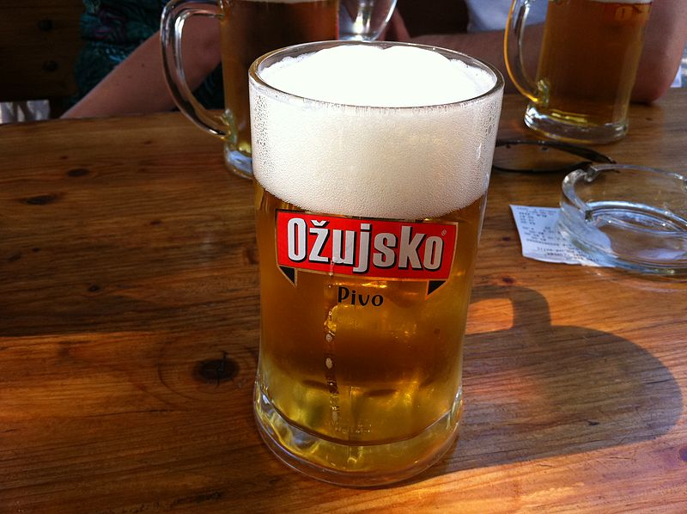 | 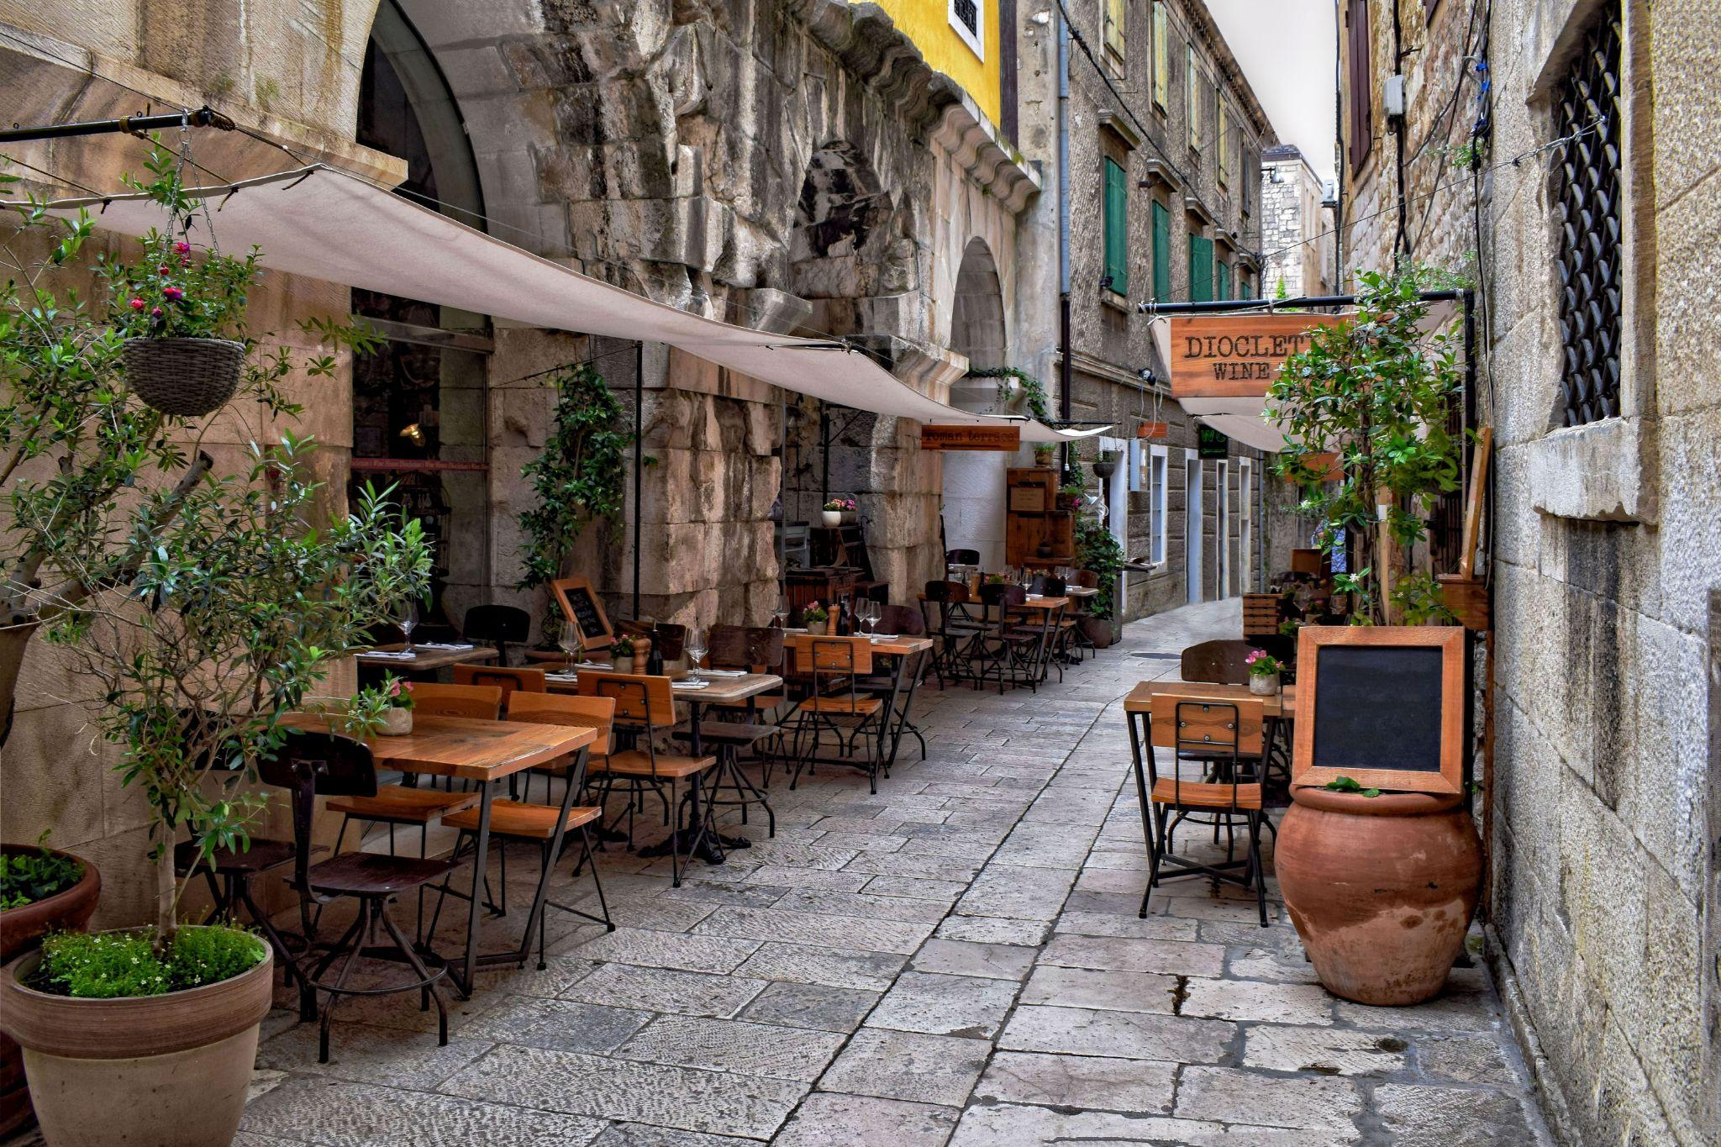
[h5p id="245"]
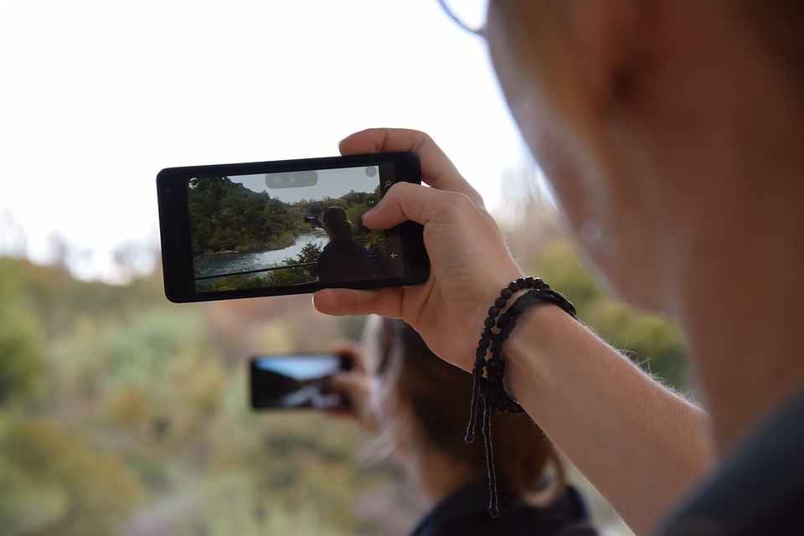 | 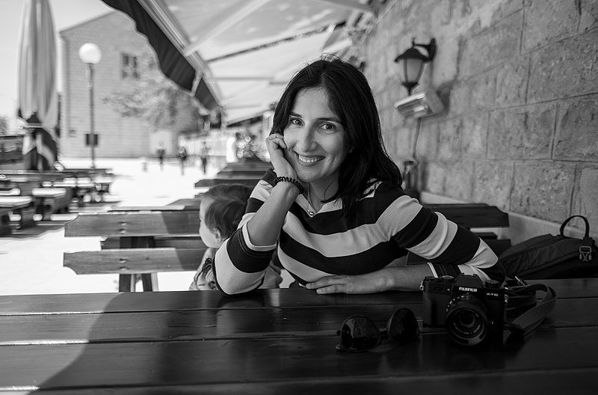
[h5p id="246"]
Images used in this document are from these sources.

