10 | 2 | Lekcija 1: Po Zagrebu

# 10.2 Zadatak 1. Trgovi po gradu

Look at some popular squares in Croatia and talk with your instructor by answering the questions below.

|  |  |
| --- | --- |
| Trg bana Josipa Jelačića, Zagreb | Trg Gaje Bulata, Split |
|  |  |
| Trg Petra Zoranića, Zadar | Trg Ante Starčevića, Osijek |

## | Pitanja

| Koji trg ti se najviše sviđa? Zašto? |
| --- |
| Što možeš raditi na ovim trgovima? |
| Koji je tvoj omiljeni trg u tvojem gradu? Zašto? |
| Koji trg ti se još sviđa u tvojem gradu? |

Look at the people who made a certain contribution to Croatian history and were deserving enough to have a square named after them (as shown in the pictures above). Write their name and who they were (i.e., their profession/occupation) under each picture.

| Zagreb | | Split | | Zadar | Osijek |
| --- | --- | --- | --- | --- | --- |
|  | |  | |  |  |
| ime | | ime | | ime | ime |
| ↦ | | ↦ | | ↦ | ↦ |
| uloga | | uloga | | uloga | uloga |
| ↦ | | ↦ | | ↦ | ↦ |

# 10.2 Zadatak 2. Po Zagrebu

👥 Look at the map below. Each of our students in Zagreb is in a specific location. Your task is to search online for information about all four places, associate each picture below with the location, give the address, which student is at that specific location (your own opinion), and provide your reason why each of them is at that specific location. The reason they are there is also just your personal opinion, based on what you have learned about Laura, Sandra, Davor, and Mario. Work with one of your classmates.

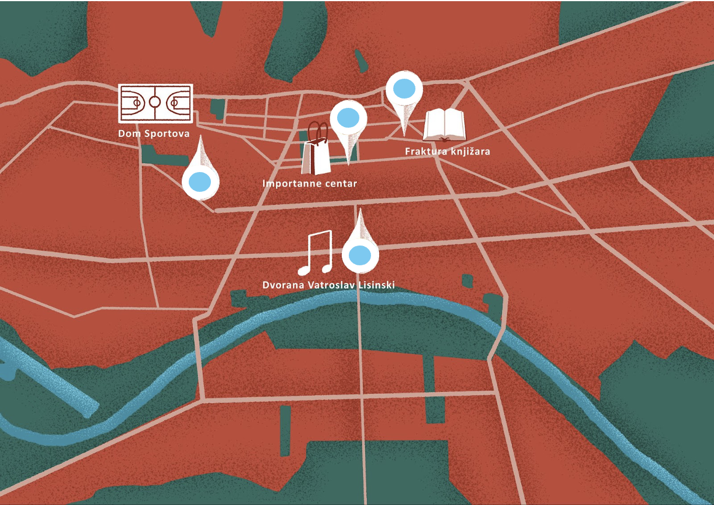

| Lokacija | Što je ovo? | Koja je adresa? | Tko je tu? | Zašto je tu? |
| --- | --- | --- | --- | --- |
|  | ↦ | ↦ | ↦ | ↦ |
|  | ↦ | ↦ | ↦ | ↦ |
|  | ↦ | ↦ | ↦ | ↦ |
|  | ↦ | ↦ | ↦ | ↦ |

Throughout the rest of today’s materials you will find out who is where. At the end of the class, you will see if you were correct in guessing who is where.

# 10.2 Zadatak 3. Hoćemo li na kavu?

🔊 Listen to **dialogue one** and complete the task.

|  |  |
| --- | --- |
| na trgu | ispod sata |

Sandra i Davor razgovaraju na telefon. Oboje su u gradu i imaju slobodnog vremena. Možda se mogu naći i zajedno popiti kavu.

## | Razumijevanje

| 1 | Gdje je Davor? |
| --- | --- |
| - |
| 2 | Gdje je Sandra? |
| - |
| 3 | Što je rekao Davor, jesu li oni blizu? |
| - |
| 4 | Zašto je Sandra nazvala Davora? |
| - |
| 5 | Kad će se oni naći? |
| - |
| 6 | Davor je rekao: Hoćeš li da se nađemo na trgu ispod sata? Na kojem trgu će se oni naći? |
| - |
| 7 | Jesu li Sandra i Davor daleko od trga? |
| - |
| 8 | Tko će prvi stići do trga, Davor ili Sandra? |
| - |

[](https://www.maxpixel.net/Pinpoint-Map-Destination-Pin-Icon-Travel-Map-Pin-1272165)

**Handout**. Look again at where Sandra is located on Google maps. Answer the questions below.

| 1 | Koji je trg blizu Sandre? Kako se zove trg? |
| --- | --- |
| - |
| 2 | Koja institucija se nalazi na trgu? Koja je adresa? |
| - |
| 3 | Koje su ulice oko trga? (List all the main streets that lead to the square.) |
| - |

# 10.2 Zadatak 4. Gdje si?

🔊 Listen to **dialogues 2 and 3**. Complete the assignment below.

|  |  |
| --- | --- |

*Sandra je nazvala Marija, a Davor je nazvao Lauru. Gdje se Laura i Mario nalaze?*

## | Razumijevanje

| 1 | Gdje je Laura? |
| --- | --- |
| - |
| 2 | Hoće li Laura na kavu s Davorom i Sandrom? |
| - |
| 3 | Hoće li Davor doći po Lauru ili će ona ići na tramvaj? |
| - |
| 4 | Gdje je Mario? |
| - |
| 5 | Zašto je Sandra u knjižari? |
| - |
| 6 | Hoće li Mario na kavu? |
| - |
| 7 | Kamo Mario mora ići? U koliko sati? |
| - |

[](https://www.maxpixel.net/Pinpoint-Map-Destination-Pin-Icon-Travel-Map-Pin-1272165) [](https://www.maxpixel.net/Graduation-Graduation-Hats-Success-Throw-Degree-4906360)

How well do you remember what our students are studying? What are they planning as their future profession? Below you have the address for each university. Google the address to find out which university is located there and fill in the missing information.

| Unska ulica 3 | Prilaz baruna Filipovića 28 | Trg John F. Kennedy 6 | Trg Drage Iblera 10 |
| --- | --- | --- | --- |
| Tko? | Fakultet: | Adresa: | Što studira? |
| Laura |  |  |  |
| Sandra |  |  |  |
| Davor |  |  |  |
| Mario |  |  |  |

Now that you know where Mario is located and where he needs to go, answer the two questions.

| 1 | Je li Marijev fakultet blizu Importannea? |
| --- | --- |
| - |
| 2 | Gdje se nalazi Marijev fakultet? (Compare it to his current location) |
| - |

# 10.2 Zadatak 5. Obaveze. Što radiš danas?

🔊 Listen to **dialogue 4** between our students and complete the task.

|  |  |
| --- | --- |

*Laura, Sandra i Davor razgovaraju o planovima za izlazak. Nažalost, Davor i Laura nisu slobodni danas. Imaju puno posla.*

## | Razumijevanje

| 1 | Kamo Sandra želi ići večeras? |
| --- | --- |
| - |
| 2 | Što misle Davor i Laura, kada je bolje organizirati izlazak? |
| - |
| 3 | Što Davor radi danas? Kakav je njegov raspored, kamo ide? |
| - |
| 4 | Što Laura radi danas? Kakav je njezin raspored, kamo ide? |
| - |

[](https://www.maxpixel.net/Pinpoint-Map-Destination-Pin-Icon-Travel-Map-Pin-1272165)

Based on the information that Laura provided in this last dialogue, complete the task.

| 1 | Laura ide u Nacionalnu i sveučilišnu knjižnicu. Koja je adresa? |
| --- | --- |
| - |
| 2 | Koje muzeje Laura mora posjetiti? (Think of her field of study. Possible museums listed below.) |
| - |
| 3 | Koja je adresa svakog muzeja koji ona mora posjetiti? |
| - |
| 4 | Tvoje mišljenje: Kamo Laura mora prvo ići?* |
| - |

* Find all the places she needs to go to. Where should Laura go first from her current location so she doesn’t lose time in traffic?

| Muzej Mimara | Hrvatski povijesni muzej | Lovački muzej |
| --- | --- | --- |
| Nacionalni muzej moderne umjetnosti | Hrvatski sportski muzej | Muzej čokolade |

# 10.2 Zadatak 6. Imena ulica i trgova

Look at two locations that our international students visited at some point while in Croatia.

| Laura je posjetila… | James je posjetio… |
| --- | --- |
|  |  |
| Muzej Mimara | Muzej grada Splita |
| Adresa je Roosveltov trg 5, Zagreb. | Adresa je Papalićeva ulica 1, Split. |

Sometimes we can abbreviate the name of a street or a square. Instead of saying the square of ban Josip Jelačić, we can say Jelačić’s square. Look at the list of locations in Zagreb and Split that Laura and James visited at some point and complete the task.

👥

How would you abbreviate the names from the left column? Pay attention to what happens with the forms in the first three examples given in the right column. Finish the rest based on these three.

| Kamo su išli? | |
| --- | --- |
| Trg bana Josipa Jelačića | Jelačićev trg |
| Šetalište Ivana Meštrovića | Meštrovićevo šetalište |
| Ulica Ivana Gundulića | Gundulićeva ulica |
| Trg kralja Tomislava |  |
| Ulica Vladimira Nazora |  |
| Trg Josipa Juraja Strossmayera |  |
| Ulica kralja Zvonimira |  |
| Ulica Antuna Gustava Matoša |  |
| Trg Ante Starčevića |  |

|  |  |
| --- | --- |
| Strossmayerovo šetalište, Zagreb | Dioklecijanova ulica, Split |

# 10.2 Zadatak 7. Što posjetiti?

👥 Work with your classmate. Have a discussion and create a dialogue in Croatian. Imagine that you are in Zagreb. You are supposed to meet each other for a tour around Zagreb. Before you make any plans or start your dialogue, you should decide together which type of activity you want to do in Zagreb. For each type of activity in the section you choose, there is a set of different addresses. Figure out what they are and find where they are on the map.

| Aktivnost | Adresa: | Atrakcija: |
| --- | --- | --- |
| Kultura | Rooseveltov trg 5 |  |
| Ulica Andrije Hebranga 1 |  |
| Preradovićeva ulica 8 |  |
| Varšavska ulica 5 |  |
| Arhitektura | Trg Marka Marulića 21 |  |
| Trg Sv. Marka 5 |  |
| Trg kralja Tomislava 22 |  |
| Trg Republike Hrvatske 10 |  |
| Shopping | Ulica Vice Vukova 6 |  |
| Trg Petra Preradovića 6 |  |
| Trg Ante Starčevića 7 |  |
| Trg Drage Iblera 10 |  |
| Razno | Mesnička ulica 19 |  |
| Aleja Hermanna Bollea 27 |  |
| Ulica Antuna Gustava Matoševa 9 |  |
| Ulica Nikole Tesle 10 |  |

When you have everything ready, create a dialogue. One of you is located at **Trg bana Josipa Jelačića** and the other one is located in front of **Hrvatsko narodno kazalište**. Make a phone call dialogue in which you ask each other where you are and then make plans where to meet. Discuss your plans. In what order would you visit all of the places? Will you walk, take a tram, or taxi to some of these destinations?

Images used in this document are from [these sources](https://docs.google.com/document/d/1GviL5eWyPJ_XM2q6MaoZi783aEhGSHFSKkRrEhnksjE/edit#heading=h.ktkus0ccq3de).