3 | 1 | Lekcija 4: Vjenčanje

# 3.1 Zadatak 12. Mlađi ili stariji?

One of you will answer the following questions to your instructor.

## | Pitanja

| Koga imaš? |
| --- |
| Imaš li mlađeg ili starijeg brata? |
| Imaš li mlađu ili stariju sestru? |

Now it’s your turn. Interview the rest of your classmates and ask them about their brothers and sisters – younger/older and their name(s). Mark the family members they have and write the name of each family member.

## Pitanje: Imaš li....?

Da, imam...... zove se... –or– Ne, nemam...

| Tko?  ↓ | mlađeg  brata | starijeg  brata | mlađu  sestru | stariju  sestru |
| --- | --- | --- | --- | --- |
|  |  |  |  |  |
|  |  |  |  |  |
|  |  |  |  |  |
|  |  |  |  |  |
|  |  |  |  |  |

# 3.1 Zadatak 13. Vjenčanje

|  |  |  |
| --- | --- | --- |
|  |  |  |

## | Pitanja

| Voliš li ići na vjenčanje? |
| --- |
| Kakva su obično vjenčanja u SAD-u i u Hrvatskoj? Velika ili mala? |
| Je li udana tvoja mlađa ili starija sestra? |
| Je li oženjen tvoj mlađi ili stariji brat? |
| Jesi li ti udana? |
| Jesi li ti oženjen? |

# 3.1 Zadatak 14. Vjenčanje i običaji

👥 **Rad u paru**. Talk with your classmate and answer the following questions.

### Što obično nosi mladoženja?

|  |  |  |
| --- | --- | --- |
| kratke hlače i majicu | džins i košulju | odijelo i kravatu |

### Tradicionalno, što obično mlada nosi?

|  |  |  |
| --- | --- | --- |
| bijelu vjenčanicu | crnu vjenčanicu | crvenu vjenčanicu |

### Gdje u SAD-u organiziraju svadbeno slavlje*?

|  |  |  |
| --- | --- | --- |
| u restoranu | u hotelu | u šatoru |

* svadbeno slavlje = wedding celebration

### Gdje u SAD-u organiziraju obred*?

|  |  |  |
| --- | --- | --- |
| na plaži | u šatoru | u crkvi |

*obred = ceremony

|  |  |
| --- | --- |
|  |  |

## Pitanja:

| 1 | Jesu li hrvatska i američka vjenčanja slična ili različita? |
| --- | --- |
| - |
| 2 | Zašto to misliš? |
| - |

# 3.1 Zadatak 15. Obitelj

🔊 Listen to the **dialogues (one to four).** Davor met his friends and is talking about a recent wedding that he went to. At the same time, Laura has a chance to learn more about his family.

#### Vocabulary

*bilo je* = it was

*to je bilo* = that was

While you listen to the dialogues, answer the following questions and complete Davor’s family tree. You will now complete the family tree fully.

| 1 | Gdje je bio Davor? |
| --- | --- |
| - |

|  |  |  |
| --- | --- | --- |
| na rođendanu | na krštenju | na pričesti |
|  |  |  |
| na krizmi | na vjenčanju | na pogrebu |

| 1 | Ima li Davor veliku ili malu obitelj? |
| --- | --- |
| - |
| 2 | Koga ima Davor? |
| - |

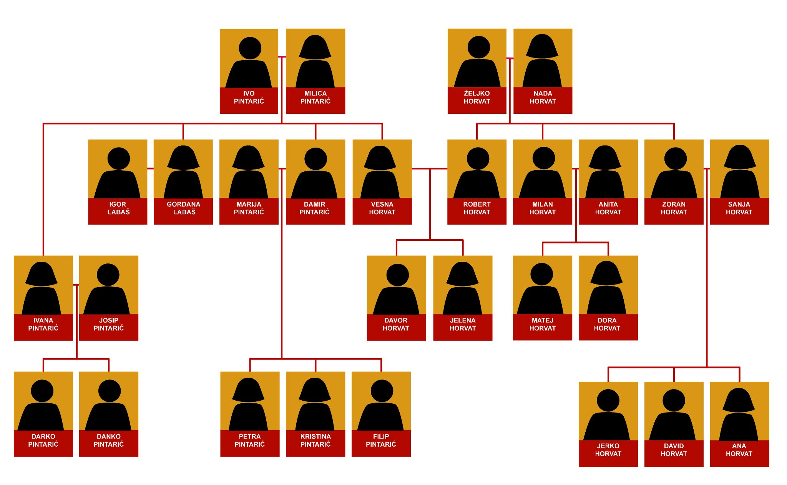

Now, talk with one of your classmates and answer the following questions.

| 1 | Ima li Davor stariju ili mlađu sestru? Kako se ona zove? |
| --- | --- |
| 2 | Ima li David starijeg ili mlađeg brata? |
| 3 | Ima li Zoran mlađeg ili starijeg brata? |
| 4 | Ima li Jerko stariju ili mlađu sestru? |

# 3.1 Zadatak 16. Udana ili oženjen?

Talk with one of your classmates. Your task is to find out if members of their family are married or not. The list of people that you need to ask about is listed below under the appropriate question form.

|  |  |  |
| --- | --- | --- |
| 0. | Jesi li TI **oženjen**? | Jesi li TI **udana**? |
|  | Je li tvoj […] oženjen? | Je Ii tvoja […] udana? |
| 1 | brat | sestra |
| 2 | bratić | sestrična |
| 3 | ujak | teta |
| 4 | stric | baka |

Images used in this document are from [these sources](https://docs.google.com/document/d/1saSnmC8BPlBCM1aAJyi67nDvf_ePZhX98Uv3LPETqkU/edit#heading=h.yvwpx9ya6cv8).