1 | 3 | Lekcija 1: Odakle si?

| Studij

1.3 Zadatak 1. Studij
[h5p id="590"]

1.3 Zadatak 2. Što studira?
Look at the picture and write the correct answer.
[h5p id="688"]

| Što voliš?
Look at the following set of words. These are the things that someone might like.
 | 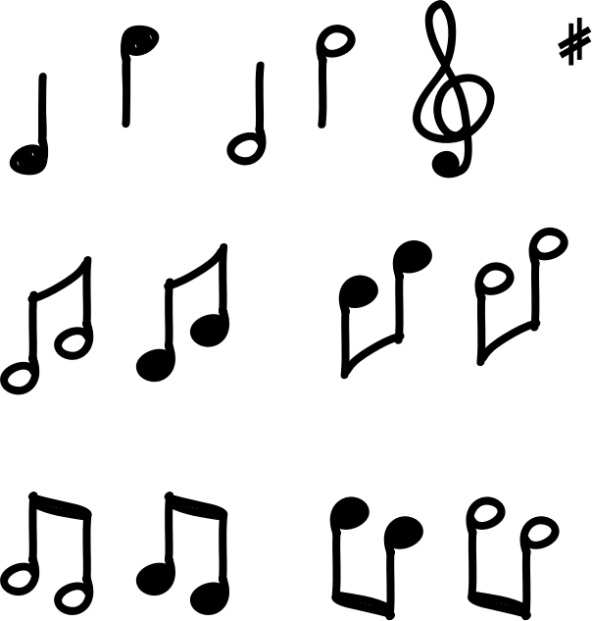 | 
film | glazba | kazalište
(audio) | (audio) | (audio)
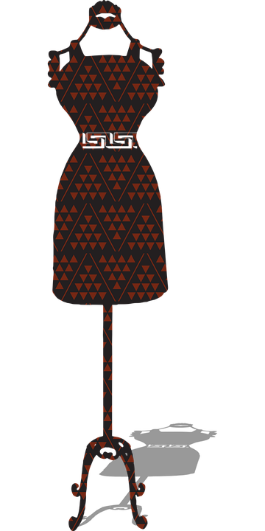 | 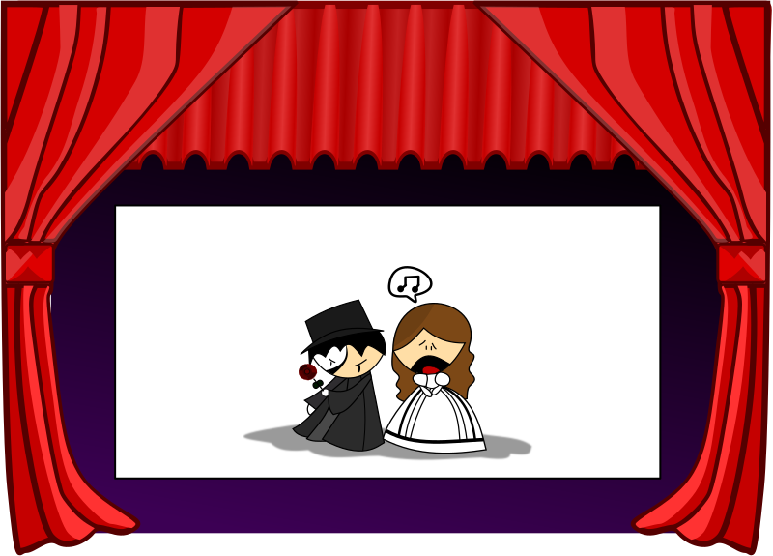 | 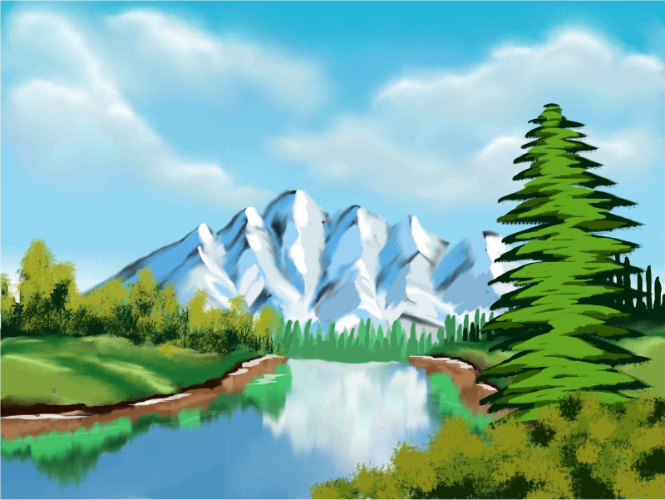
moda | opera | priroda
(audio) | (audio) | (audio)
 | 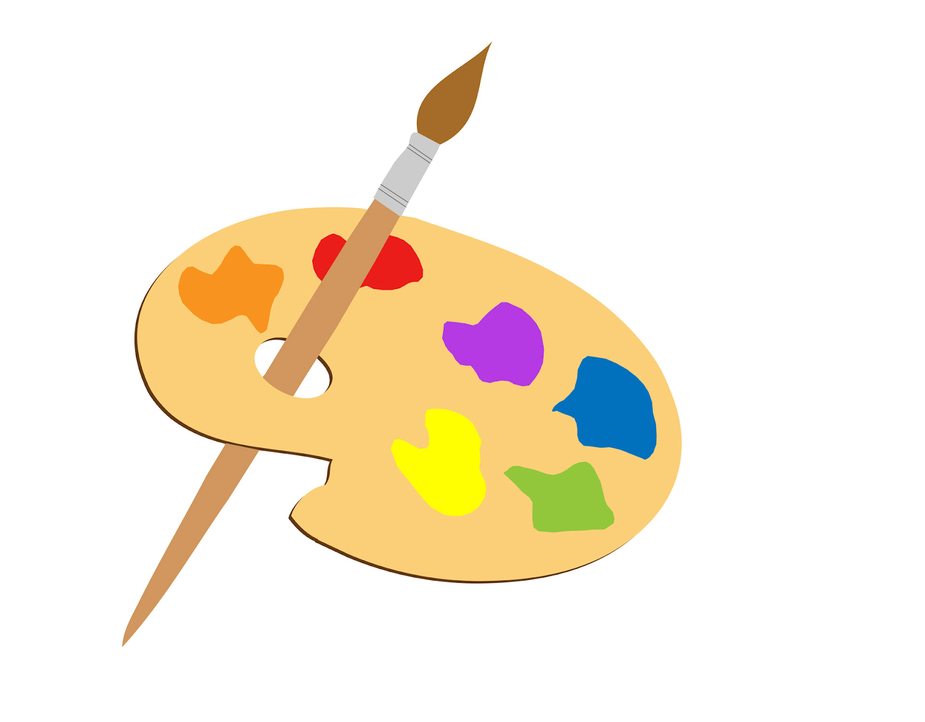
sport | umjetnost
(audio) | (audio)

1.3 Zadatak 3. Što voli?
Look at the pictures and complete the sentences.
[h5p id="689"]
Images used in this document are from these sources.

