3 | 1 | Lekcija 7: Slika i prilika

| Verbal nouns
In this lesson you encountered sentences such as:
Zanima me sport. | Zanima me trčanje.

#1
In the first sentence (Zanima me sport.) we used the regular noun in the Nominative case.

#2
In the second sentence (Zanima me trčanje.), instead of using the verb trčati we used a verbal noun in the Nominative case trčanje. In the sentences that express your interest in something, in Croatian it is more natural to use a noun and not the verb. In other words, just like in English, it is better to say I’m interested in running, rather than I’m interested to run.*

Thus, these verbal nouns are useful and replace the verb. A verbal noun is a noun that is created out of a verb. Only certain verbs can be used to create verbal nouns. There will be more about this topic next semester. Here are some verbs and their verbal noun pairs that you have encountered so far.
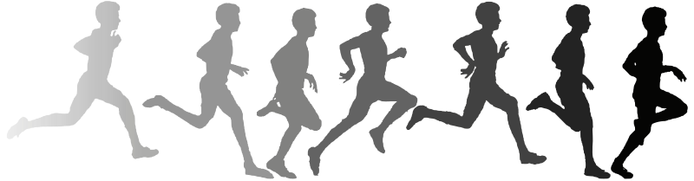 |  | 
trča-ti | trča-nje | spava-ti | spava-nje
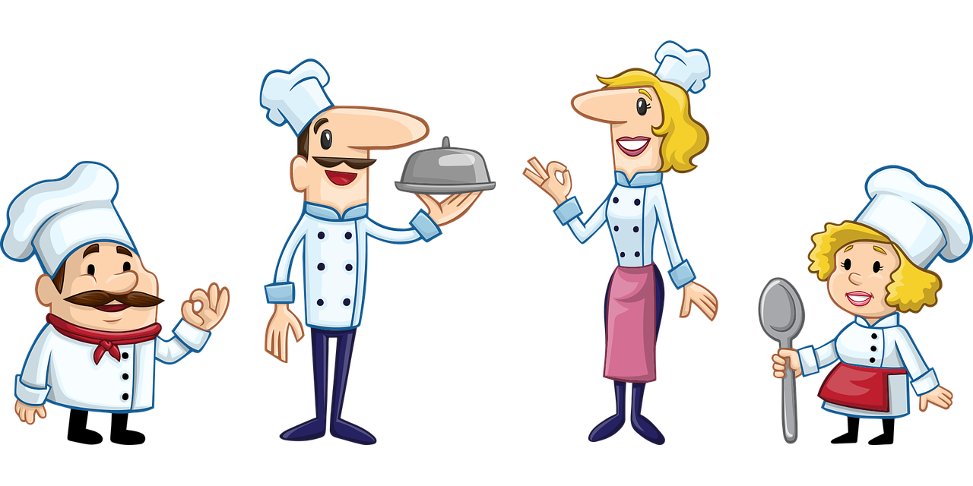 |  | 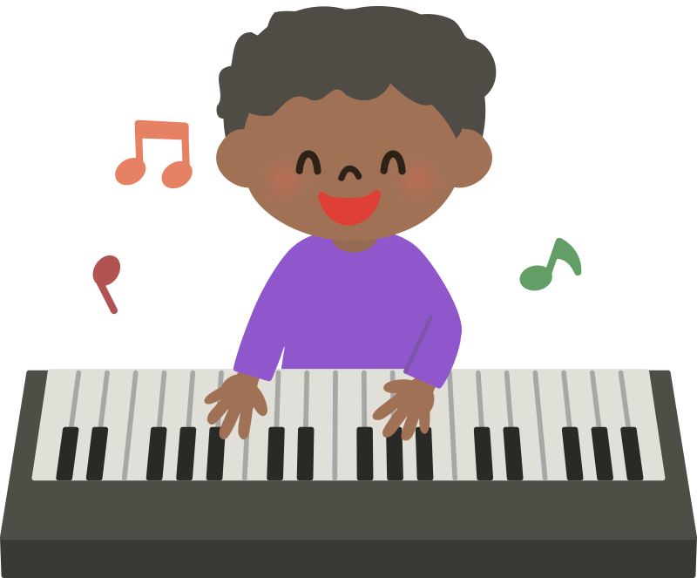
kuha-ti | kuha-nje | svira-ti | svira-nje
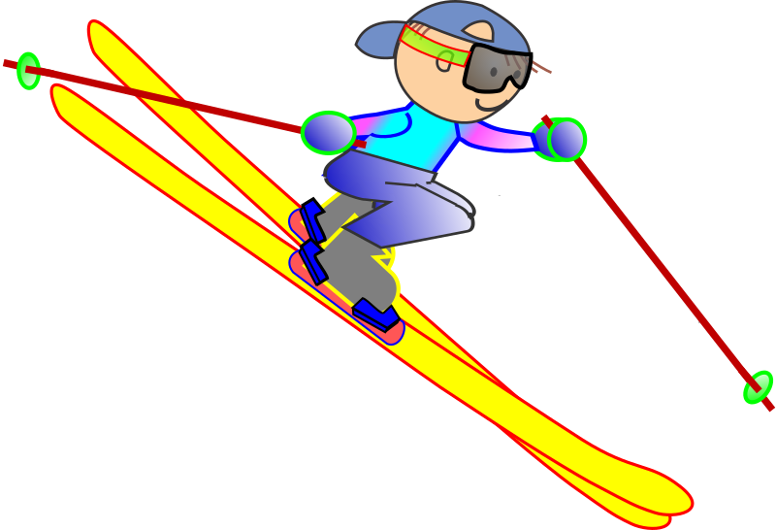 |  | 
skija-ti | skija-nje | čita-ti | čita-nje
 |  | 
plesa-ti | plesa-nje | džogira-ti | džogira-nje

As you can see, in order to create a verbal noun, we need to cut the final –ti from the infinitive form of the verb and add –nje (trča-nje).

| Izgled (Appearance)
Today we also explored how to talk about someone’s appearance. Now it’s your turn! Based on what we covered in class, complete the task below. How much do you remember about describing hair and eyes?
Choose the image that best represents the given sentence.
[h5p id="630"]
Images used in this exercise are from these sources.

