7 | 1 | Lekcija 3: Ljetni odmor

7.1 Zadatak 16. Razgovaramo
👥 Rad u paru. Your instructor will give you a write-up from one of your classmates’ homework assignments (Zadatak 7. S kim putovati?). It gives you your classmate’s plans for the summer and a list of possible people they potentially want to travel with.
 | 
STUDENT A | STUDENT B
Since your friend is not sure who to travel with, your task is to: | While your classmate presents you with their options:

Read what they wrote | Comment on whether you agree and express your final opinion on who to travel with
Talk with your classmate in order to present your suggestions/opinions. Be sure to include: advice on who to go with and provide your reasons why you picked specific people over someone else | Say why you pick a certain person (or a group of people) as a final choice

7.1 Zadatak 17. Intervju
👥 Grupni rad. Interview at least two of your classmates. Then, decide who would be better company to travel with. Provide your reason and write your comments/final conclusion below. Who do you want to travel with and why?
 | 

 | Pitanje | OSOBA 1 |  |  | OSOBA 2
 |  | DA | NE |  | DA | NE
1 | Ti si vesela osoba?
2 | Ti si dinamična osoba?
3 | Ti si druželjubiva osoba?
4 | Ti si aktivna osoba?
5 | Ti voliš prirodu?
6 | Ti voliš noćni život i klubove?
7 | Ti si na odmoru uvijek na mobitelu?
8 | Ti uvijek znaš kamo ići na odmoru?
9 | Ti voliš dobro jesti?
10 | Ti si opuštena osoba?
11 | Ti više voliš ljetni odmor?
12 | Ti više voliš zimski odmor?
13 | Ti se više voliš skijati ili sunčati?
14 | Ti više voliš planinariti ili plivati?
15 | Ti želiš imati sve pod kontrolom?
16 | Ti planiraš svaku minutu na odmoru?
17 | Tebi sve mora biti po planu i programu?
18 | Ti si uvijek spreman/spremna za akciju?

| S kim želiš putovati i zašto?
→

7.1 Zadatak 18. S njim ili s njom?
🔊 Listen to the dialogue and complete the task below. Mario i Davor razgovaraju o njihovim planovima za ljeto. Oni su odlučili s kim žele putovati.
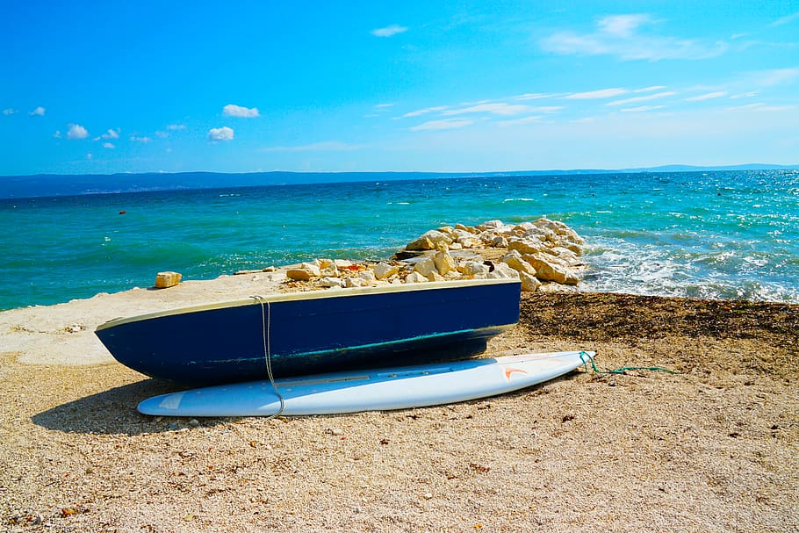 | 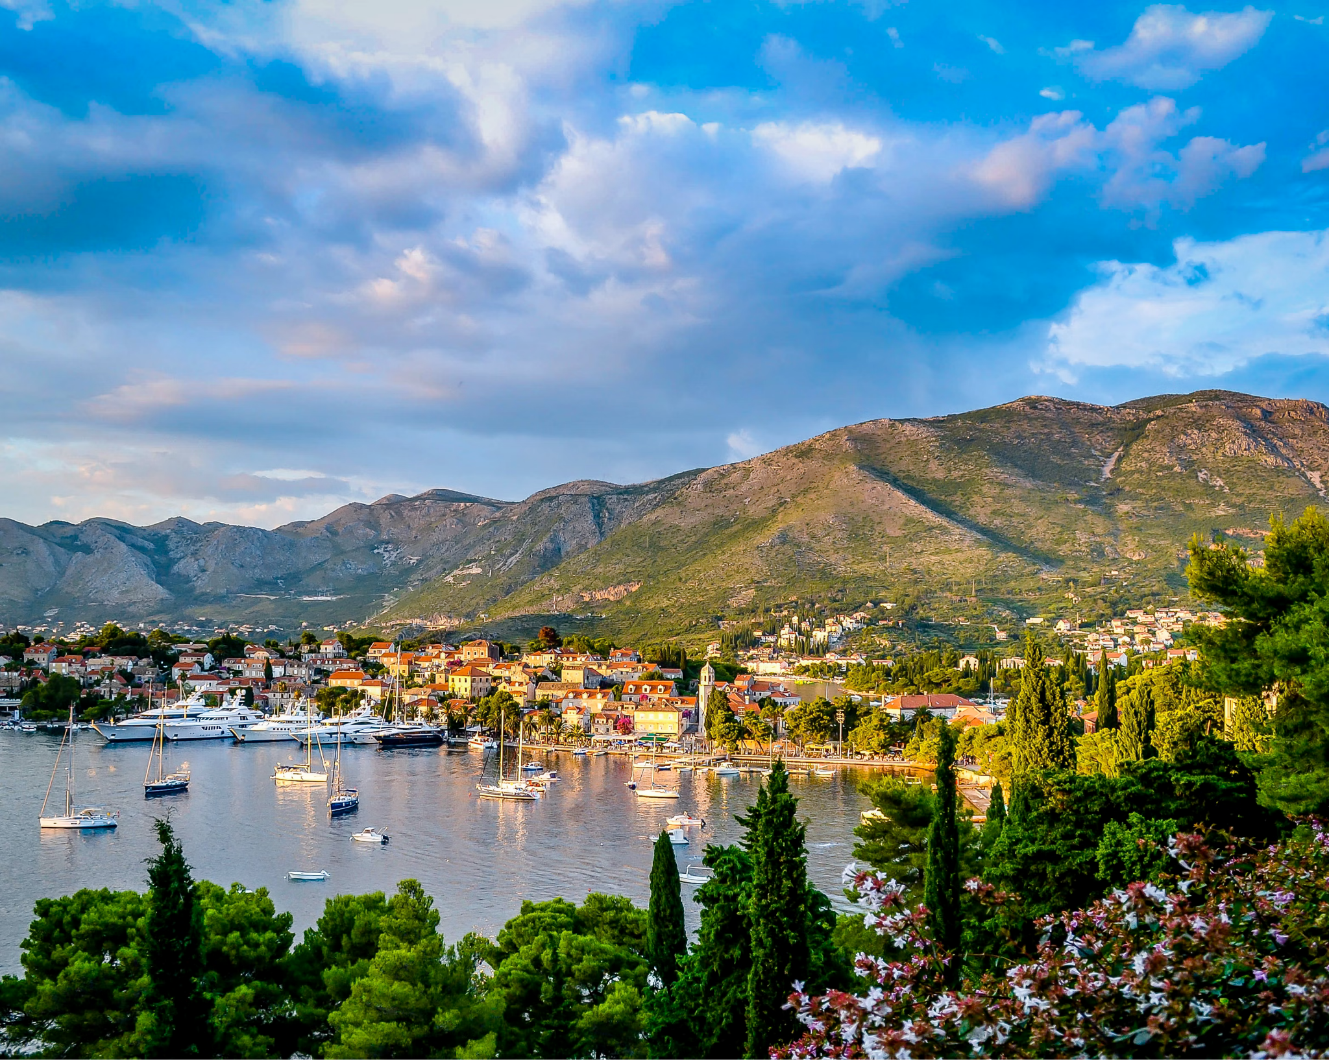

| Razumijevanje
1 | S kim Davor planira na ljetovanje?
 | -
2 | Što Davor može raditi s njom?
 | -
3 | Što Davor misli, kakav će biti odmor s njom?
 | -
4 | Što će Davor raditi sam?
 | -
5 | S kim Mario planira na ljetovanje?
 | -
6 | Što Mario može raditi s njim?
 | -
7 | Što Mario misli, kakav će biti odmor s njim?
 | -
8 | Što će oni posjetiti?
 | -

| Osobna pitanja
Imagine that you have a chance to travel with Davor and/or Mario and answer the questions.
1 | Je li bolje putovati s Davorom ili s Marijem? Zašto?
 | -
2 | Što želiš raditi s Davorom na Visu? Kamo želiš ići s njim?
 | -
3 | Što želiš raditi s Marijem u Istri? Kamo želiš ići s njim?
 | -

7.1 Zadatak 19. S kim ne ideš na odmor?
Check the Google document handout with Mario’s and Davor’s options for traveling that you already encountered in previous tasks. At this point, you already know who they plan to travel with. Now, read the following statements from Davor and Mario. Who do they not want to travel with? Read each argument and decide who they are referring to. In the first column write who says it. In the second column write to whom they are referring to by answering the question. The first one is done for you.
Davor ili Mario? | S kim ne želi putovati? | RAZLOG [reason]
Mario | S Jasnom i Katarinom | S njima nije dobra ideja. Navečer vole izlaziti u klubove.
 |  | S njim nije zabavno. On ne voli noćni život.
 |  | S njom je dosadno, uvijek je na mobitelu.
 |  | S njim nije dobro putovati. Ne voli izlaziti u klubove.
 |  | S njima nije zanimljivo. Ne vole biti na suncu.
 |  | S njim nije zabavno. On voli skijanje, ne voli more.
 |  | S njom nije dobro putovati jer ona ne voli prirodu.
 |  | S njom nije dobro putovati. Ona voli izlaziti u klubove.

7.1 Zadatak 20. S kim ideš na odmor?
Finish the sentences so that they are true for you. First, use the information from column (a), then from column (b), and finally add one reason from column (c). Column (a) and (b) follow each other in the same row. In section (c) you can choose whatever is true for you. Your instructor will check your answers.
(a) | (b) | (c)
s bratom | s njim | ugodno
s tatom |  | dinamično
s prijateljem |  | zabavno
s ujakom |  | dosadno
sa sestrom | s njom | neugodno
s mamom |  | zanimljivo
s prijateljicom |  | monotono
s tetom |  | smiješno
s braćom | s njima | uzbudljivo
s roditeljima |  | ?
s prijateljima |  | ?
sa sestrama |  | ?
s prijateljicama |  | ?

| Odgovori na pitanja.
Na primjer: Želim putovati sa stricem. S njim je uvijek zanimljivo.
S kim želiš putovati?
→
S kim ne želiš putovati?
→
S kim često putuješ?
→

7.1 Zadatak 21. Planiramo odmor
👥 Grupni rad. Choose one of the city maps. Explore the city online and find at least four different locations that you would like to visit. Since you are working as a group, it has to be something you all like/are interested in.
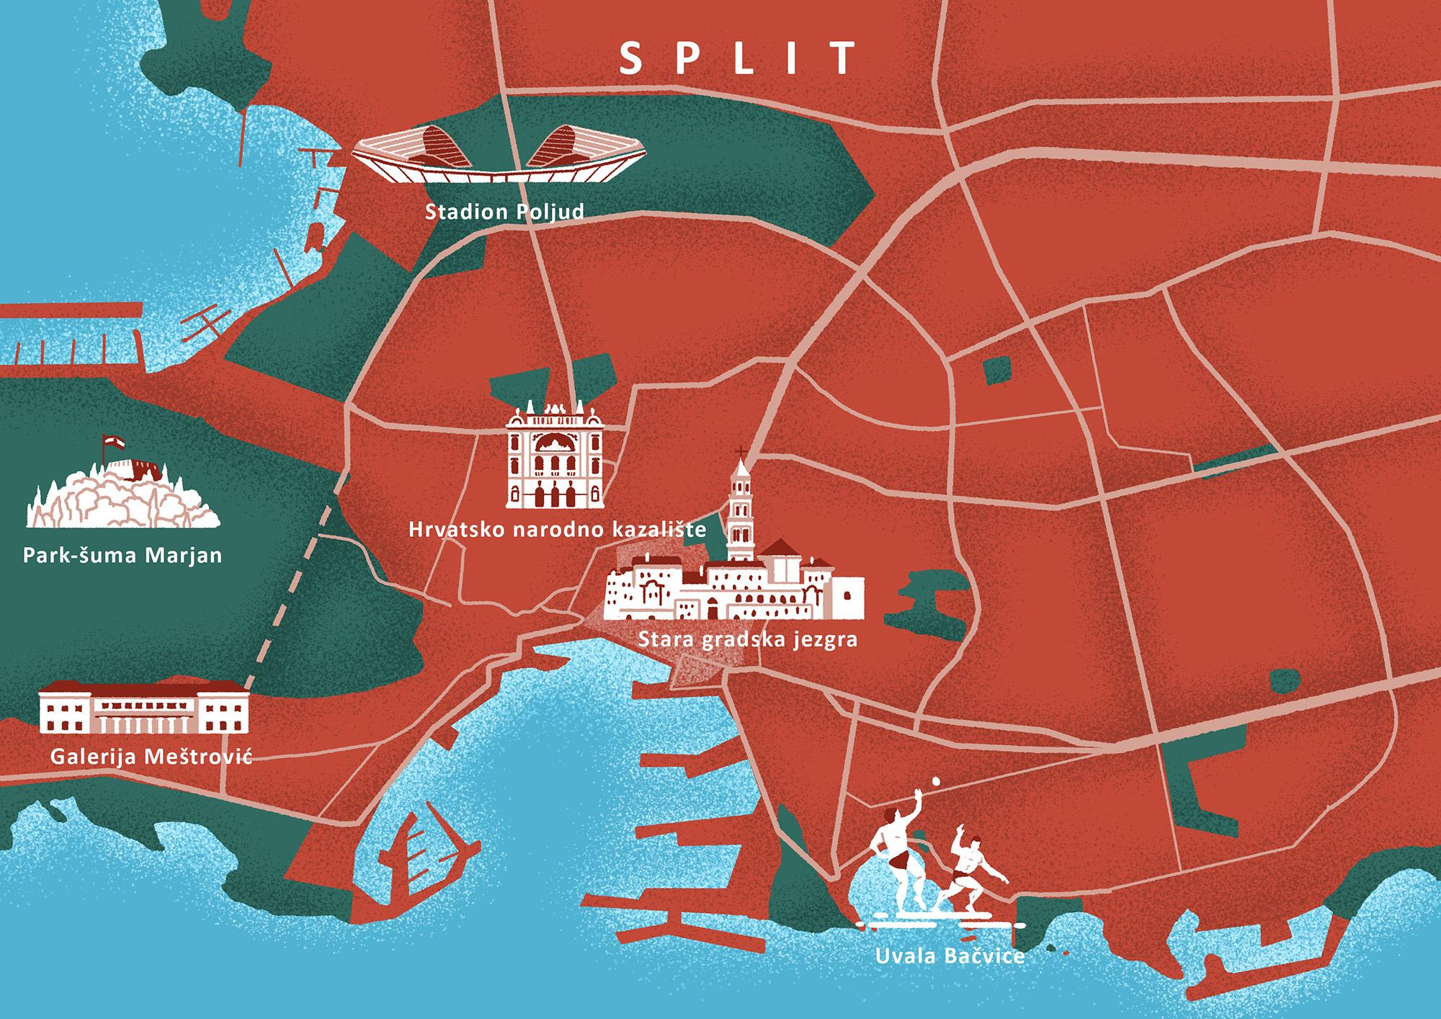 | 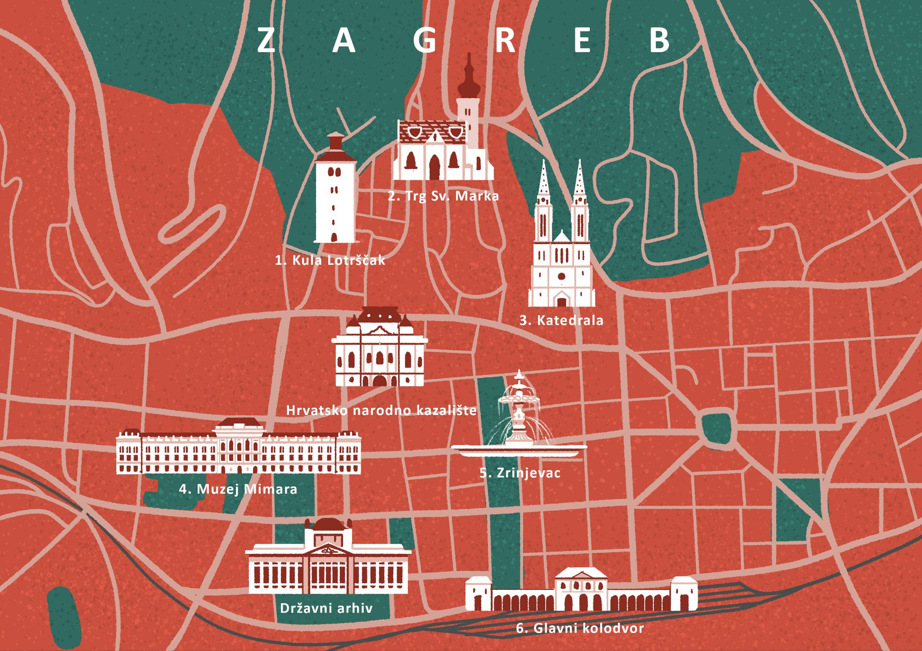

Part 1
While looking at the map, ask each other the following questions in order to find things you all like. Feel free to ask any other questions that might be relevant. These are just examples.
| Pitanja
Želiš li vidjeti/posjetiti […]?
Sviđa li ti se […]?
Želiš li ići u/na [...]?

Part 2
When you are done exploring the map, and you have collected the answers from everyone in your group, find an appropriate set of pictures online that will represent your choice. Under each picture, write the appropriate caption (i.e., what does it represent).
copy-paste picture #1 here | copy-paste picture #2 here
Što je to? | Što je to?
copy-paste picture #3 here | copy-paste picture #4 here
Što je to? | Što je to?

Part 3
For each city attraction that you chose, write who you are going with and why. Be sure to mention what you will do there. Here is an example for one location:
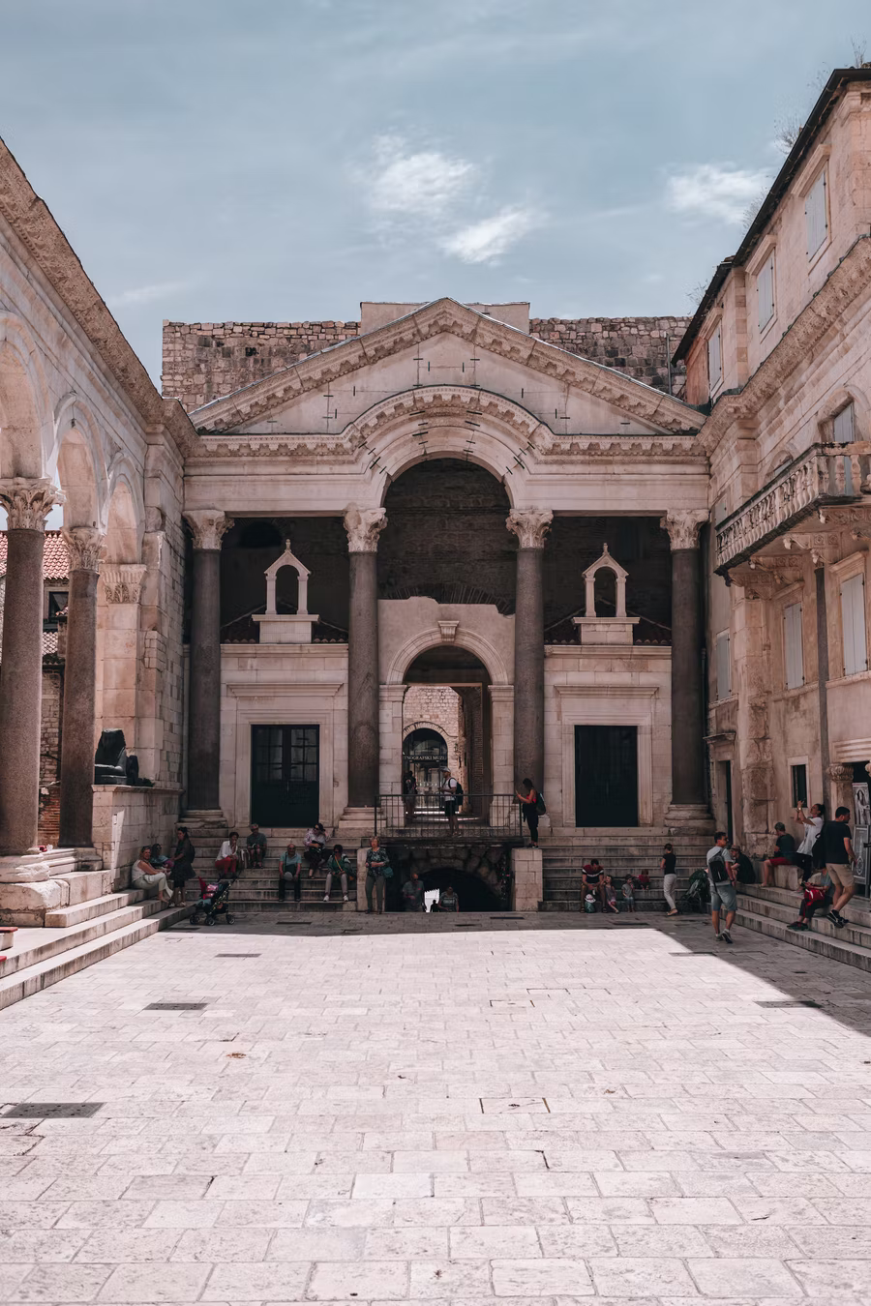 | 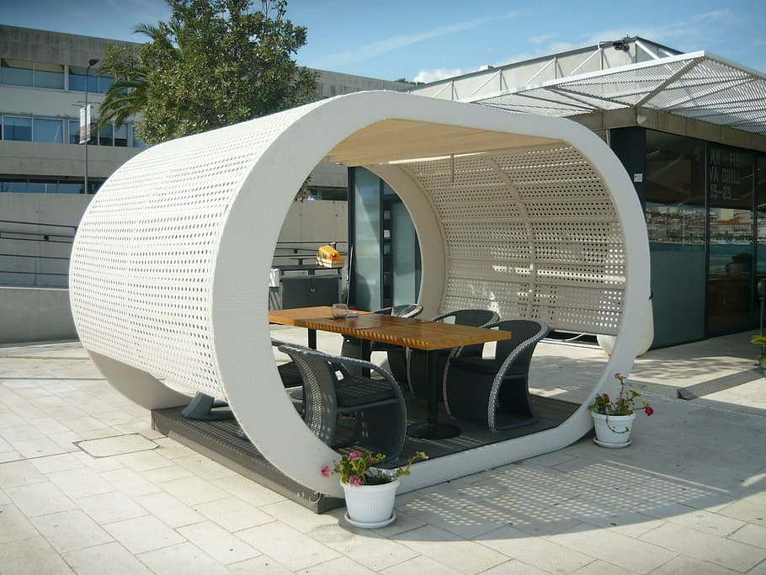
Na primjer: Želim putovati u Split. Mislim da je Marko dobro društvo za putovanje. Uvijek je spreman za akciju. S njim mogu posjetiti Dioklecijanovu palaču. Možemo ići na plažu, plivati i sunčati se. Navečer s Markom mogu ići na večeru ili u klubove. On je organizirana osoba. Kada putuje, uvijek puno istražuje o lokacijama koje planira posjetiti. Puno čita i uvijek zna gdje možemo jesti dobru hranu.

*istraživati (Present Tense: ja istražujem) - English: to do research/investigate.

| Lokacija 1
→
| Lokacija 2
→
| Lokacija 3
→
| Lokacija 4
→
Images used in this document are from these sources.

