6.10 - koníčky - hobbies

Let’s learn about hobbies in Czech. First, we need to learn the word for hoby, which is koníček.

  některé typické koníčky | 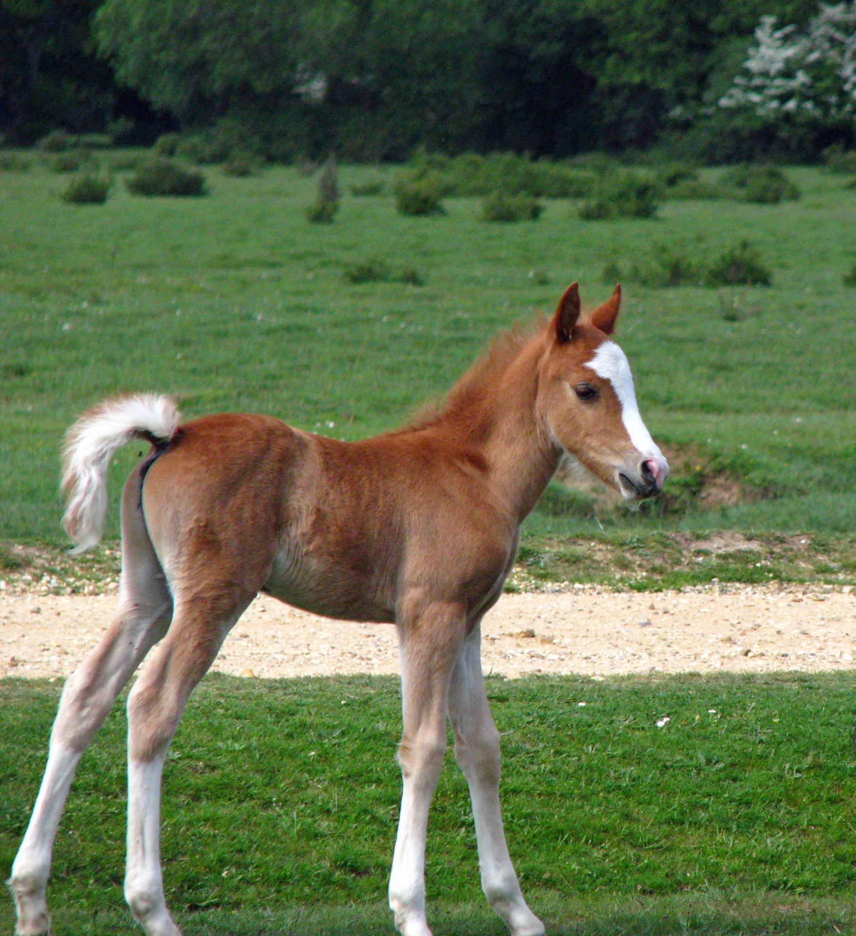  tohle je taky koníček

Interesting Etymology

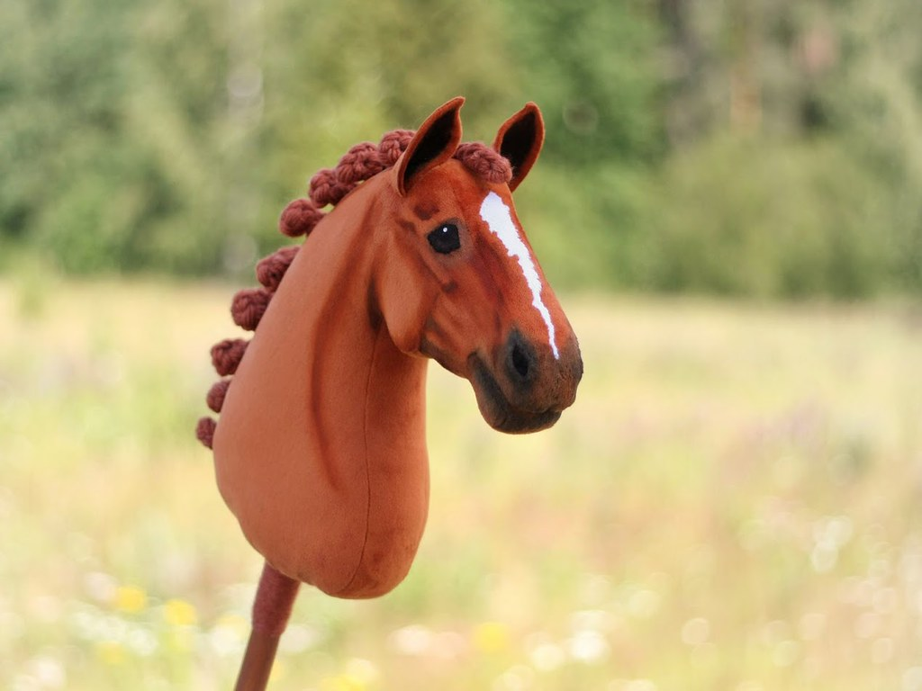 | You already know the word kůň (jezdit na koni - to ride a horse). Well, it turns out the word koníček is a little horse (diminutive form). While they are unrelated, I always remember the term hobby horse (pictured right) as a way to remember the word koníček. Interestingly, some Czechs treat koníček as animate. Obviously a hobby itself is not animate, but since it also means little horse, they will treat it as such – mám zajímavého koníčka (MA) / mám zajímavý koníček (MI) or To jsou moji koníčci (MA) or To jsou moje koníčky (MI). You can do it either way and be ok, but just be aware this is why the endings change on it.

One useful word to talk about hobbies (as well as tons of other stuff) is různý - ‘various’:


Já mám různé koníčky, například ježdění na skateboardu, videohry, kytara a skákání s padákem.

Images used in this document come from these sources.

