6.9 - Hudební nástroje

Co Čech, to muzikant.
Where there is a Czech, there is a musician.

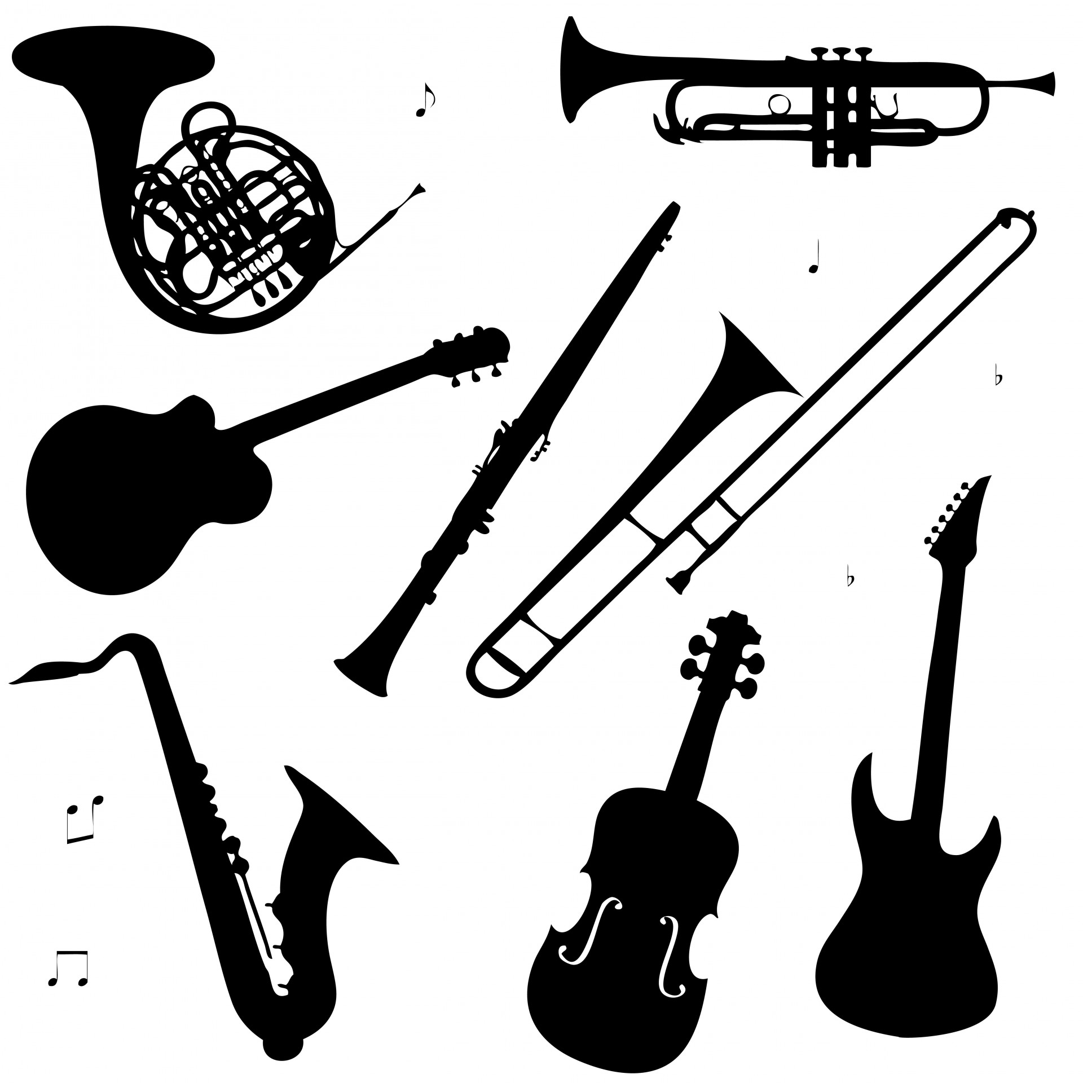 | 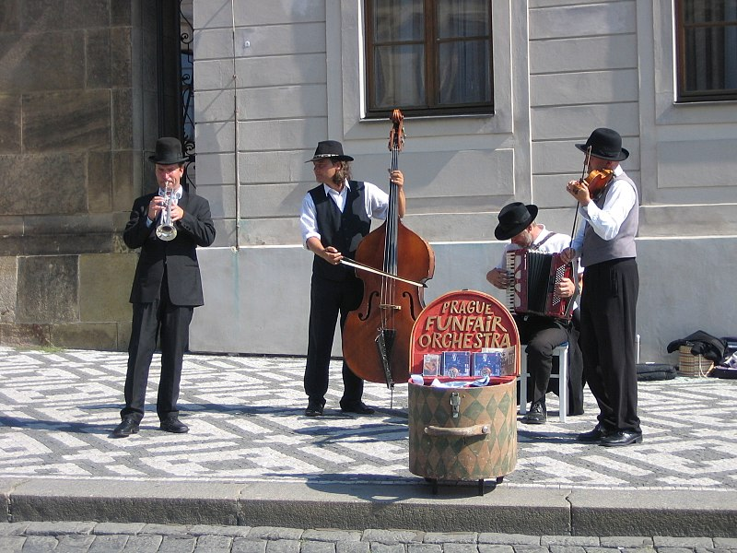

Playing an instrument is very common in the Czech Republic and the common phrase given above attests to this (don’t worry if the phrase is hard to make out in Czech – it’s using somewhat uncommon colloquial language).

So we know the word hrát ‘to play’, right? So what else do we need to know? Well, the only other thing is to learn the whole construction, which is hrát na + Instrument (in accusative case):

Miloš hraje na bicí
Lucka hraje na kytaru.

It can also be used with umět ‘to know how’:

Neumím hrát na saxofon.
Václav umí dobře hrát na trumpetu.

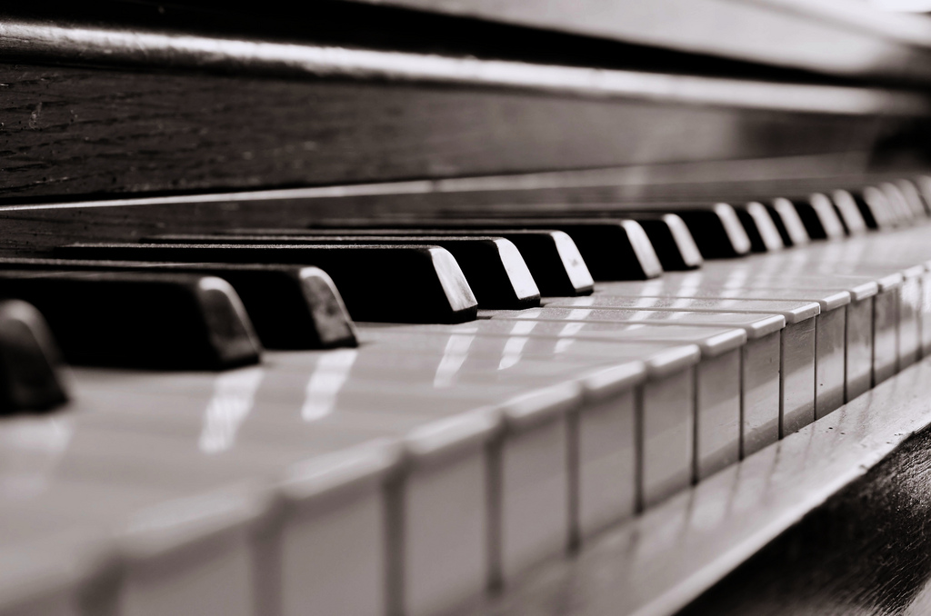 | klavír, piano | piano
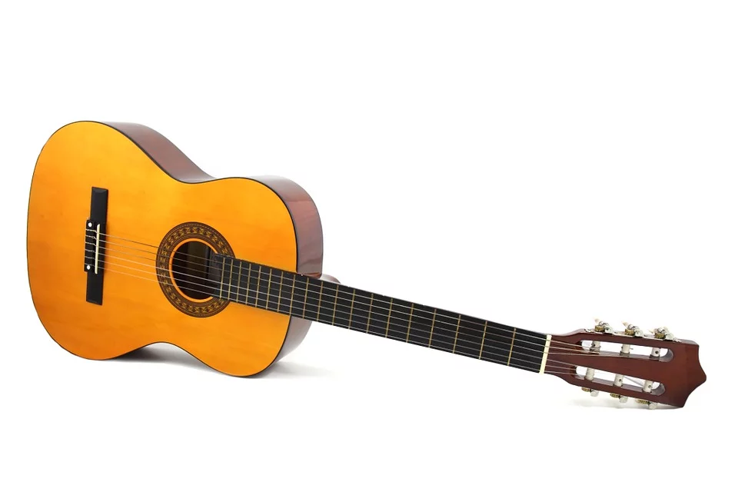 | kytara | guitar
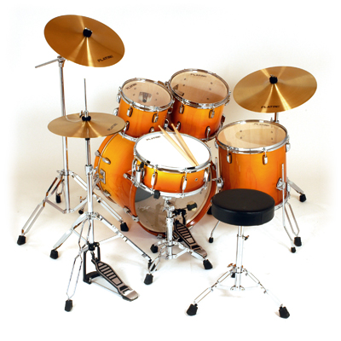 | bicí, bubny | drums
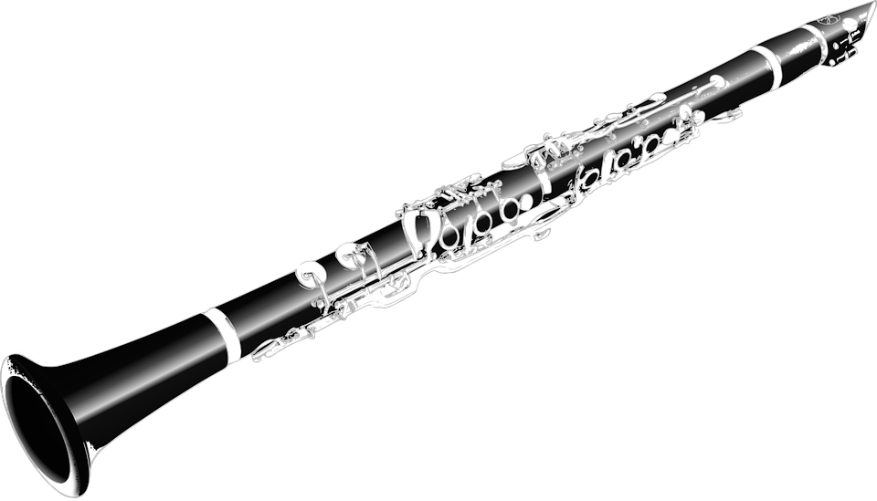 | klarinet | clarinet
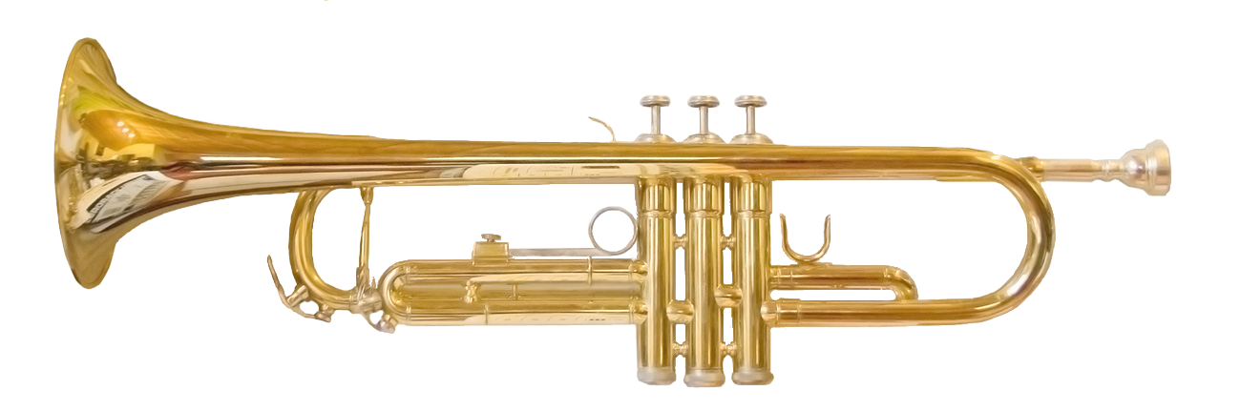 | trumpeta | trumpet
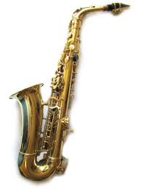 | saxofon | saxophone
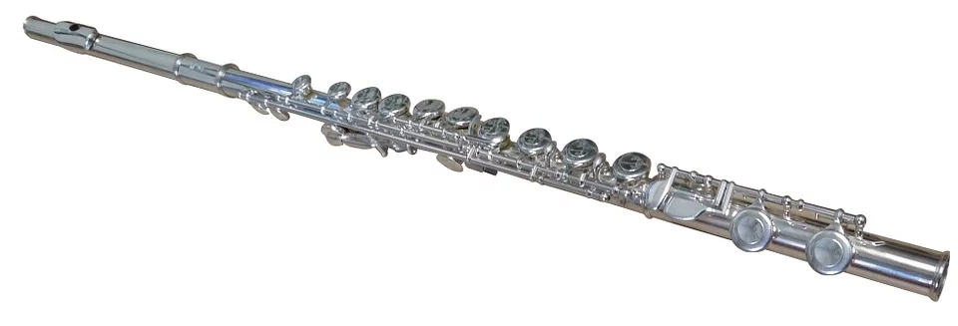 | flétna | flute

Images used in this document come from these sources.

