# 2.6 - *mít* + ACC plural forms (family members)

In [the previous lesson](https://docs.google.com/document/d/e/2PACX-1vRyc9SyABunORq9R33SpYUzToQfZeAJBL00BJ04YWY55_q3lWOLzyh5rDpepjsp1KNr9ScaZ2iNrBmd/pub) we learned the singular forms, so you could say things like *Jan has a brother, Marie has a cousin*, etc. That’s all fine and good, except people often have more than one brother, cousin, etc.

The following forms are useful in the plural:

**Accusative Plural Forms**

|  | **MA** | **MI** | **F** | **N** |
| --- | --- | --- | --- | --- |
| **Hard stem** | **-y**  bratry  Nom. pl. bratři  Acc. pl. bratry | **-y**  batohy  Nom. pl. batohy  Acc. pl. batohy  (i.e. no change) | **-y**  sestry  Nom. pl. sestry  Acc. pl. sestry | **-a**  piva  Nom. pl. piva  Acc. pl. piva |
| **Soft stem** | **-e**  synovce  Nom. pl. synovci  Acc. pl. synovce | **-e**  počítače  Nom. pl. počítače  Acc. pl. počítače  (i.e. no change) | **-e**  sestřenice  neteře  **-i**  věci  Nom. pl. sestřenice, neteře, věci  Acc. pl. sestřenice, neteře, věci | **-e**  moře  **-í**  náměstí  Nom. pl. moře, náměstí  Acc. pl. moře, náměstí |

Each box has a comparison of the Nominative plural and the Accusative plural. The highlighted forms in the Masculine animate should be a bit of good news. **This is the only place where nominative pl. and acc. pl. will differ.**

[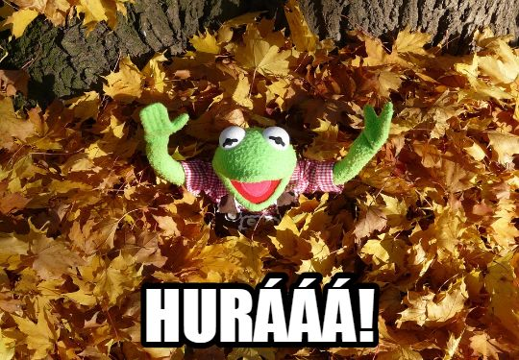](http://maxpixel.freegreatpicture.com/Great-Green-Hurray-Cheer-Kermit-Frog-Leaf-Piles-62817)

**Examples:**

*Máte bratry nebo sestry?*

Do you have brothers or sisters?

*Už nemám dědečky, ale mám jednu babičku.*

I no longer have grandfathers, but I have one grandmother.

You might also want to say how many relatives, dogs, cats, etc. you have. You can combine these with numbers ***dva/dvě, tři, čtyři*:**

*Petr má dva bratry.*

Petr has two brothers.

*Lukáš má dvě sestry.*

Lukáš has two sisters.

*Já mám čtyři tety.*

I have four aunts.

However, for now let’s not try to say **anything 5+** because that’ll need some extra forms.

[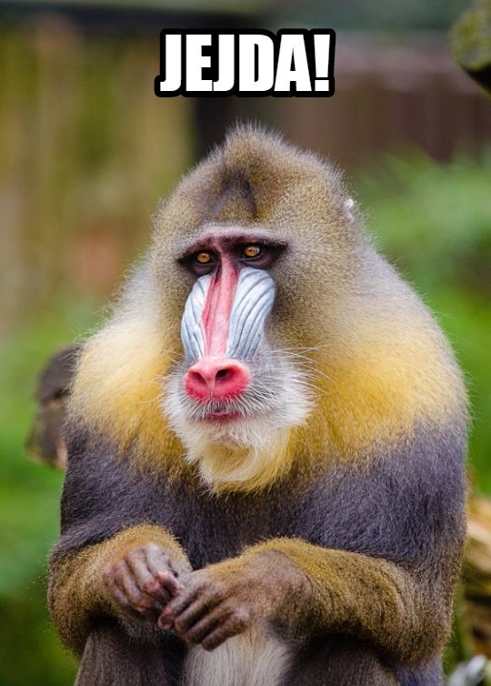](http://maxpixel.freegreatpicture.com/Cute-Mandrill-Mandrillus-Sphinx-Portrait-Sad-Face-1194343)

*jejda* means ‘oh dear!’

Images used in this document come from [these sources](https://docs.google.com/document/d/1ob3WPBc2PIWuMMfyjF6IDcxuBo1iyfqvtcL5dd9D0rE/edit#heading=h.dt10ywyj1226).