# 8.3 - Prepositions *v* and *na*

In this lesson we will learn a little more about the prepositions *v (ve)* ‘in, at’ and *na* ‘on, at’. Their first meanings (i.e. ‘in’ and ‘at’) are not difficult, e.g. -

|  |  |
| --- | --- |
| *Kočka je v krabici.*  ‘The cat is **in** the box.’ | *Kočka je na krabici.*  ‘The cat is **on** the box.’ |

However, Czech does not have a word that corresponds directly to our word ‘at’. Instead, Czech uses either *v* or *na* in this meaning:

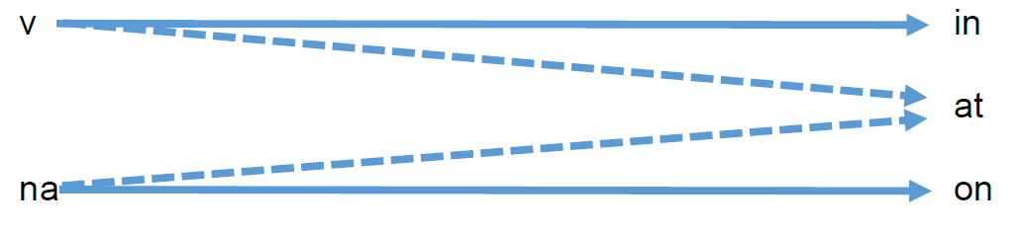

Examples of locations with *v* and *na*:

| *v (ve)* | | *na* | |
| --- | --- | --- | --- |
| *v práci* | ‘at work’ | *na nádraží* | ‘at the train station’ |
| *v kině* | ‘at the movies’ | *na koleji* | ‘at the dorm’ |
| *v kavárně* | ‘at the cafe’ | *na záchodě* | ‘in the restroom’ |
| *v lese* | ‘in the | *na koncertě* | ‘at a concert’ |

As a default, you should pick the preposition *v*. The vast majority of places you encounter will be used with this preposition. The preposition *na* is only used sometimes in the meaning ‘at’, typically in the following circumstances:

| * activities and events | *na koncertě* ‘at a concert’  *na výstavě* ‘at an exhibit’  *na přednášce* ‘at a lecture’  *na hodině češtiny* ‘at Czech class’  *na výletě* ‘on a trip’ |
| --- | --- |
| * places associated with transportation | *na nádraží* ‘at the train station’  *na stanici* ‘at the station’  *na zastávce* ‘at the bus/tram stop’  *na letišti* ‘at the airport’ |
| * public institutions | *na poště* ‘at the post office’  *na úřadě* ‘at the city/state office’  *na ambasádě* ‘at the embassy’  *na univerzitě* ‘at the university’ |
| * cardinal directions | *na severu* ‘in the north’  *na jihu* ‘in the south’  *na východě* ‘in the east’  *na západě* ‘in the west’ |

These rules work for the most part, but can often be confusing. Additionally, there are just some words that use *na* without any rhyme or reason, such as:

*na záchodě* - in the bathroom

*na venkově* - in the countryside

*na koleji* - in the dorm

*na chatě* - at the cottage

*na hradě* - at the castle

*na náměstí* - on the square

Often it is just easier to memorize a list of words that are used with *na*. These words will be marked in your vocabulary.

*v* and *ve*

*ve* is typically used when there is a consonant cluster that would make pronouncing *v* a bit more difficult:

*ve škole* - ‘in school’

ve městě[1] - ‘in the city’

*ve kterém roce* - ‘in what year’

It’s also used when the following word begins with *v* or *f*:

*ve Vídni* - ‘in Vienna’

*ve filmu* - ‘in the film’

Images used in this document come from [these sources](https://docs.google.com/document/d/1HQqSIqnOQo0_cjj3ZbBSyDe-fgq1AEZhIxgZ_W4CIUA/edit#heading=h.yvl7fhfmr120).

1. It may look like there is no consonant cluster here, but recall that the letter *m* followed by *ě* is pronouns *mň*, which means you’re actually pronouncing a consonant cluster.