10 | 2 | Lekcija 1: Po Zagrebu

| The Street Names
How to say the street names in Croatian?
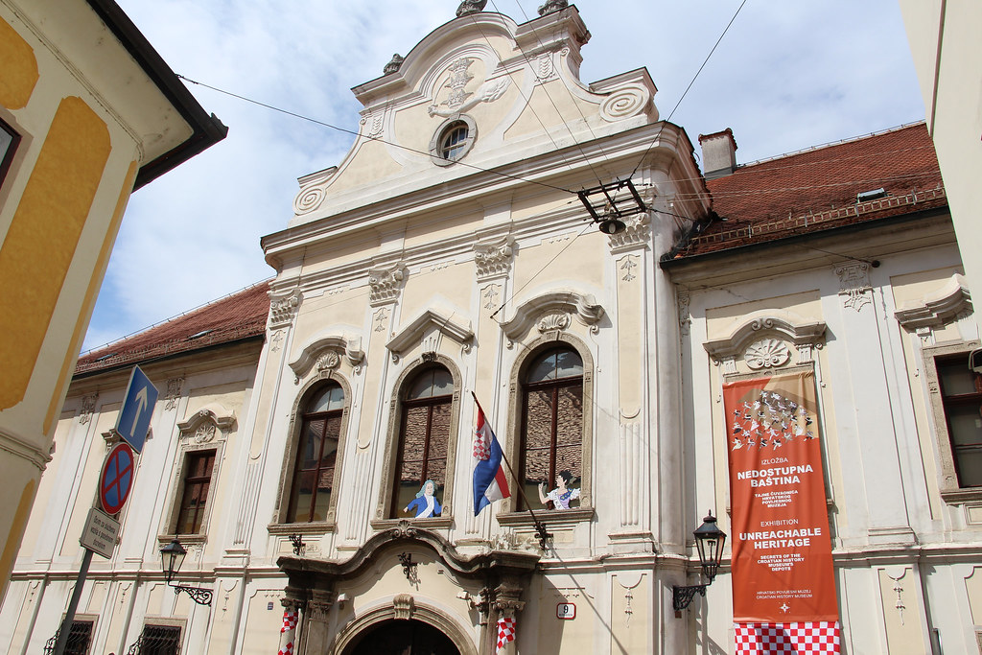 | 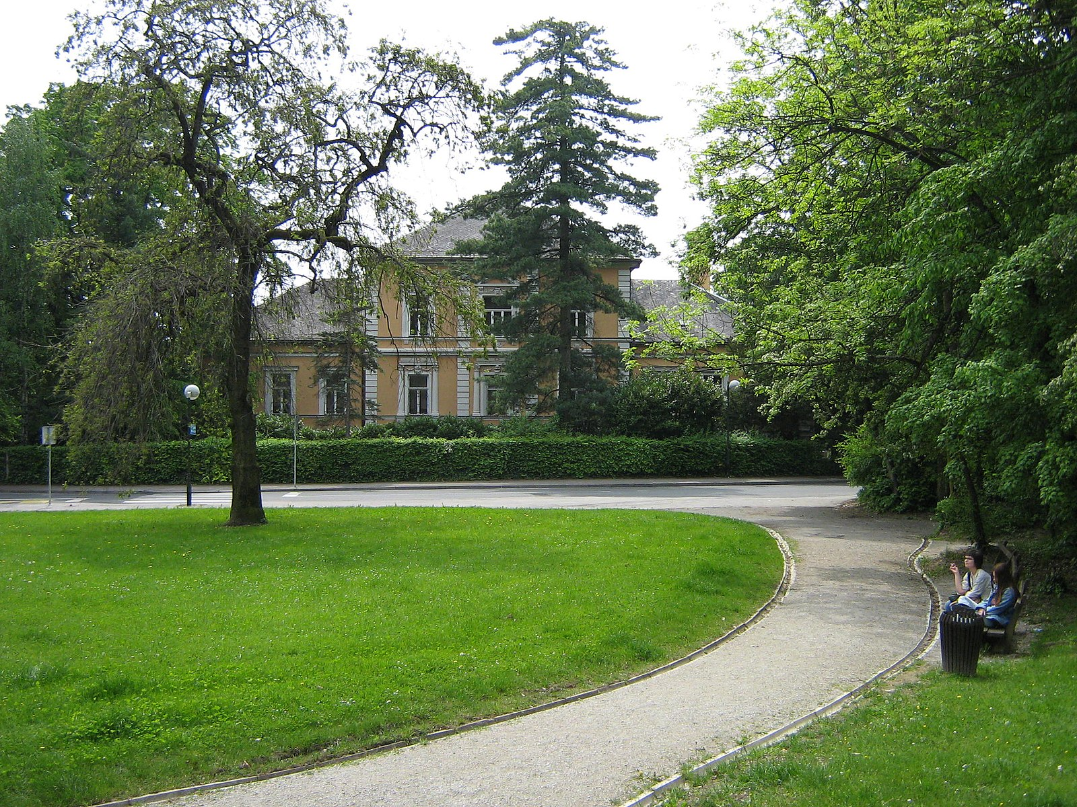
Hrvatski povijesni muzej | Hrvatski muzej arhitekture
Ulica Antuna Gustava Matoša 9 | Ulica Ivana Gorana Kovačića 37

| 1 | The Use of Genitive
Usually when talking about streets in Croatia, they are mostly named after certain people or historical events. For the purposes of this lesson, we will look only at the streets that are named after certain people.
Ulica Antuna Gustava Matoša | Ulica Ivana Gorana Kovačića
The street of Antun Gustav Matoš | The street of Ivan Goran Kovačić

In these given examples, as you can see, we need to use the Genitive case. The use of Genitive is required because we are expressing the notion “of something/someone” (the street of…).

| 2 | The Use of Possessive Adjective
Most of the time the street names expressed in Genitive case can be simplified in conversation by using the possessive adjective form. When talking about street names, we will take the very last part of the street name (i.e., the last name of a person) and we will make the possessive adjective form expressing that something belongs to someone. In these examples: Matoš’s street and Kumičić’s street.
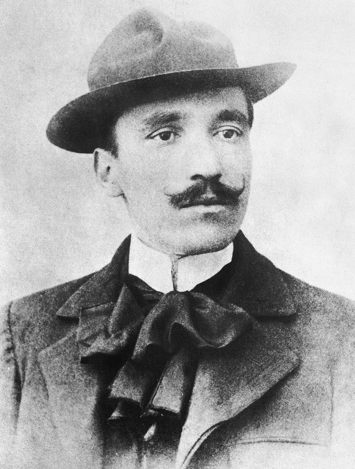 | 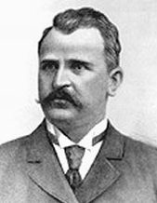
Ulica Antuna Gustava Matoša | Ulica Eugena Kumičića
[becomes] ↓ | [becomes] ↓
Matoševa ulica | Kumičićeva ulica

| Museums, Squares, Monuments, Statues
This same rule of using the Genitive case applies for museums, galleries, squares, monuments, statues, and other institutions that are named after a certain person.
 | 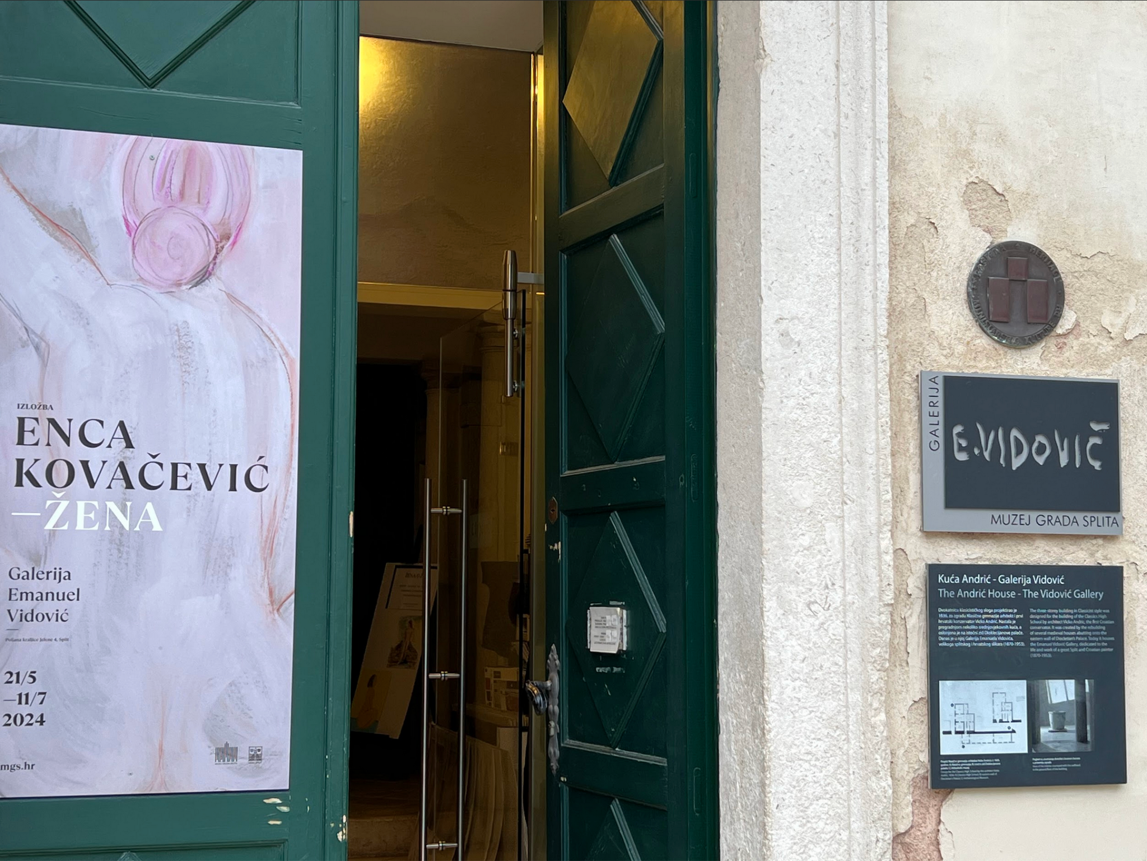 | 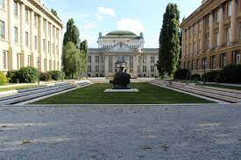
Muzej  Nikole Tesle | Galerija  Emanuela Vidovića | Trg  Marka Marulića
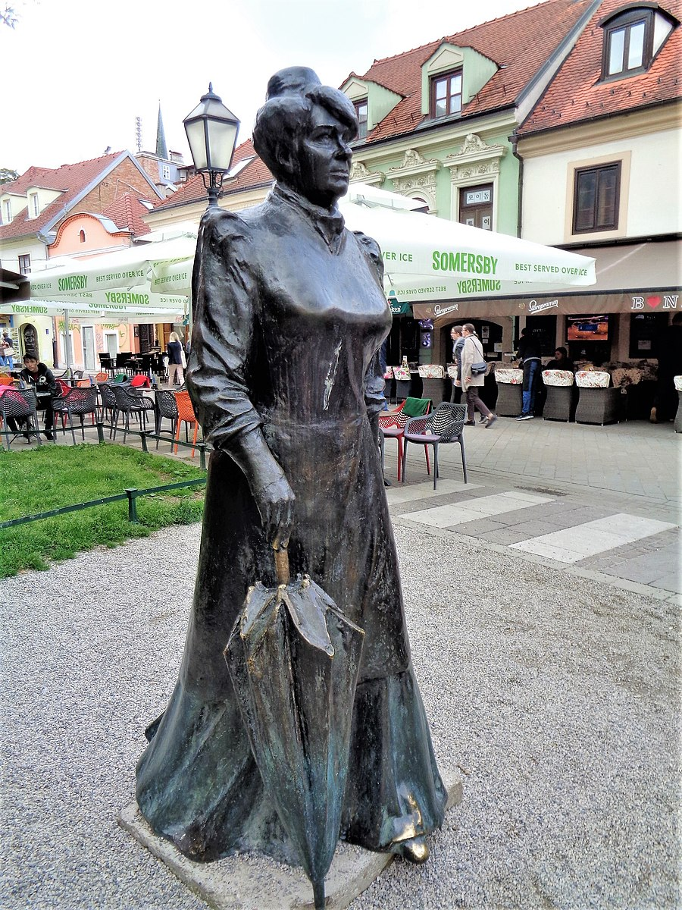 | 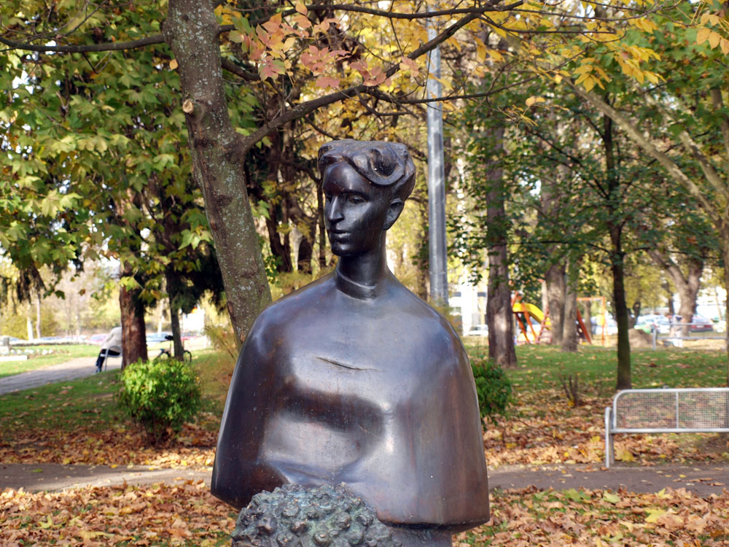 | 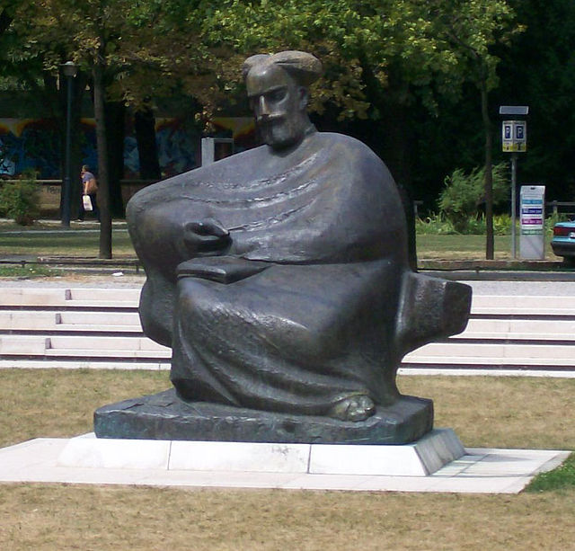
Kip  Marije Jurić Zagorke | Kip  Ivane Brlić Mažuranić | Kip  Marka Marulića

Pay attention! The difference between male and female forms.
Trg Marka Marulića | The square of Marko Marulić
Muzej Nikole Tesle | The museum of Nikola Tesla
Kip Ivane Brlić Mažuranić | The statue of Ivana Brlić Mažuranić
Kip Marije Jurić Zagorke | The statue of Marija Jurić Zagorka

Masculine names will take a certain Genitive case ending based on how the first and last name ends.
masculine | Marko Marulić - the first name ends in –o and the last name ends in a consonant, both take the Genitive masculine ending
 | Nikola Tesla - both the first and last name end in –a; it takes Genitive feminine ending
feminine | Ivana Brlić Mažuranić - remember, only the first name changes. Never the last name. Regular feminine ending in –a. It requires the use of the feminine genitive ending.
 | Marija Jurić Zagorka - the same rule applies. However, the “Zagorka” part in her name is a nickname that also has to change.

Images used in this document are from these sources.

