10 | 2 | Lekcija 1: Po Zagrebu

# 10.2 Zadatak 1. Zelena potkova

“The Lenuci Horseshoe or the Green Horseshoe is a U-shaped system of city squares with parks in downtown [...] Zagreb. The horseshoe was conceived in 1882 by Croatian urbanist Milan Lenuci. The parks were designed between 1883 and 1887, at a time when today's Donji grad formed the southern outskirts of Zagreb.” [Source](https://en.wikipedia.org/wiki/Lenuci_Horseshoe)

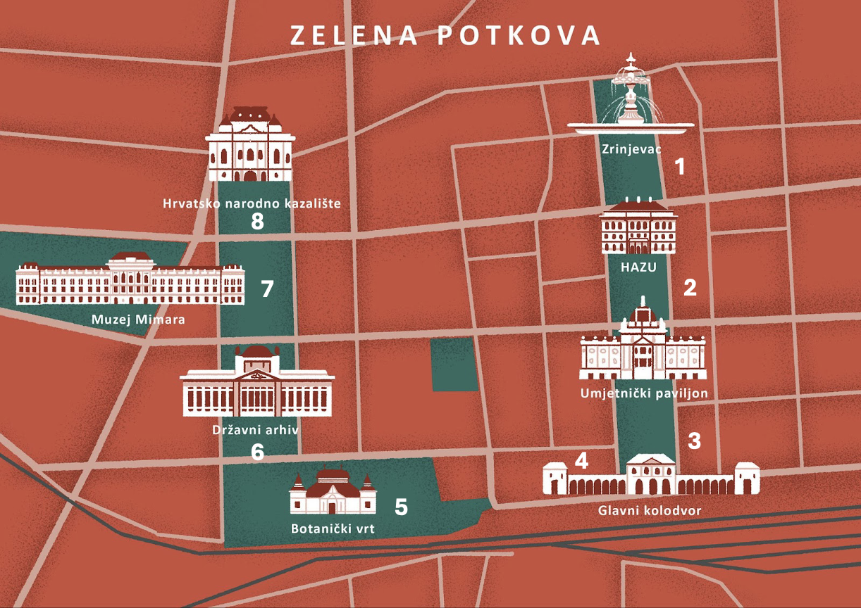

| 1  Trg Nikole Šubića Zrinskog | 2  Trg Josipa Juraja Strossmayera | 3  Trg kralja Tomislava | 4  Trg Ante Starčevića |
| --- | --- | --- | --- |
| 5  Botanički vrt | 6  Trg Marka Marulića | 7  Trg Ivana, Antuna i Vladimira Mažuranića | 8  Trg Republike |

Look at the specific places that we can visit within this green area. Write where they are located – on which square. You might need to search online for the locations or look at the image above.

|  |  |  |
| --- | --- | --- |
| Hrvatsko narodno kazalište | Park Zrinjevac | Zdenac života |
| ↦ | ↦ | ↦ |

# 10.2 Zadatak 2. Po Splitu

👥 Look at the map. Each of our students in Split is in a specific location. Your task is to search online for all four locations, associate each picture below with location, write the address, which student is at which specific location, and provide your reason why each of them is at that specific location. The reason why they are there is just your personal opinion, based on what you have learned about James, Ines, Matija, and Luka.

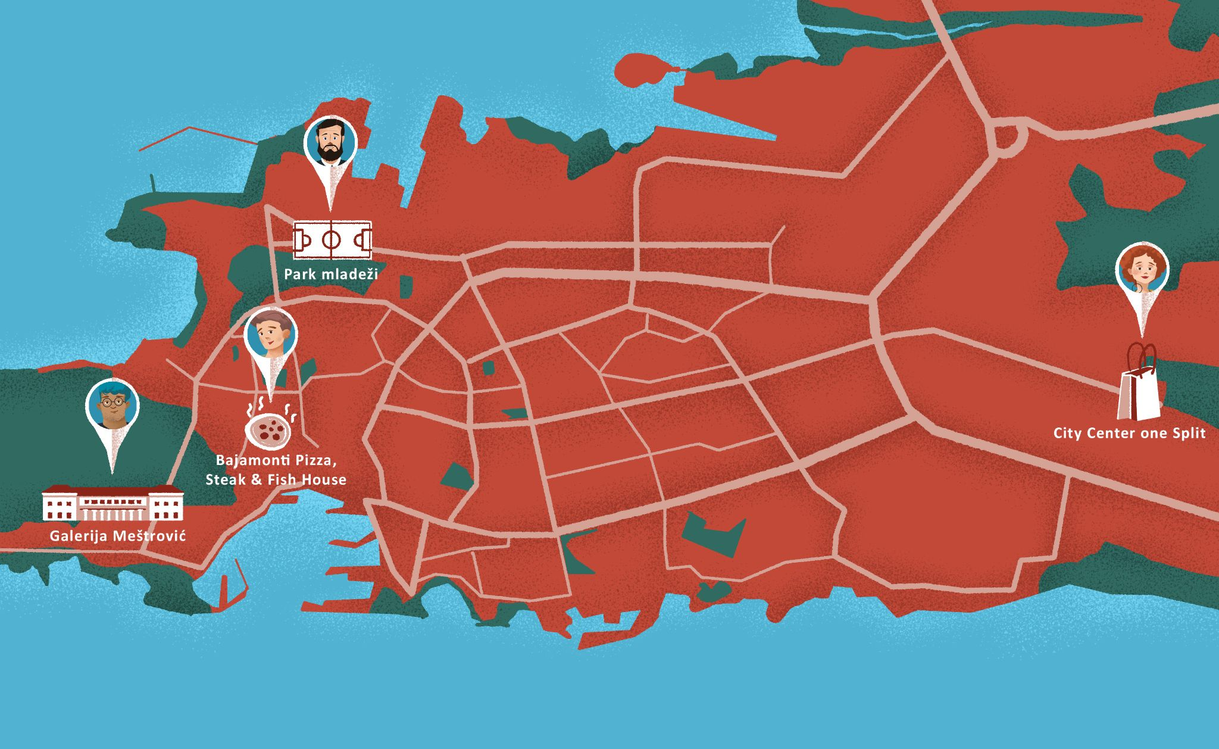

| Lokacija | Što je ovo? | Koja je adresa? | Tko je tu? | Zašto je tu? |
| --- | --- | --- | --- | --- |
|  | ↦ | ↦ | ↦ | ↦ |
|  | ↦ | ↦ | ↦ | ↦ |
|  | ↦ | ↦ | ↦ | ↦ |
|  | ↦ | ↦ | ↦ | ↦ |

[](https://www.maxpixel.net/Pinpoint-Map-Destination-Pin-Icon-Travel-Map-Pin-1272165) [](https://www.maxpixel.net/Graduation-Graduation-Hats-Success-Throw-Degree-4906360)

How well do you remember what our students are studying in Split? What is their future profession? Below you have the address for each university. Google the address to find out which university is located there, and fill in the missing information.

| Poljička cesta 35 | Ulica Fausta Vrančića 17 | Ulica Ruđera Boškovića 32 | Ulica Domovinskog rata 8 |
| --- | --- | --- | --- |
| Tko? | Fakultet: | Adresa: | Što studira? |
| Matija |  |  |  |
| James |  |  |  |
| Ines |  |  |  |
| Luka |  |  |  |

# 10.2 Zadatak 3. Što posjetiti

Search where the following locations are in Split. When you have your answers, meet with another student and discuss what you would like to visit from the list and why. Make a comment about where it is located in comparison to Dioklecijanova palača (for example: *blizu, daleko od, sjeverno od*, etc.). Submit your video recording online.

| Što? | Koja je adresa/lokacija? |
| --- | --- |
| Muzej grada Splita |  |
| Gradsko kazalište lutaka |  |
| Hrvatsko narodno kazalište |  |
| Kinoteka Zlatna vrata |  |
| Spomenik Marka Marulića |  |
| Restoran Bajamonti |  |
| Stara gradska vijećnica |  |

# 10.2 Zadatak 4. Po Hrvatskoj

💻 **Prezentacija**: Pick one city in Croatia. Find at least 5 different things that you would like to visit there – include the addresses. These can be museums, a city square, monuments, etc. Tell us in what part of the city each place is located (north, south, east, west of downtown). How would you organize your day visiting these places (i.e., in which order)? Tell us also why you want to visit these places. Watch the presentations and make comments – would you go there, what you think of these places. Would you add anything?

|  |  |
| --- | --- |

## | Pitanja

| Što želiš posjetiti? |
| --- |
| Koja je adresa? |
| Zašto želiš posjetiti to mjesto/lokaciju? |
| Gdje se nalazi? |

# 10.2 Zadatak 5. Kamo idemo prvo?

👥 This is a modified task from today’s class session. Work with a different classmate and choose a different section. Make a video recording of your discussion and dialogue in Croatian.

|  |  |
| --- | --- |

Task: Imagine that you are in Zagreb. You are supposed to meet each other for a tour around Zagreb. Before you make any plans or start a dialogue, you should decide together which type of activity you want to do in or near Zagreb. For each type of activity in the chosen section you have a set of different addresses. Find what they are and where they are on the map.

| Aktivnost | Adresa: | Atrakcija: |
| --- | --- | --- |
| Kultura | Rooseveltov trg 5 |  |
| Ulica Andrije Hebranga 1 |  |
| Preradovićeva ulica 8 |  |
| Varšavska ulica 5 |  |
| Arhitektura | Trg Marka Marulića 21 |  |
| Trg Sv. Marka 5 |  |
| Trg kralja Tomislava 22 |  |
| Trg Republike Hrvatske 10 |  |
| Shopping | Ulica Vice Vukova 6 |  |
| Trg Petra Preradovića 6 |  |
| Trg Ante Starčevića 7 |  |
| Trg Drage Iblera 10 |  |
| Razno | Mesnička ulica 19 |  |
| Aleja Hermanna Bollea 27 |  |
| Ulica Antuna Gustava Matoševa 9 |  |
| Ulica Nikole Tesle 10 |  |

When you have everything ready, make a dialogue. One of you is located at park Zrinjevac and the other one is located in front of botanički vrt. Make a phone call dialogue in which you ask each other where you are and make plans for where to meet. Discuss your plans, what would the order of visiting all the places be? Will you walk, take a tram, or taxi to some destinations?

# 10.2 Zadatak 6. Konverzacija – kultura

|  |  |
| --- | --- |

In today's lesson we talked about street/square names in Croatia. Think of your country and street names. Answer the questions.

| 1 | What did you notice about the naming of streets in Croatia? What is the most common pattern? |
| --- | --- |
| - |
| 2 | Does the same system/pattern exist in your country? Explain your answer. |
| - |
| 3 | Look at the names of streets in Croatia from today's lesson. Who are the people that have a street named after them? Give us at least 4 examples/people. |
| - |
| 4 | In your city – can you name a few streets named for a person? Who were these people? Is this similar to what exists in Croatia? |
| - |
| 5 | Why do you think Croatia doesn't use numbering for naming streets, such as 1st street, 2nd street, etc? |
| - |

### | Amerikanci u Hrvatskoj

|  |  |  |
| --- | --- | --- |

| Find the address of the following places and answer the question below. |
| --- |
| Muzej Mimara, Zagreb: |
| Američka ambasada u Zagrebu: |
| Ekonomski fakultet, Zagreb: |
| Why were places named for these particular people? |
| → |

Images used in this document are from [these sources](https://docs.google.com/document/d/1GviL5eWyPJ_XM2q6MaoZi783aEhGSHFSKkRrEhnksjE/edit#heading=h.shfvwvk0v5f7).