3 | 1 | Lekcija 7: Slika i prilika

3.1 Zadatak 23. Što ih zanima?
Look at the following sentences and indicate who has interest in what. Remember that you need to use only nouns (as shown below in the example) to indicate what the interest is. There is more than one possible answer. The first one is done for you.
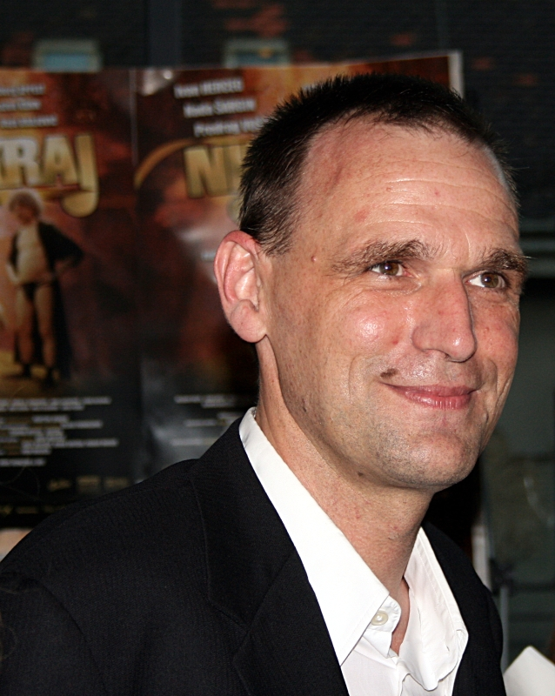 | 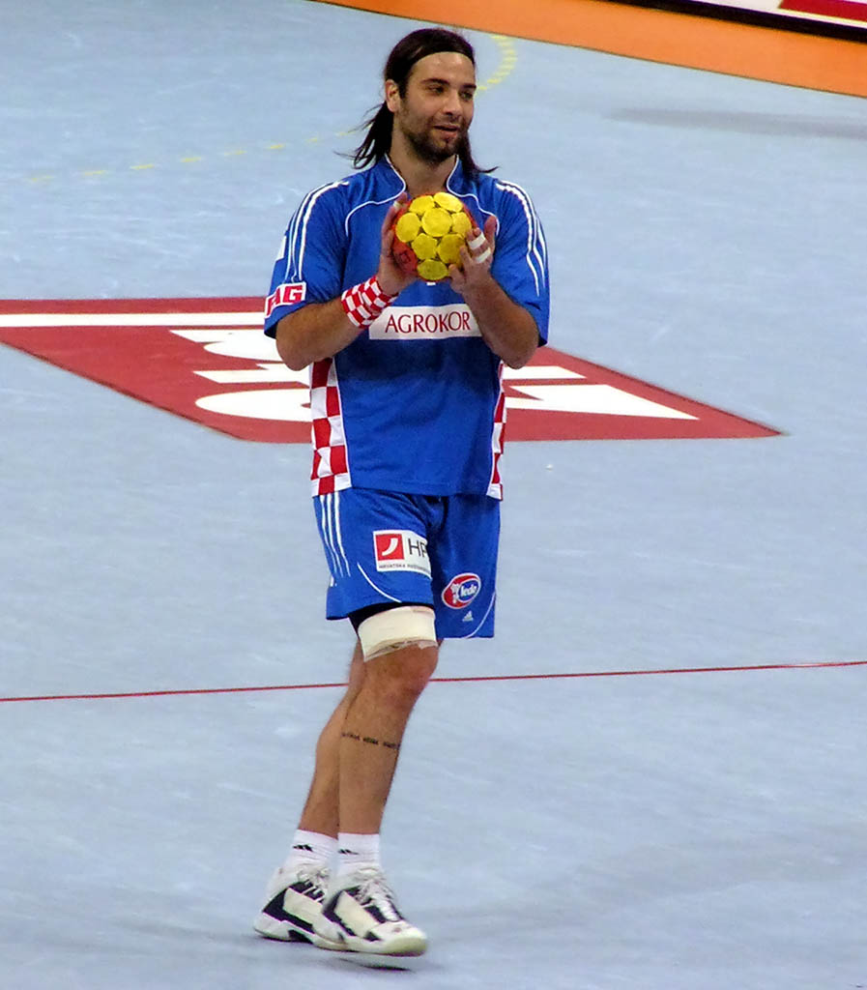 | 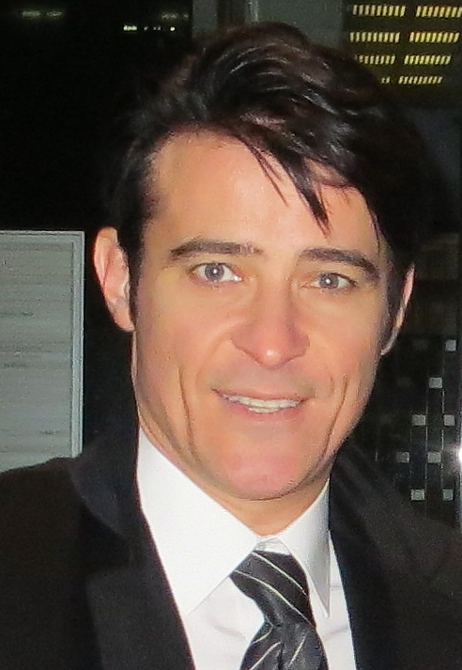
Vinko Brešan | Ivano Balić | Goran Višnjić

1 | 🎤 Marko Tolja je pjevač i voli svirati gitaru.
2 | 📚 Olja Savičević Ivančević voli pisati romane i pjesme.
3 | 🎬 Vinko Brešan voli snimati filmove.
4 | 🎭 Goran Višnjić voli glumiti.
5 | Vinko Brešan i Goran Višnjić vole snimati filmove.
 | -
6 | 🤾 Ivano Balić voli igrati rukomet.
7 | 🎾 Goran Ivanišević i Ivo Karlović vole igrati tenis.
8 | ⛷️ Janica Kostelić i njezin brat Ivica skijaju svaki dan.
9 | 🎶 Josipa Lisac voli pjevati.

3.1 Zadatak 24. Poznate obitelji
Below you will find information about two famous families. Talk with one of your classmates. Each of you needs to pick one family to work on before you meet. Based on your choice of family, look at the given information and prepare a logical presentation for your classmate. When ready to present, meet with your classmate. After you are done presenting, provide comments, opinions, or any additional information to your classmate. Submit your recording online.
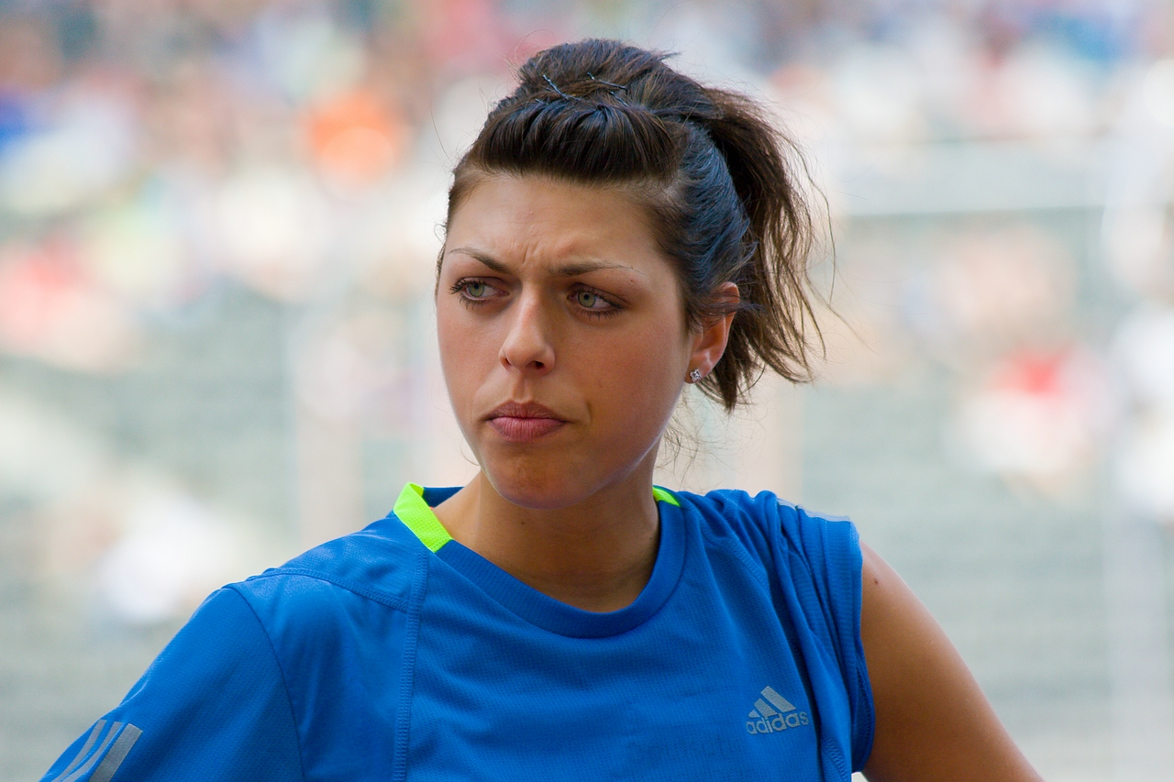 | Obitelj 1

Blanka Vlašić i njezina obitelj
mama | Venera | sin | Nikola, Marin, Luka
tata | Joško | kćerka | Blanka

Tko? | Što? | Interes?
Venera | bivša skijašica | sport, skijanje
Joško | Blankin trener, bivši atletičar | sport, atletika
Nikola | nogometaš | sport, nogomet
Blanka | atletičarka | sport, atletika

Blanka Vlašić is a very famous person in Croatia. She did several TV commercials. Search online to find at least one TV commercial that Blanka did. You'll need to show it to your classmate.
1 | Na koga sliči Blanka?
 | -
2 | Što Blanka reklamira? [reklamirati = to advertise]
 | -

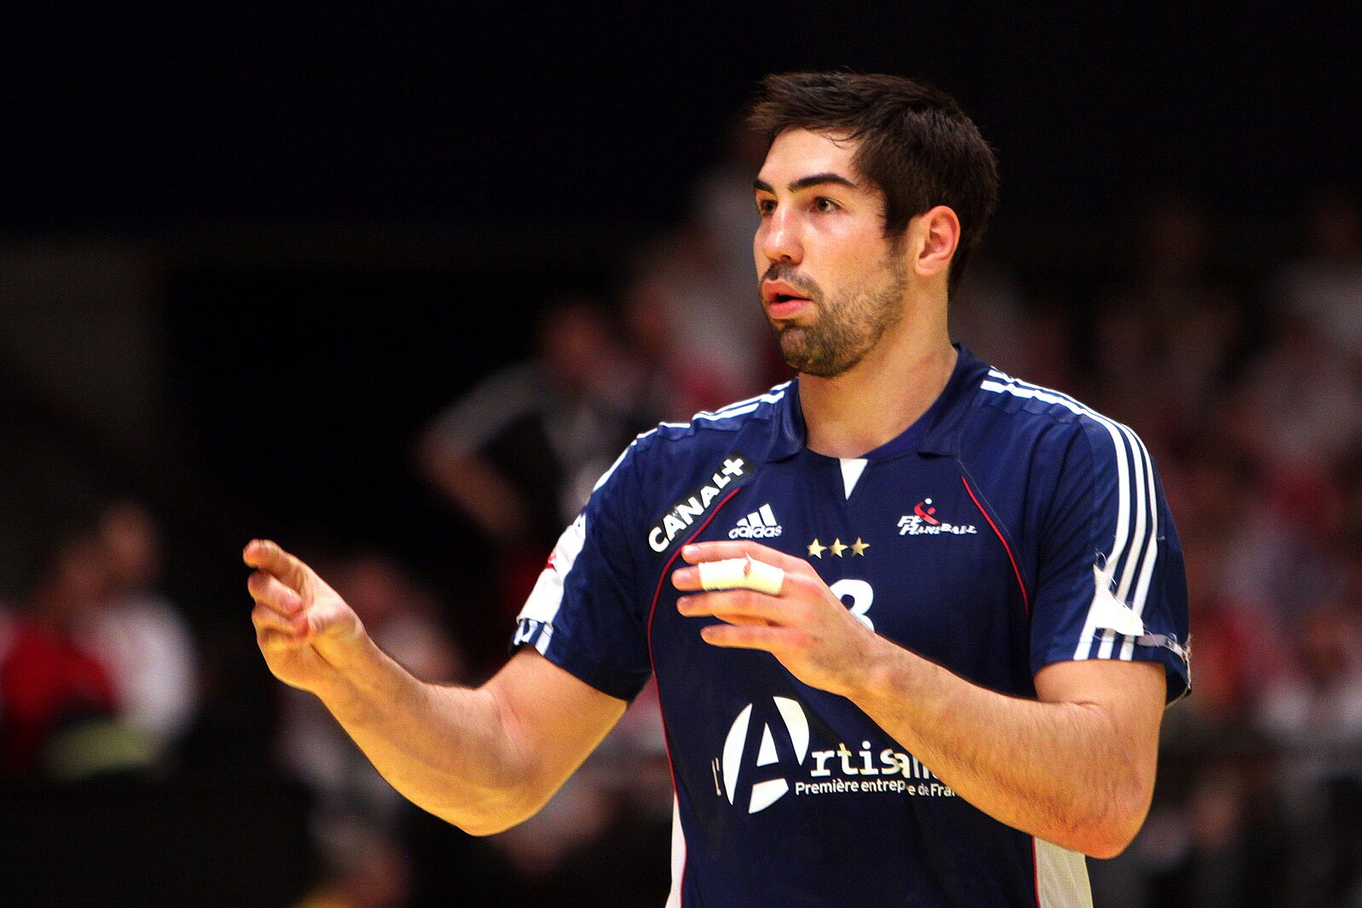 | Obitelj 2

Nikola Karabatić i njegova obitelj
mama | Radmila | sin | Nikola
tata | Branko | sin | Luka

Tko? | Što? | Interes?
Radmila | liječnica, Srpkinja | medicina
Branko | Trener, Hrvat | sport, rukomet
Nikola | rukometaš, Francuz | sport, rukomet
Luka | rukometaš, Francuz | sport, rukomet, tenis

Nikola Karabatić is a very famous person in France, but also in Croatia and Serbia. He did several TV commercials. Search online to find at least one TV commercial that Nikola did. You'll need to show it to your classmate.
1 | Na koga sliči Nikola?
 | -
2 | Što Nikola reklamira? [reklamirati = to advertise]
 | -

3.1 Zadatak 25. Poznate svjetska obitelji
Written assignment. Following the example from the previous task, write about one famous family of your choice. Be sure to include all family members – who they are, where they are from, what they do, what their interests are, any physical similarities, and what presence they may have in the media(commercials). Include a link if you find any commercial that a person/family did.

3.1 Zadatak 26. Interesi
Video recording. Work with one of your classmates that you have not worked with so far.
 | 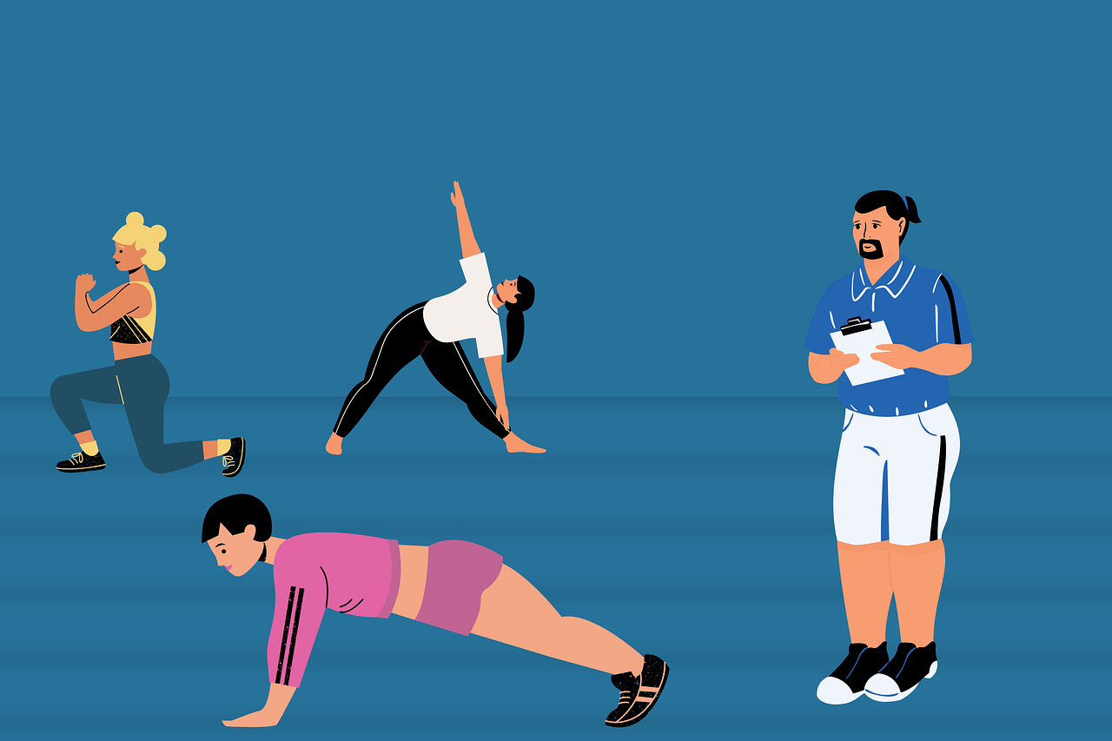
For this assignment you will need a picture of your family. If you do not want to share your personal photo with your classmates and/or video recorded assignment, find a picture online that you will use as your family. The goal of the assignment is to make a cohesive dialogue between two friends who are getting to know each other. Touch upon the topic of your family. You want to provide your new friend with more information. Follow the questions that your friend will ask you based on the picture you show them.

Questions in a dialogue to ask (related to family):
 | members of your (nuclear) family
 | what they do
 | their interests
 | activities in their free time
 | physical description/similarities
 | comments on specific family members
 | married or not married

3.1 Zadatak 27. Izreka

| Fraza
Answer in English
Listen to the dialogue from today’s session one more time. Pay attention to Sandra and her comments that she provides about Laura’s sister. There is one specific phrase that she used to make a comment about Laura’s sister. 🍏
1 | What did she say? What do you think it means? Can you think of an English equivalent?
 | -

Images used in this exercise are from these sources.

