2 | 3 | Lekcija 3: Izlazak

| More about numbers
You have already learned ordinal numbers 0 to 10. Now let’s investigate how would you say the following numbers in Croatian:
(audio) | 20 | dva + deset | dvadeset
(audio) | 30 | tri + deset | trideset
(audio) | 40 | četiri + deset > četirideset > tird > trd | četrdeset
(audio) | 50 | pet + deset > petdeset > td > d | pedeset
(audio) | 60 | šest + deset > šestdeset > std > sd > zd | šezdeset
(audio) | 70 | sedam + deset | sedamdeset
(audio) | 80 | osam + deset | osamdeset
(audio) | 90 | devet + deset > devetdeset > td > d | devedeset
(audio) | 100 | sto | sto

2.3 Zadatak 7. Brojevi
Listen to the following numbers and write the correct number that you hear. For example: [you hear “deset”] - Answer: Broj - 10.
[h5p id="698"]
Knowing the form of numbers above, now you are able to create any number from 20 to 100. Look at the following examples between 21 – 29.
(audio) | 21 | dvadeset (i) jedan
(audio) | 22 | dvadeset (i) dva
(audio) | 23 | dvadeset (i) tri
(audio) | 24 | dvadeset (i) četiri
(audio) | 25 | dvadeset (i) pet
(audio) | 26 | dvadeset (i) šest
(audio) | 27 | dvadeset (i) sedam
(audio) | 28 | dvadeset (i) osam
(audio) | 29 | dvadeset (i) devet

2.3 Zadatak 8. Koji je broj?
(audio)
[h5p id="276"]

2.3 Zadatak 9. Jesu li oni mladi ili stari?
Look at the following pictures and information. Are they young or old?
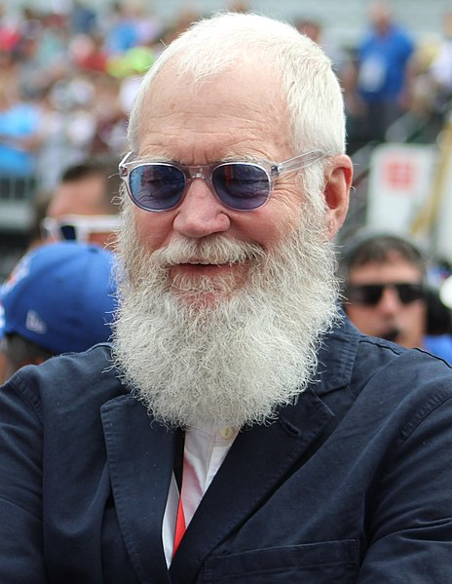 | 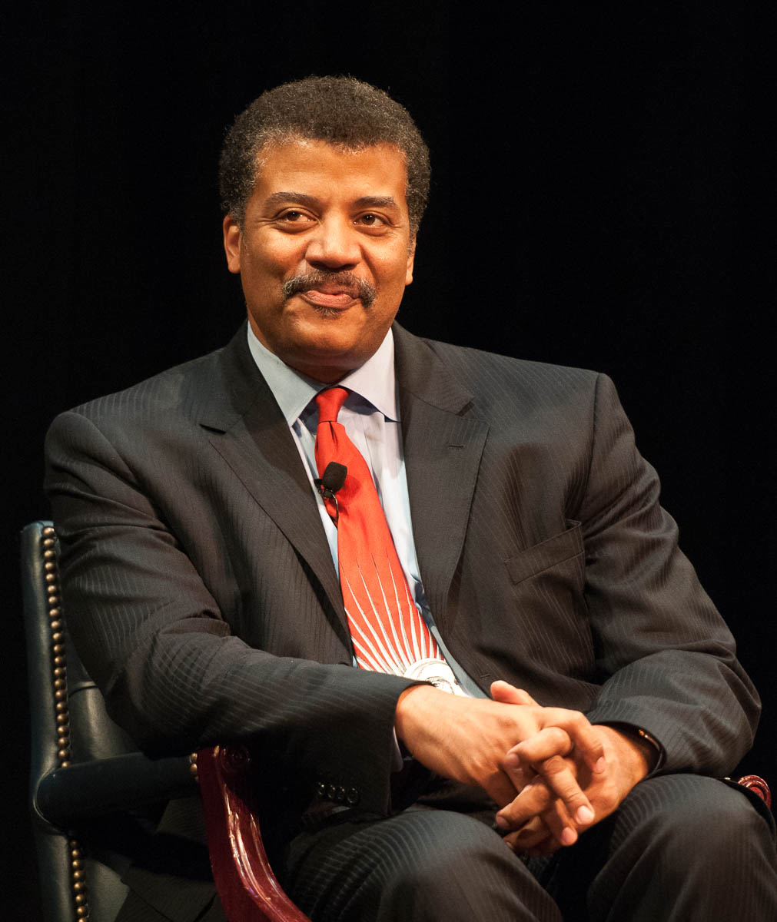 | 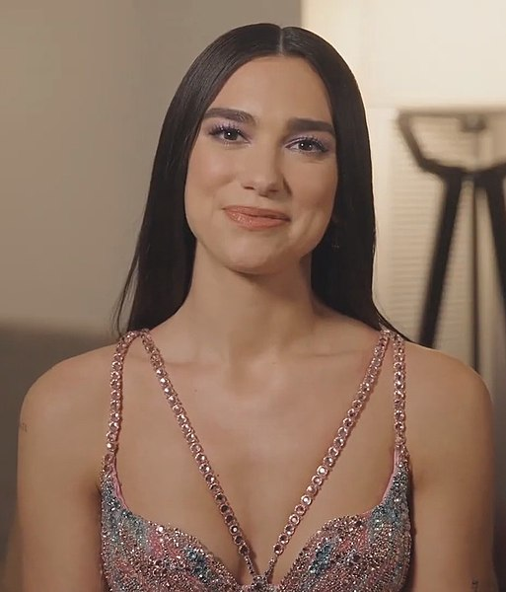
David Letterman  12.4.1947. | Neil deGrasse Tyson  5.10.1958. | Dua Lipa  22.8.1995.
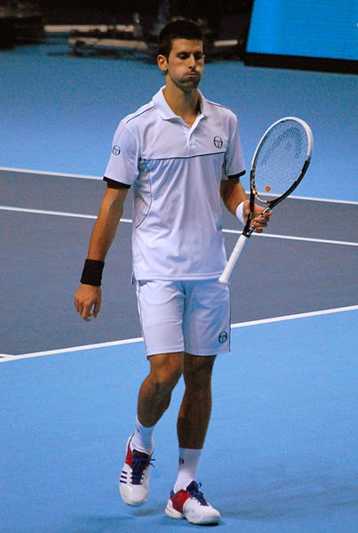 | 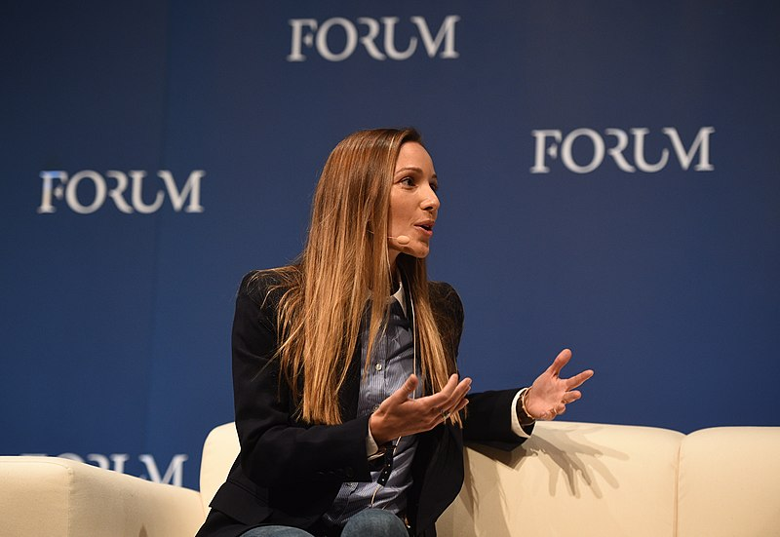 | 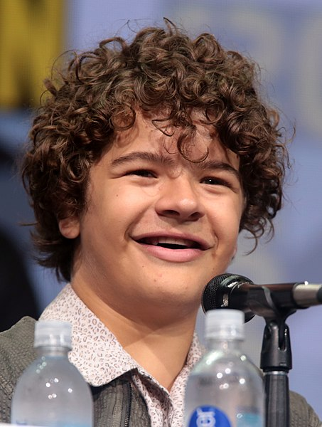
Novak Đoković  22.5.1987. | Jelena Đoković  17.6.1986. | Gaten Matarazzo  8.9.2002.

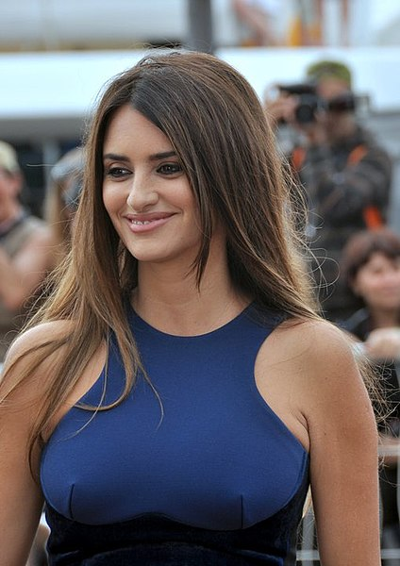 | 28.4.1974.  Je li ona stara?  Ne, ona nije stara. Ona je mlada. (or)  Je li ona mlada?  Da, ona je mlada.
[h5p id="235"]
[h5p id="236"]
Images used in this document are from these sources.

