9 | 3 | Lekcija 2: Doktore, pomozite!

| What can the doctor do?
Do you know what these images represent? What are the actions that a doctor can do when you go for a visit?
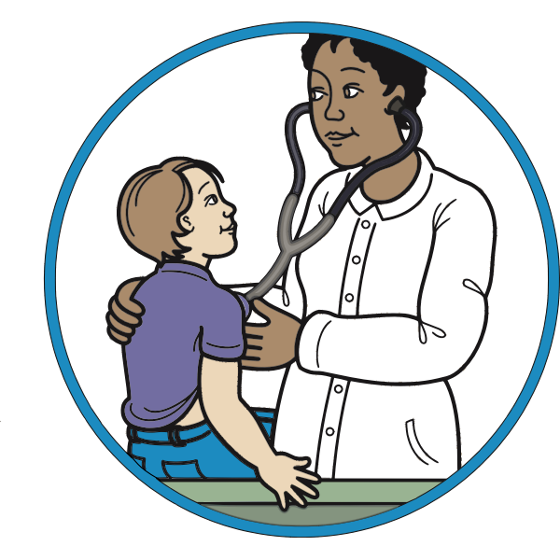 | 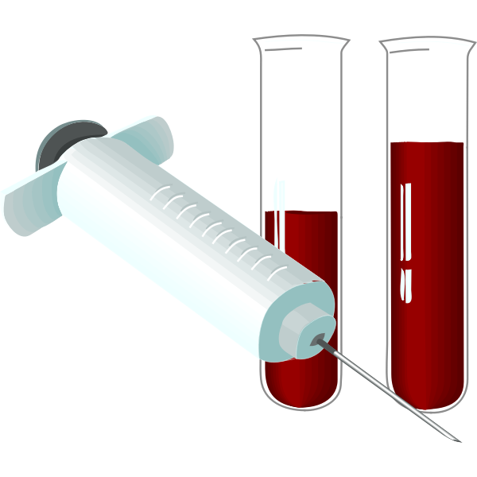 | 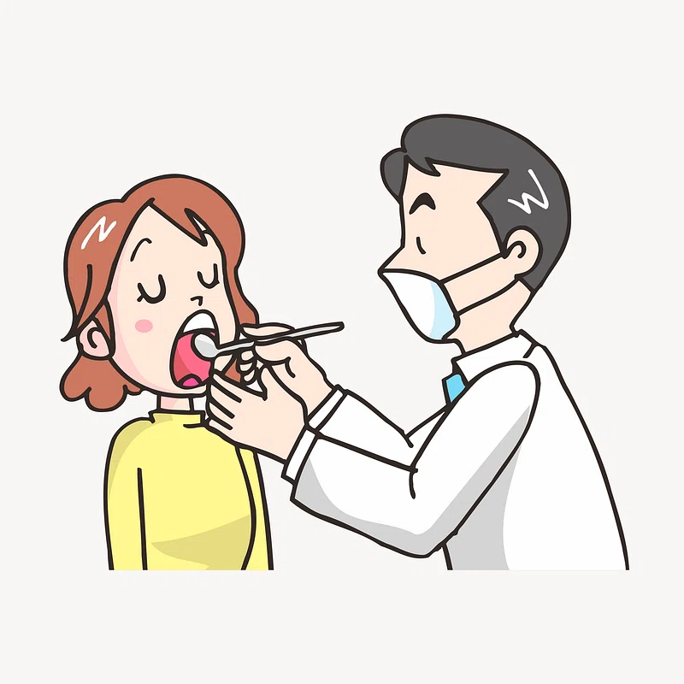 | 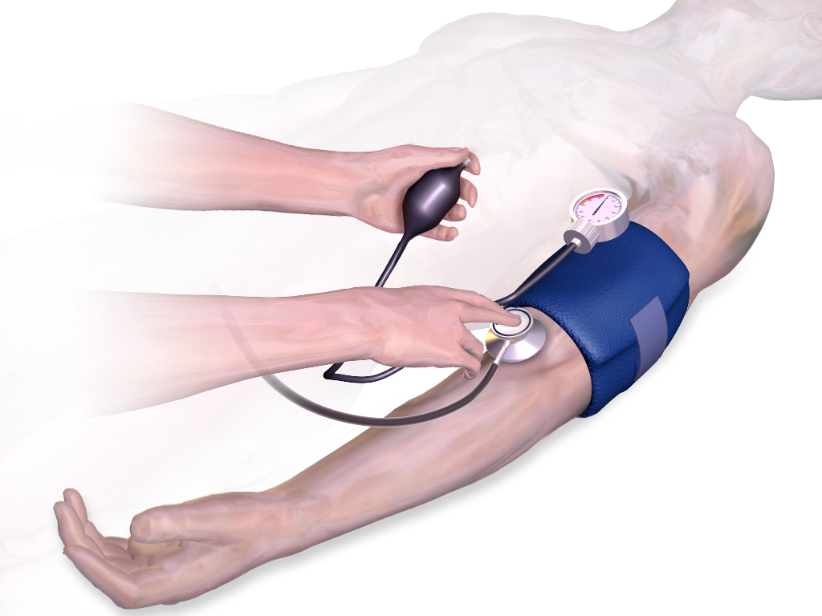
 | 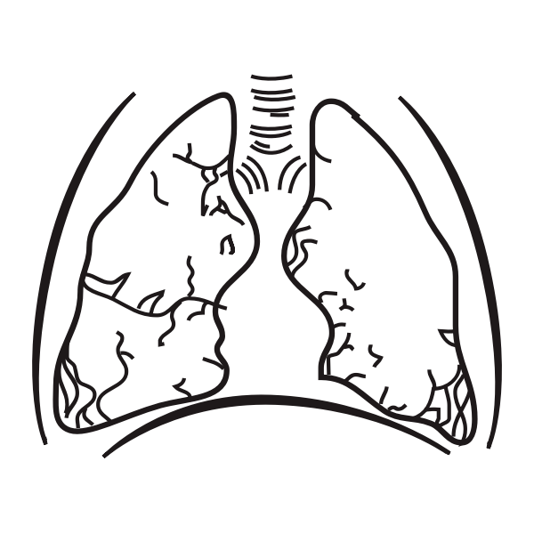 | 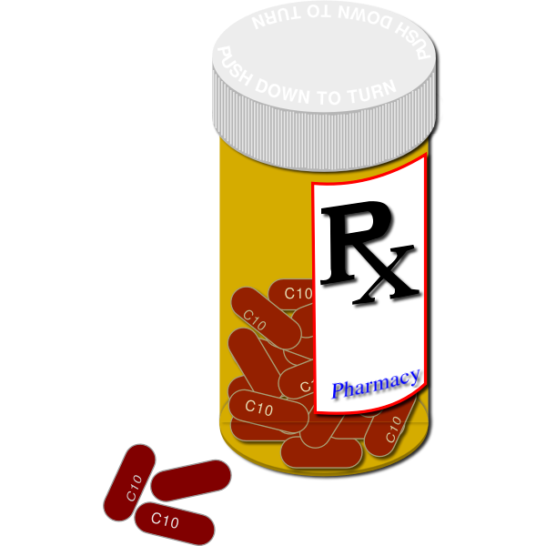 | 
[h5p id="848"]
[h5p id="849"]

| Verbs related to a doctor-patient communication
Some useful verbs that you might need when talking to a doctor. What are the verbs that a doctor might use, and what are some verbs that you might use to describe your condition?
 | 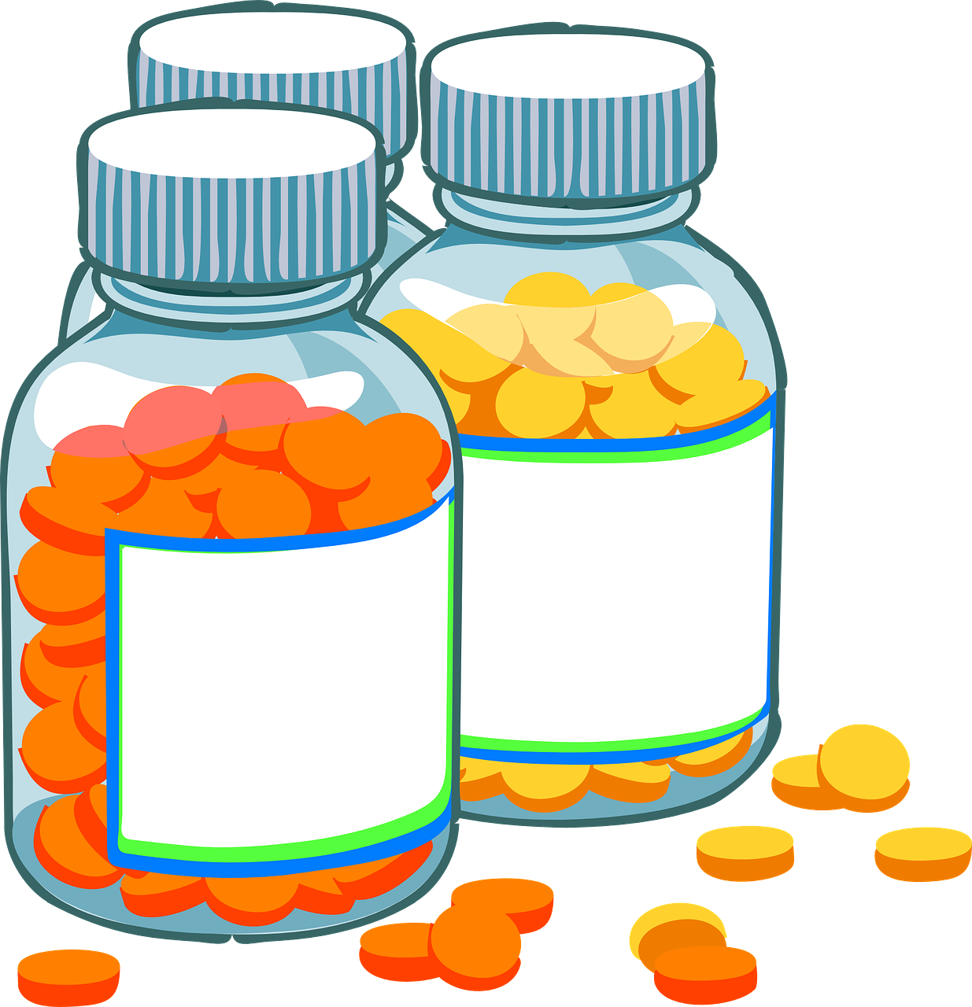 |  | 
napisati recept | tableta | antibiotik | ljekarna
[h5p id="847"]
Images used in this document are from these sources.

