3.5 - *chtěl bych / chtěla bych* - ‘I would like…’

[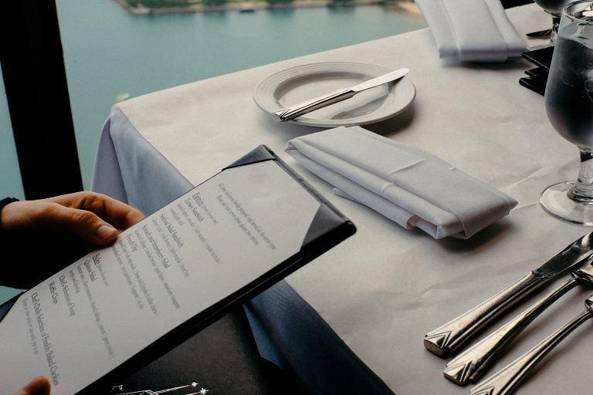](https://www.flickr.com/photos/barnimages/27873291575)

We’ve already learned how to order using *dát si* ‘to have (for oneself). However, you can also say what you “would like” using the forms below:

| ***chtěl / chtěla bych* ‘I would like’** | *chtěli / chtěly bychom* ‘we would like’ |
| --- | --- |
| *chtěl / chtěla bys* ‘you would like’ | *chtěl / chtěla byset* ‘you (formal) would like’  *chtěli / chtěly byste* ‘you (plural) would like’ |
| *chtěl / chtěla by* ‘he/she would like’ | *chtěli / chtěly by* ‘they would like’ |

You really will need to use just the forms ***chtěl / chtěla bych* “I would like…”** at this point. However, the rest of the paradigm (you, he/she, we, you all, they…) are given in the chart as well. For all of these, the form of *chtěl* (*chtěla, chtěli*, etc.) depends on the gender and number of the subject of the sentence. In other words, Eva and Jolana below would each say *chtěla bych*, while Jáchym and Michal would each say *chtěl bych*.

| *chtěla bych...* | *chtěl bych...* | *chtěla bych...* | *chtěl bych...* |
| --- | --- | --- | --- |

In groups, they would use the forms *chtěli / chtěly* in the plural (*chtěly* would be reserved for groups consisting exclusively of females):

|  |  |  |  |
| --- | --- | --- | --- |
| *chtěli bychom...* | | *chtěly bychom...* | |

Finally, when you are ordering using these phrases, make sure you put whatever follows in the accusative case:

| *Chtěl bych vodu.*  ‘I’d like water’ | *Chtěla bych smažený sýr.*  ‘I’d like fried cheese’ | *Chtěli bychom dvě piva.*  ‘We’d like two beers |
| --- | --- | --- |

Note on word order:

This won’t come up a lot now, but technically the forms bych, bys, by… all are in 2nd position (just like *se* and *si*, see [2.5 - Reflexive *se* and *si* and 2nd position](https://realityczech.org/reflexive-se-and-si-and-2nd-position)), so if something comes first in the sentence, the order will be switched around, e.g. - *Chtěl bych čaj* vs. *Já bych chtěl čaj*; *Chtěli by pivo* vs. *Petr a Sára by chtěli pivo*.

Images used in this document come from [these sources](https://docs.google.com/document/d/1JlaI0O7h4GtnAtCG0C7zxTcXZpBmQTS1F4zGv-d11ZE/edit#heading=h.shl5f0hg5pzi).