2 | 3 | Lekcija 5: Moji interesi

# 2.3 Zadatak 16. Kamo trebam ići?

Listen carefully to your classmates while they are presenting on their cities. Which one is your favorite? Talk with the classmate who talked about your favorite place. Provide him/her with your comments about their city. Say why you like the city, and what is (are) your favorite location(s) from what you saw. Say what else you want to do in the city. Finally, ask additional questions about the city. For example: **(1)** where does your classmate usually like to go with friends, **(2)** where do they usually go when they have free time, **(3)** what is their favorite spot in the city, etc.

### Bilješke (*notes*):

# 2.3 Zadatak 17. Izlet u Šibenik

Read the text correspondence between Matija and James. Based on the text correspondence and your knowledge about Šibenik, answer the questions.

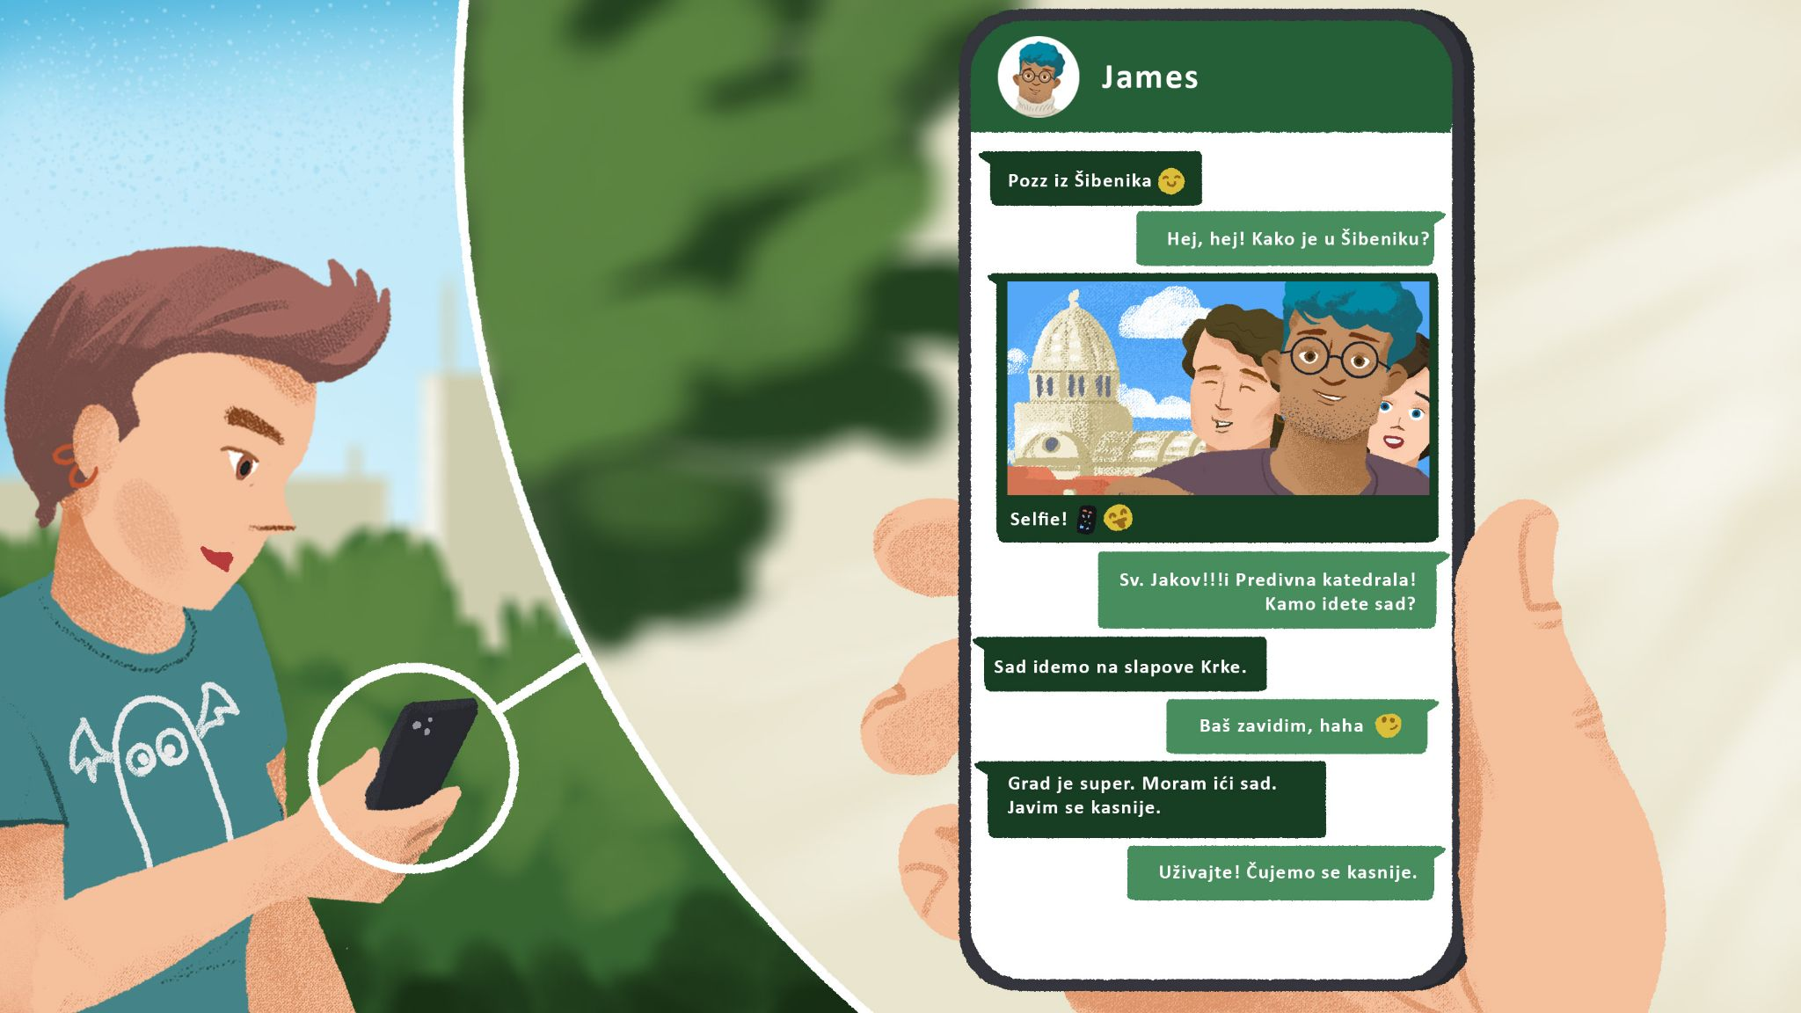

| 1 | Što misliš, kako je u Šibeniku? |
| --- | --- |
| - U Šibeniku je odlično. 👍  - U Šibeniku je dosadno. 👎 |
| 2 | Kamo ide James ? |
| - |
| 3 | Što James može raditi tamo? [tamo = “over there”] |
| - |
| 4 | Što ti misliš, kakav je Šibenik? |
| - |

# 2.3 Zadatak 18. Izlet u Sarajevo

Read the text correspondence between Laura and Mario. Then, answer the questions.

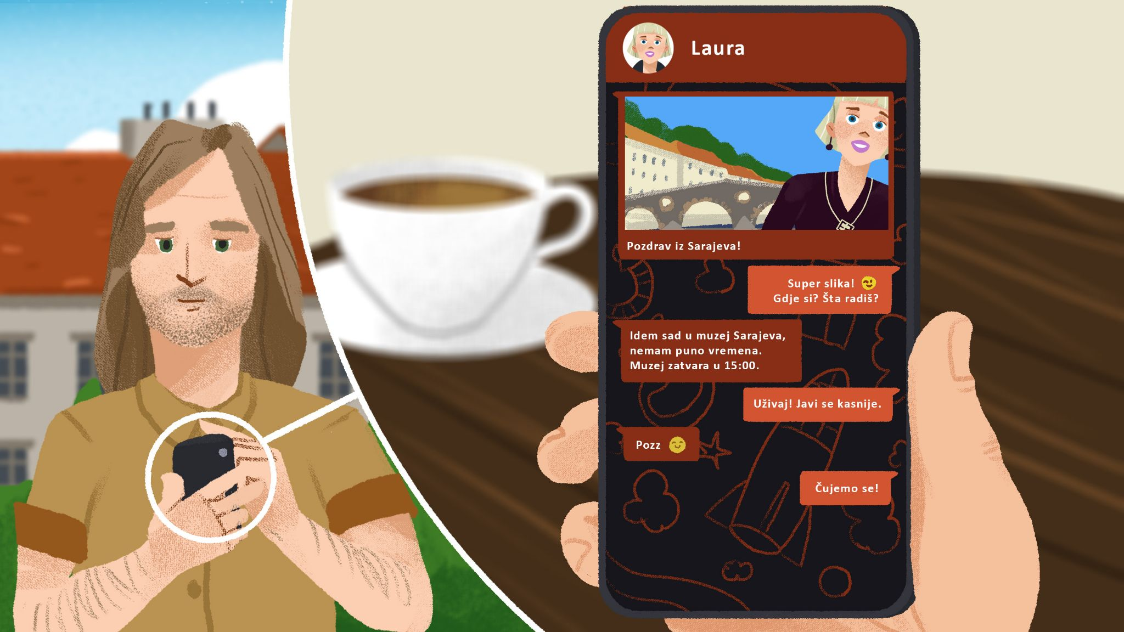

| 1 | Kamo ide Laura? |
| --- | --- |
| - |
| 2 | U koliko sati zatvara muzej? |
| - |
| 3 | Što ti misliš, kakvo je Sarajevo? |
| - |

# 2.3 Zadatak 19. Razgovor na kavi

🔊Listen to the **dialogue** between Matija and James. They are talking about James' recent trip to Šibenik and they are also making plans for the near future.

Work with your classmate and answer the following set of questions.

## | Razumijevanje [Comprehension]

| 1 | Što možemo vidjeti ako idemo u Šibenik? |
| --- | --- |
| - |
| 2 | Što možemo vidjeti ako idemo na slapove Krke? |
| - |
| 3 | Što fakultet organizira sljedeći mjesec? |
| - |
| 4 | Zašto su izleti dobri? |
| - |
| 5 | Kamo Matija planira ići za Novu godinu? |
| - |
| 6 | Tko ide u Dubrovnik? |
| - |

## | Osobna pitanja [Personal questions]

| 1 | Što ti radiš za Novu godinu? |
| --- | --- |
| - |
| 2 | Kamo ideš za Novu godinu? |
| - |
| 3 | Ideš li kući za Novu godinu? |
| - |
| 4 | Imaš li plan za Novu godinu? |
| - |
| 5 | Kamo želiš ići ove godine za Novu godinu? [ove godine = “this year”] |
| - |

Images used in this document are from [these sources](https://docs.google.com/document/d/1N5zeKO3pRuG7ajnhUyh-uT-tD1fF2HyhxSPejokVqwk/edit#heading=h.mxen1dypwxrf).