1 | 1 | Lekcija 1: Dobar dan!

# 1.1 Zadatak 1. Dobar dan!

🔊Listen to the following phrases and pronounce them as you hear them.

|  |  |  |
| --- | --- | --- |
| Dobro jutro! | Dobar dan! | Dobra večer! |

What would be the appropriate greeting at the following hours?

| 14:00 | [odgovor] → |  |
| --- | --- | --- |
| 11:00 | [odgovor] → |  |
| 19:00 | [odgovor] → |  |
| 08:00 | [odgovor] → |  |
| 23:00 | [odgovor] → |  |
| 12:00 | [odgovor] → |  |

# 1.1 Zadatak 2. Ja sam…

🔊Let's meet our international students. **Step 1:** Listen while they present themselves. **Step 2:** Now you try! **Tko si ti? (*Who are you?*)** Present yourself to the rest of the class. Follow the text in this task as an example when presenting yourself. If in class, walk around and introduce yourself to each of your classmates. If online, your instructor will ask you to present yourself, or to post a video online for other students to learn more about you.

**Tko je on/ona?**

Your instructor will ask you to present one of your classmates.

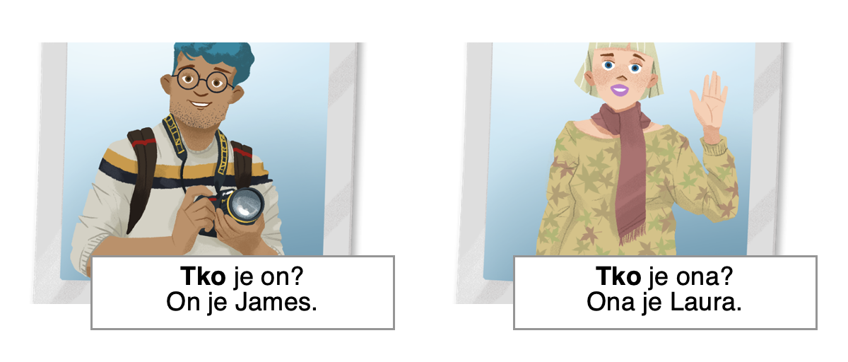

# 1.1 Zadatak 3. Kako se kaže?

📄 **Handout**. Let’s practice the pronunciation and investigate some basic words in Croatian. You will use [Google slides](https://docs.google.com/presentation/d/1da8-wllsZskxZevKQ_dCGs9VHk1Mb1HobfTarsw91ls). Ask and answer questions with a partner. Take turns asking each other what you see on each Google slide.

## | Pronunciation activity

|  | Što je ovo?  Ines: To je knjiga. |  |
| --- | --- | --- |

Images used in this document are from [these sources](https://docs.google.com/document/d/1RhtjowizA-v9Nr-FhpuxDqzicXn49s24K8kSvLZC9gw/edit#heading=h.u9fjnm2lm1ln).