# 2.11 - Languages we know...

[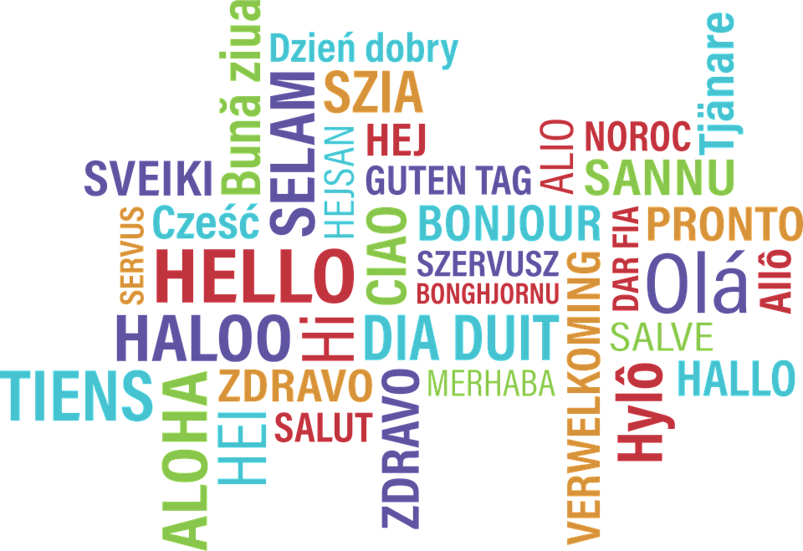](https://pixabay.com/en/hello-bonjour-hi-greeting-foreign-1502369/)

A lot of the verbs we have learned can be used to talk about your skills with other languages:

| *číst (čt-)* | to read |
| --- | --- |
| *mluvit* | to speak |
| *psát (píš-)* | to write |
| *rozumět* | to understand |
| *učit se* | to study, learn |
| *umět* | to know a skill |

These verbs can be used with various languages (see table below) to create sentences in Czech.

*Mluvím česky.*

I speak Czech.

*Božena rozumí francouzsky.*

Božena understands French.

*Učíme se rusky.*

We’re studying Russian.

*Mluvíte anglicky?*

Do you speak English?

*Učíme se česky.*

We’re learning Czech.

| Language Adverbs |  |
| --- | --- |
| *anglicky* | English |
| *francouzsky* | French |
| *italsky* | Italian |
| *japonsky* | Japanese |
| *německy* | German |
| *polsky* | Polish |
| *portugalsky* | Portuguese |
| *rusky* | Russian |
| *slovensky* | Slovak |
| *česky* | Czech |
| *čínsky* | Chinese |
| *španělsky* | Spanish |

These forms are slightly different from the adjectives we’ve learned so far (adjectives would end with a long -ý). Technically speaking, these are adverbs (in that they describe how we speak). Just know the difference between *anglický slovník* (adjective used to describe a noun) and *mluvím anglicky* (what language you speak).

**Adverbs denoting how well you speak/understand/write a language:**

| *plynně/plynule* | fluently |
| --- | --- |
| *výborně* | excellent |
| *docela dobře* | quite well |
| *dobře* | well |
| *trochu* | a little |
| *málo* | very little |

Examples:

*Mluvím dobře česky.*

I speak Czech well.

*Kdo rozumí dobře španělsky?*

Who understands Spanish well?

*Sára a Bedřich umějí málo německy.*

Sára and Bedřich know little German.

*Už mluvím plynně česky.*

I (can) already speak fluent Czech.

**Note:** the difference between *trochu* and *málo* is similar to the following in English: I speak a little (trochu) Czech **vs.** I speak little (málo) Czech. In the case of *trochu*, you are focusing on the fact that you do know some Czech, on the other hand with *málo* you are saying that you don’t know much Czech.

umět + infinitive

You can use the verb *umět* + the infinitive of another verb to talk about things you know how to do. In this sense, it often has the meaning of *can* in English. See the following examples:

*Umím psát česky.*

I know how to/can write in Czech.

*Neumíme tančit.*

We don’t know how to dance / We can’t dance.

*Umíš lyžovat?*

Do you know how to ski?

Images used in this document come from [these sources](https://docs.google.com/document/d/1ob3WPBc2PIWuMMfyjF6IDcxuBo1iyfqvtcL5dd9D0rE/edit#heading=h.p2o46jh0rn0r)