7 | 1 | Lekcija 1: Moje putovanje

7.1 Zadatak 1. Kamo putovati?
Look at the following websites and answer the following questions.

Korak 1: Make notes for the following questions.
 | Kamo putovati? | Gdje zimovati? | Gdje ljetovati?
ja
brat ili sestra
roditelji
roditelji i ja

Korak 2: Answer the above questions in full sentences and answer why?
Na primjer: Moj prijatelj putuje u Austriju sljedeći mjesec. Putuje u Beč, zato što voli i studira klasičnu glazbu. On zimuje u Francuskoj. Voli skijati i bordati. Ljetuje u Hrvatskoj ili Italiji. Voli surfati, plivati i sunčati se.
ja
brat ili sestra
roditelji
roditelji i ja

7.1 Zadatak 2. Moj odabir
Use the same websites from the previous task. Find one place that you would like to travel to during the months listed below. Be sure to mention the country you want to travel to, the exact location in that country, and what you would like to do there. Be careful how you express the meaning of “in a certain month”. Na primjer: U veljači želim putovati u Zagreb. Želim skijati na Sljemenu.
ožujak
srpanj
studeni
siječanj

7.1 Zadatak 3. Turizam
Browse through each of the websites again and find out what the motto is for each country. What do you think of each website and the locations in each country in general? Give your general impressions.
 | 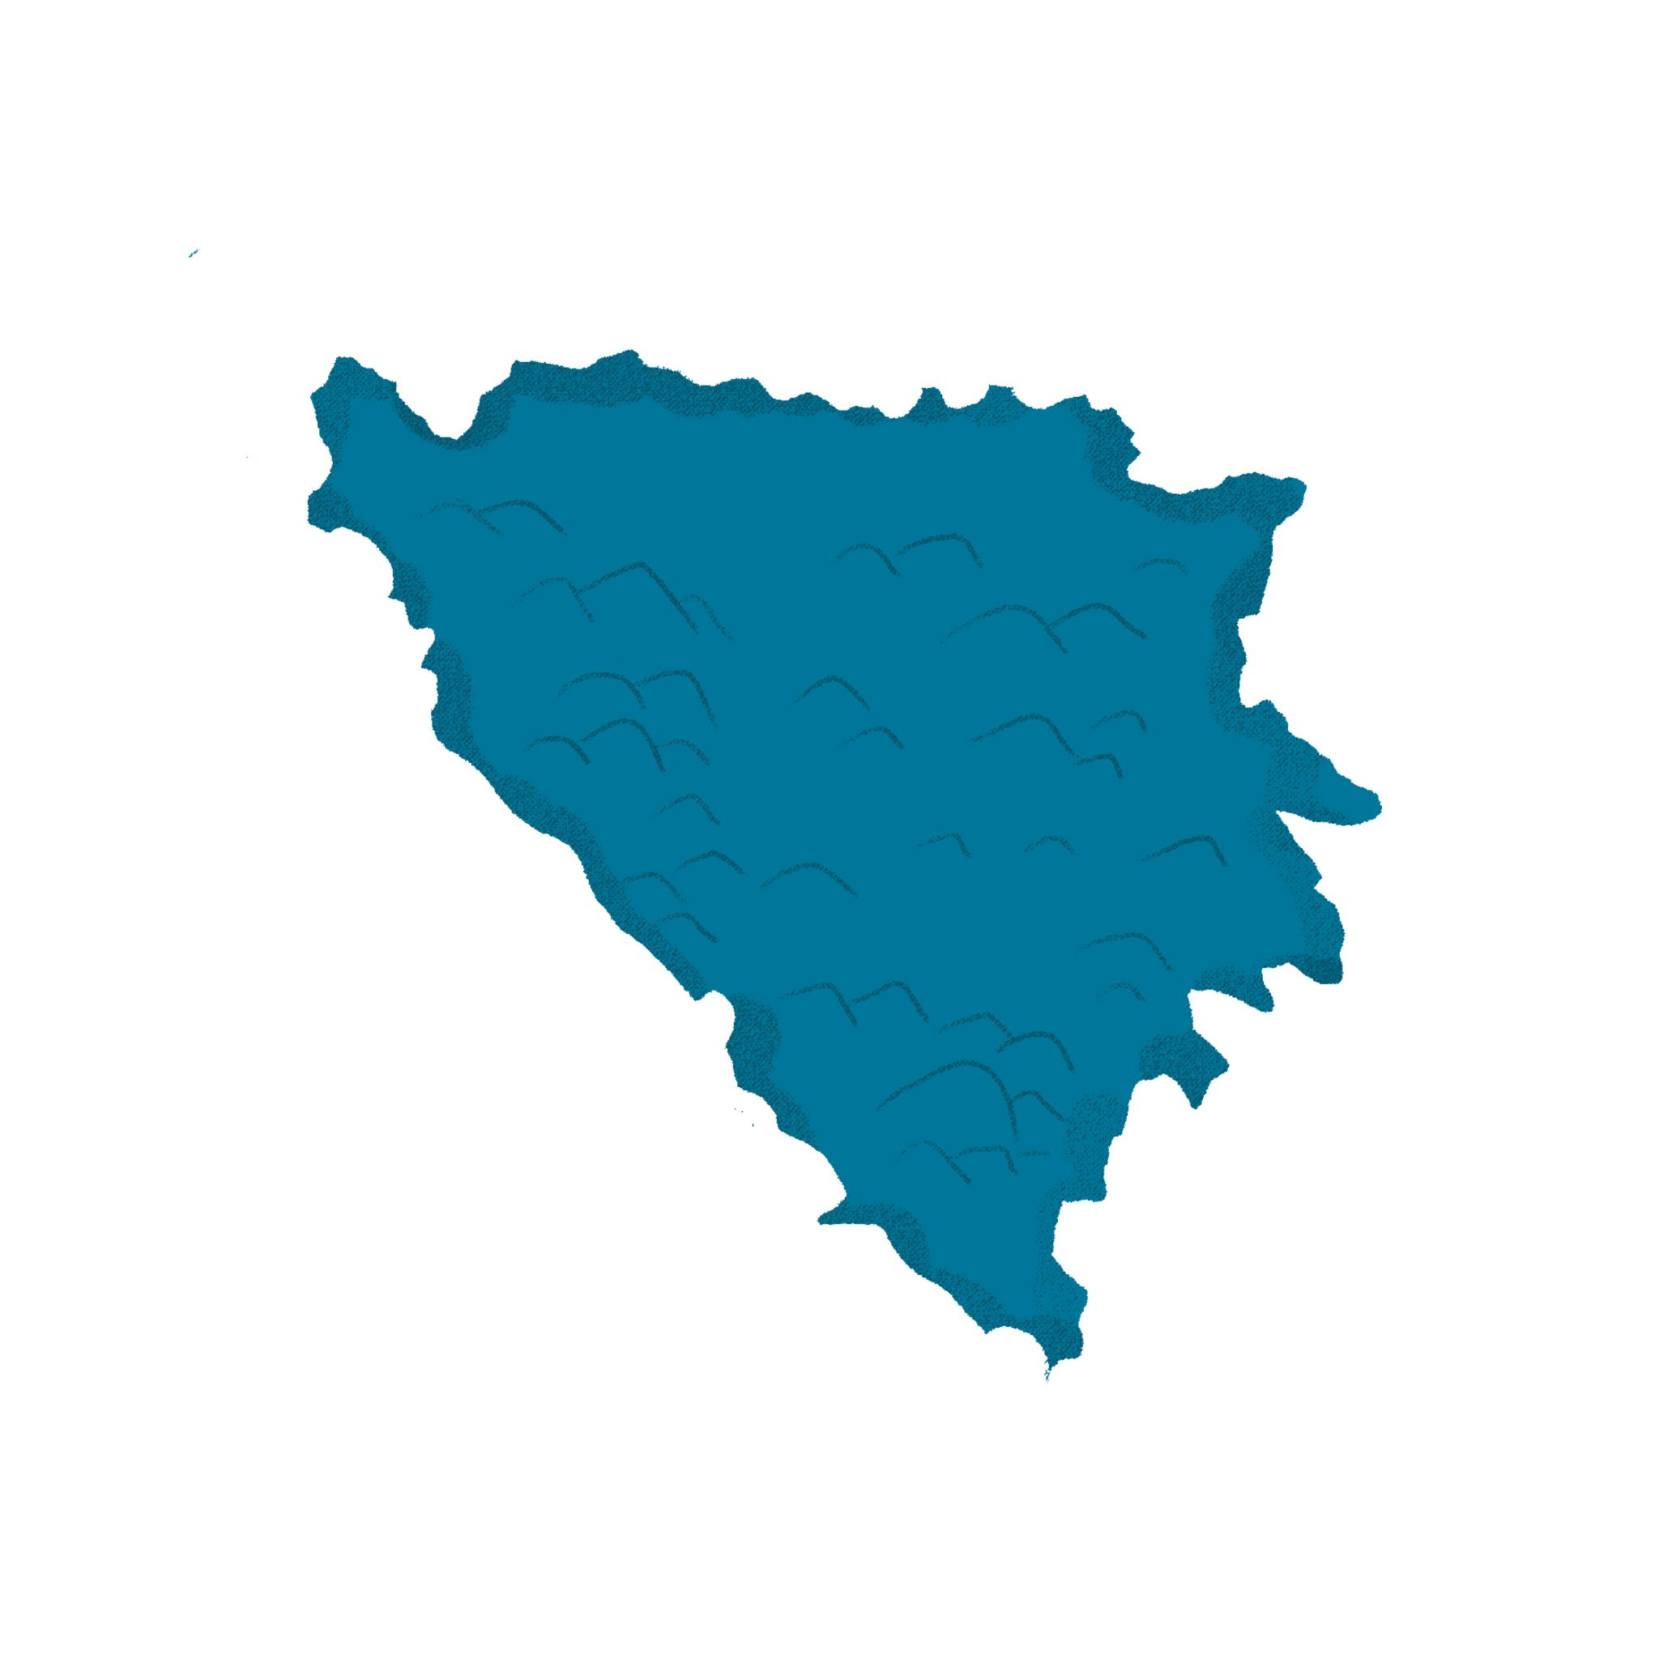 | 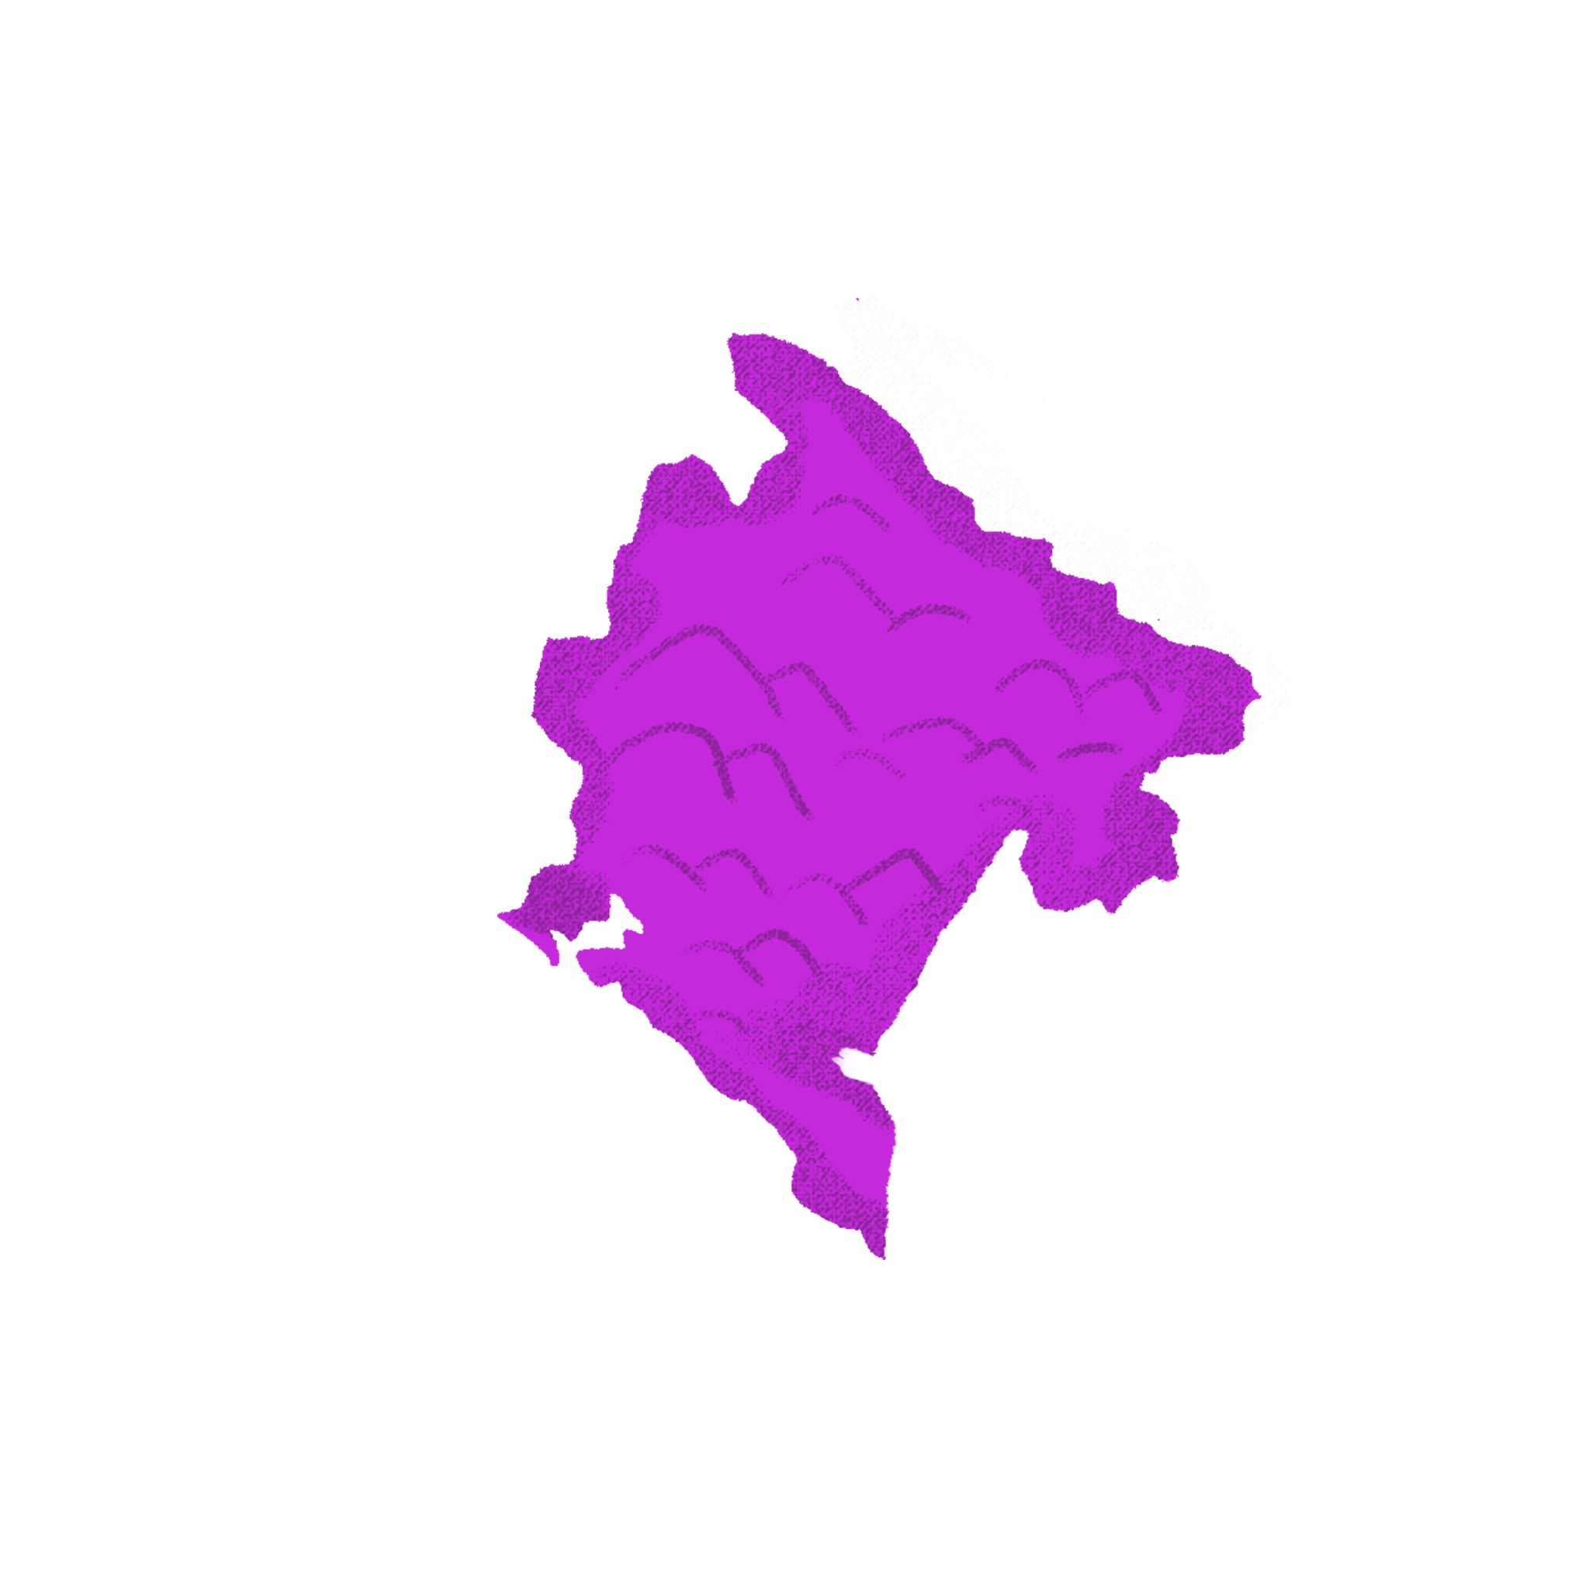 | 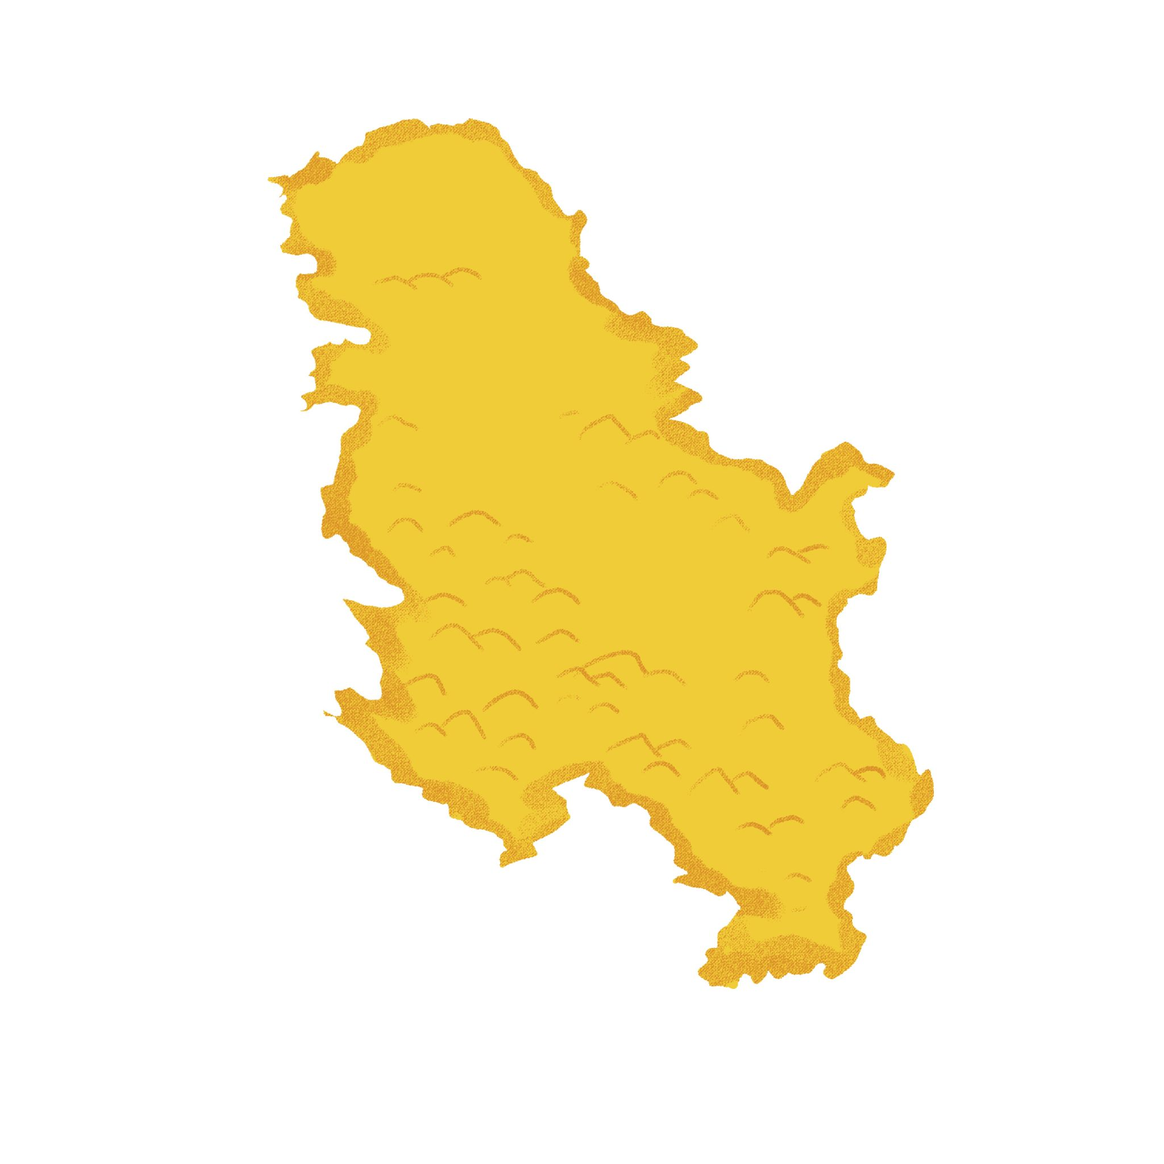

1 | Hrvatska
 | -
2 | Bosna i Hercegovina
 | -
3 | Crna Gora
 | -
4 | Srbija
 | -

7.1 Zadatak 4. Što rade?
Complete each sentence with the appropriate verb and in the correct form. You need to use all the verbs. One will be repeated. There are multiple ways to do this assignment.
ići | ljetovati | zimovati | kupovati | putovati

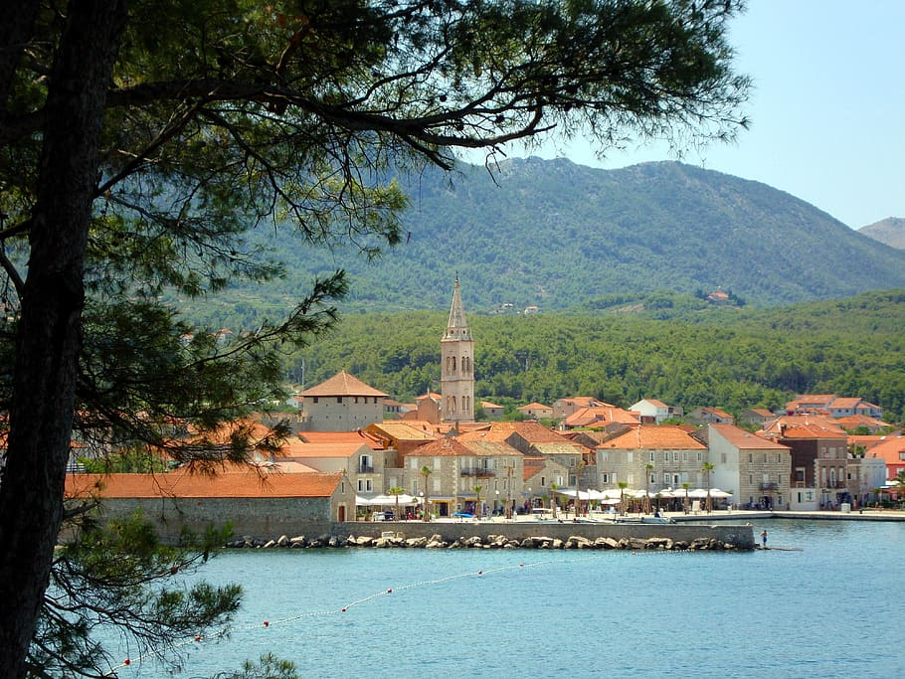 | 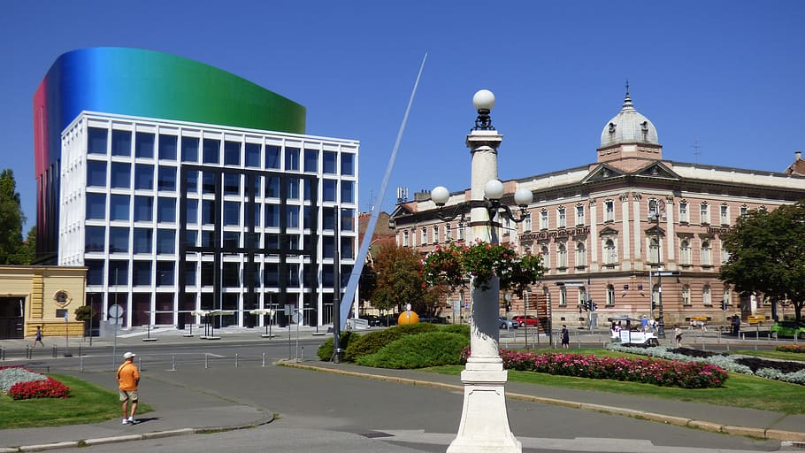
Marija i ja ____________ na otoku Hvaru. | Ti ____________ u Zagreb?
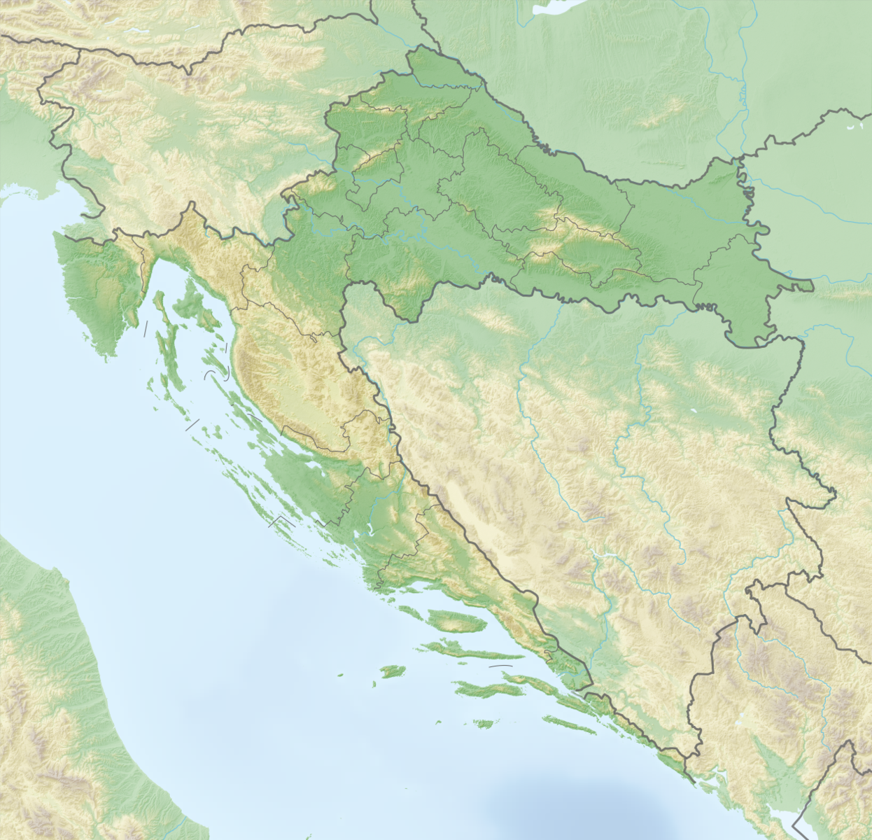 | 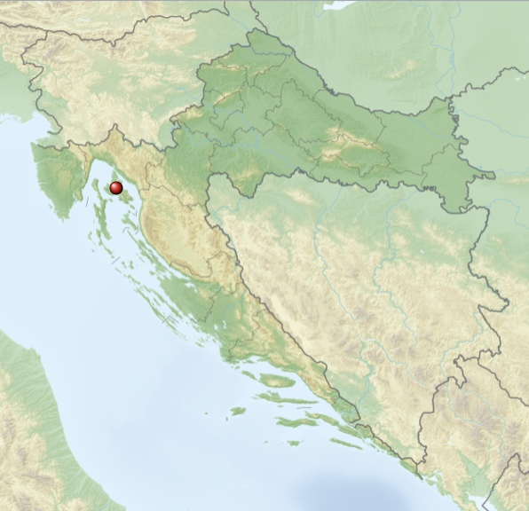
Darija ____________ u Hrvatskoj. | Ivo svake godine ____________ na Krk.
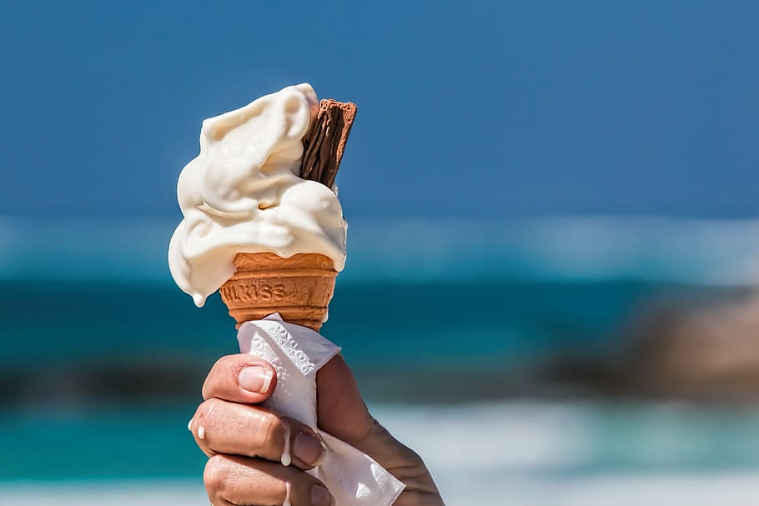 | 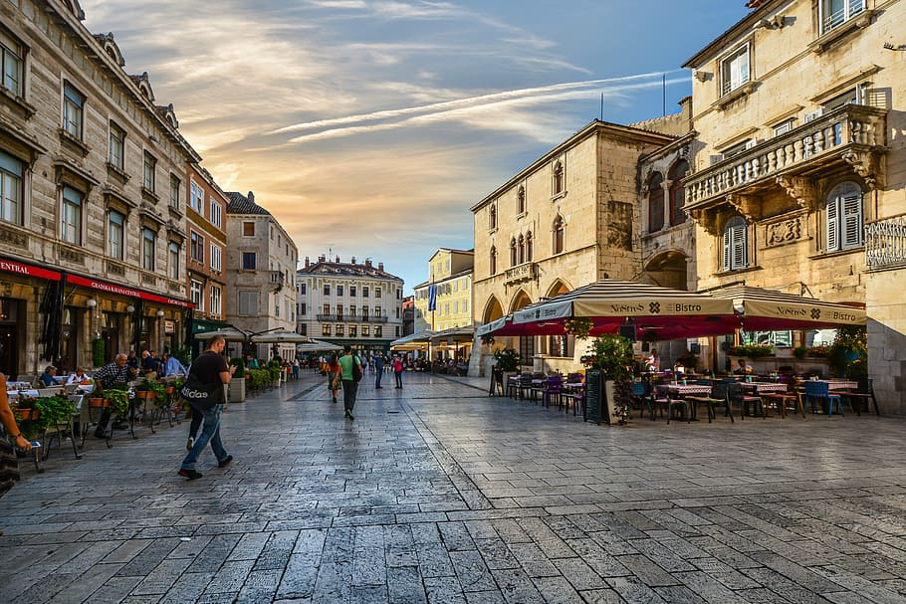
Marija ____________ sladoled. | Marko i Ana ____________ u Splitu.

7.1 Zadatak 5. Kako se kaže?
How would you express the following situations in Croatian?
 | 

1 | Say that you are always stressed about exams.
 | -
2 | Say to your friend that you believe in them and that they will pass all the exams.
 | -
3 | Ask your friend how their studying is going.
 | -
4 | How would you say that you are very busy? (There is a phrase for this.)
 | -
5 | How would you express that you are envious of your friend? (positive message)
 | -
6 | How would you express that you're excited about something?
 | -

Images used in this document are from these sources.

