8.3 - Nouns ending in -um (like muzeum, studium)

A number of nouns we’ve now encountered end in -um. Historically speaking, these are all words borrowed from Latin, and end in the Latin neuter suffix -um (equivalent to Czech neuter ending -o).

Here are some of the most common ones you will encounter in beginning - intermediate level Czech studies:

centrum - ‘center’
muzeum - ‘museum’
gymnázium - ‘college-prep high school’
studium - ‘studies’

Nominative | centrum | slovo
Genitive | centra | slova
Dative | centru | slovu
Accusative | centrum | slovo
Vocative | centrum! | slovo!
Locative | centru | slově / slovu
Instrumental | centrem | slovem

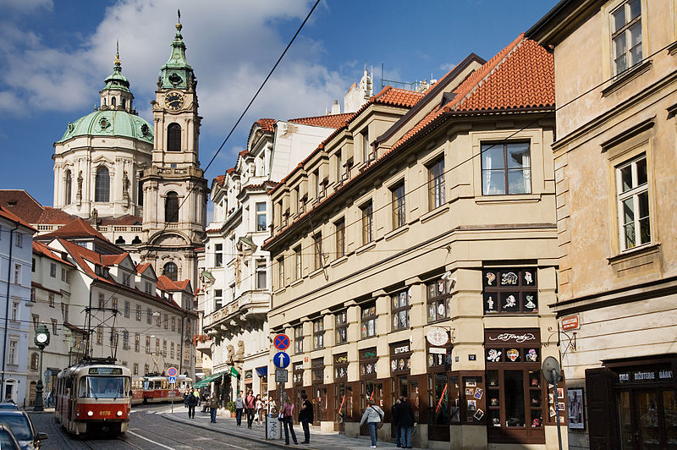 | 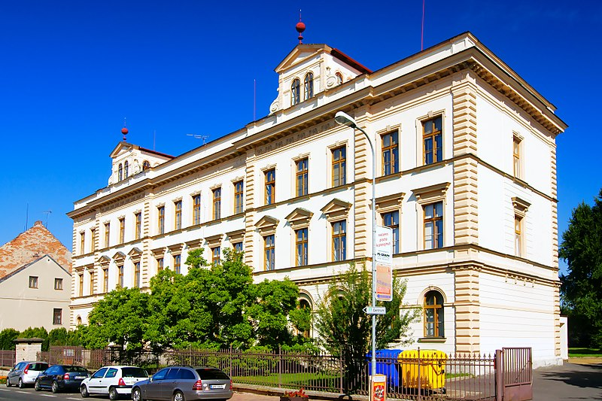
Petra bydlí v centru Prahy.  Petra lives in the center of Prague. | Pavel studuje na gymnáziu.  Pavel is a student in high school.

Images used in this document come from these sources.

