4.2 - Czech Months

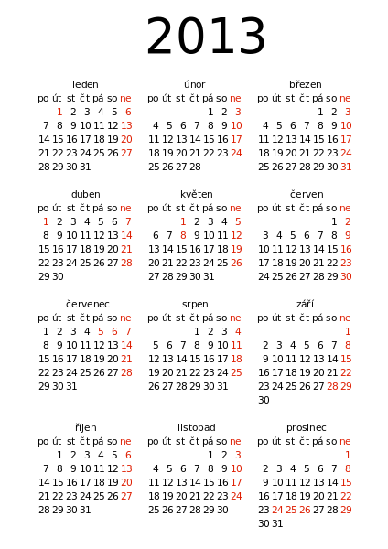
Czech has special words for each of the months (see table below). These words are often formed from various words indicating what is going on in the surrounding world and the changing seasons. The etymology (origin of a word’s meaning) for each of the months + its definition is given in the table below. Finally, the last column tells you how to say in a month, e.g. - v lednu ‘in January’, v květnu ‘in May’.

Name of month | Etymology | English | In the month...
leden | led – ice  because it’s really cold in this month, hence the ice | January | v lednu
únor | nořit se – to bob  the ice in the rivers and ponds would bob up and down | February | v únoru
březen | bříza – birch  birch trees start to sprout their blossoms early in the spring | March | v březnu
duben | dub – oak  the oak trees begin to grow their leaves | April | v dubnu
květen | květina - flower  flowers begin to blossom during this time | May | v květnu
červen | červený – red  many of the red flowers as well as fruits such as strawberries, raspberries and cherries come out during červen | June | v červnu
červenec | červený - red  červenec continues with more red flowers and fruits | July | v červenci
srpen | srp – sickle  this is the beginning of the harvest, when the sickle is used to gather grain and other food products are collected from the fields | August | v srpnu
září | za říje – during the rut  deer begin their rut in this season, mating before the winter cold | September | v září
říjen | říj – rut  deer continue their rut | October | v říjnu
listopad | listy padají – leaves fall  though leaves fall typically a bit earlier, but this point the trees are typically bare | November | v listopadu
prosinec | siný (Old Cz.) – gray blue  nights are longest in December – the deep gray blue of the night sky is extra apparent at this time | December | v prosinci

Listopad je můj nejoblíbenější měsíc.
November is my favorite month.

Vánoce jsou v prosinci.
Christmas is in December.

Její narozeniny jsou v únoru.
Her birthday is in February.

Images used in this document come from these sources.

